1 Simplify the expression 6w⁵y³ ÷ 15(wy)⁴.
2 The population of a town increases by 6% every year. In January 2006 the population was 5500.
a Find the population of the town:
i in January 2007
ii after n years.
b Find the year in which the population will reach 11 000.
3 The value of a particular piece of equipment, initially valued at $60 000 depreciates by 8% every year.
a Find the value of the piece of equipment after 1 year.
b Find the value of the piece of equipment after n years.
c After how many years will the value be less than $20 000?
4 Simplify each of the following, giving your answer with positive index:
a
b 
c
d 
5 Write in the form 2^{an + b}
6 Write 2^{–x} × 3^{–x}  6^{2x}  3^{2x}  2^{2x} as a power of 6.
7 Simplify each of the following:
a
b
c
d

8 Simplify each of the following:
a
b 
c 
d  
9 Solve each of the following equations for x:
a 2^{x} =
b 2^{x – 4} = 256
c 2^{x} = 0.65
d log₂ (x – 2) = 6
e log₃ (2x – 4) – log₃ (6) = 3
f log₁₀ (x – 4) + log₁₀ (x + 4) = 3
10 Sketch the graphs of each of the following. Give the equations of asymptotes and the axes intercepts:
a y = 2^{x} – 4
b y = log₂ (2x)
c y = log₂ (x – 4)
d y = log₂ (x – 4) – 3
11 a Find a sequence of transformations which transform the graph of y = log₂(x) to the graph of y = –3 log₂ (5 + x).
b Sketch the graph of y = –3 log₂ (5 + x).
c Solve the equation –3 log₂ (5 + x) = 10 for x.

Answers
1
2 a i 5830 ii 5500(1.06)^{n}
b 2017
3 a $55 200 b $60 000(0.92)^{n} c 13.18 years
4 a 8ab b ab⁵ c 2b d $\frac{1}{\text{32}a}$
5 2^{2n – 4}
6 6^{3x}
7 a 2^{–1/6} b a^{11/20} c 2^{19/6} d 2^{3/5}
8 a ab^{2/3} b ab^{1/5} c a^{1/5}b^{3/5} d
9 a –4 b 12 c log₂ 0.65
d 66 e 83 f 2
10 a
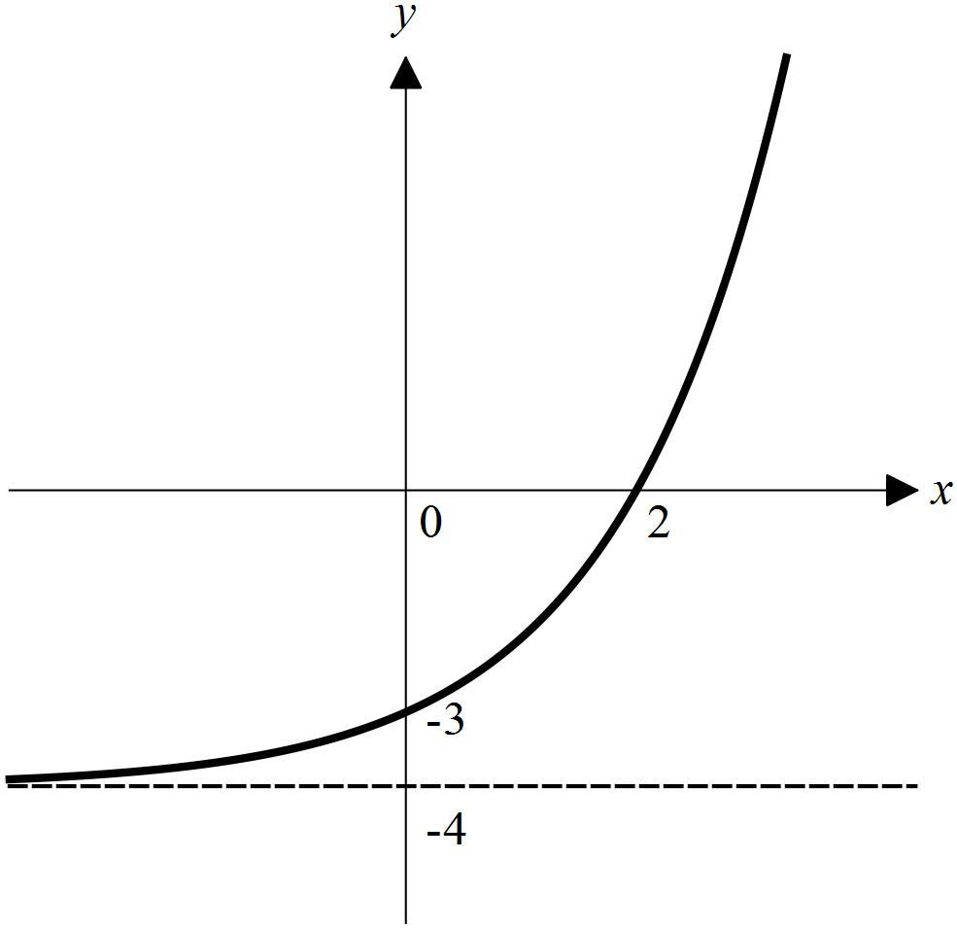
b
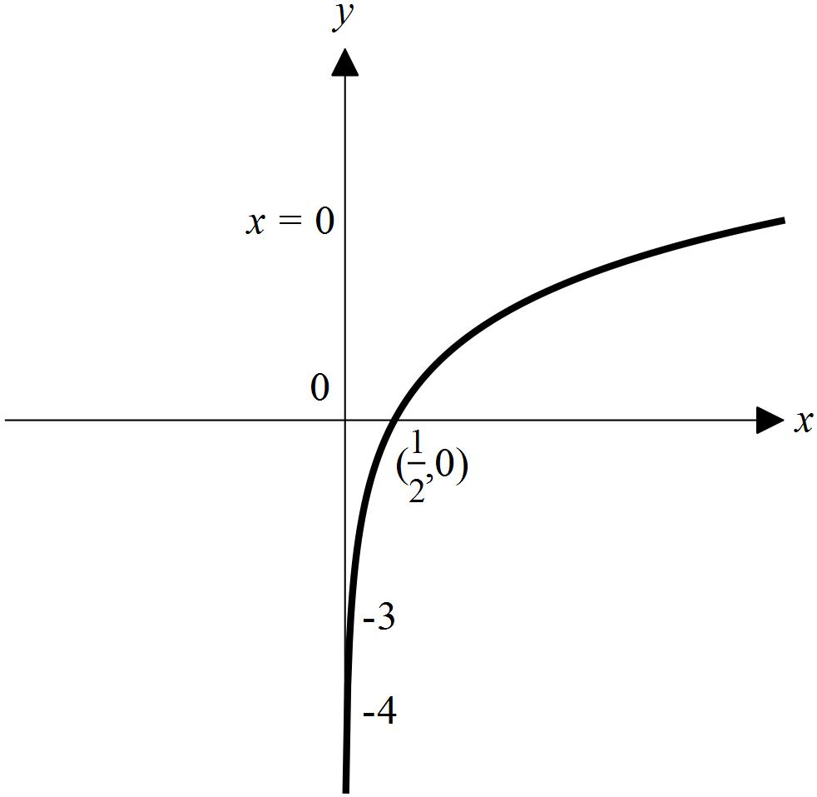
c
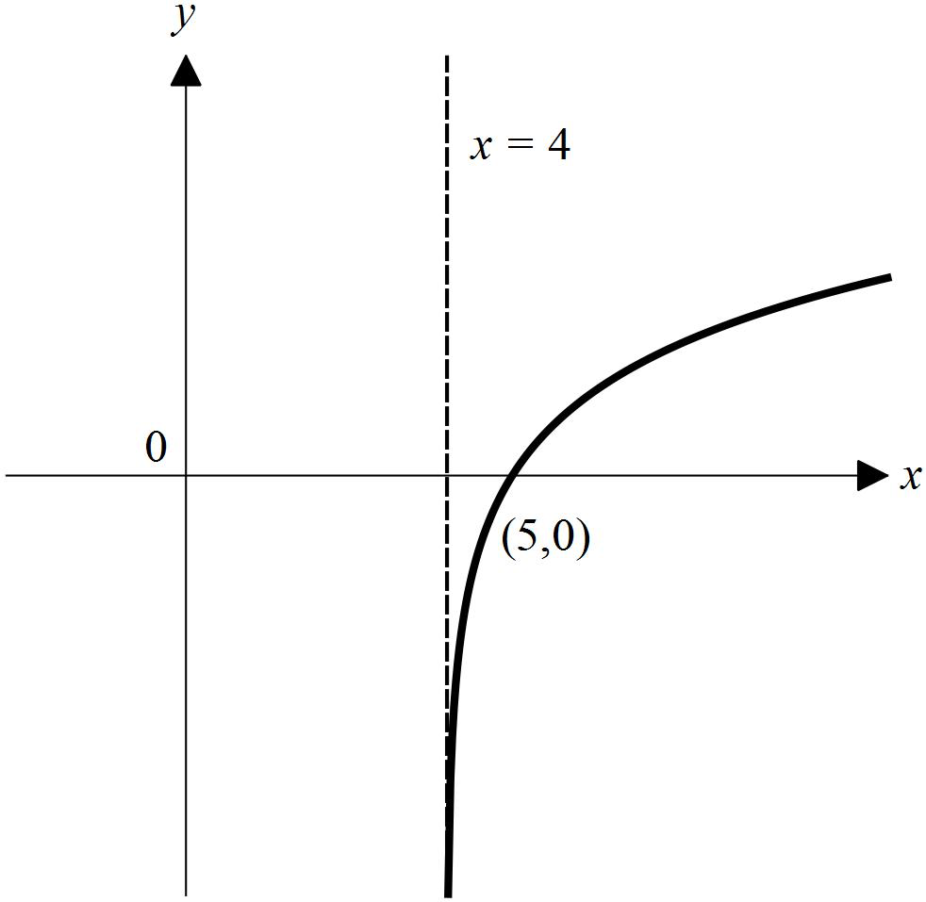
d
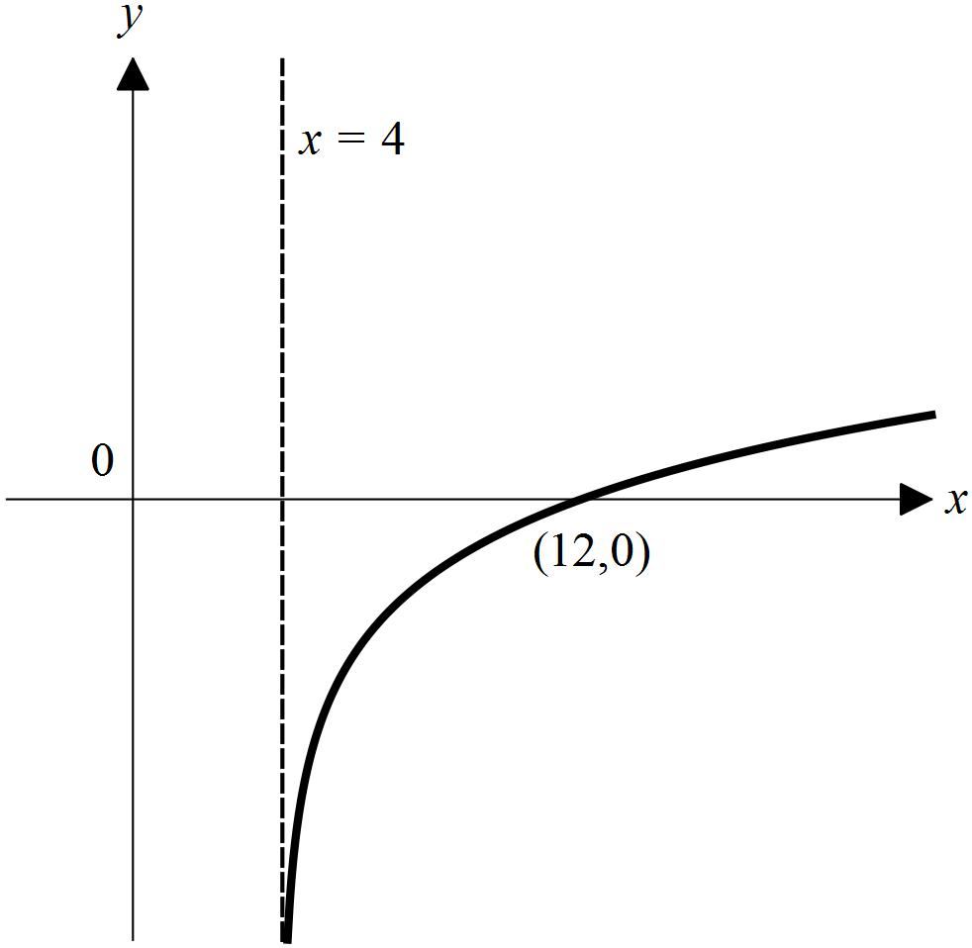

11 a Reflection in the x-axis, dilation of factor 3 from the x-axis, translation of 5 units in the negative direction of the x-axis
b
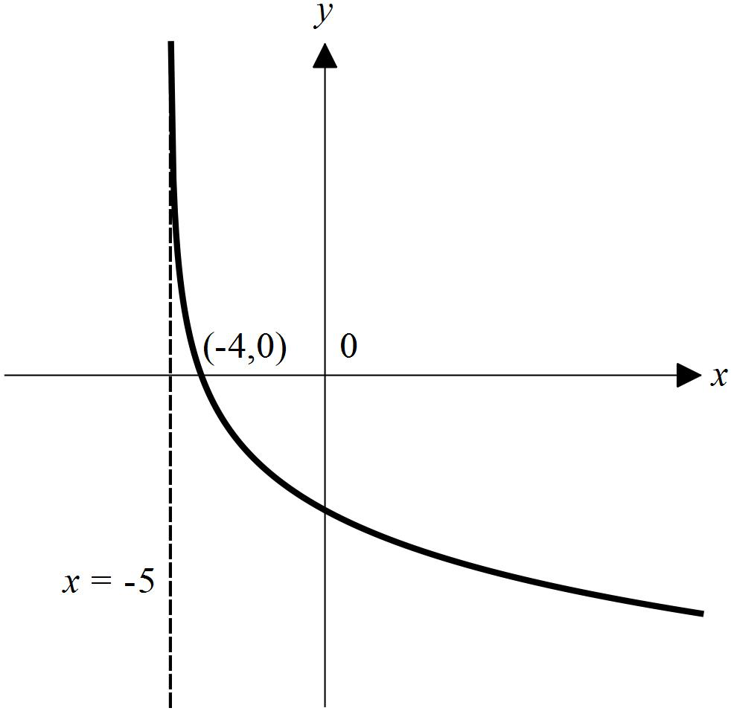
c x = 2^{–10/3} – 5

