1 Find the coordinates of the stationary point of each of the following curves:
a $y=x^{2}+4x−\text{12}$
b y = 2t³ – 5t² – 4t + 13
2 Let $y=x^{4}+x^{3}+x^{−2}+8$.
a Find the average rate of change of y between x = 1 and x = 2.
b Find the gradient of the curve at x = 2.
3 Find the equation of the tangent and the normal to the curve y = x³ − 2x² + 4 at the point where x = 2.
4 A particle moves from rest in a straight line so that after t seconds it is s metres from a fixed point O on the line, where s = t³ − 6t² + 12.
a Find the position of the particle after 3 seconds.
b Find the time and position when the particle comes to rest again.
c Find the total distance travelled in the first 4 seconds.
5 The line y = ax + 3 is tangent to the parabola y = x² + x + b when x = 1. Find the values of the constants a and b.
6 Water is being poured into a tank so that the volume, V mL, of water in the tank at time t minutes is given by $V(t)=\frac{1}{3}\left(8t^{2}−\frac{t^{3}}{2}\right), 0≤t≤\text{10}\text{.}$
a Find the volume of water in the tank at time:
i t = 0 ii t = 10
b Find the rate of flow of water into the tank at any time t.
c Find the rate of flow of water into the tank at t = 5.
7 The diagram shows the graph of y = 4 − 3x², for x ≥ 0 and y ≥ 0. B is a point on the graph and OABC is a rectangle. Find the value of x for which the area of OABC is a maximum.
x
y
O
B
A
C
8 Consider the function y = x³ – x² – 5x – 3.
a Factorise and find the x- and y-intercepts for the graph.
b Find the coordinates of the turning points.
c Sketch the graph of the function, labelling all the important features.
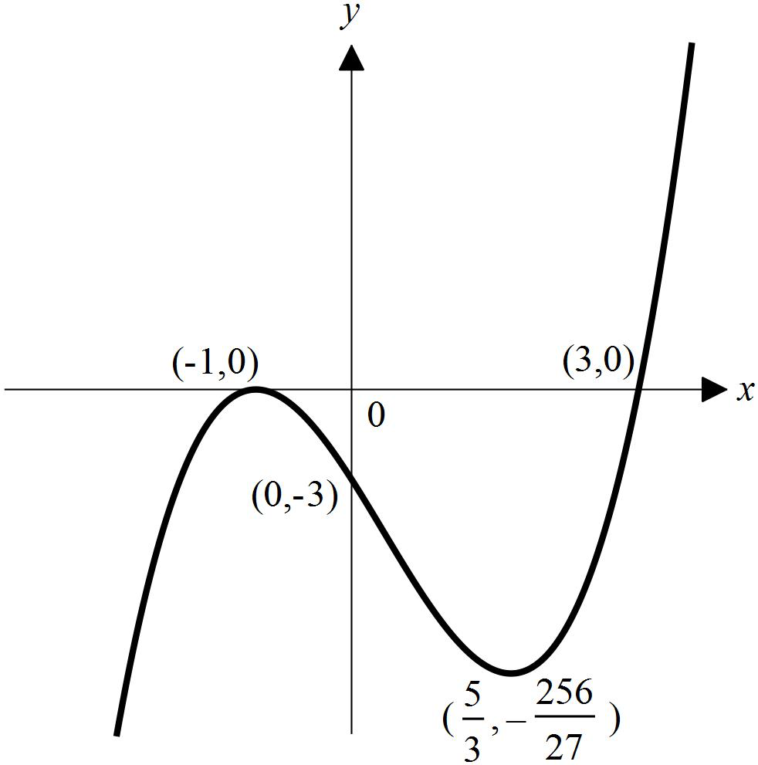
9 The derivative of a curve is $\frac{\text{dy}}{\text{dx}}=−2x+8$. Find the equation of the tangent to this curve at the point (−2, 3).
10 A rectangular box, made of thin sheet metal and without a lid, is of length 2x cm, width x cm and height h cm.
a Write down, in terms of x and h, the area of sheet metal required to make the box.
b Given that the area of sheet metal is 600 cm², show that $h=\frac{\text{600}−2x^{2}}{6x}$.
c Hence show that the volume, V cm³, of the box is given by $V=\text{200}x−\frac{2x^{3}}{3}$.
d Find $\frac{\text{dV}}{\text{dx}}$ and find the value of x for which V is a maximum.
e Hence calculate the volume of the largest such box that can be constructed using 600 cm² of sheet metal.
11 A particle moves in a straight line so that its position x cm relative to O at time t seconds is given by x = t² − 9t + 8, t ≥ 0.
a Find its initial velocity.
b Find when and where its velocity equals zero.
c Determine its average velocity for the first 4 seconds.
d Determine its average speed for the first 4 seconds.
12 a Let f:[–3, 5] → R, f(x) = x² + 2. Find the maximum and minimum value of the function.
b Let f:[–2, 1] → R, f(x) = x³ + 2x + 6. Find the maximum and minimum value of the function for its domain

Answers
1 a (−2, −16) b $\left(−\frac{1}{3}, \frac{\text{370}}{\text{27}}\right)$ and (2, 1)
2 a 21.25 b 43.75
3 Tangent: y = 4x − 4; normal: 4y + x = 18
4 a −15 m b t = 4 s, s = −20 m
c 32 m
5 a = 3 and b = 4
6 a i 0 ii 100
b $V^{'}(t)=\frac{1}{3}\left(\text{16}t−\frac{3t^{2}}{2}\right)$ c 14$\frac{1}{6}$ mL/min
7 x = $\frac{2}{3}$
8 a (x + 1)²(x − 3) x-inter: (-1,0) and (3,0); y-inter: (0, -3)
b (−1, 0) and $\left(\frac{5}{3}, −\frac{\text{256}}{\text{27}}\right)$
c
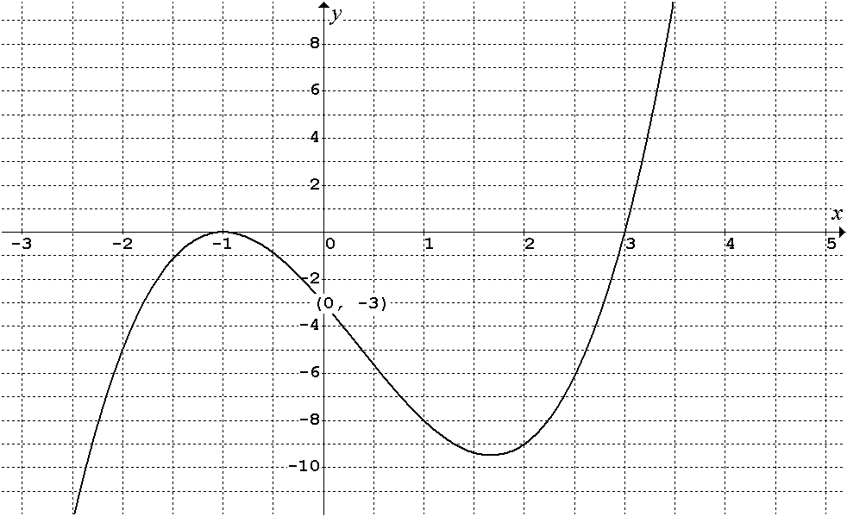
Need to label two turning points and all intercepts.
9 y = 12x + 27
10 a Area = 2x² + 6xh
d $\frac{\text{dV}}{\text{dx}}$ = 200 − 2x², V is maximum for x = 10
e Max volume = $\frac{\text{4000}}{3}$ cm³

11 a –9 cm/s b t = s, x = – cm
c –5 cm/s d 5 cm/s
12 a Maximum value = 27; minimum value = 2
b Minimum value = –6; maximum value = 9

