Name: _______________________

**Unit 1 General Maths – Application Task**

1. ***A delivery company has four trucks named T1 , T2 , T3 and T4. Each truck delivered a certain number of boxes, parcels and letters on Thursday, as shown in the matrix below:***

B P L

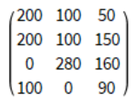

T1

T2

T3

T4

1. Write down the order of this matrix

(1 mark)

1. How many letters did truck 1 deliver?

(1 mark)

1. Which truck didn’t deliver any parcels?

(1 mark)

1. What is the value of the element at position a32 in this matrix?

(1 mark)

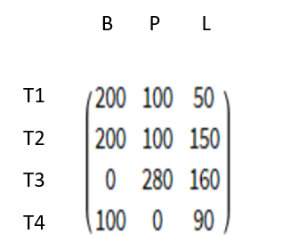

1. Show how you could multiply by a row matrix to get the total number

of boxes, parcels and letters in a matrix answer. (Chapter 4i)

(2 marks)

1. Were more boxes, parcels or letters delivered in total?

(1 mark)

1. Show how you could multiply by a column matrix to get the total

number of deliveries for each truck. (Chapter 4i)

(2 marks)

1. Which truck delivered the most items in total?

(1 mark)

1. ***The deliveries on Friday and Saturday were different to those on Thursday.***
2. On **Friday**, the deliveries were 50% of what they were on Thursday. Change 50% to a decimal and write this decimal as a scalar in front of the matrix below. Then multiply the scalar by the matrix **and write the result in the space on the right**:

50% = _______



(3 marks)

1. On **Saturday**, the deliveries were 110% of what they were on Thursday. Change 110% to a decimal and write this decimal as a scalar in front of the matrix below. Then multiply the scalar by the matrix **and write the result in the space to the right**:

110% = ______



(3 marks)

1. Use matrix addition to fill out the total deliveries matrix below (Thursday + Friday + Saturday):

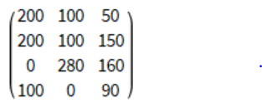

Total Deliveries =

(2 marks)

1. If boxes cost $3.25, parcels cost $2.50, and letters cost $1.50, fill out the Item Price matrix below. Also copy the Total Deliveries matrix from the previous question. Then multiply these two matrices together to give the Total Price Per Truck:

Total Deliveries Item Price Total Price Per Truck



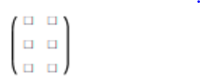

.

=

.

( 4 x 3 ) ( 3 x 1 ) ( 4 x 1 )

(3 marks)

1. Which truck had the most amount of money spent on item deliveries?

(1 mark)

1. ***There are four towns that the trucks deliver to.***
2. Draw a road network for the towns in the space below, labelling the towns as W, Y, K and C. The road network must include the following:

* Multiple roads must connect between two of the towns
* One town must have a scenic loop road that returns to that town without going to another town
* One town must only have a single roadgoing to it

(4 marks)

1. Create a one-step adjacency matrix that shows the number of direct road connections between the four towns. (Chapter 4f)

(2 marks)

1. If you were to add up the numbers in the first column of this matrix,

what would the result show?

(1 mark)

1. If you were to add up the numbers in the third row of this matrix, what

would the result show?

(1 mark)

1. Write a matrix operation (calculation) in the space below that works out the number of two-step paths between each of the towns. Also show the result in a matrix. (Chapter 4f)

(3 marks)

1. Using the result from part f, identify the two towns that have the greatest number of two-step paths between them.

(Note – it could also be between a town and itself)

(1 mark)

1. ***The population of two of the towns in the delivery network is changing. Town Y initially has 2000 people and Town K initially has 1000 people.***
2. Write down a (2 x 1) initial state matrix called S0 with these numbers in it. Label which town is which number.

(2 marks)

1. After each year, 20% of the people in Town Y move to Town K, and 10% of the people in town K move to Town Y. All the other residents stay where they are. Write down a (2 x 2) transition matrix called T with all of the relevant decimals included in it. (Chapter 4g)

(4 marks)

1. In the space below, show a matrix calculation that works out S1 - the number of people in each town after one year. **Also show the result of the calculation in a matrix with the two towns labelled**. (Chapter 4g)

(4 marks)

1. In the space below, show a matrix calculation that works out S2 - the number of people in each town after two years. **Also show the result of the calculation in a matrix with the two towns labelled**. (Chapter 4h)

(4 marks)

1. By experimenting with larger matrix powers, find the number of years it takes until the populations in Towns Y and K reach a steady state (don’t change any more). Show the matrix calculation when this first occurs below, including the result matrix with the steady state populations. **Also state how many years it took for this to happen in a sentence**. (Chapter 4h)

(5 marks)