# 2018

Question 6

Which one of the following terms refers to enlargement of the liver?

A. hepatomalacia

B. hepatomegaly

C. hepatoma

D. hepatitis

Question 11

What does the suffix -sclerosis refer to?

A. to break down

B. reconstruction

C. condition of softening

D. condition of hardening

Question 12

Which medical term refers to the condition of being without menstrual flow (menstruation)?

A. amenorrhoea

B. dysmenorrhoea

C. oligomenorrhoea

D. hypomenorrhoea

Question 13

In the word ‘polycythaemia’, ‘cy’ is the

A. prefix.

B. suffix.

C. root word.

D. combining vowel.

Question 15

An incision into a bone is called an

A. osteotome.

B. osteotomy.

C. ostectomy.

D. osteoblast.

Question 16

Which one of the following terms refers to ‘pertaining to the head’?

A. cardiac

B. cephalic

C. cerebral

D. encephalic

Question 19

Which combining form means ‘testicle’?

A. orchid/o

B. perine/o

C. spermat/o

D. epididym/o

Question 20

Ringing in the ear is called

A. otalgia.

B. vertigo.

C. tinnitus.

D. otorrhoea.

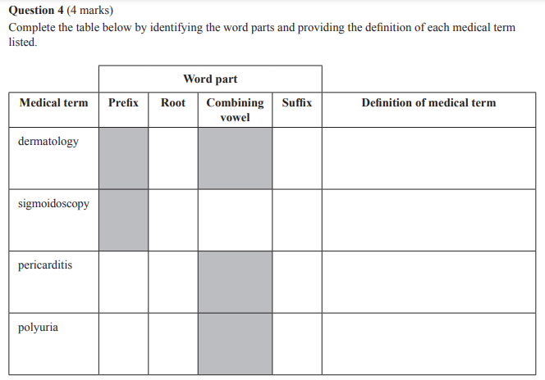

Question 8 (7 marks)

Read the following medical report.

Mr Baldacci, a 68-year-old male, presented to the ED with severe abdominal pain and vomiting.

He has not opened his bowels for 5/7. He has a PMHx of bowel cancer that was surgically removed, prostatectomy, hypothyroidism and dermatitis. His TPR is 37.8 °C, 80 bpm, 25 pm and BP – 150/90 mmHg. The Dr ordered him to be admitted to hospital for a colonoscopy, which showed a small bowel obstruction. He has been in hospital for 5 days undergoing Rx and is scheduled for D/C tomorrow. He has an OPD appointment for 6/52.

Complete the table below by providing the definition of, or the full medical term for, each word/abbreviation listed.

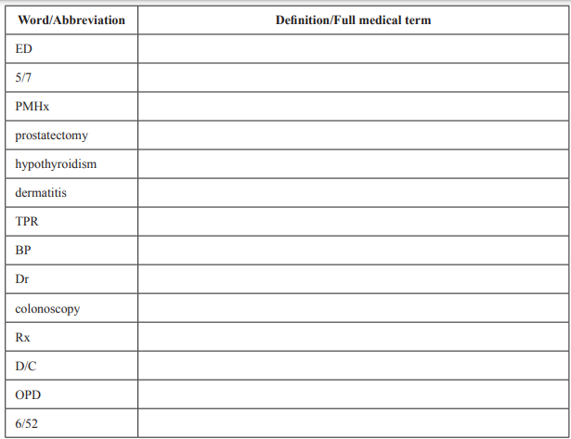

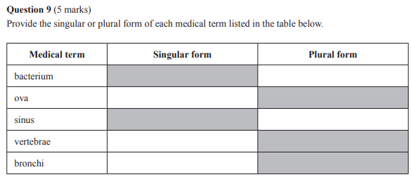

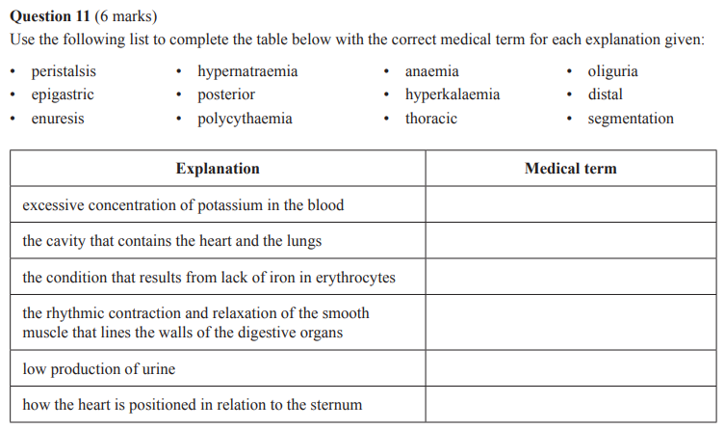 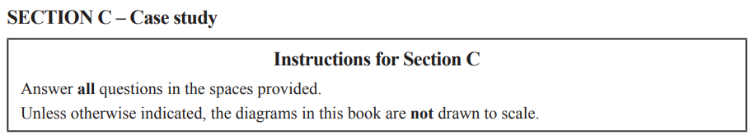 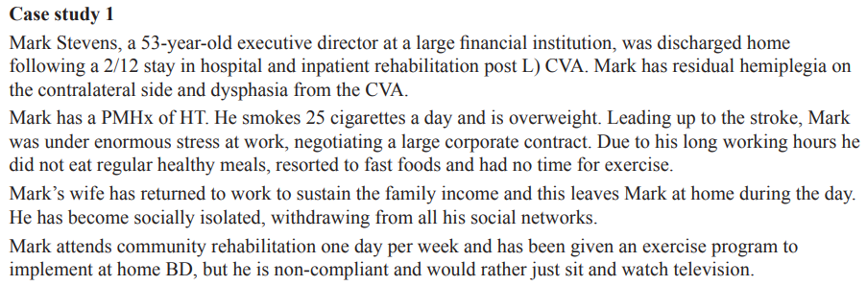 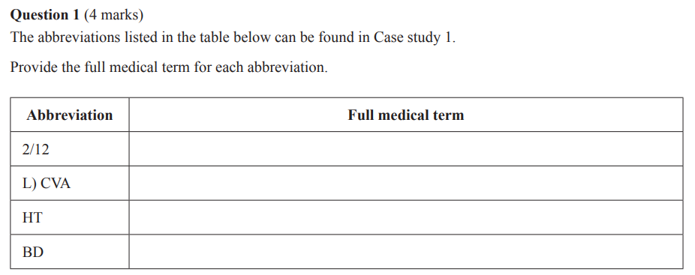

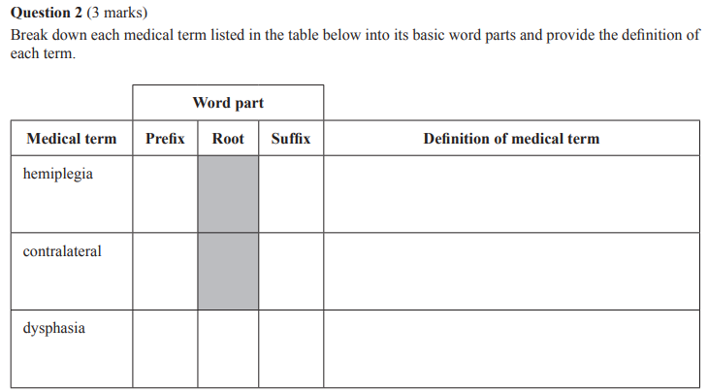 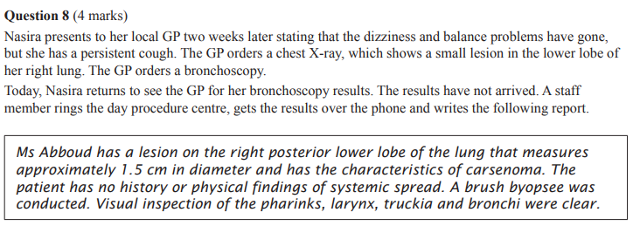 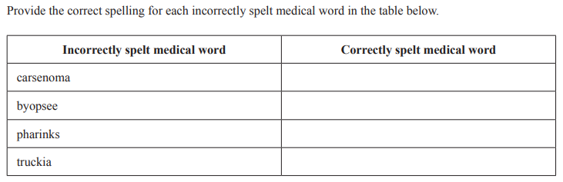

# 2019

Question 1

A patient is being transferred to the CCU.

The unit the patient is being transferred to is the

A. Chest Care Unit.

B. Cancer Care Unit.

C. Cardiac Care Unit.

D. Coronary Care Unit.

Question 4

Which medical term refers to the abnormal narrowing of an artery or arteries?

A. atherostenosis

B. arteriostenosis

C. atherosclerosis

D. arteriosclerosis

Question 8

What is the medical abbreviation for ‘three times a day’?

A. D

B. BD

C. q3h

D. TDS

Question 10

Which combining form means ‘liver’?

A. hydr/o

B. histol/o

C. hepat/o

D. haemat/o

Question 12

Which root word means ‘tongue’?

A. rhin/

B. palat/

C. gloss/

D. odont/

Question 14

The term ‘olfactory’ refers to the sense of

A. taste.

B. sight.

C. smell.

D. touch.

Question 18

Which one of the following means ‘located between the ribs’?

A. intercostal

B. intracostal

C. mediastinal

D. costochondral

Question 20

Which one of the following prefixes means ‘around’?

A. epi

B. peri

C. hypo

D. hyper-

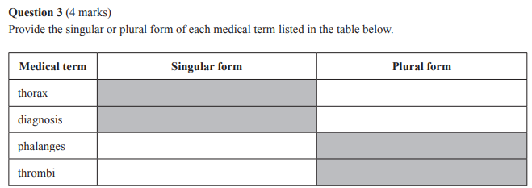

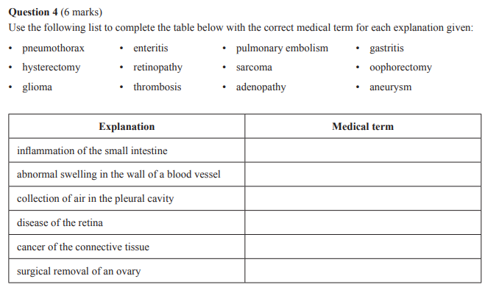

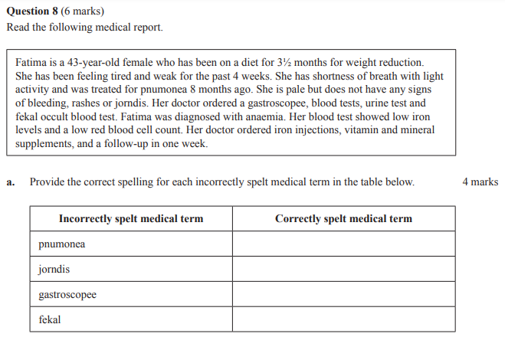

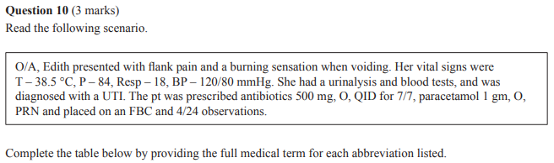 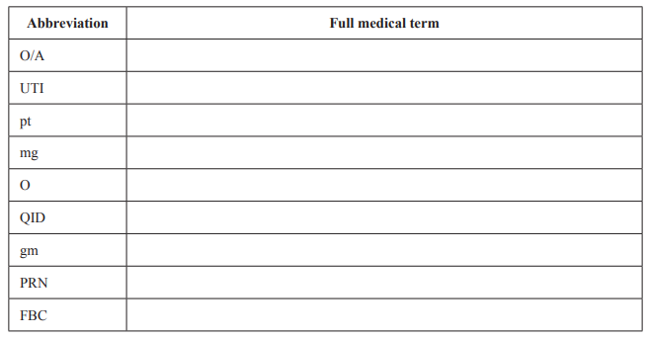  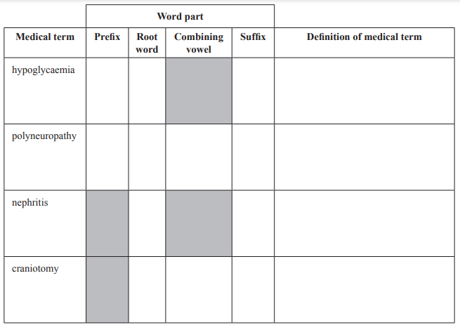

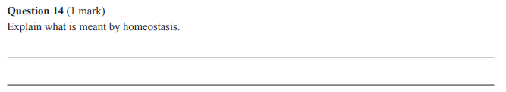 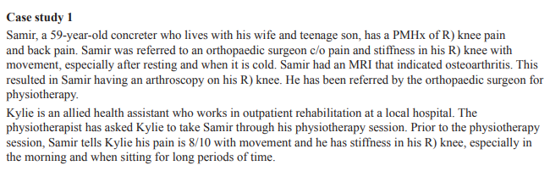 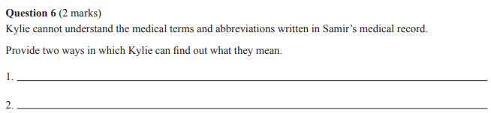

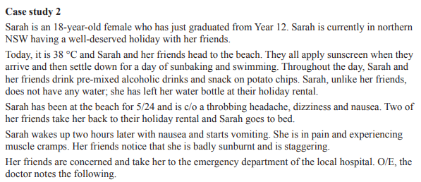

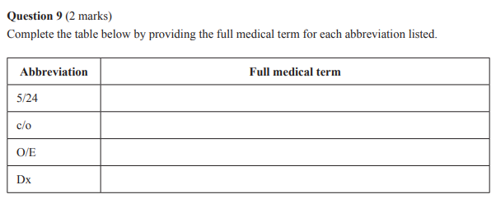

# 2020

Question 2

‘Gastr/o’, which means ‘stomach’, is referred to as a

A. combining form.

B. root word.

C. prefix.

D. suffix.

Question 5

Which root word means ‘head’?

A. cephal/

B. gingiv/

C. crani/

D. haem/

Question 6

Cardiac tissue can be found in the

A. muscles.

B. bones.

C. heart.

D. skin.

Question 14

Which prefix means ‘painful’?

A. dys

B. anti

C. contra

D. derm

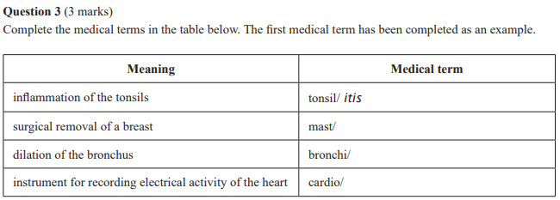

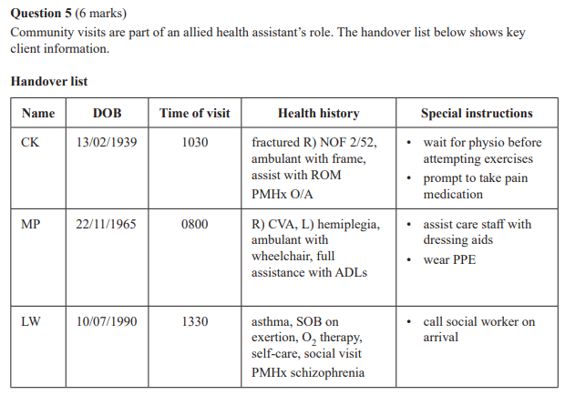 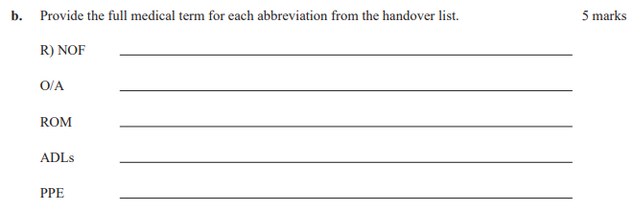

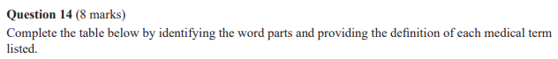

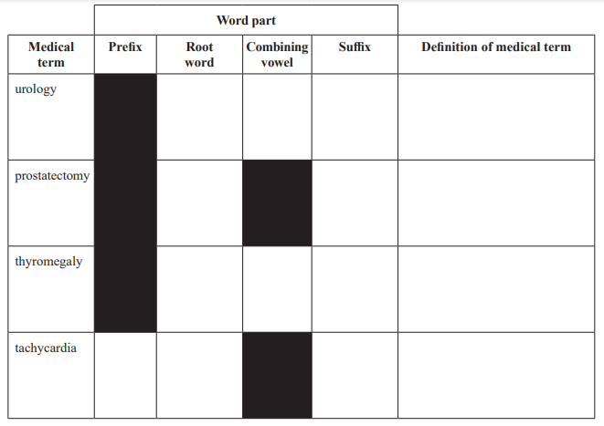

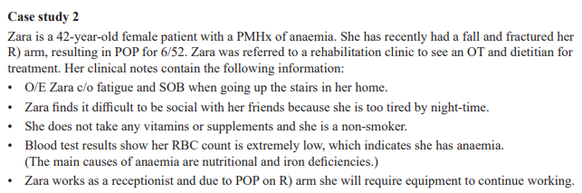 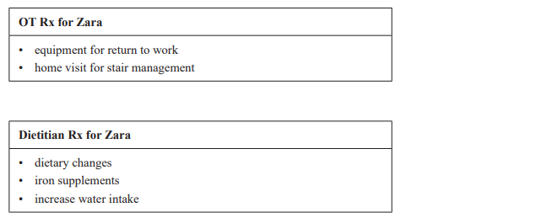

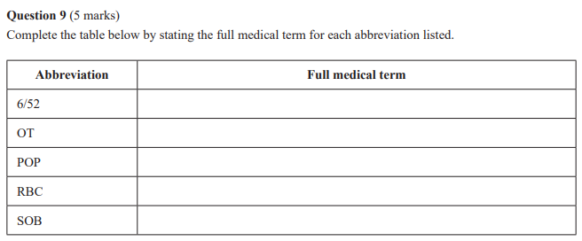

# 2021

Question 5

Which group of root words is associated with the urinary system?

A. vesicul/, ureter/ and thym/

B. ven/, pulmon/ and phleb/

C. retin/, somat/ and vas/

D. nephr/, ren/ and uria/

Question 8

Which one of the following is the suffix that means ‘recording instrument’?

A. -opsy

B. -scope

C. -graph

D. -ray

Question 12

When ‘a-’ is used to mean ‘without’, it is being used as a

A. suffix.

B. prefix.

C. root word.

D. combining vowel.

Question 13

Which one of the following gives the meaning of ‘-logy’?

A. condition of pain

B. tumour/swelling

C. inflammation of

D. study of

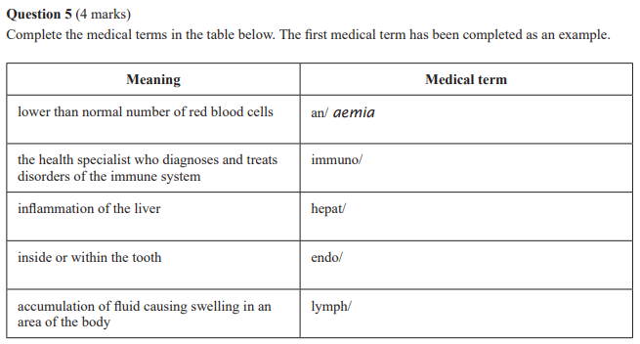 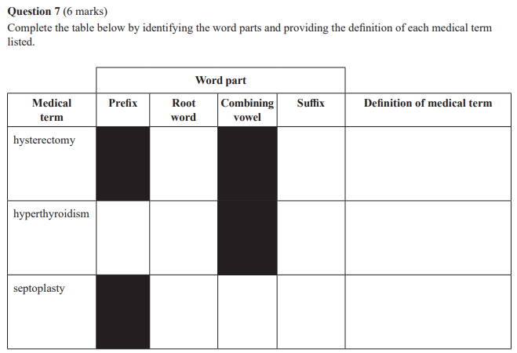 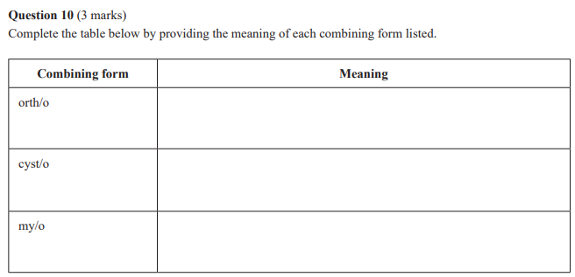 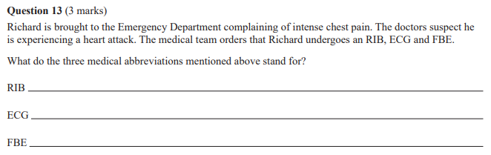 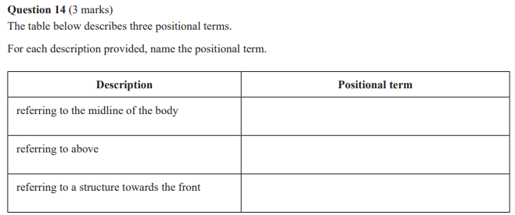

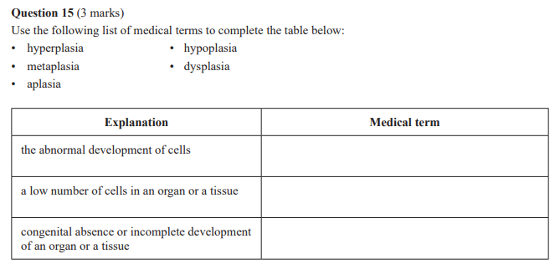 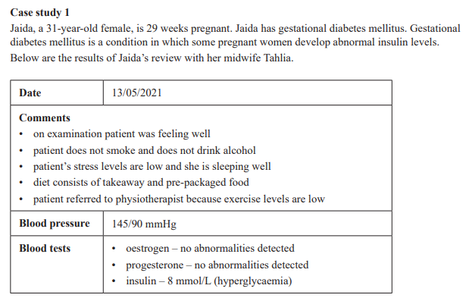 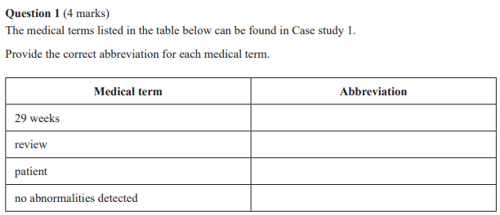

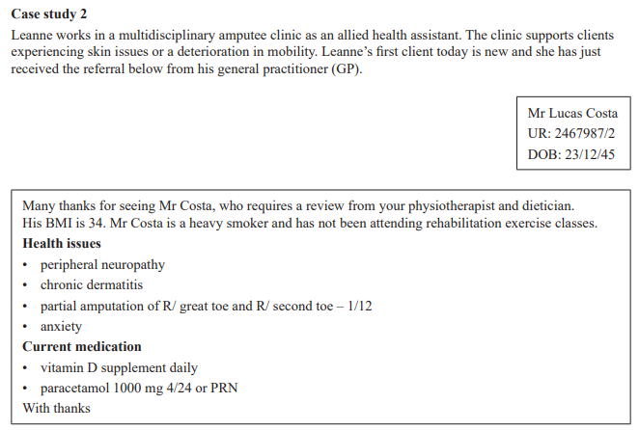 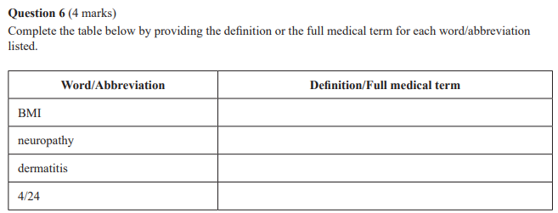

# 2022

Question 6

The decrease in the size of an organ or body tissue due to lack of stimulation is known as

A. hyperplasia.

B. dysplasia.

C. atrophy.

D. hypertrophy.

Question 12

Which one of the following is the meaning of ‘peri-’?

A. above

B. below

C. within

D. around

Question 15

Which one of the following is the suffix that means ‘enlargement’?

A. -megaly

B. -tomy

C. -itis

D. -ism

Question 17

Which one of the following medical terms best describes a slow heart rate?

A. systole

B. bradycardia

C. tachycardia

D. asystole

Question 19

Which one of the following is the root word for ‘skin’?

A. duoden/

B. proct/

C. derm/

D. chloe/

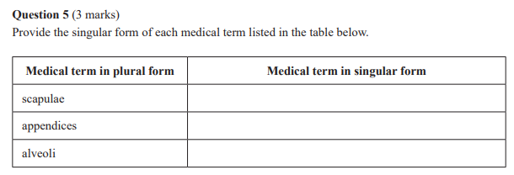

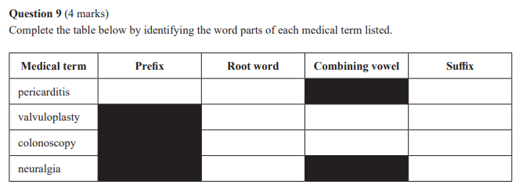 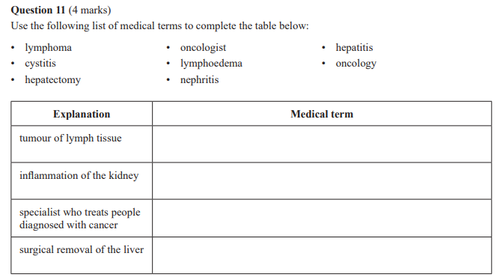

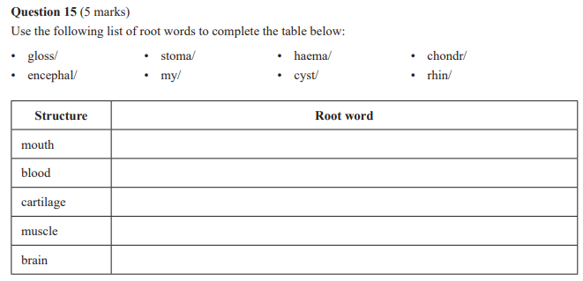

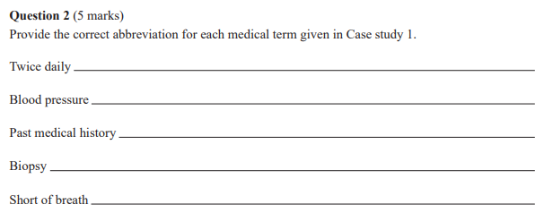

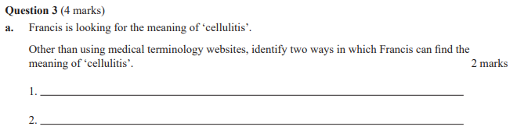 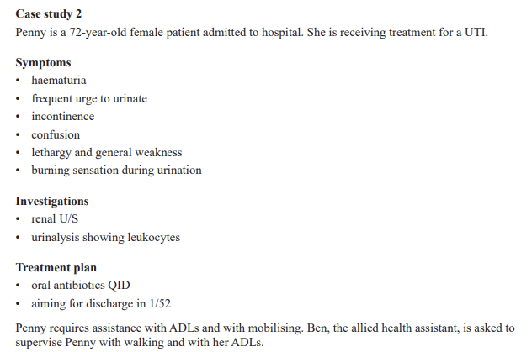

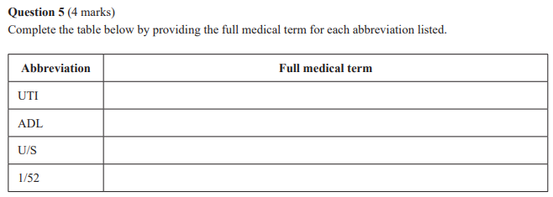 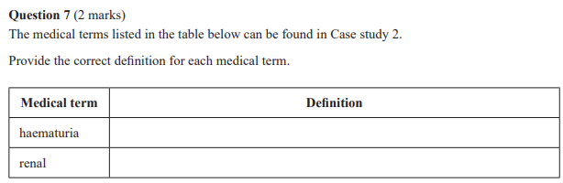

# 2023

Question 1

A cytologist is a specialist in the study of

A. muscles.

B. tissues.

C. organs.

D. cells.

Question 5

What does the term dysmenorrhea mean?

A. beginning of menstruation

B. absence of menstruation

C. normal menstruation

D. painful menstruation

Question 6

Osteoblasts are best described as

A. bone transporting cells.

B. bone destroying cells.

C. bone forming cells.

D. bone shaping cells.

Question 12

In the word suprascapular, ‘supra’ is the

A. combining vowel.

B. root word.

C. suffix.

D. prefix.

Question 17

The abbreviation CABG stands for

A. congestive arteritis bypass graft.

B. congestive artery bypass graft.

C. coronary arteritis blood graft.

D. coronary artery bypass graft.

Question 18

ICU stands for

A. Independent Cardiac Unit.

B. Intensive Care Unit.

C. Inpatient Care Unit.

D. Isolated Client Unit.

Question 19

What is the plural form for the medical term ‘ganglion’?

A. gangliomas

B. ganglions

C. ganglius

D. ganglia

