**Infection control and cleaning practice instructions**

1. PPE Donning (face shield instead of goggles)

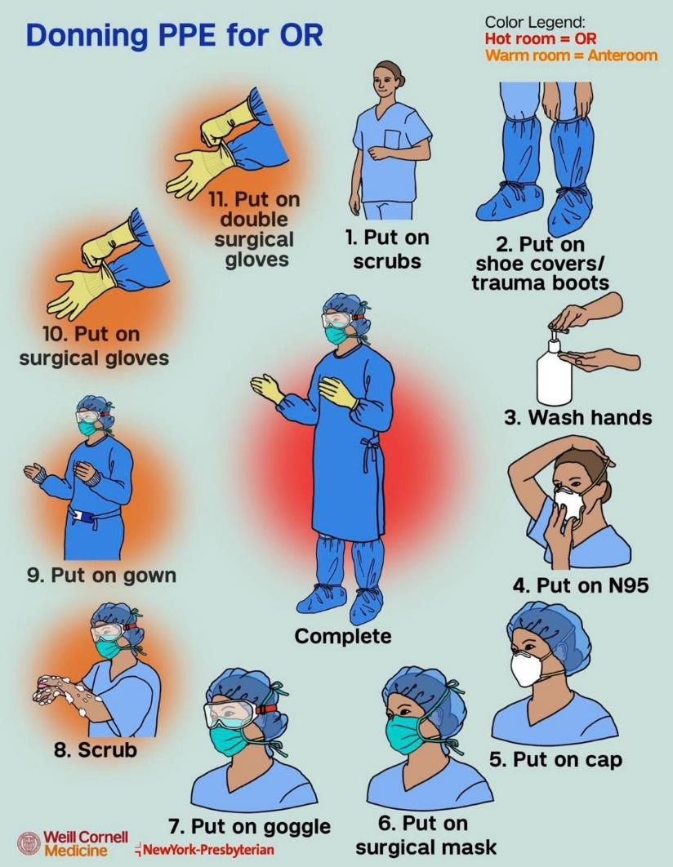

1. Equipment selection: disposable papers, mop, vacuum cleaner
2. Disinfectant preparation: Chlorine calculator

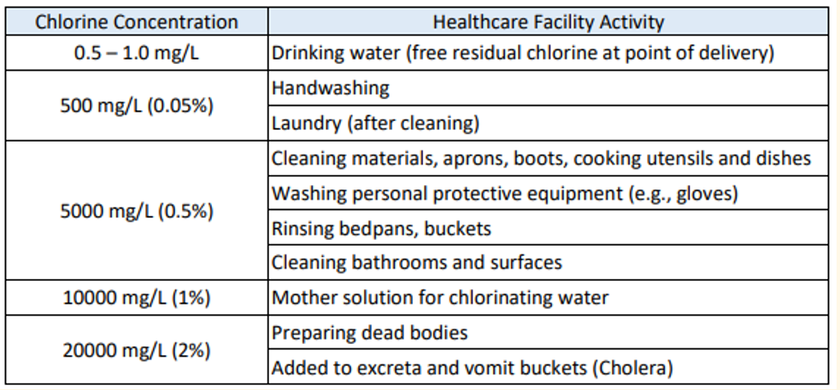

1. Remove wastes to correct bins.

What containers needed for all sorts of wastes? Blood, Urine, Syringe, Faeces, Medications

What rubbish bins needed? Yellow? Black? Blood, Urine, Syringe, Faeces, Medications

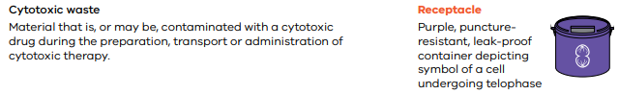

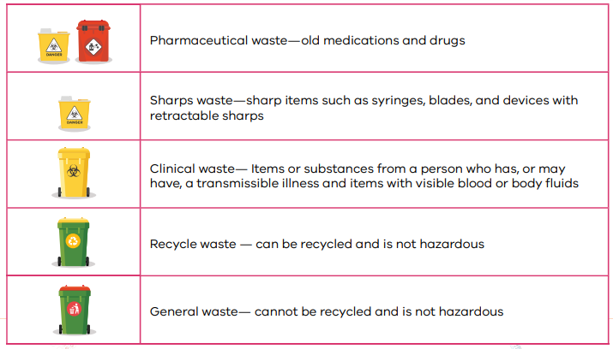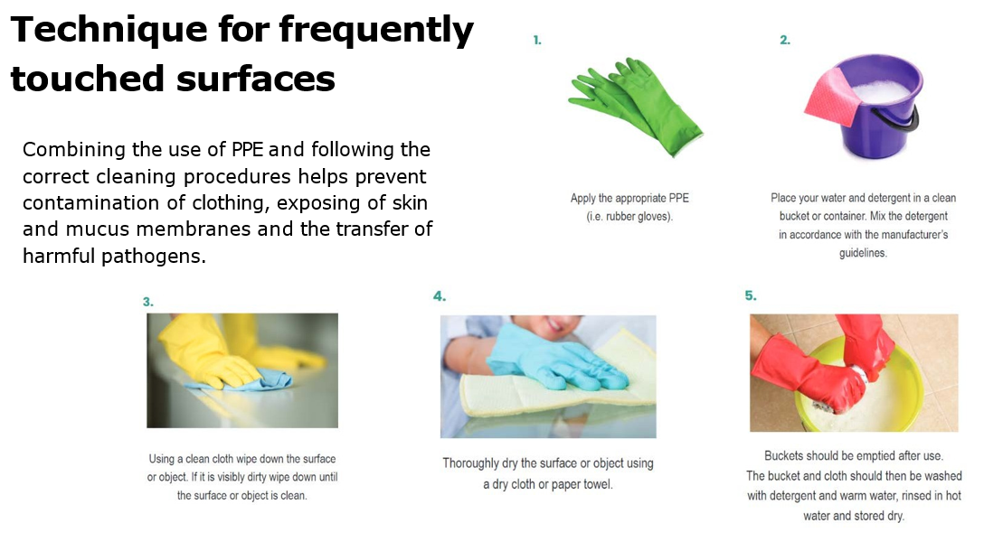

1. Cleaning equipment and put them back to original position.
2. Doffing PPE

