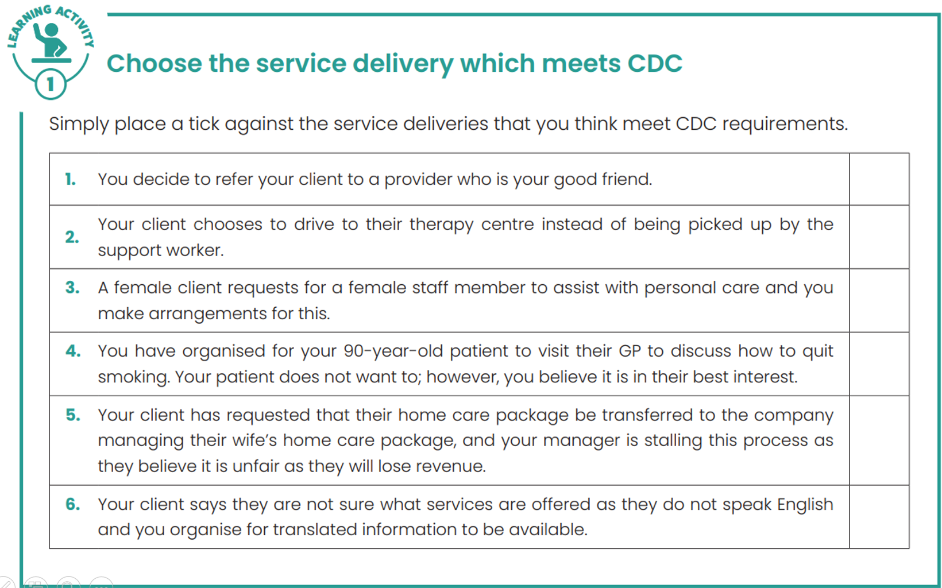

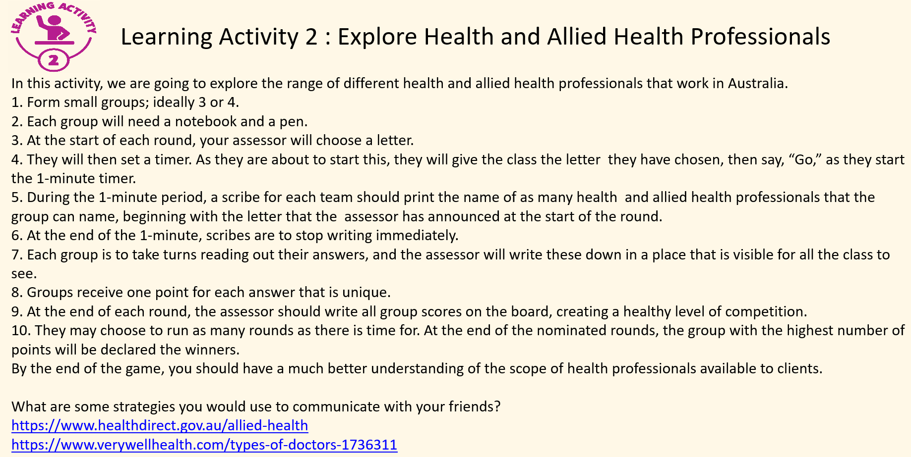

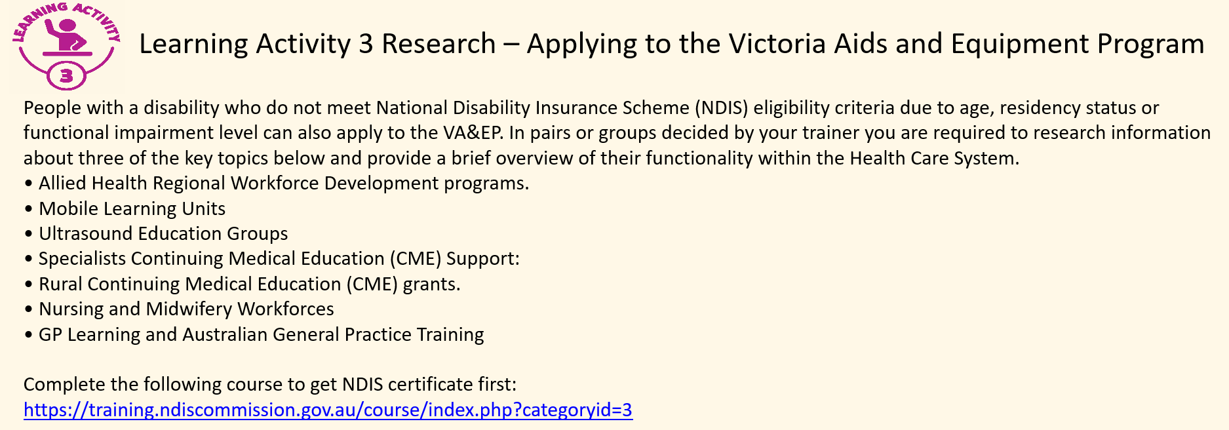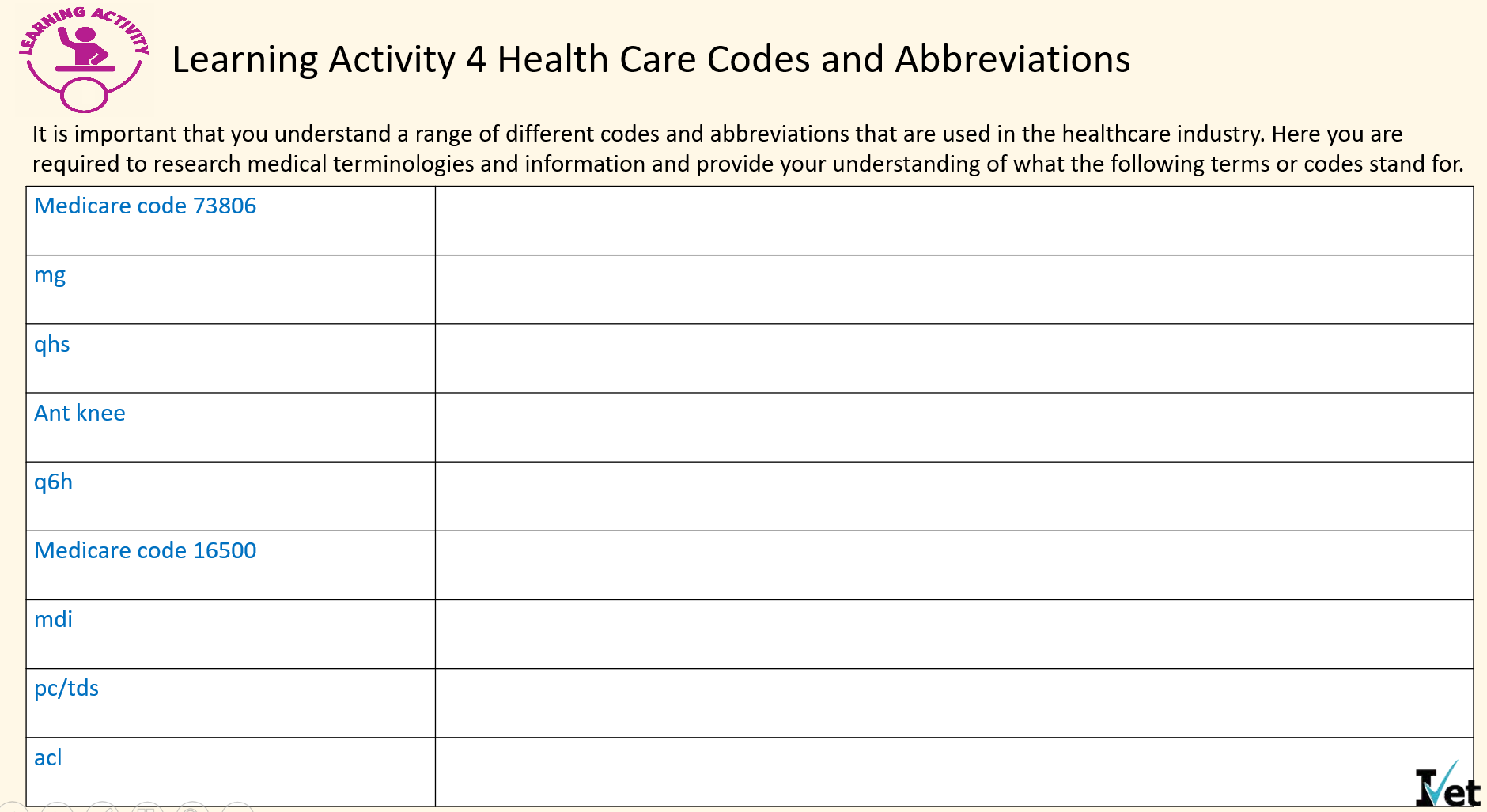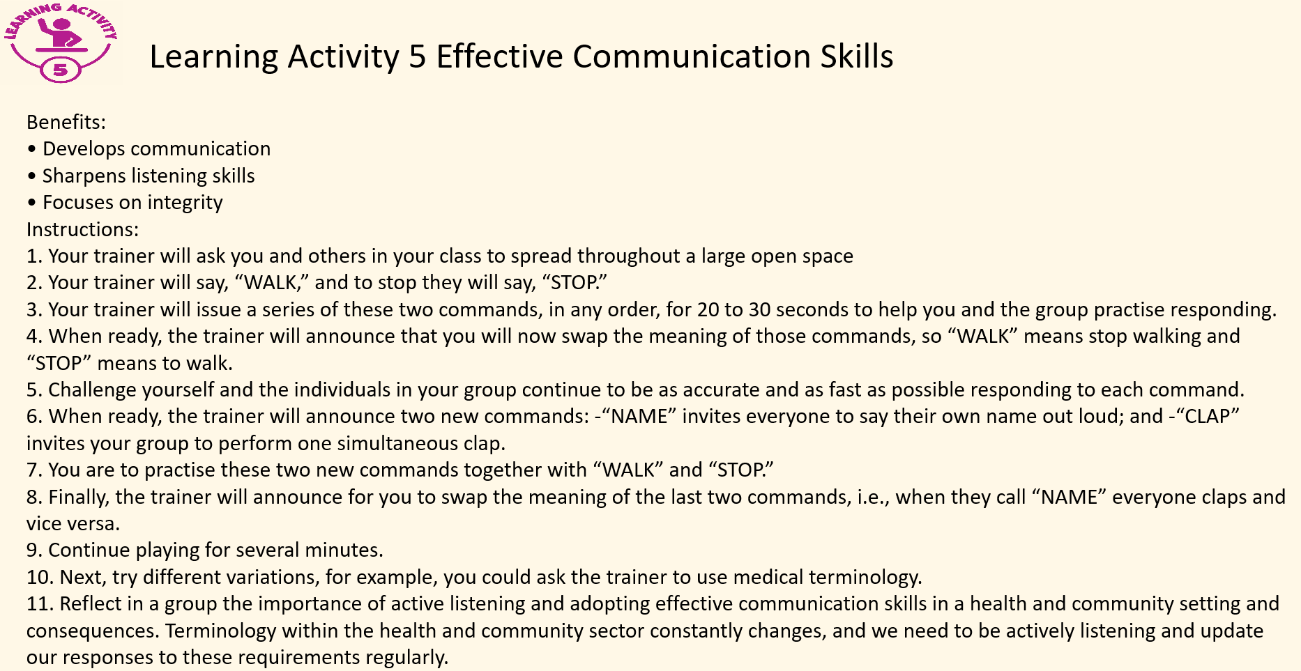



**REFERRAL FORM**

1234 Dawnsville Road

Yarraville, 3013

Phone: (03) 1234 5678

Email: info@ivetsuperclinic.com.au

ABN: 84 000 000 000

Date of Referral

**Referring to:**

Insert name of doctor you are referring to  
Insert provider Number of doctor you referred to

Insert address of where you are referring the patient to

Address Line 1

Address Line 2

Address Line 3

Dear Insert name of doctor you are referring to:

|  |  |
| --- | --- |
| RE: | Insert patient Name  Insert patient Address  Insert patient phone number  Medicare No: insert medicare number here XXXXXXXXXX/ X |

Insert description of why you are referring the patient to another medical facility and any recommendations that you may have.

**Past History**Insert description of any past medical conditions, surgeries etc.

**Allergies**Insert description of any current allergies

**Current Medication**Insert description of any current medication

Thank you for your care and assistance.

Yours Sincerely,

Insert Name of referring Doctor with provider number here

**Important note:**

This referral has been created in consultation with the named patient who has consented to this referral being forwarded to relevant address and in-line with privacy and confidentiality standards as set out by the AMA.

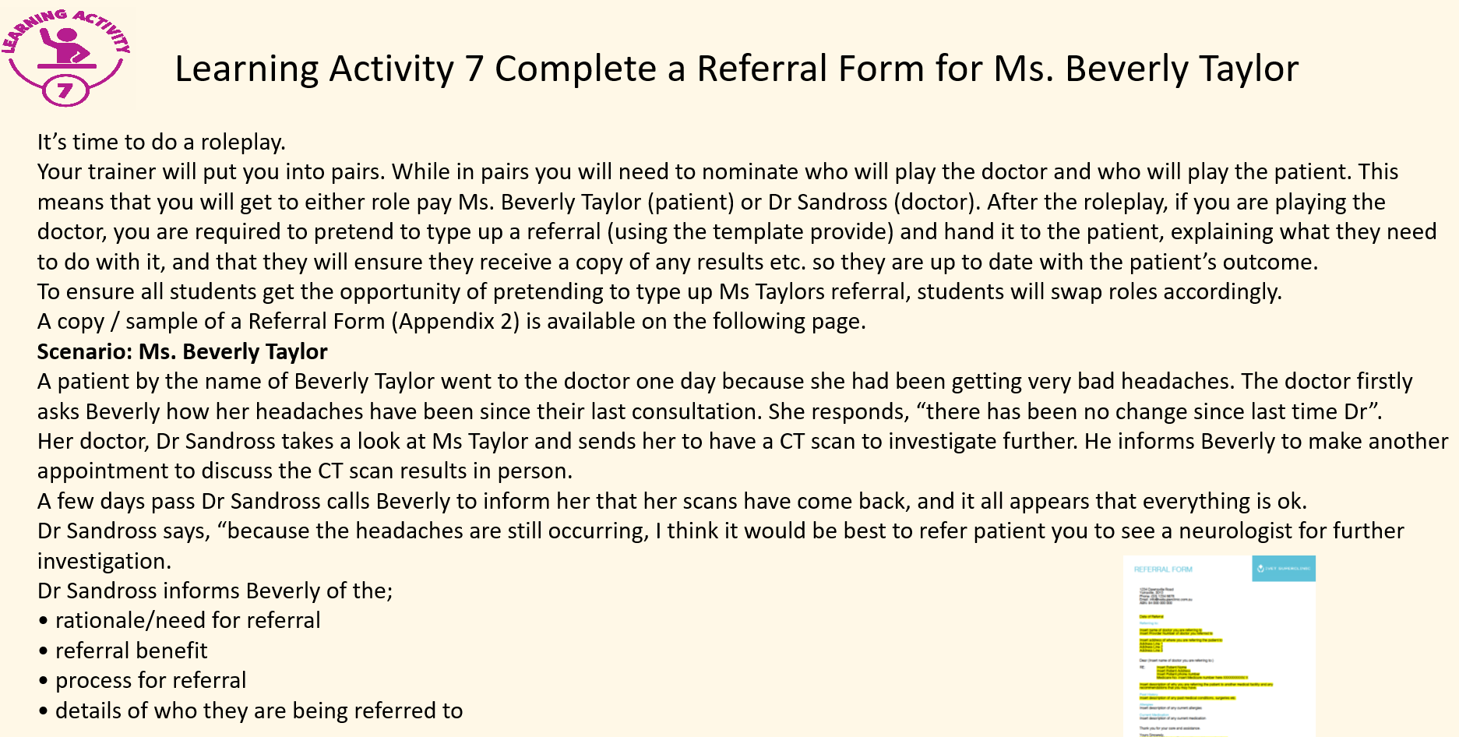

**REFERRAL FORM**

1234 Dawnsville Road

Yarraville, 3013

Phone: (03) 1234 5678

Email: info@ivetsuperclinic.com.au

ABN: 84 000 000 000

Date of Referral

**Referring to:**

Insert name of doctor you are referring to  
Insert provider Number of doctor you referred to

Insert address of where you are referring the patient to

Address Line 1

Address Line 2

Address Line 3

Dear Insert name of doctor you are referring to:

|  |  |
| --- | --- |
| RE: | Insert patient Name  Insert patient Address  Insert patient phone number  Medicare No: insert medicare number here XXXXXXXXXX/ X |

Insert description of why you are referring the patient to another medical facility and any recommendations that you may have.

**Past History**Insert description of any past medical conditions, surgeries etc.

**Allergies**Insert description of any current allergies

**Current Medication**Insert description of any current medication

Thank you for your care and assistance.

Yours Sincerely,

Insert Name of referring Doctor with provider number here

**Important note:**

This referral has been created in consultation with the named patient who has consented to this referral being forwarded to relevant address and in-line with privacy and confidentiality standards as set out by the AMA.

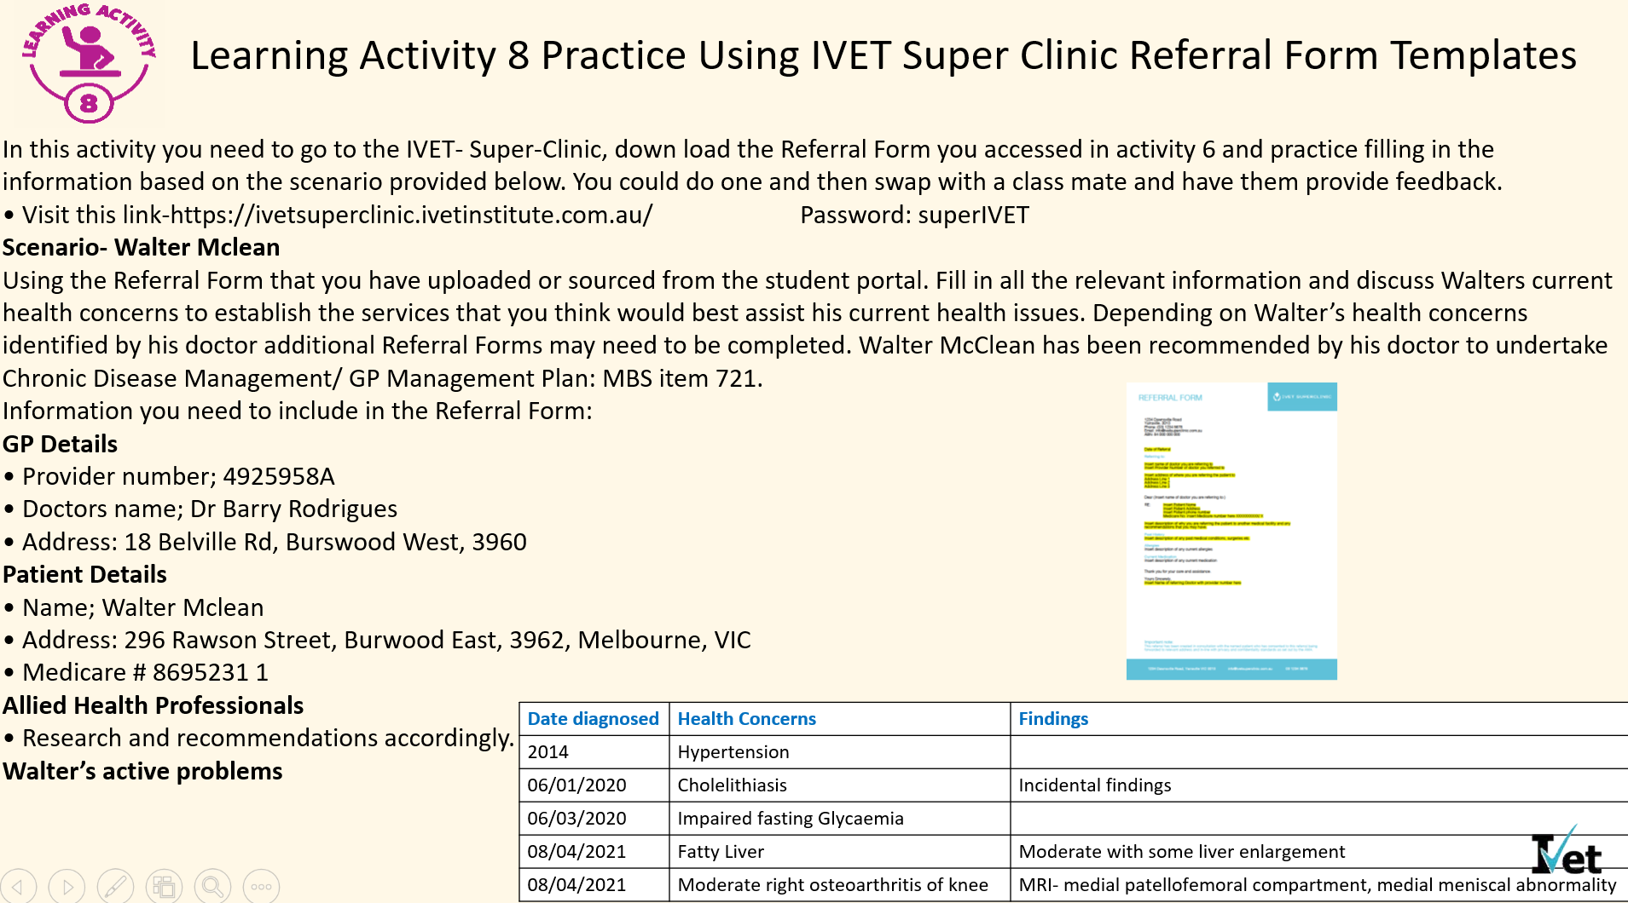

**REFERRAL FORM**

1234 Dawnsville Road

Yarraville, 3013

Phone: (03) 1234 5678

Email: info@ivetsuperclinic.com.au

ABN: 84 000 000 000

Date of Referral

**Referring to:**

Insert name of doctor you are referring to  
Insert provider Number of doctor you referred to

Insert address of where you are referring the patient to

Address Line 1

Address Line 2

Address Line 3

Dear Insert name of doctor you are referring to:

|  |  |
| --- | --- |
| RE: | Insert patient Name  Insert patient Address  Insert patient phone number  Medicare No: insert medicare number here XXXXXXXXXX/ X |

Insert description of why you are referring the patient to another medical facility and any recommendations that you may have.

**Past History**Insert description of any past medical conditions, surgeries etc.

**Allergies**Insert description of any current allergies

**Current Medication**Insert description of any current medication

Thank you for your care and assistance.

Yours Sincerely,

Insert Name of referring Doctor with provider number here

**Important note:**

This referral has been created in consultation with the named patient who has consented to this referral being forwarded to relevant address and in-line with privacy and confidentiality standards as set out by the AMA.