Area of Australia 1
- The scale on the map below shows that the width of one square is 125 km. How many ${km}^{2}$ are there in each square?
- If the area of the square is 4 $cm^{2}$ and the triangle is 2 $cm^{2}$, what is the area of the combined shape?
- Use these concepts to calculate the area of each state and the whole country.
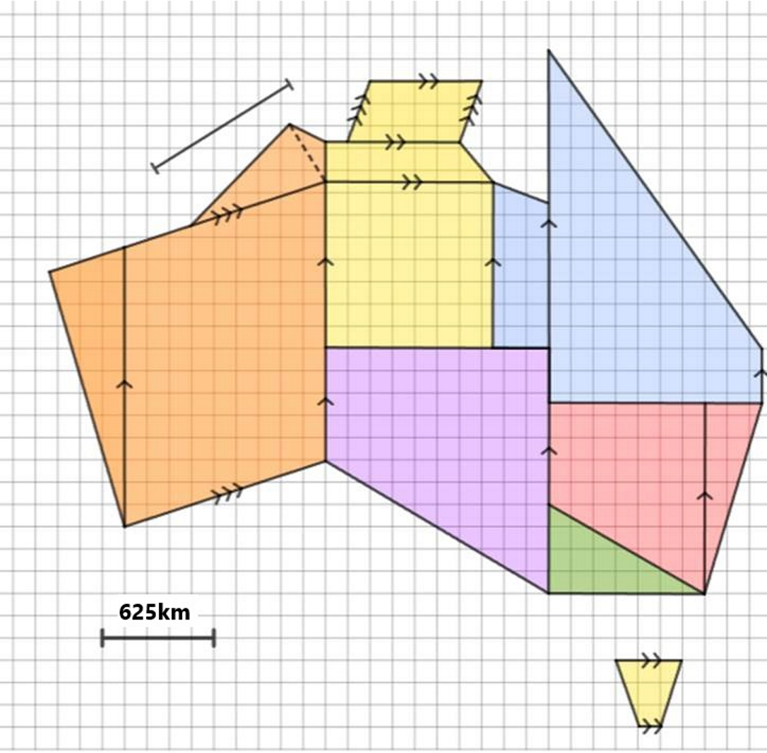
HINT: the kite has a width of 519 km and length of 1185 km

