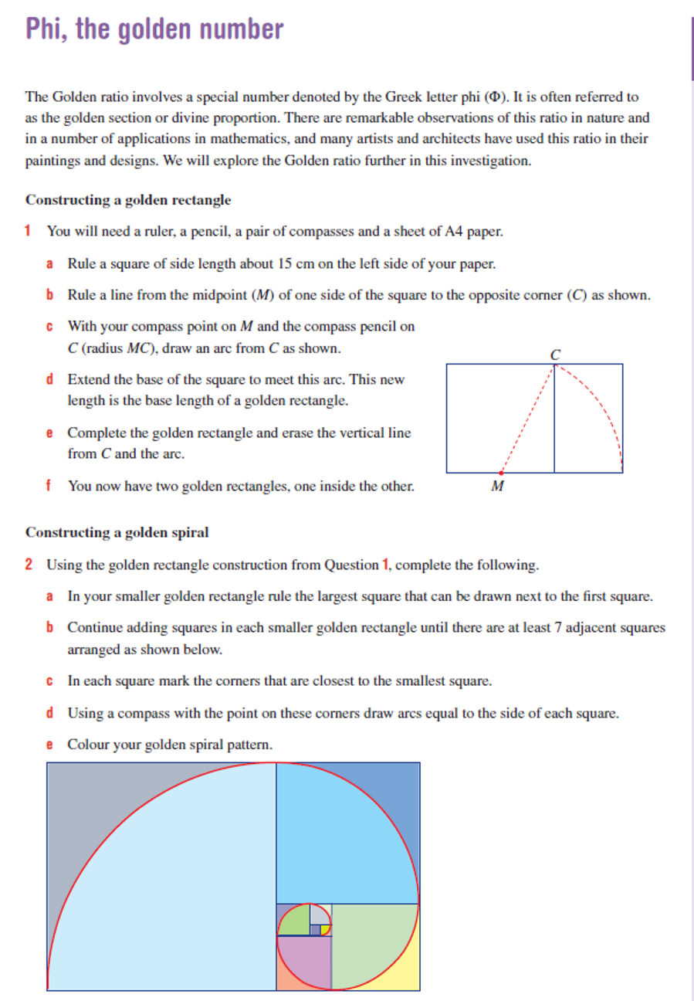

EXTRA!

If the length/width of the square was 1, what would the width of the big rectangle be? *\*Hint: use Pythagoras $a^{2}+b^{2}=c^{2}$*

EXTRA! EXTRA!  
What is the ratio of side lengths for both rectangles? To figure this out, divide the long side by the shorter side for both rectangles.

EXTRA!

The width of these squares forms the Fibonacci sequence: 1, 1, 2, 3, 5, 8, 13, 21, …… i.e. each number is the sum of the previous two numbers, 1+1=2, 5+8=13 etc.

* Create the next 5 numbers in the Fibonacci sequence.
* Starting with the 2nd number in the sequence make a list of the answers when you divide a number in the sequence by the previous number, calculate to 5 decimal places.
* If you did not find the golden ratio on the other page, look it up online and compare it to your solutions. What do you think happens as you divide bigger and bigger numbers in the sequence by the previous number?