COMPARE: Types of Savings Accounts

1. Research information for a savings account from following Bank list: ING, Ubank, Wise, NAB, Westpac, CommBank, ANZ, HSBC. Record your findings on the table below.

|  |  |  |  |  |  |
| --- | --- | --- | --- | --- | --- |
| Bank Name | Account Name | Interest Rate | Min. Deposit | Fee | < 18 Yrs Y/N |
| ING |  |  |  |  |  |
| Ubank |  |  |  |  |  |
| Wise |  |  |  |  |  |
| NAB |  |  |  |  |  |
| WESTPAC |  |  |  |  |  |
| CommBank |  |  |  |  |  |
| ANZ |  |  |  |  |  |

1. Robert wants to get serious about saving for a new car. Which account would you recommend? Why?
2. Cindy has been working for 8 years, and she’s built up a huge emergency fund -- $45,000, which would be 6 months of her salary. How much is her monthly salary? She’s hoping to earn a bit more interest than she currently is with that $45,000 just sitting in her traditional bank’s savings account. Which account would you recommend? How much will she have in her account by the end of the first year with your choice?
3. Your family is planning an oversea trip. Read the same article above and compare it on the following table.

|  |  |  |  |  |
| --- | --- | --- | --- | --- |
| Bank Name | ATM Withdrawal Fee | Currency Conversion Fee | Free Conversion Amount | Fee above free conversion amount |
| ING |  |  |  |  |
| Ubank |  |  |  |  |
| Wise |  |  |  |  |
| ANZ |  |  |  |  |
| WESTPAC |  |  |  |  |
| CommBank |  |  |  |  |
| NAB |  |  |  |  |
| HSBC |  |  |  |  |

Your recommendation travel card:



Online and Mobile Banking

## *Student Activity Packet*

## UNIT: BANKING

### 

|  |  |
| --- | --- |
| **""** | LEARN IT |

## 

## **ARTICLE:** [**The Advantages of Personal Internet Banking**](https://mybank.com/blog/the-advantages-of-personal-internet-banking/)

## Mobile banking uses smart phone apps to interact with your bank accounts. Online banking is a more broad category that includes any device that is connected to the internet. Being able to conduct transactions online and on our phones has reduced the need for people to go to banks in person and do things on paper. Read the *Advantages* section of the article to learn more about the benefits of online banking. Then, answer the questions.

1. **The article listed 7 major advantages of online banking. Choose 2 and, in your own words, explain how they can make banking easier or more convenient.**

1. **Do you already conduct your banking online or through your phone? If yes, which of these advantages do you find helpful? If not, which of these do you think you would find to be the most helpful? Why?**

## **ARTICLE:** [**Online Bill Pay: What It Is and Why to Use It**](https://www.nerdwallet.com/blog/banking/online-bill-pay-what-it-is-why-you-should-use-it/)In the Data Crunch, you saw that many people are utilizing online and mobile banking with their checking accounts. They love the convenience and time-saving features of online banking, including the ability to pay their bills online. Skim this article to learn more. Then, answer the questions.

1. **What might be the benefit of setting up a recurring payment through online bill pay?**

## 

CREATE: Your Savings Goals

**Part I: Identify Your Savings Goals**

1. Using post-it notes, small pieces of paper, or a piece of scrap paper, brainstorm specific savings goals you would like to meet. These goals can vary from small (saving for a new pair of sunglasses) to big (saving for college). Aim to come up with at least 15-20 ideas.
2. Now sort your ideas into three piles:
   1. Short-term goals: goals you would like to achieve within two months
   2. Medium-term goals: goals you would like to achieve from within two months to three years
   3. Long-term goals: goals you would like to achieve three or more years out
3. Fill out the table below using the piles you created.

|  |  |  |
| --- | --- | --- |
| **Short-Term Goals**  **< 2 months** | **Medium-Term Goals**  **2 months - 3 years** | **Long-Term Goals**  **> 3 years** |
|  |  |  |

1. Which goal, in each category, would motivate you most to save? Why?
   1. Short-term:
   2. Medium-term:
   3. Long-term:

Strategies to Save

## **VIDEO:** [**How Much Should I Save?**](https://www.youtube.com/embed/u-gFLH3Epb0)

After you establish your savings goals, it’s time to start saving! What’s a reasonable amount to save from your paycheck? Watch this video on general guidelines for how much to save. Then, answer the questions.

1. **How much does the video recommend you save?**
2. **What categories encompass the portion of your paycheck that is designated for saving?**

1. **Why does it make sense to start saving or investing right now?**

## 

## **INFOGRAPHIC:** [**50/30/20 Infographic**](https://cdn.zephyrcms.com/f2355e37-2e91-45ba-a8f3-0e91187cf8e5/-/progressive/yes/-/format/jpeg/-/stretch/off/-/resize/1000x/50-30-20-budgeting-infographic.jpg)

## **ARTICLE:** [**Your Guide To The 50/30/20 Budgeting Rule**](https://www.forbes.com/advisor/banking/guide-to-50-30-20-budget/#49fe1b6be063)

The 50/30/20 budgeting rule is a well known rule of thumb and considered easy to follow. Use the infographic and article to answer the questions.

1. **True or False: When calculating the percentages for each budget category, you should use your pre-tax income**
2. **Fill in some examples of items that would fit into each budget category, you are earning $1000 per week after tax, calculate on the right column about how much for 50% essentials etc.**

|  |  |  |
| --- | --- | --- |
| **50% Needs** |  | 50% of $1000 =? |
| **30% Wants** |  | 30% of $1000 =? |
| **20% Savings** |  | 20% of $1000 =? |



[***How Have Prices For Consumer Goods Changed Over the Past 20 Years?***](https://www.aei.org/carpe-diem/chart-of-the-day-or-century-8/)

*Data Crunch*

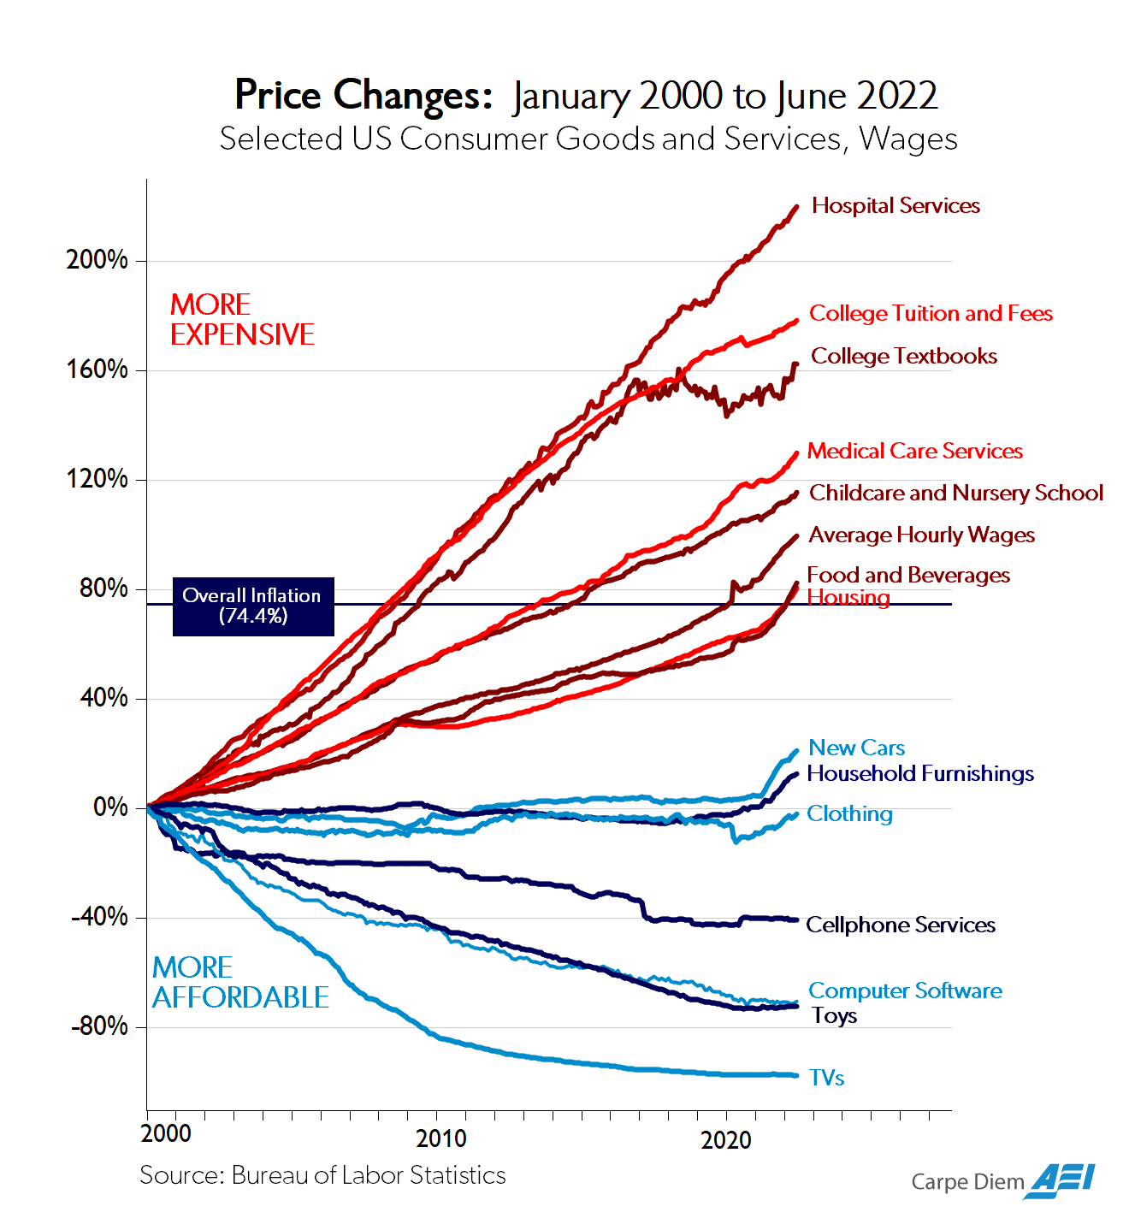

|  |  |
| --- | --- |
| 1. **Which item has increased the most in price? Decreased the most in price?**   **DOK 1** | 1. **According to the graph, which items are priced within about 20% of their original prices in 2000?**   **DOK 1** |
| 1. **How would you classify the industries in which the prices of items have increased and decreased the most?**   **DOK 2** | |
| 1. **Look at how this graph is constructed. Why do you think the creators of this graph chose NOT to place 0% (the starting point in 2000) at the center of the y-axis?**   **DOK 2** | |
| 1. **Hypothesize why prices of items like Cellphone Services and Televisions decreased so dramatically between 2000-2022.**   **DOK 3** | |

[***How Do Consumers Use Mobile Banking?***](https://www.miteksystems.com/thank-you/research-reports/4167)

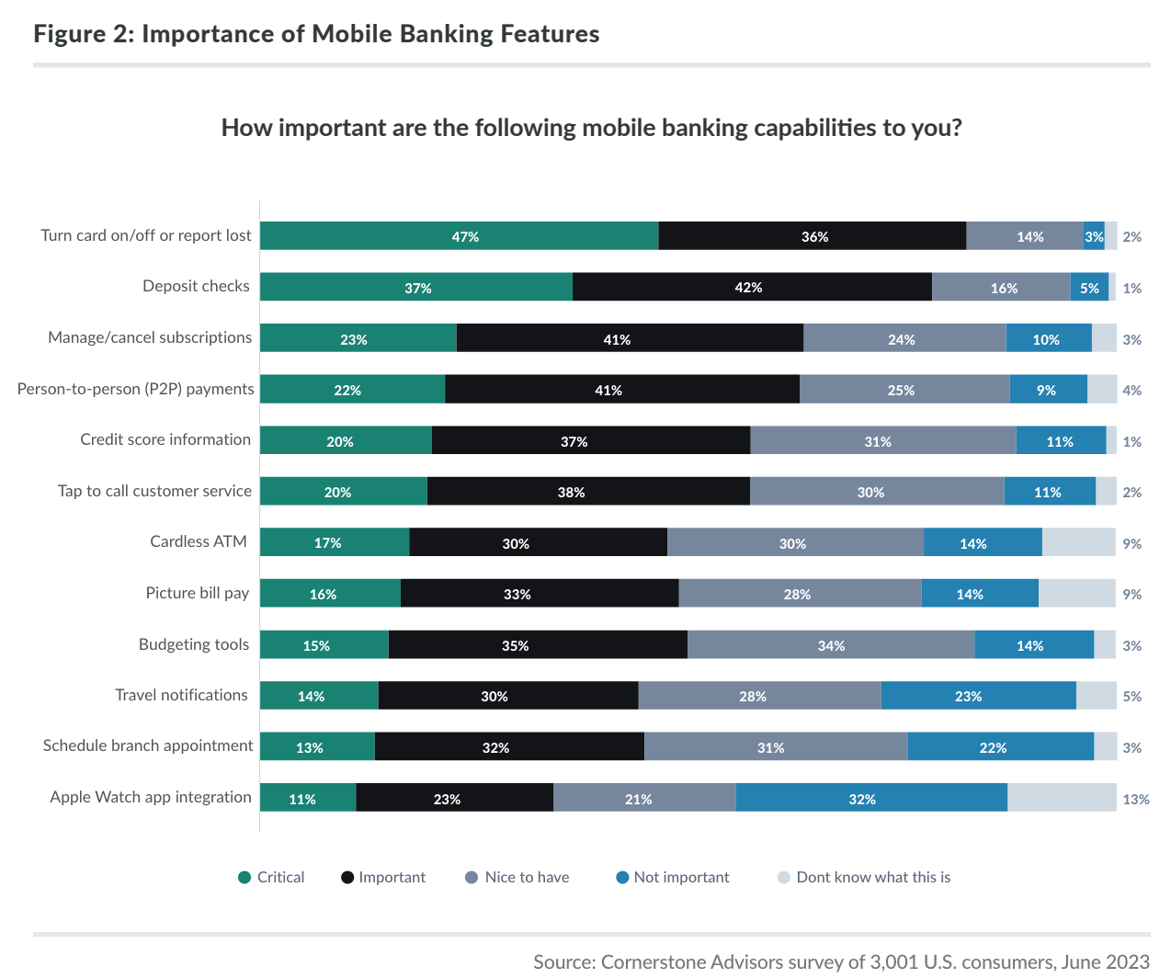

|  |  |
| --- | --- |
| 1. **Which 3 mobile banking features do consumers consider to be critical?**   **DOK 1** | 1. **What percentage of consumers rated depositing checks as an “important” or “critical” feature?**   **DOK 1** |
| 1. **Which feature is the least important to consumers? Why might that be the case?**   **DOK 2** | |
| 1. **Maha looks at this graph and says: “This survey shows that Americans really care about the security of their bank account” Do you agree or disagree with Maha’s conclusion? Explain your reasoning.**     **DOK 3** | |
| 1. **How do you think this data would look if it only looked at how Gen Z uses mobile banking? Why?**   **DOK 3** | |