Financial Math 6.15 Amortisation FV↓ 6.18 Amortisation FV↑ 5.9 6.18 Effective Interest Rate
 | Recurrence Relation | Application | Explicit Rules | Graphs | CAS Notes #
Arithmetic Sequences  D  Common difference | $v_{0}=principal,v_{n+1}=v_{n}+D$  D =$\frac{r}{100}×v_{0}$ | Simple Interest  6.16.1 | $v_{n}=v_{0}+n*D$ | 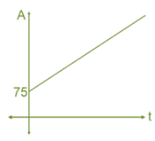 | solve Interest in $  5.1 Sequence list  5.2 Future Value
 | $v_{0}=Initial Value,v_{n+1}=v_{n}― D$  D =$\frac{r}{100}×v_{0}$ | Flat Rate Depreciation  6.16.2 | $v_{n}=v_{0} ― n*D$ | 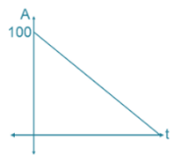 | solve depreciate $  5.1 Sequence list  5.3 Future Value
 | $$v_{0}=Initial Value,v_{n+1}=v_{n}―D$$  D =$Unit cost in dollars$ | Unit Cost Depreciation  6.16.3 | $v_{n}=v_{0} ― n*D$ | 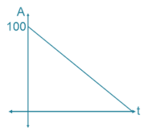 | 5.1 Sequence list  5.4 Future Value
Geometric Sequences  R  Common Ratio  Growth Factor  Decay factor | $$v_{0}=principal,v_{n+1}={R*v}_{n}$$  $R=1+\frac{r}{100*p}$, $r_{a}=\left(R-1\right)*100*p$ | Compound Interest  6.16.4 | $$v_{n}= R^{n}*v_{0}$$ | 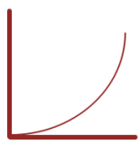 | solve Common Ratio  5.1 Sequence list  5.5 Future Value  5.7 Find r  5.8 Find n
 | $$v_{0}=Initial Value,v_{n+1}={R*v}_{n}$$  $R=1 ―\frac{r}{100}$, $r=\left(1-R\right)*100$ | Reduced Balance Depreciation  6.16.5 | $$v_{n}= R^{n}*v_{0}$$ | 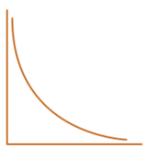 | solve Common Ratio  5.1 Sequence list  5.6 Future Value  5.7 Find r  5.8 Find n
Combined Arithmetic  &  Geometric  Sequences  R  Growth Factor  D  Repayment | $$v_{0}=Initial Value,v_{n+1}={R*v}_{n} ― D$$  $R=1+\frac{r}{100*p},$ D = $\frac{r}{ 100*p}×v_{0}$, $D=\left(R-1\right)*V_{0}$ | FV → Interest Only Loan  /Perpetuities  6.16.6 |  | 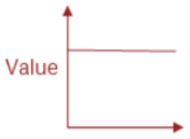 | solve Common Ratio  6.1 Sequence list  6.13 Interest only  6.14 Perpetuities
 | $$v_{0}=Initial Value,v_{n+1}={R*v}_{n} ― D$$  $R=1 + \frac{r}{100*p} ,$ $r_{a}=\left(R-1\right)*100*p$ | FV↓ Reduced Balance Loans  /Annuities  6.16.7 | Compound Interest loan extra payment | 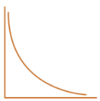 | solve Common Ratio  6.1, 6.2, 6.3 Sequence list  6.4 Financial Solver  6.6, 6.9 Analyse Loan  6.7, 6.10 Analyse Annuities  6.12 Condition change
 | $$v_{0}=Initial Value,v_{n+1}={R*v}_{n} + D$$  $R=1+\frac{r}{100*p}, ,$ $r_{a}=\left(R-1\right)*100*p$ | FV↑ Compound Interest Investment  Annuity Investment  6.16.8 |  |  | solve Common Ratio  6.1 Sequence list  6.5, 6.8 Analyse investment  6.11 Condition change
Note: Yellow parts need real number, blue parts are formula to calculate, Letter P indicates Compounding monthly etc. Needing rate per month, Monthly Ratio etc. Green CAS Notes
 | SIMPLE INTEREST | FLAT RATE DEPRECIATION | UNIT COST DEPRECIATION | COMPOUND INTEREST | REDUCING BALANCE DEPRECIATION
Description | A constant amount of interest that is added to the principal at regular time periods. It is calculated as a percentage of the principal. | The value of an asset decreases by a constant amount each time period. This amount is a percentage of the initial value. | The value of an asset uses value after each unit of use. | Takes into account both the principal and any accumulated interest earned in previous periods. The value of the investment grows with increasing amounts each time period. | The value of an asset depreciated by a set percentage, rather than a set amount. The amount of depreciation decreases each time period.
Reccurence relation | V₀ = principal, V_{n+1} = V_{n} + D  D = r/100 x V₀ | V₀ = initial value of asset, V_{n+1} = V_{n} - D  D = r/100 x V₀ | V₀ = initial value of asset, V_{n+1} = V_{n} - D  D = the depreciation (cost) per unit of use | V₀ = principal, V_{n+1} = RV_{n}  R = 1 + r/100 x CP | V₀ = principal, V_{n+1} = RV_{n}  R = 1 - r/100 x CP
Rule | V_{n} = V₀ + nD  D = r/100 x V₀ | V_{n} = V₀ - nD  D = r/100 x V₀ | V_{n} = V₀ - nD  D = the depreciation (cost) per unit of use | V_{n} = R^{n} x V₀  R = 1 + r/100 x CP | V_{n} = R^{n} x V₀  R = 1 - r/100 x CP
Graph | 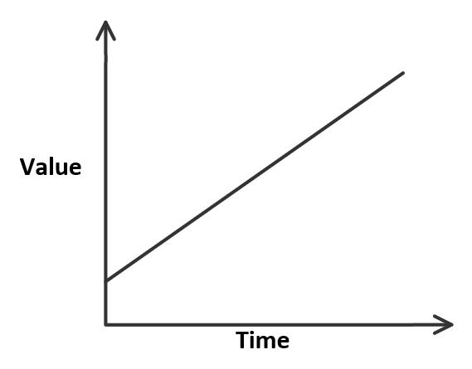 | 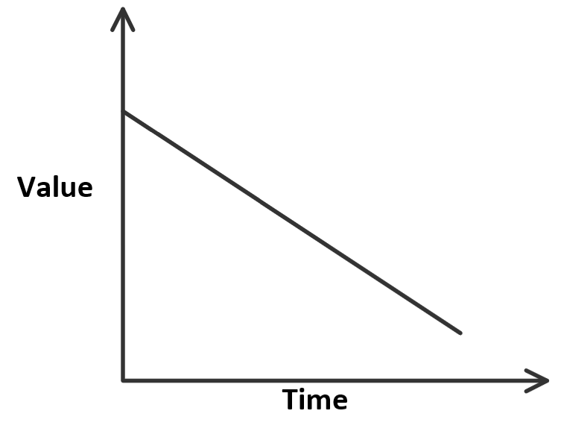 | 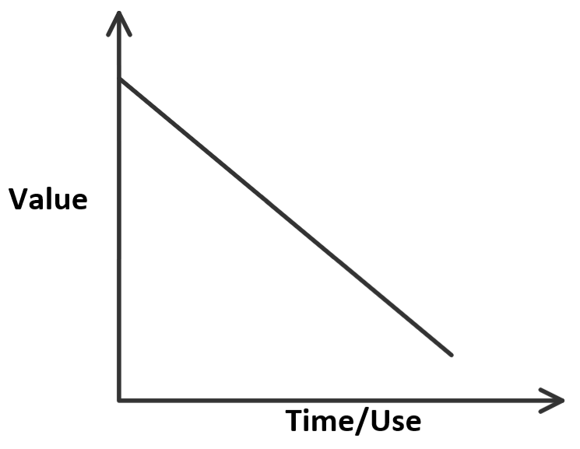 | 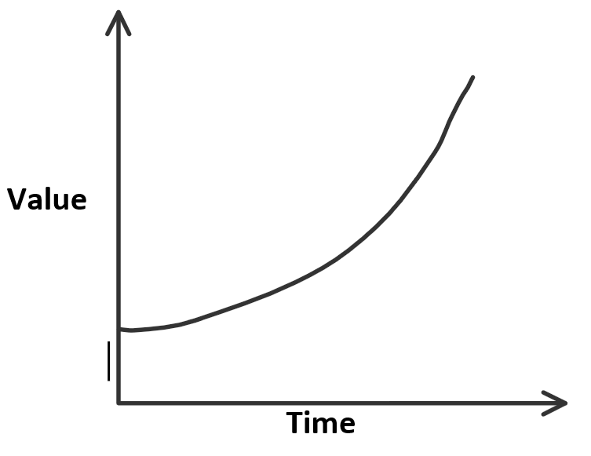 | 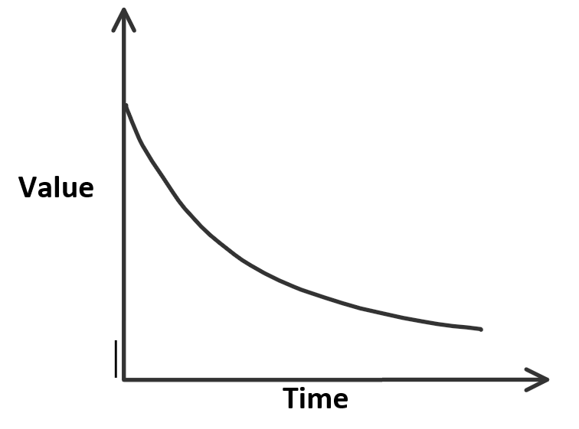
r = interest rate per annum.
CP/P = compound period. If there are no compound periods, then CP = 1
Recurrence relation: step by step process.
Rule: find values in the future in one step.

Standard compound periods:
1 = yearly
2 = biannually
4 = quarterly
6 = half yearly
12 = monthly
26 = fortnightly
52 = weekly
365 = daily

 | REDUCING BALANCE LOANS | INTEREST ONLY LOANS | ANNUITY | PERPETUITY | ANNUITY INVESTMENT
Description | Has compound interest but also requires a fixed amount to be paid at regular intervals. | The borrower only repays interest that is charged. As a result, the principal must be paid back at the termination of the loan. | A form of investment, where compound interest is earned, and a fixed sum is paid to the investor periodically until the investment reaches $0. | Type of annuity that lasts indefinitely. The amount of money invested remains the same as the regular payment to the investor is only the interest earned. | An investment where interest is received, and regular payments are made. Money is not being paid out to the investor; the account is growing.
Recurrence Relation | V₀ = principal, V_{n+1} = RV_{n} - D  R = 1 + r/100 x CP  D = regular payment | D = r/100 x V₀  D = payment | V₀ = principal, V_{n+1} = RV_{n} - D  R = 1 + r/100 x CP  D = regular payment | D = r/100 x V₀  D = payment | V₀ = principal, V_{n+1} = RV_{n} + D  R = 1 + r/100 x CP  D = regular payment
Graph | 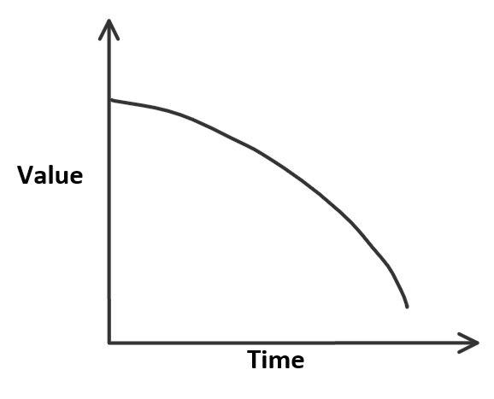 | 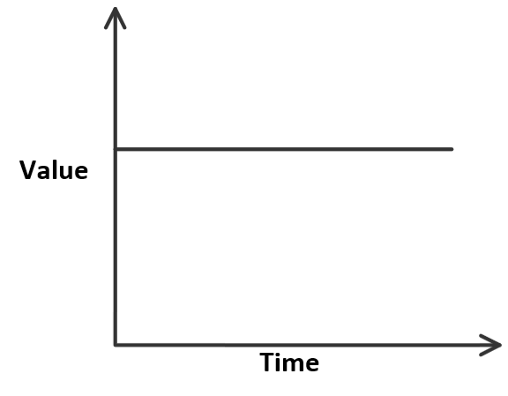
Finance Solver | N  I(%)  PV Positive  Pmt Negative  FV Positive Negative Zero  PpY  CpY | N 1  I(%)  PV Positive  Pmt Negative  FV Negative value of the PV  PpY  CpY | N  I(%)  PV Negative  Pmt Positive  FV Positive Zero  PpY  CpY | N 1  I(%)  PV Negative  Pmt Positive  FV Positive value of the PV  PpY  CpY | N  I(%)  PV Negative  Pmt Negative  FV Positive  PpY  CpY

5.1 Using a calculator to generate a sequence of numbers from a rule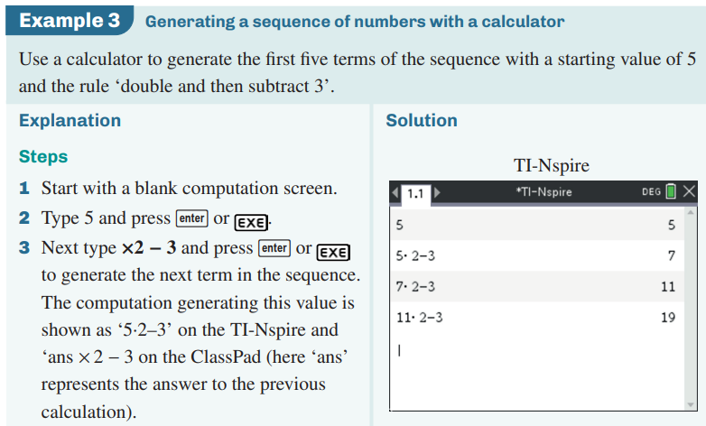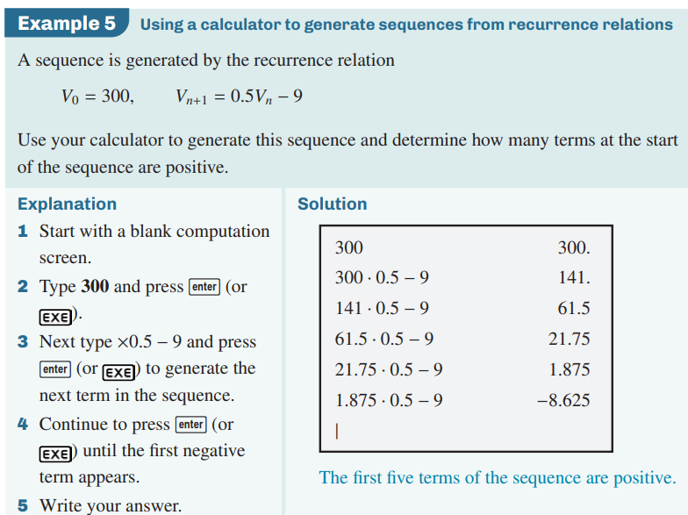
5.2 Simple interest loans and investments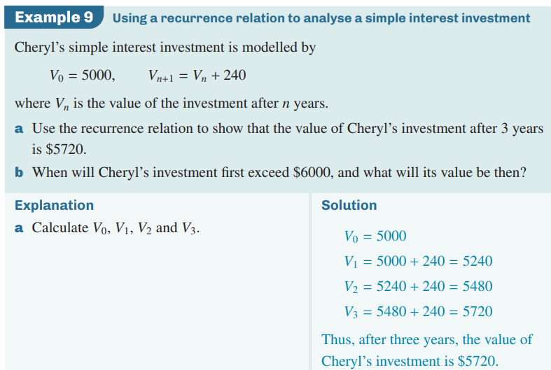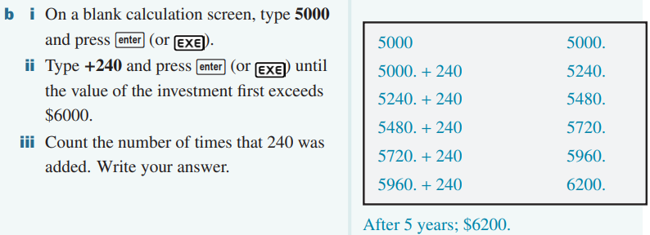
5.3 Flat rate depreciation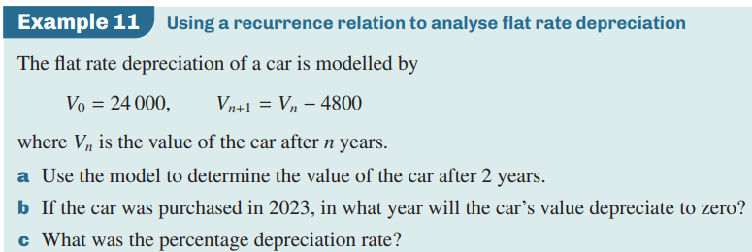
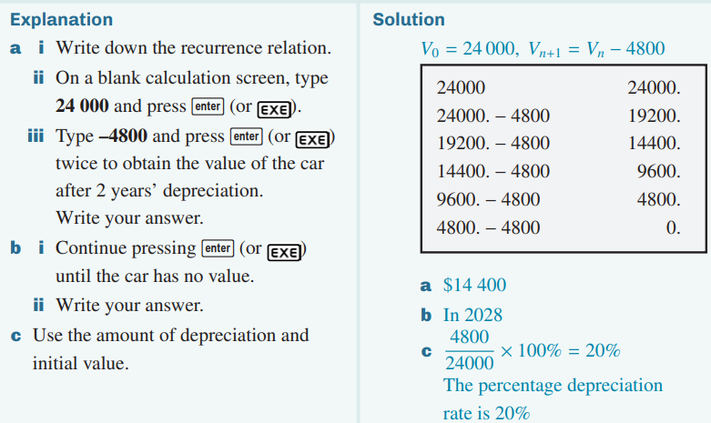
5.4 Unit cost depreciation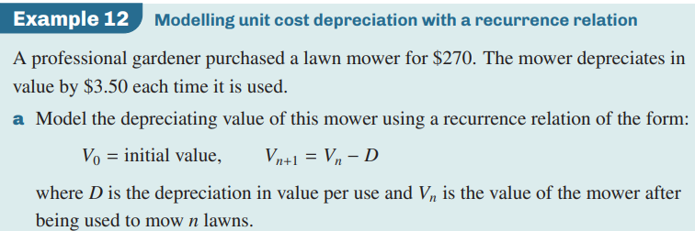 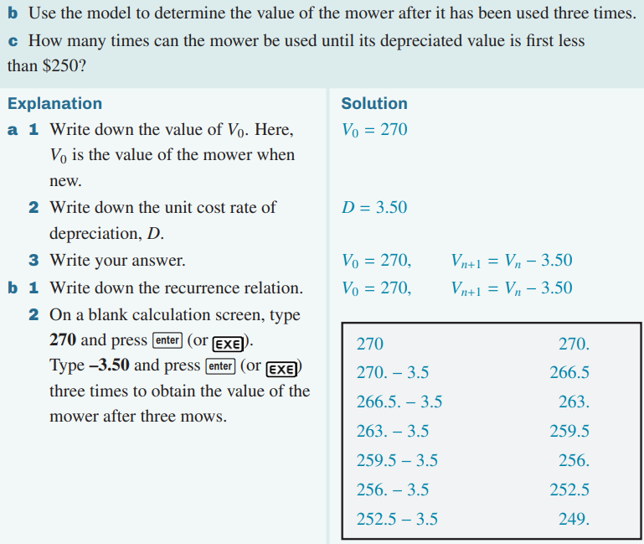 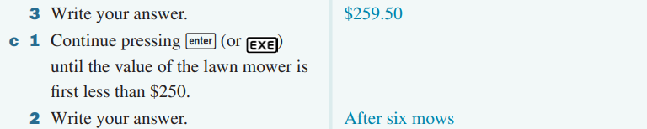
5.5 Compound interest investments and loans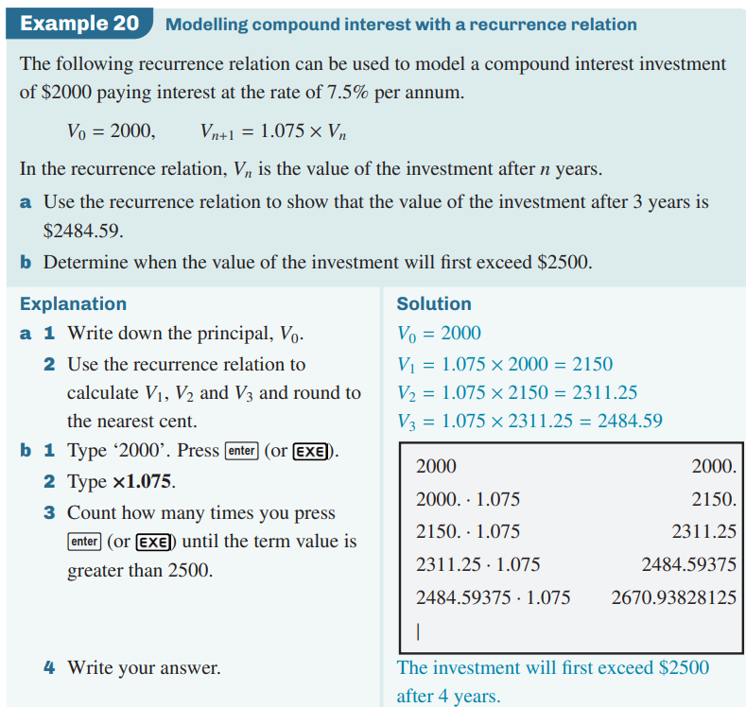
5.6 Reducing balance depreciation 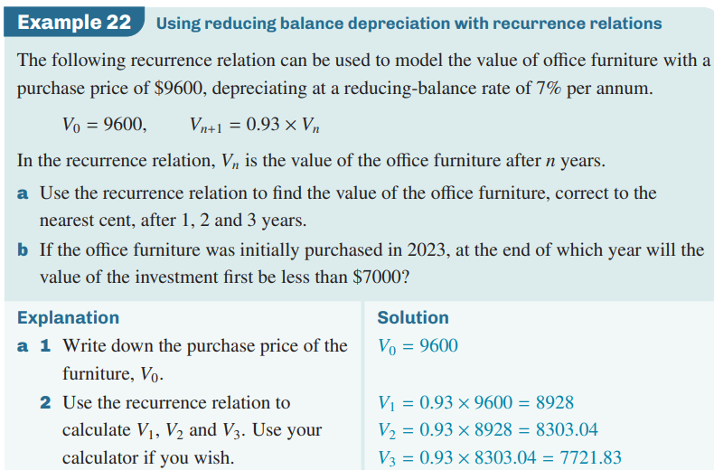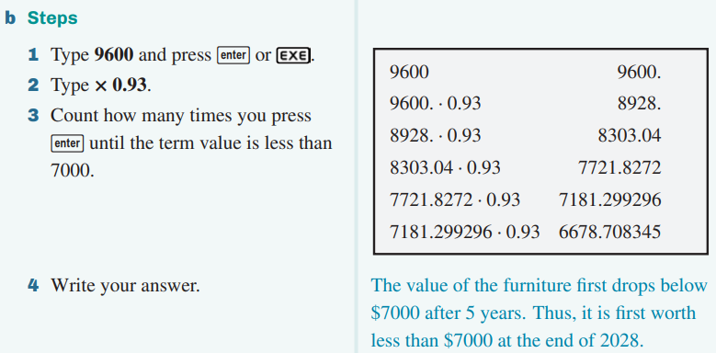
5.7 Geometric growth and decay problems to find n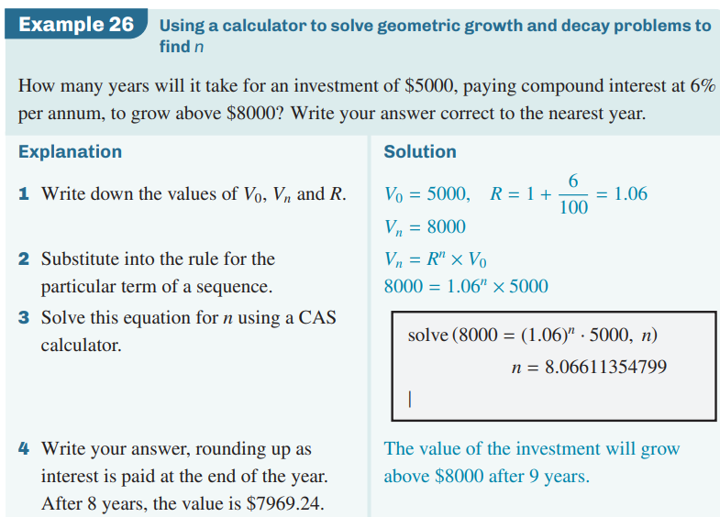
5.8 Geometric growth and decay problems to find r
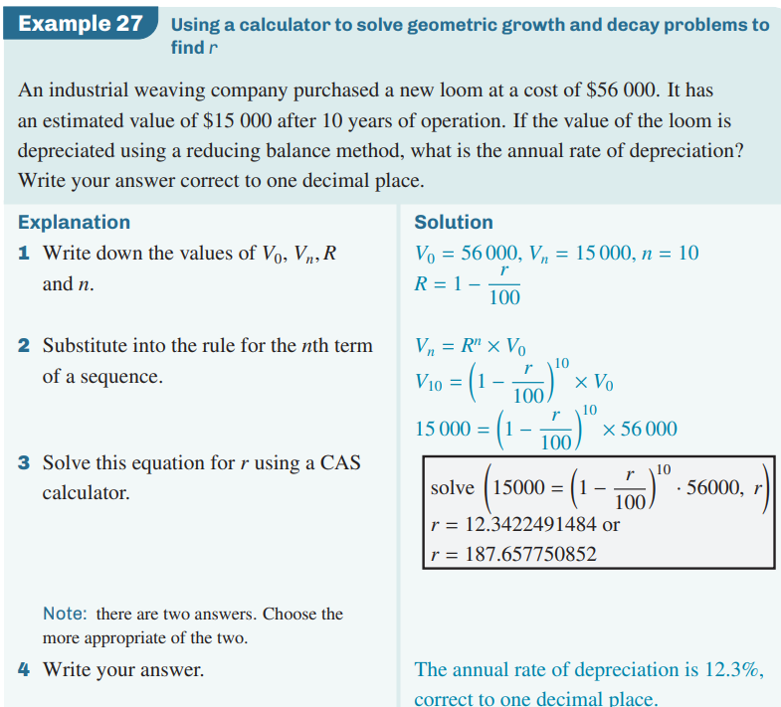
5.9 Effective interest rate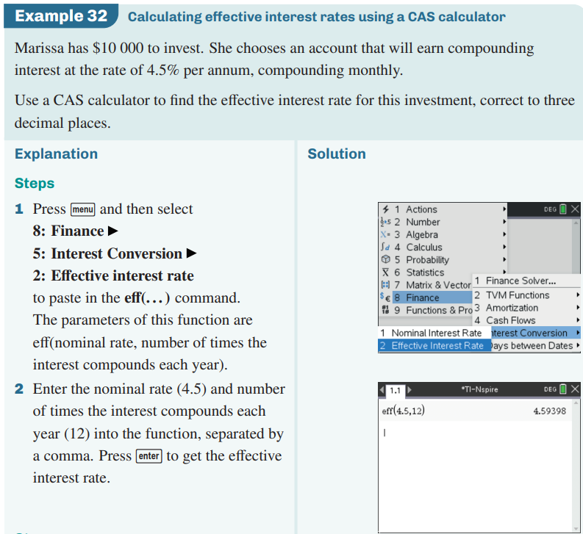

6.1 Compound interest investments with regular additions to the principal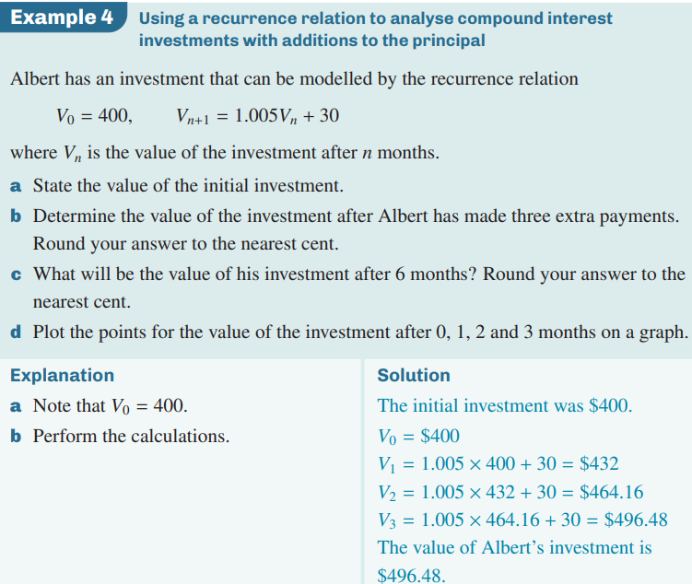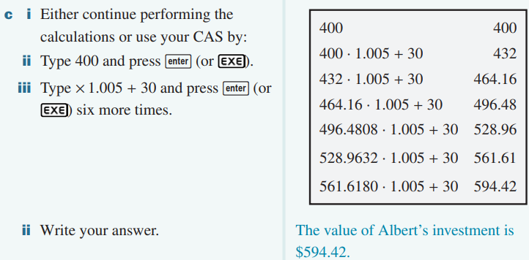
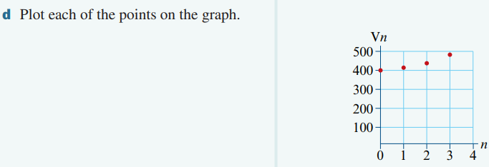
6.2 Using a recurrence relation to analyse a reducing balance loan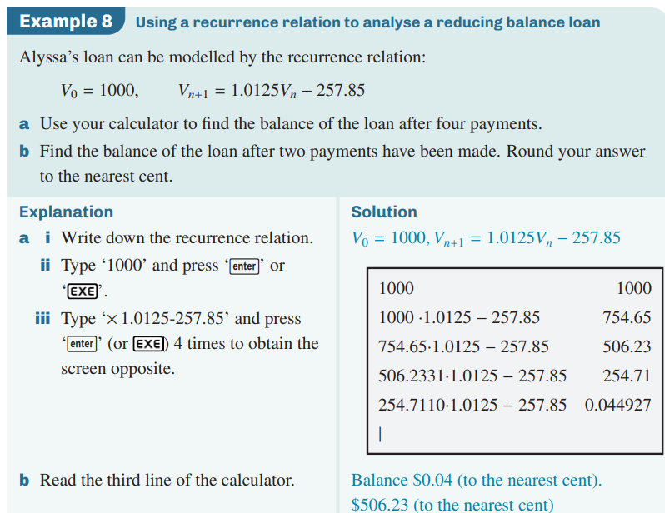
6.3 Annuities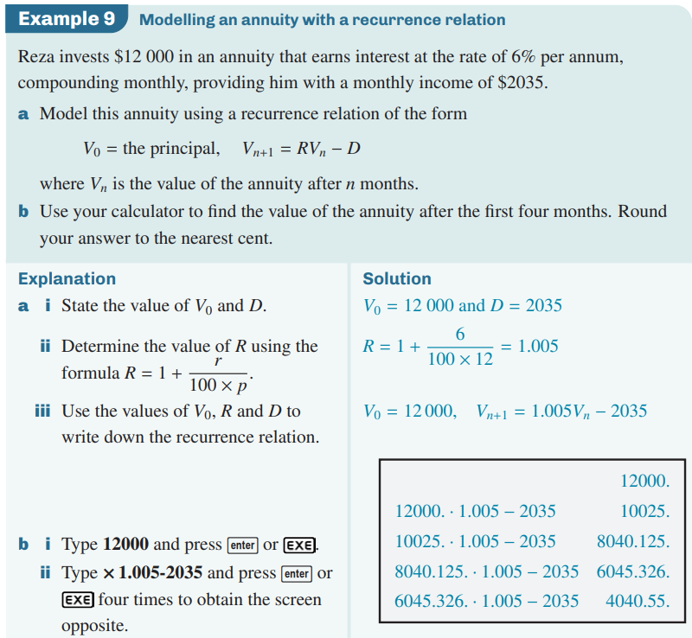
6.4 Using a finance solver to find the balance and final payment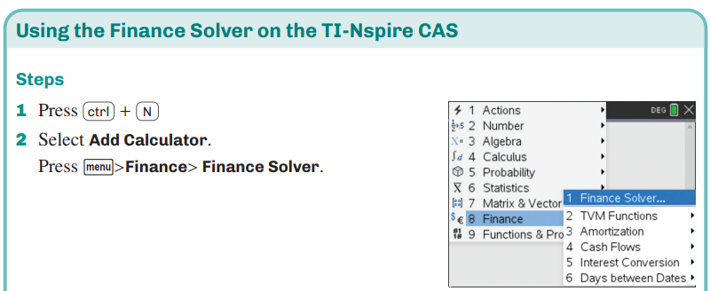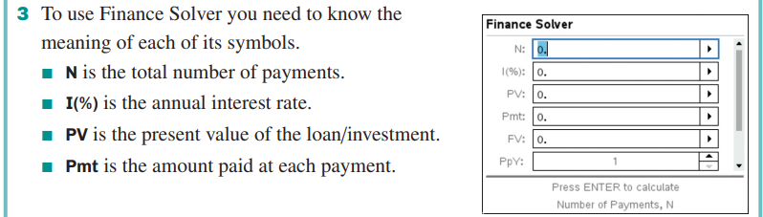
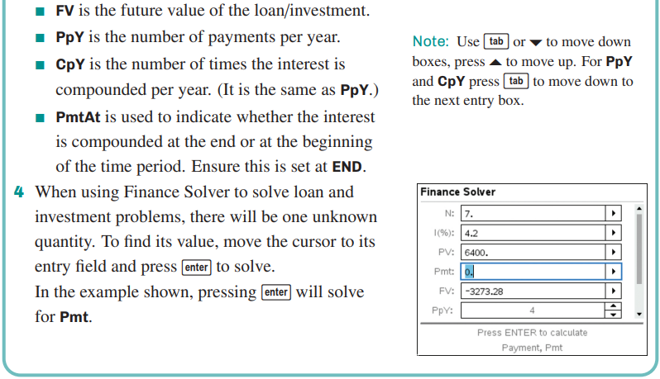
6.5 Using a financial solver to analyse a compound interest investment with regular additions to the principal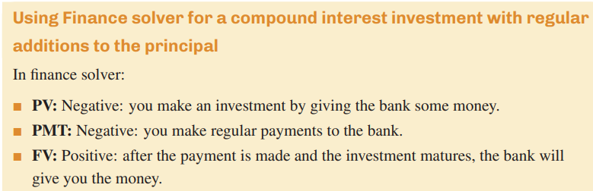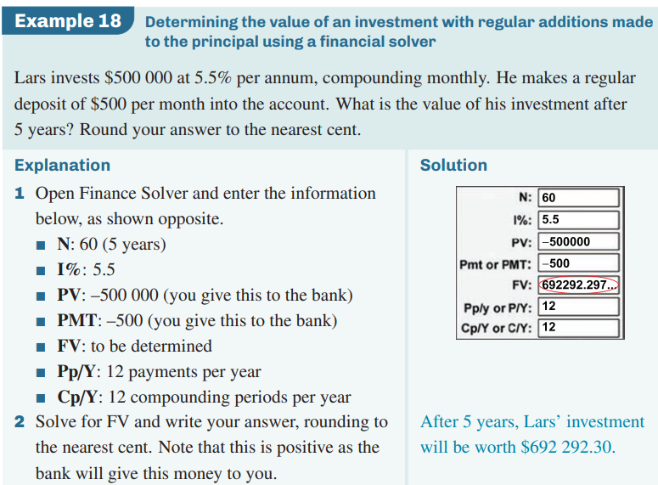
6.6 Using finance solver for a reducing balance loan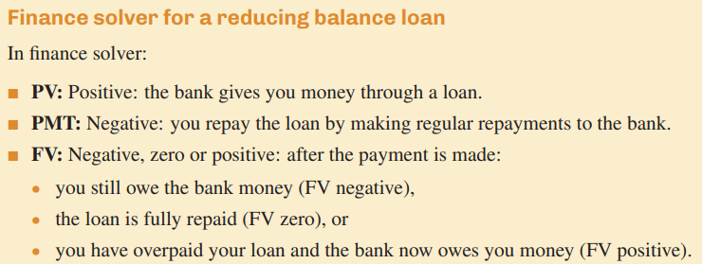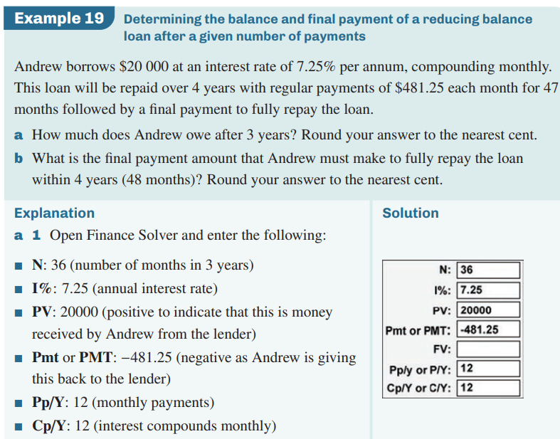
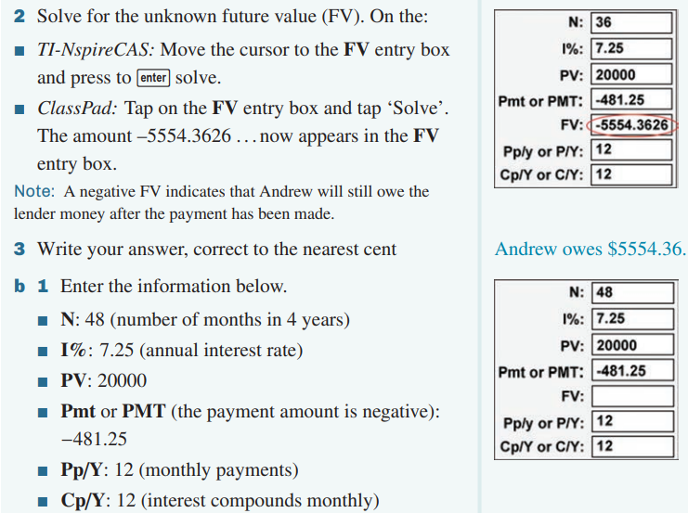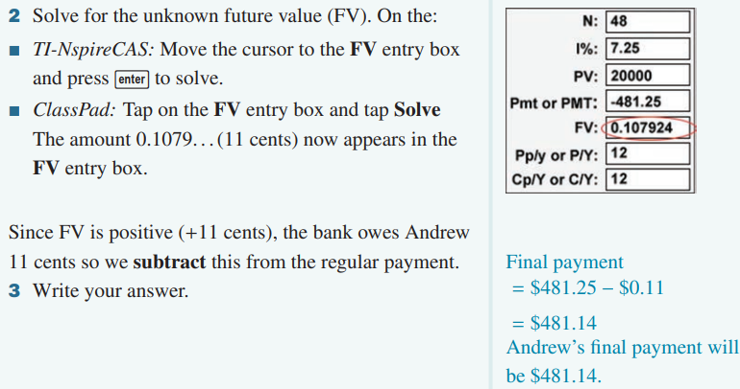
6.7 Using a finance solver to analyse an annuity
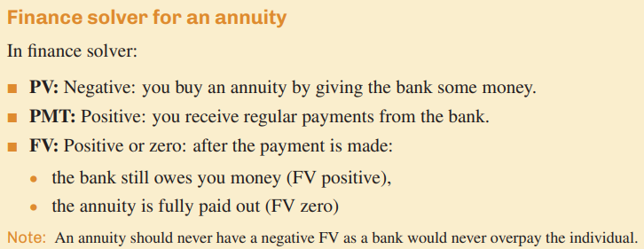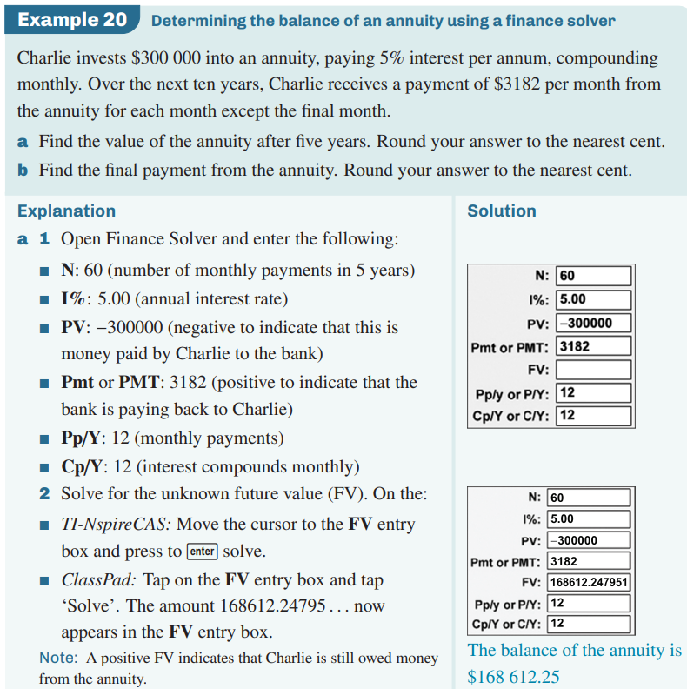
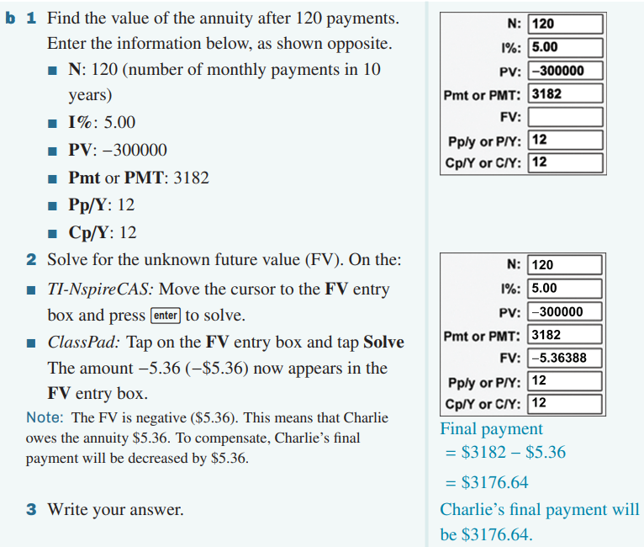6.8 Using a finance solver to find interest rates, time taken and regular payments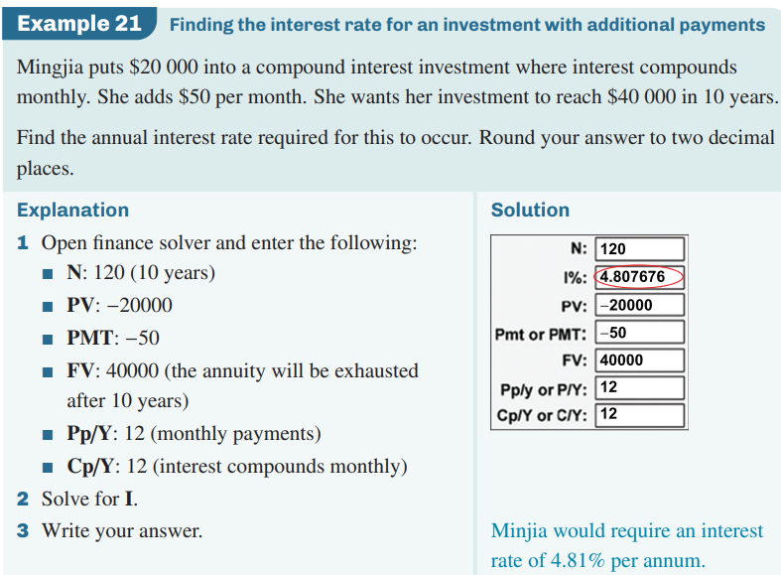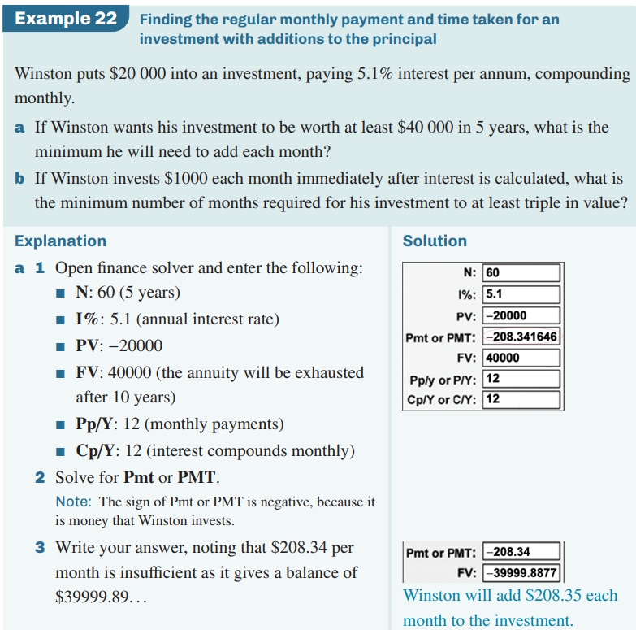
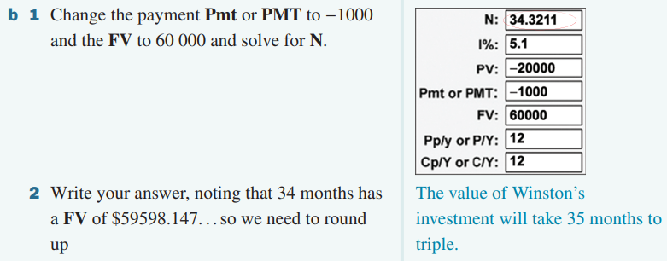
6.9 Analysing a reducing balance loan with financial solver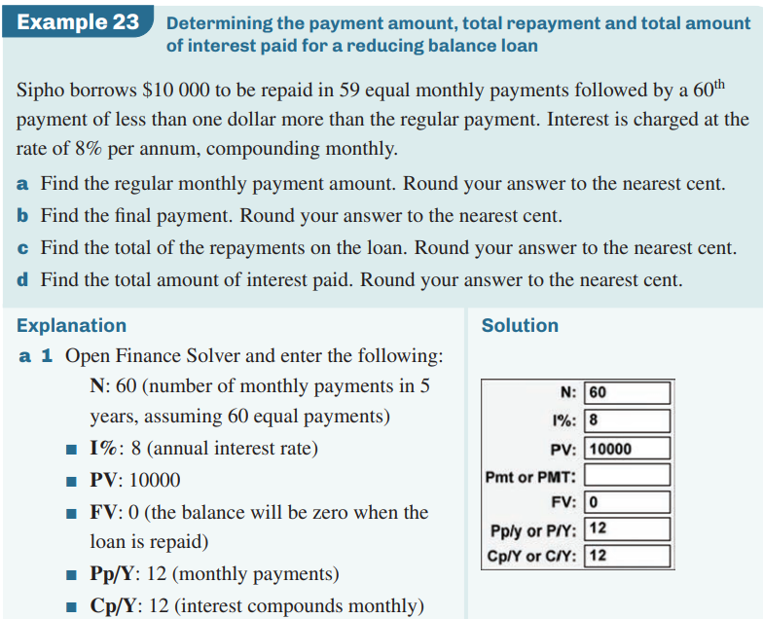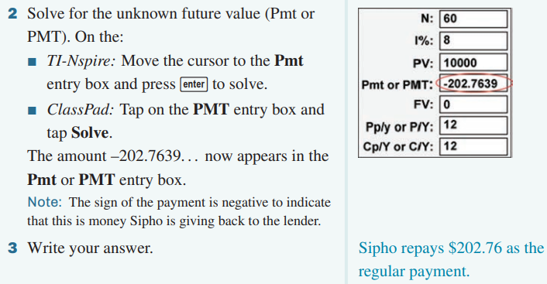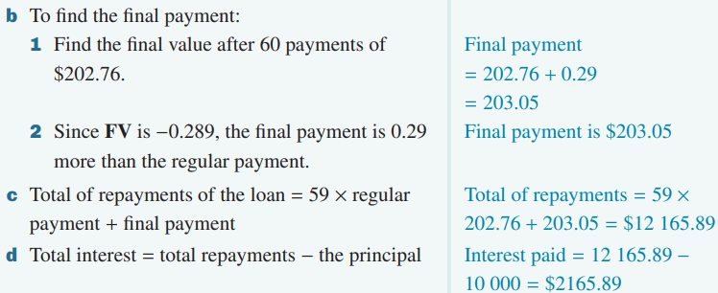
6.10 Analysing an annuity with financial solver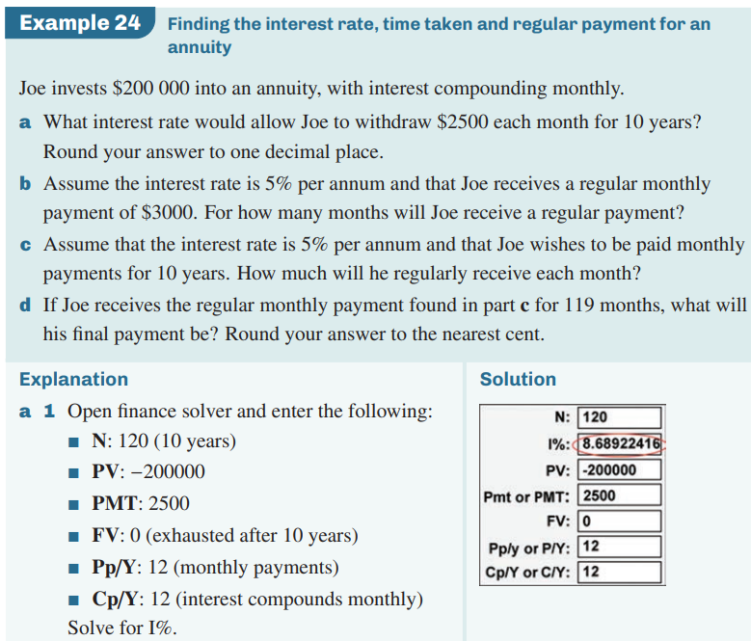
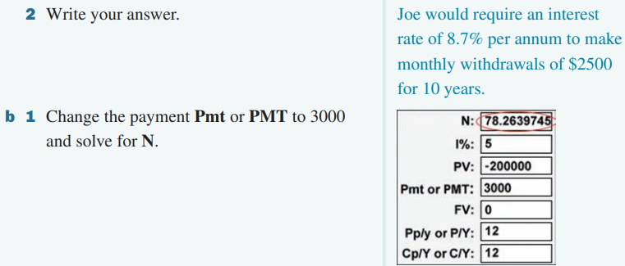
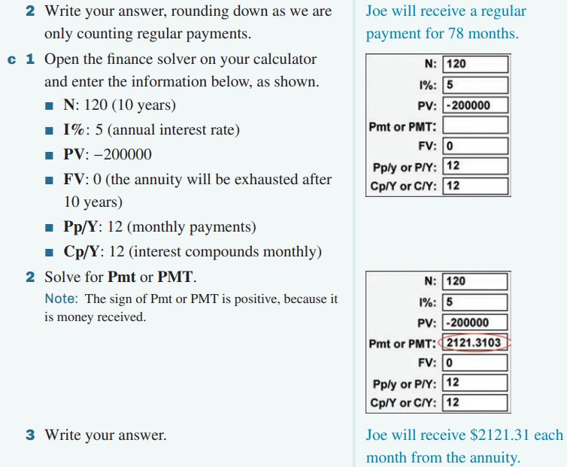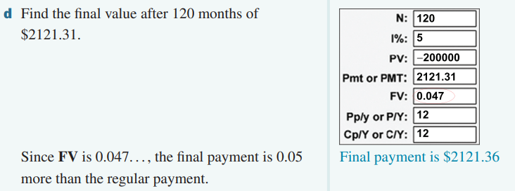
6.11 Changing the regular payment to an investment
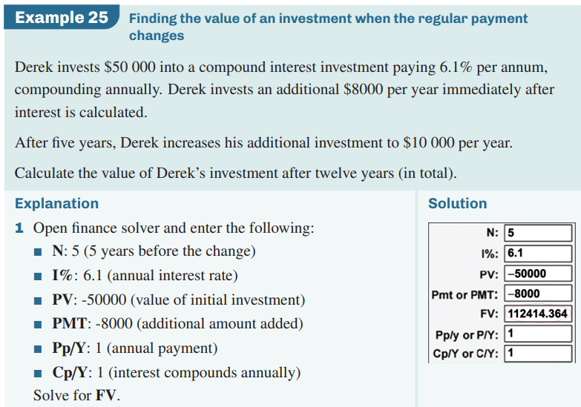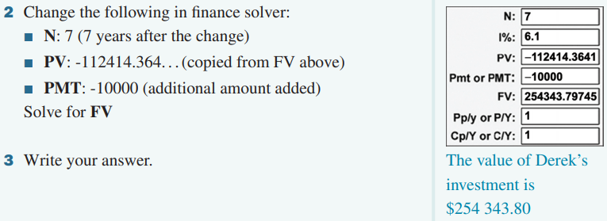
6.12 Changing the interest rate
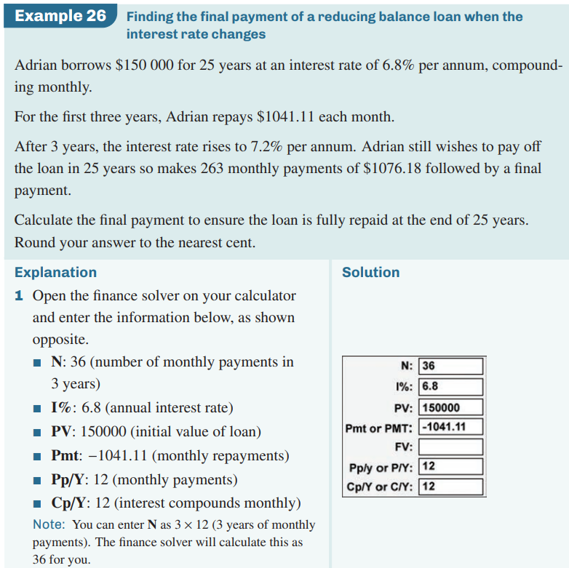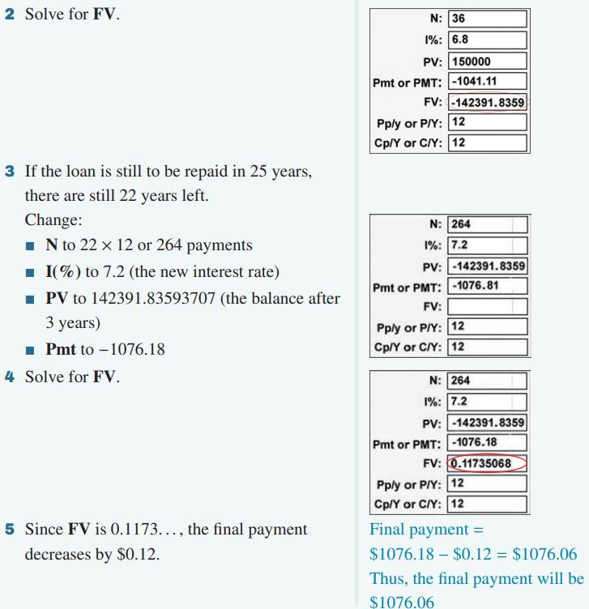
6.13 Interest-only loans
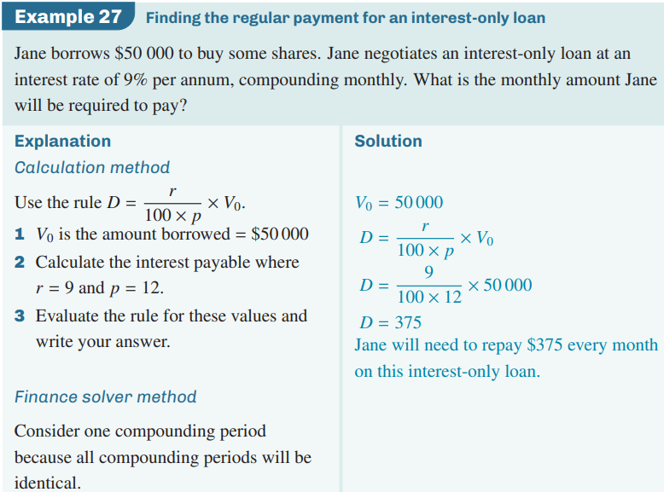
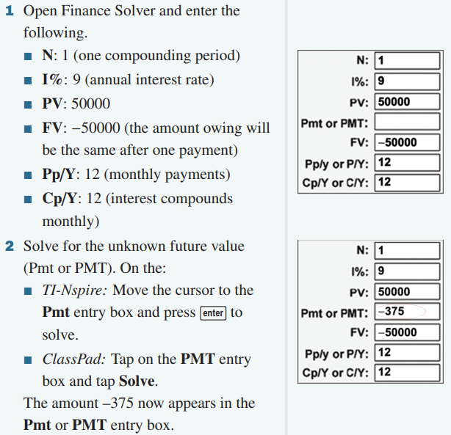
6.14 Perpetuities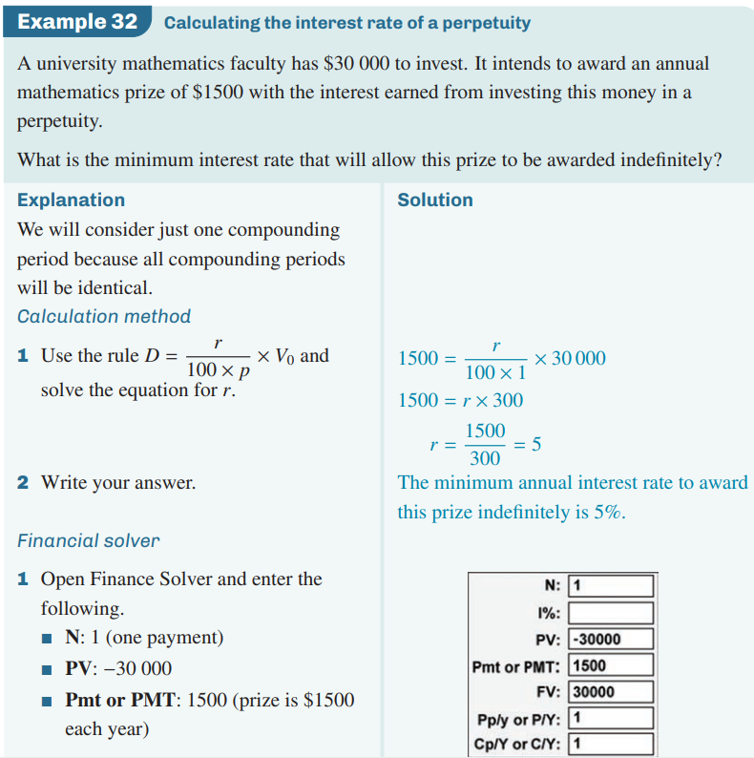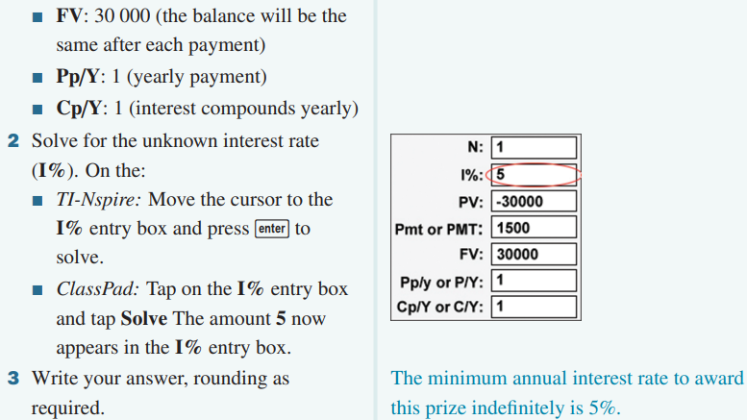
6.15 Using “amortloan” template
Creating an amortisation table with “amortloan”
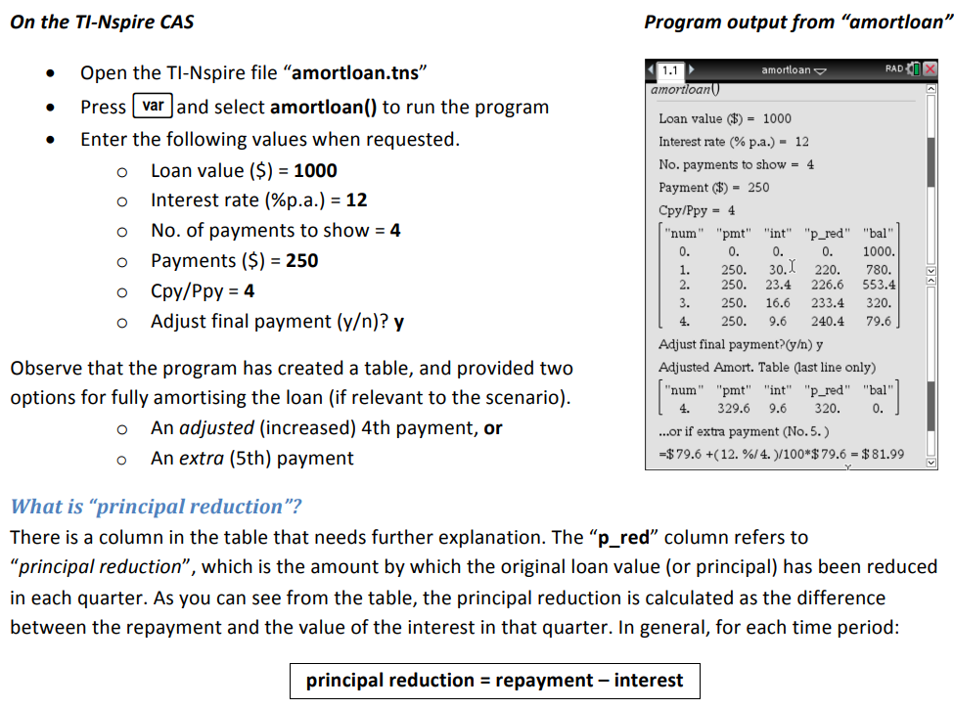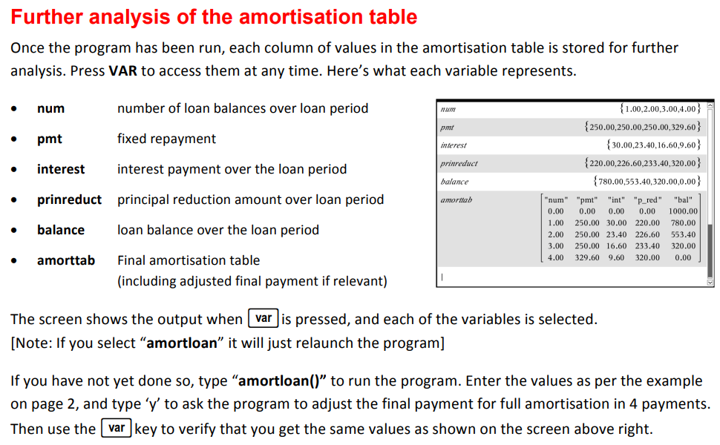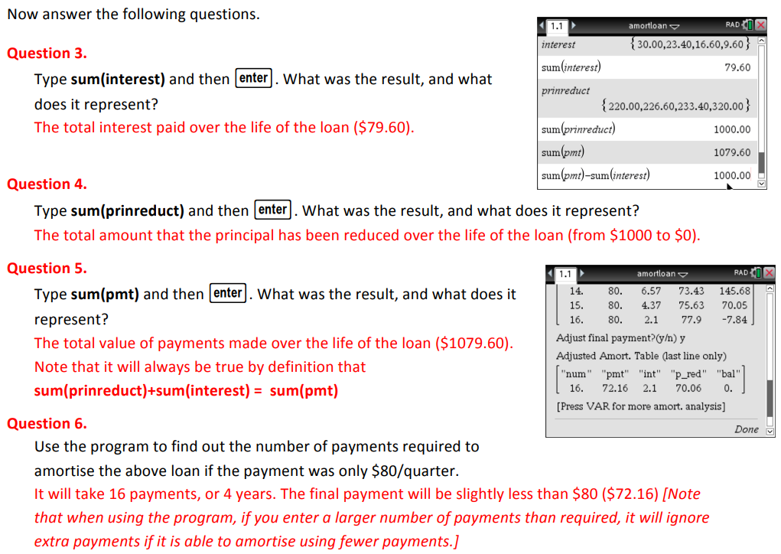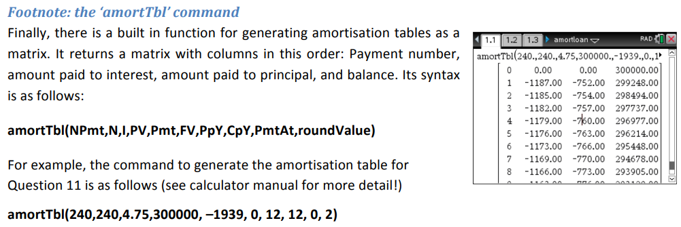
6.16 Using” 1-8 financial products” template
Green area=input; Pink & Orange= output
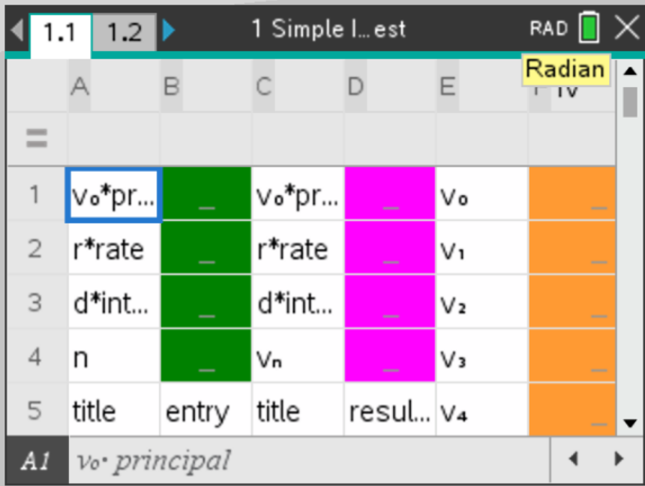
6.17 Using” amortspread” template
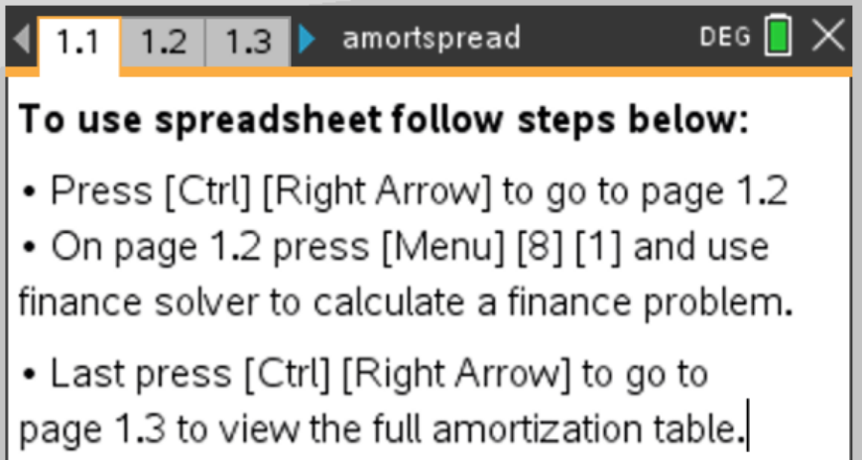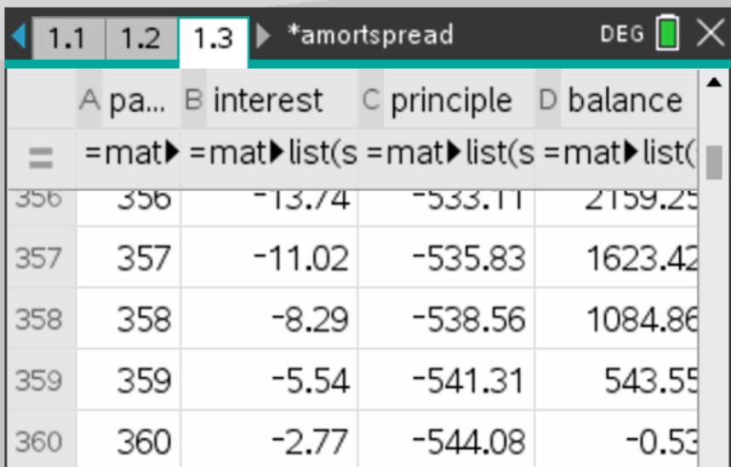
6.18 Using” Effective Interest Rate” template
Can compare 3 sets of nominal interest rates
