Factors and Multiples game

Rules:

* You will need 2 different coloured pencils and the 100 square grid below
* Player 1 colours in a number less than 50
* Player 2 has to colour in a number which is a factor or a multiple of the first number
* Player 1 now has to colour a number which is a factor or a multiple of the number player 2 coloured in
* Play continues until one player cannot go

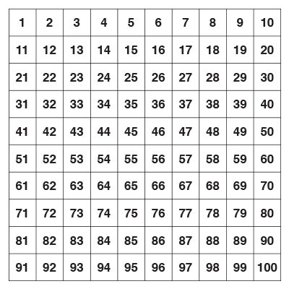

Factors and Multiples game

Rules:

* You will need 2 different coloured pencils and the 100 square grid below
* Player 1 colours in a number less than 50
* Player 2 has to colour in a number which is a factor or a multiple of the first number
* Player 1 now has to colour a number which is a factor or a multiple of the number player 2 coloured in
* Play continues until one player cannot go

