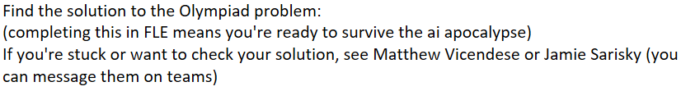Machine generated alternative text:
Two positive integers, a and b, satisfy the equation 
224 + 221 + 221 + 221 
2024 
Find the value of a H- b. 
23b • 