Machine generated alternative text:
What is 
Computational 
Thinking? 
Computational Thinking is a set of skills that underpin learning within the Digital Technologies 
classroom. These skills allow students to engage with processes, techniques and digital 
systems to create improved solutions to address specific problems, opportunities or needs. 
Computational Thinking uses a number of skills, including: Machine generated alternative text:
DECOMPOSITION 
Breaking down problems into smaller, easier parts. 
PATTERN RECOGNITION 
Using patterns in information to solve problems. 
ABSTRACTION 
Finding information that is useful and taking away any information 
that is unhelpful. 
MODELLING AND SIMULATION 
Trying out different solutions or tracing the path of information to 
solve problems. 
ALGORITHMS 
Creating a set of instructions for solving a problem or completing 
a task 
EVALUATION 
Assessing a solution to a problem and using that information again 
on new problems. 

**Networking**

**This Challenge has questions that require students to read and interpret variations of networks or network graphs in order to solve the problem.**

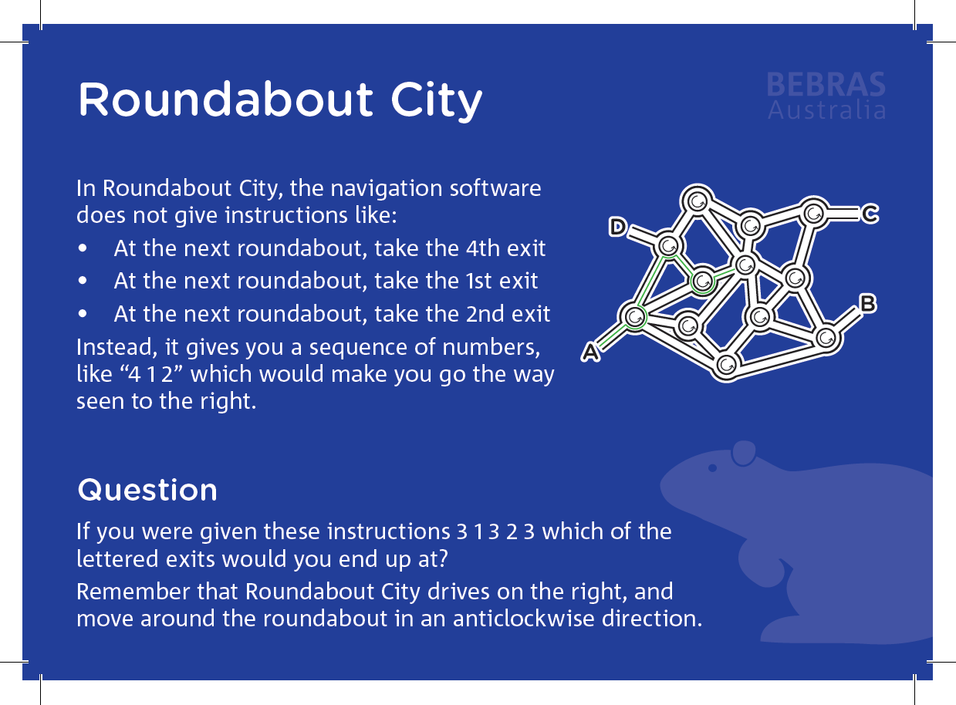

**Solution:**

