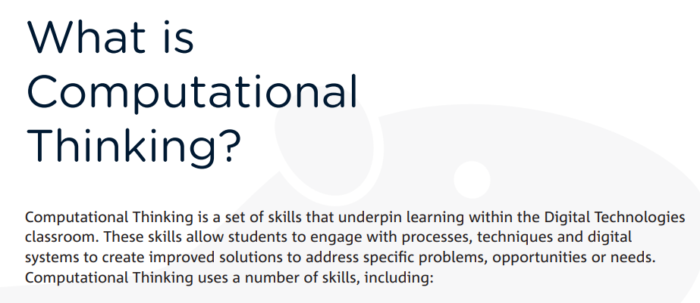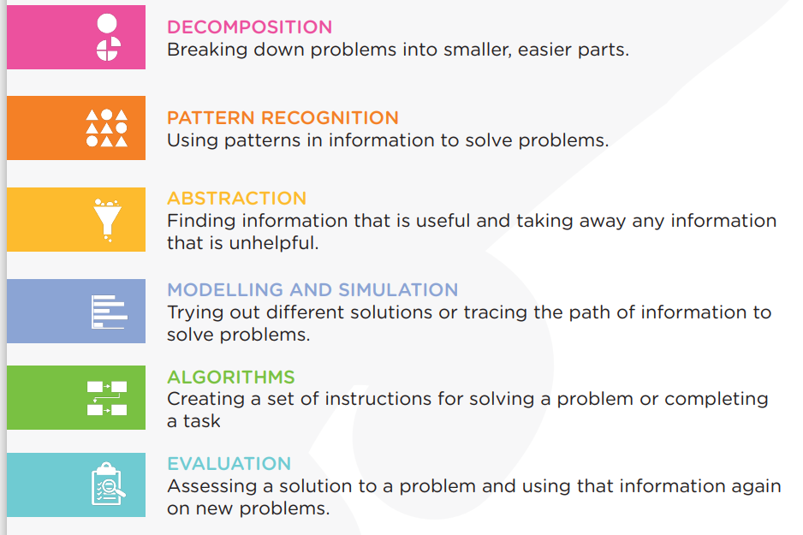
You will now complete something that is more like the competition we'll be attempting in class.
Use the problem reflection OneNote page, and see if the problem solving technique is similar to what experts think is the best way with the solutions (teacher has them below)

