Before we get started on triangles, let's review angle types:

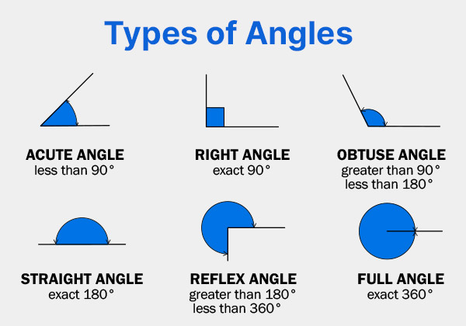

[Math Antics - Triangles](https://www.youtube.com/watch?v=mLeNaZcy-hE)

