Prove it pentagon

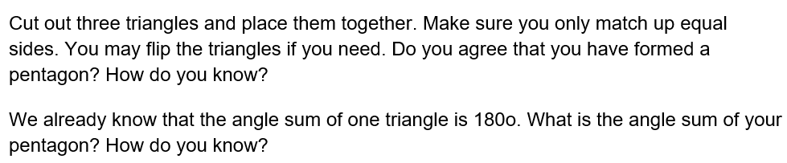

Prove it hexagon

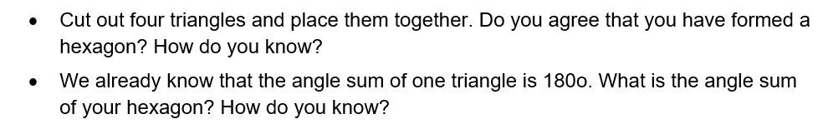

Prove it polygon

