Let's revise quadrilateral properties:

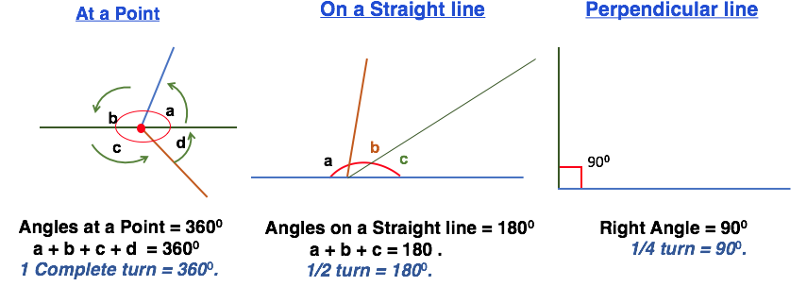

[Angles around a point](https://www.youtube.com/watch?v=Yt2yvO-xkhY)