Draw and label each of the following angle words in your workbook:

* Right
* Complementary
* Straight
* Supplementary
* Vertically opposite
* Adjacent angles

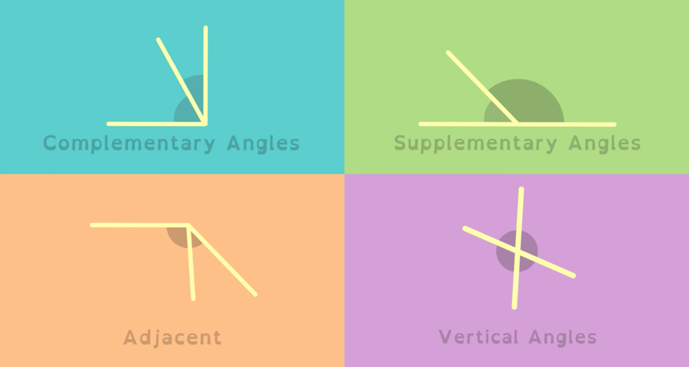

[Complementary, Supplementary & Vertical Angles - Geometry](https://www.youtube.com/watch?v=QjwbvNdUSTk)

[Angle Pair Relationships: Adjacent, Vertical, Complementary, Supplementary](https://www.youtube.com/watch?v=JPjQaELCdC0)

**DO TOGETHER AS A CLASS:**   
<https://www.mathspad.co.uk/interactives/angles/angles.php>