REVIEW VIDEO - Math Antics - Angle Basics
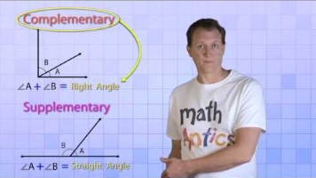
Finding Unknown Angles

