Prepare to be amazed…

<https://pi.math.cornell.edu/~mec/Winter2009/Mihai/section8.html>

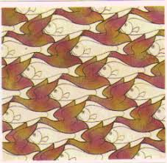

M.C Escher