Key Ideas:
- A budget is an estimate of income and expenses for a period of time and is used to see how much money, if any, is remaining.
- Budgets assist in making financial decisions about "needs" and "wants" and future financial goals
- Expenses can be classified in two ways:
  - Fixed expenses do not change over a period of time. Think loans, mortgages, regular bills.
  - Variable expenses changes over time. Think clothing, entertainment, food.
- Expenses can be listed as the dollar amount or as a percentage of income:
  - To calculate the percentage of income:
    - $\frac{Costs}{Income}×100\%=Costs as a \%$
  - If only given the percentage:
    - $\$ Cost=Cost as a \%×Income$

Fixed & Variable Expenses
You’re 18 years old, just started working part-time, and earn $600 per week.

What kind of things do you spend your money on each week? Are these "needs" or "wants"? Are they fixed or variable expenses?

Example 1
Identify which expenses are fixed and which are variable and calculate how much savings are for the month

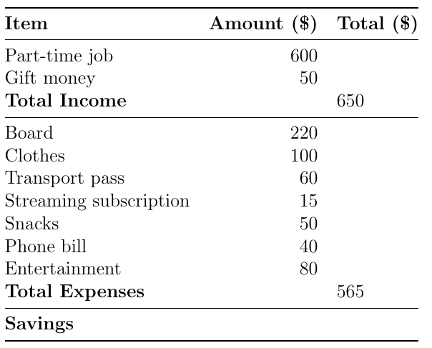

Example 2
Using the above budget, calculate the percentage of income spent on each of board and clothes and the percentage saved (all to two decimal places).
Rule: $\frac{Costs}{Income}×100\%=Costs as a \%$

Board: $\frac{220}{650}×100\%=33.85\%$

Savings: $\frac{85}{650}×100\%=13.08\%$

Example 3
Calculate the dollar value of going out when income is $800 for the week and going out costs 13% of income

Rule: $\$ Cost=Cost as a \%×Income$

$$13\%×800=0.13×800=\$104$$

