Key Ideas:
- PAYG Taxation
  - Employee works for and is paid by employer
  - Employer calculates the tax that the employee should pay on this income
  - Employer sends the money to the Tax Office
  - Wages - paid per hour worked
- At the end of the year
  - if you have paid too much, you will get a refund
  - If you have not paid enough, you will get a tax bill
- $Taxable Income=Gross income -Deductions$
  - Deductions - Expenses you’ve incurred to earn your income
    - E.g. a builder needs a hammer
but a math teacher doesn’t
- $Effective Rate of Tax= \frac{Tax Paid}{Gross income}$

Watch until 1:45
How does income tax work? | Everyday Money | ABC Australia

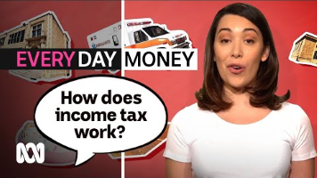

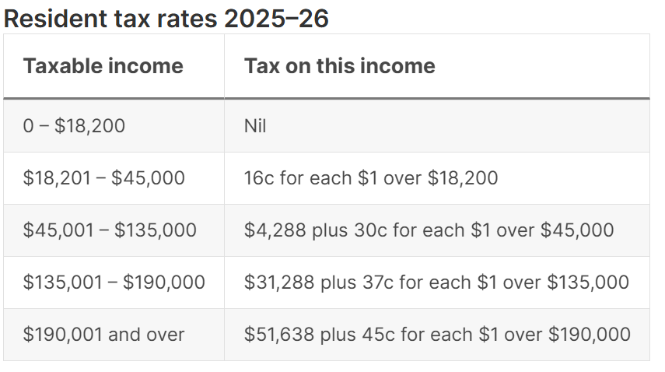

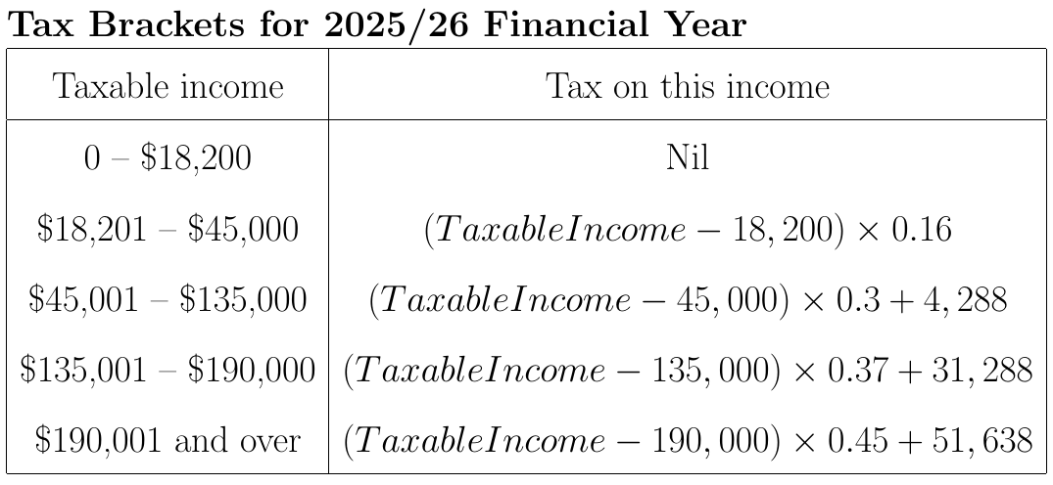

Example 1
A first year teacher earns $75,726 and has $2,300 of deductions.
Find:
- Their taxable income
- The tax bracket they fall in
- Their tax payable
- How much they should pay each week so they don't have a tax debt at the end of the year

- $Taxable income=Gross income -Deductions=\$75,726-\$2,300=\$72,426$
- They fall in the third tax bracket, the $\$45,001-\$135,000$ bracket
- $Tax payable=\left(Taxable Income -45,000\right)×0.3+4,288=\$12,515.8$
- $12,515.8÷52=\$240.69$

