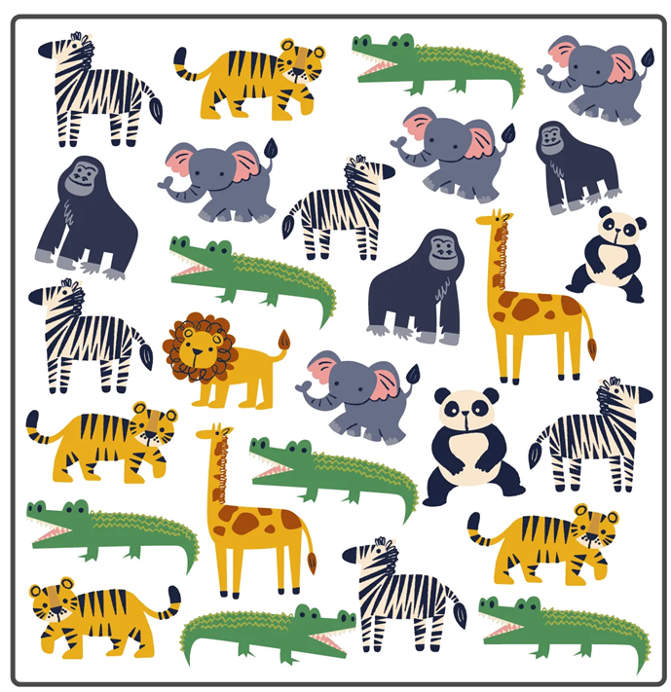

Questions to ask the class:

* How did you group them?

* Why did you group them that way?

* Did anyone group the elephant and the crocodile together? Why not?