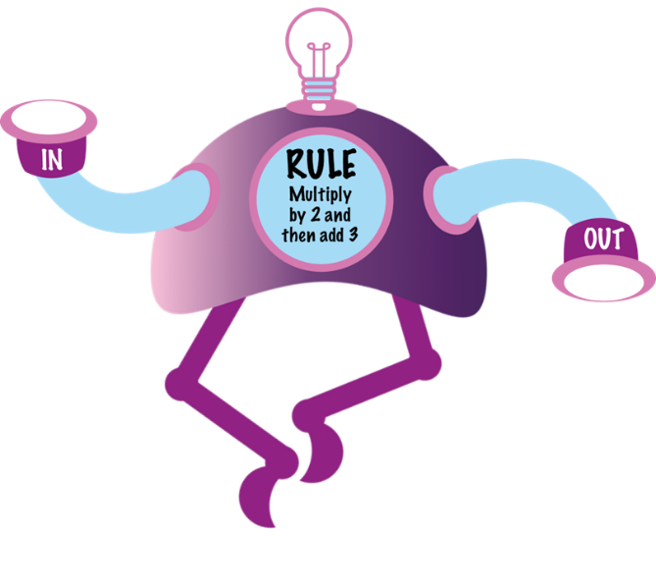
- Choose 3 numbers to put in the robot and figure out what 3 numbers come out

