I CAN Determine your number by a series of operations!!

A Student chooses a number and secretly writes it on their page

|  |
| --- |
|  |

Students choose an operation (e.g. *2)

|  |
| --- |
|  |

Then students choose another operation (e.g. +5)

|  |
| --- |
|  |

Then students choose another operation (e.g -1)

What is the final answer? Student write on board.

|  |
| --- |
|  |

Teacher magically determines the answer through backtracking

*2 +5 -1

|  |  |  |  |
| --- | --- | --- | --- |
|  |  |  |  |

Demonstrate the algebraic expression using n

n*2+5-1=

**Example 1:**

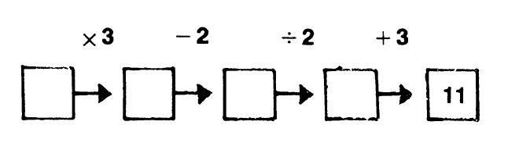

**Example 2:**

Ce n the class recreate the Story and find 
star*'" 
2(3n — 1) +1 —47 