Key Ideas:
- Distributive law - multiplying a number by a group of numbers added together is the same as doing each multiplication separately.
  - The terms inside the brackets are multiplied by the term outside the brackets

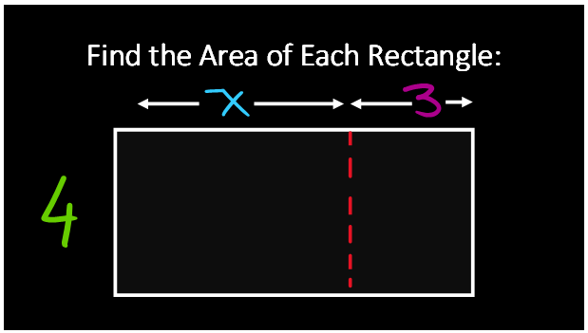

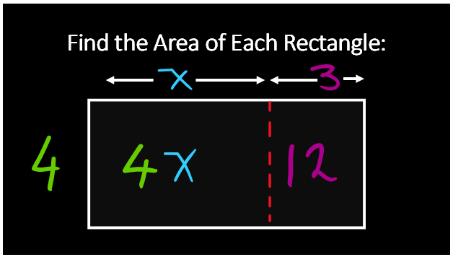

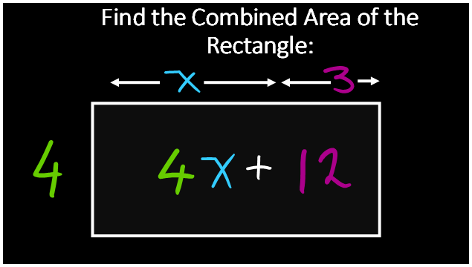

As such:
$$a\left(b+c\right)=ab+ac$$
$$a\left(b-c\right)=ab-ac$$
^this is all you need to know for this topic!

Example 1:
$$y\left(2y-3\right)$$
$$=y×2y+y×-3$$
$=2y^{2}+-3y$
$$=2y^{2}-3y$$

Example 2:
$$3+7\left(x+2\right)$$
$$=3+7×x+7×2$$
$$=3+7x+14$$
$$=17+7x$$

Example 3:
$$-7\left(w-3\right)$$
$$=-7×w+-7×-3$$
$$=-7w+21$$

