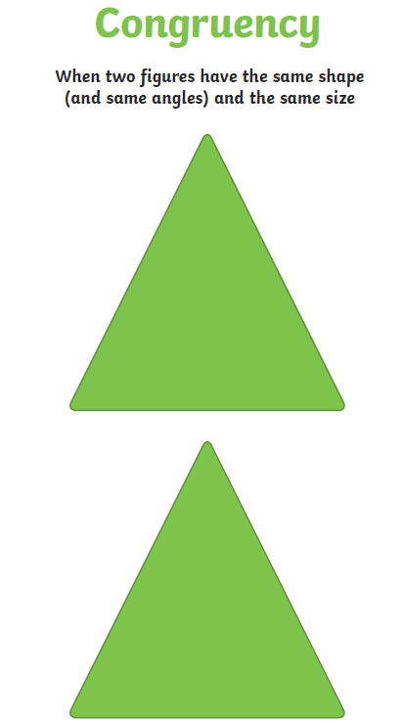

Click on the link below to explore congruence definitions and examples. Click on Rotation, Reflection and Translation to see each in action.

https://www.mathsisfun.com/geometry/congruent.html

