Key Ideas:
- A scale drawing has exactly the same shape as the original object, but a different size.
- The scale on a drawing is written as a scale ratio:
  - Drawing length : Actual length
- The second number in the ratio can be referred to as the scale factor.
  - If there is only one number, it's the scale factor
  - A scale fraction of less than 1 (such as $\frac{1}{3}$ means the shape is smaller)

Example 1:
Enlarge this image using a scale factor of two:
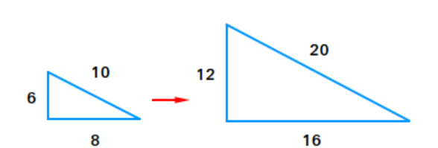

Example 2:
Reduce this image using a scale factor of $\frac{1}{2}$:

