Key Ideas:
- GeoGebra allows students to:
  - Construct shapes precisely.
  - Apply and visualise enlargements dynamically.
  - Use sliders to change scale factors.
  - Transform shapes

Demonstrate creating a scale factor:
https://www.geogebra.org/m/ntczbaxv
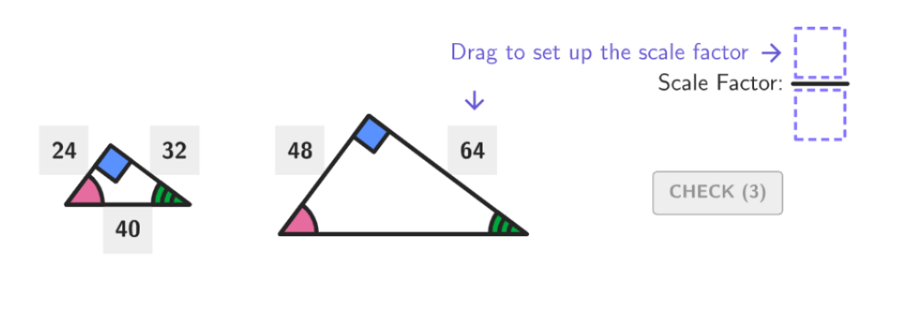

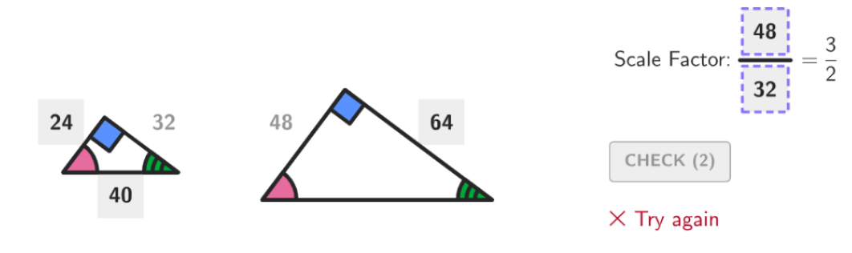
Scale factor is incorrect between a different side of each triangle has been used

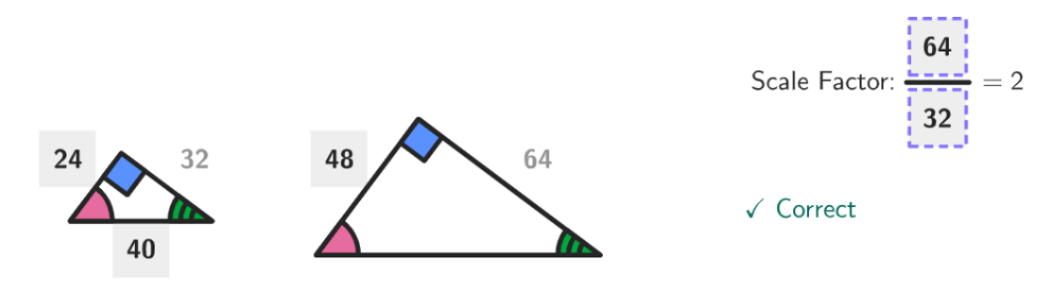
The same side on each triangle has been used and we can see that the scale factor is 2, meaning the second triangle is twice as large as the first.

