FLE - Congruence, Similarity, & Enlargement Project - 2025

Name: ______________________

FLE Class: _________

Teacher: _______________

Part A – Matching definitions
Draw a line to match the definition to the abbreviation

If three sides  are the same  the triangles will be congruent |  | ASA
If both triangles are  right-angled and have the same hypotenuse and a  non-included side the triangles will be congruent |  | RHS
If two sides and the angle between them (the ‘included angle’) are the same the triangles will be congruent |  | SSS
If two angles and the side between them are the same, the triangles will be congruent |  | SAS

Part B – Congruence test labels
Label each pair of triangles with the appropriate congruence test.

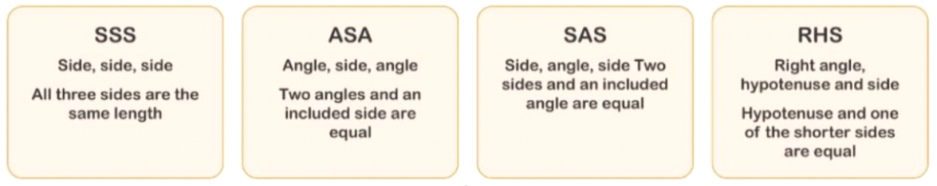
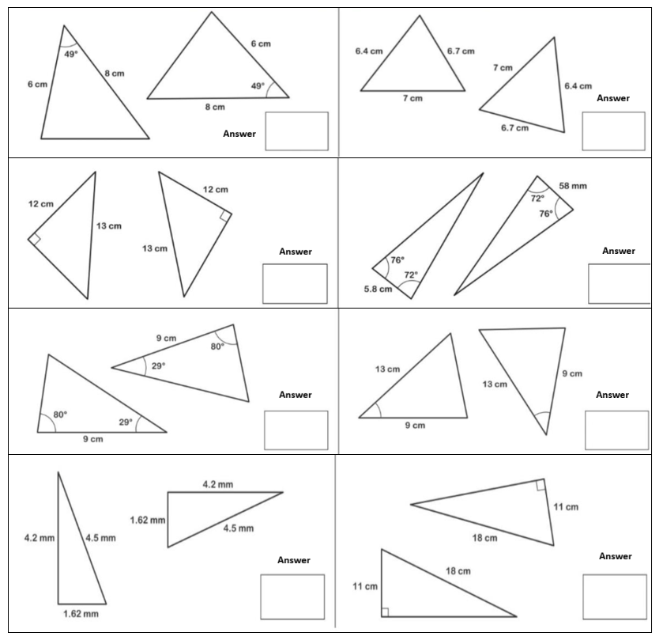

PART C – Paper Airplane Design
Designed and construct a paper airplane and identify four sets of congruent triangles and justify them with congruence tests/theorem.
Method:
- Precisely fold your blank A4 into an airplane
- Open completely and label all paired triangles with vertices
- Also label angles and sides relating to your rules
- Colour code your congruent triangles
- Complete triangle set blanks below (e.g. Angle ABC = DEF)
- Hand in your airplane with project
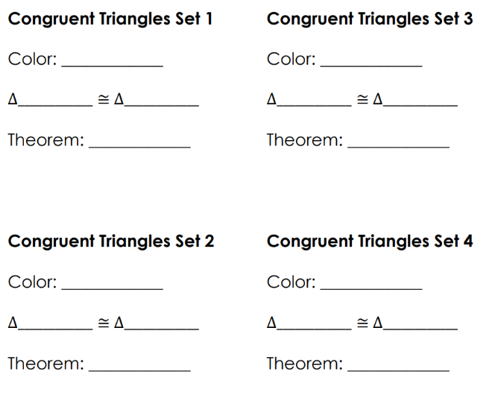
PART D – Drawing congruent triangles and similar shape
- Using the grid paper provided, draw 4 identical pairs of triangles to represent each congruence test
- SSS, ASA, SAS, & RHS
- Each triangle should reflect the other.
- Label each triangle with necessary side length and angle degrees

- Draw 1 small and 1 enlarged shape to show a similarity (Orange)
- The similar shape should show a line of symmetry down the middle.
- Label each shape with necessary side length and angle degrees

- Fold grid paper in half to with identically reflected shapes to demonstrate the congruence of your triangles and a line of symmetry for your similar shape.

Part D - Drawings
