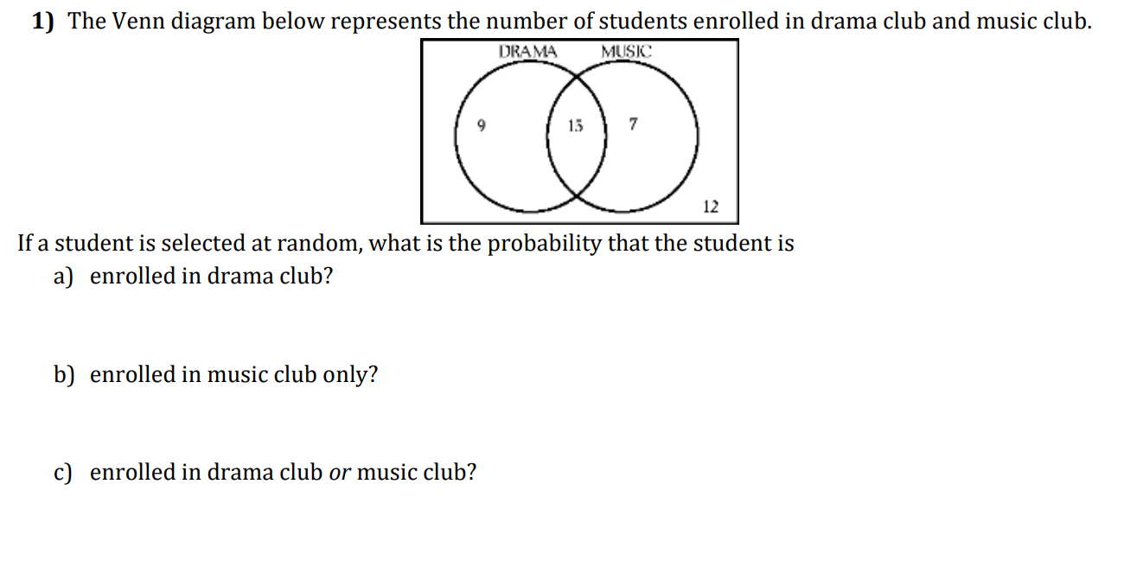
2) There are 120 children in a summer camp. All the children in a summer camp play at least one sport, from a choice of football (F) or basketball (B). From these 120, 15 children played both sports and 24 children play football.
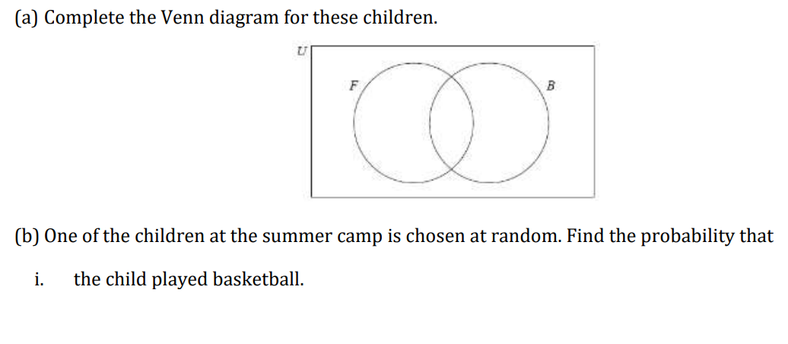

ii. the child played football and basketball.

