1. A bag contains only black and white counters. Grace picks a counter at random and then replaces it. Grace then picks a second counter.
(a) Complete the tree diagram.
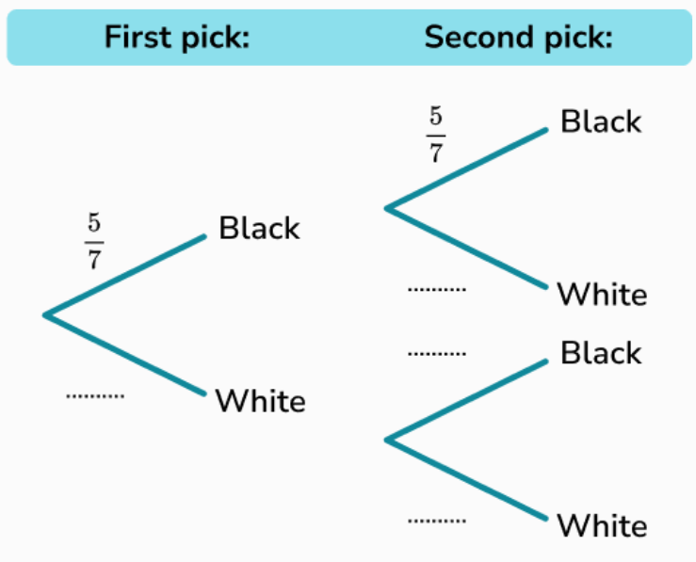
(b) Work out the probability that Grace picks 22 black counters.

