2. Amir has two bags. In the first bag there are 33 red counters and 22 blue counters. In the second bag there are 44 red counters and 55 blue counters. Amir takes at random a counter from the first bag. He then takes at random a counter from the second bag.
(a) Complete the tree diagram.
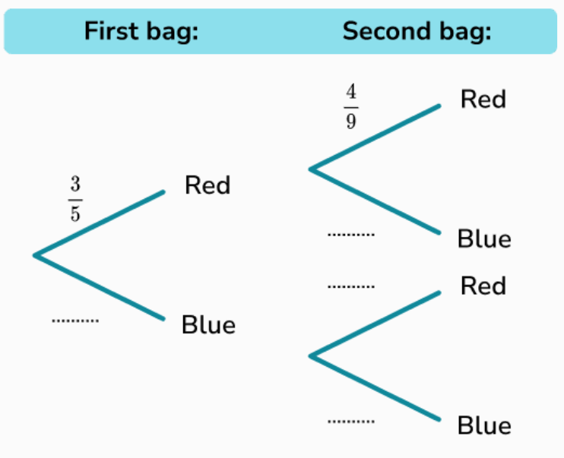
(b) Work out the probability that Amir takes two blue counters.

