1. Natalie has 8 socks in a drawer. 5 of the socks are black. 3 of the socks are white. Natalie takes out a sock at random, writes down its colour and DOESN”T put it back into the drawer. Then Natalie takes out a second sock, at random, and writes down its colour.
(a) Complete the probability tree diagram.
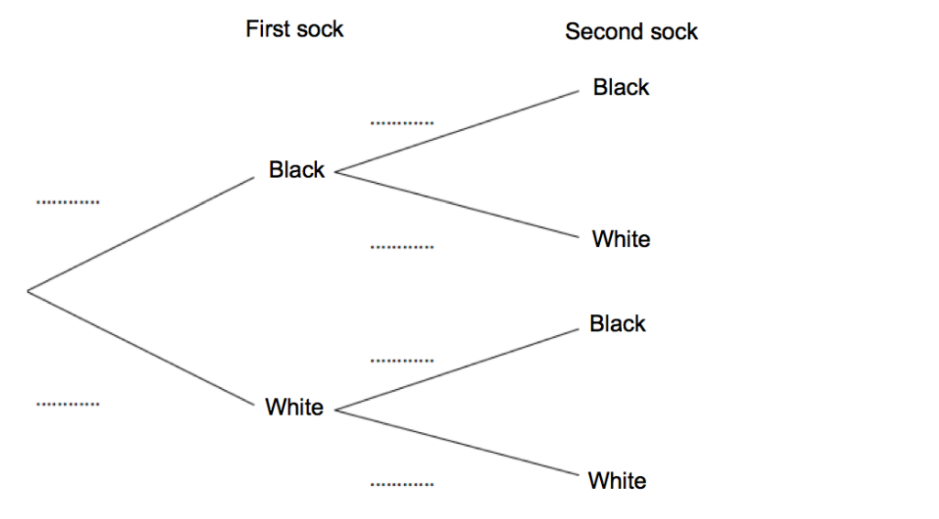
(b) Work out the probability that the two socks are the same colour.
2. There are green and blue counters in a container. Kevin takes at random a counter from the container. He DOESN”T replace the counter in the container. Kevin takes at random a second counter from the container.
(a) Complete the probability tree diagram.
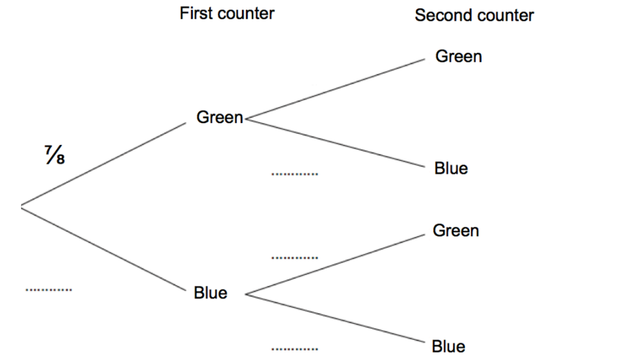
(b) Work out the probability that Kevin picks counters that are different colour.

