Topics | Data Types 1A |  | Display/Analyse Tools |  | Report/Explain/Interpret/Describe
Univariate Data  Chapter 2 | Categorical variables1B | Nominal data | Bar chart, Pie Chart, Frequency Table1a, Segmented bar chart |  | Mode/ Modal Value  Frequency types, Frequency % = $\frac{Count}{Total Count}×100\%$
Univariate Data  Chapter 2 | Categorical variables1B | Ordinal data
Univariate Data  Chapter 2 | Numerical variables1C | Discrete data | Boxplots 1c 1.2, Grouped Frequency Tables | Stem plot 1b, dot plot 1b 1.2 | Shape  Centre  Spread  Outliers  1F | Symmetric 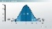  Mean $\overline{x}$ 1.1  Standard Deviation S 1G 1.1  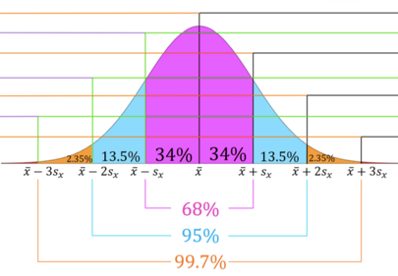  68-95-99.7% rule 1H  1I Z-score=Z=$\frac{x-\overline{x}}{S}$  1I $x$ = $\overline{x}+Z*S$ | Skewed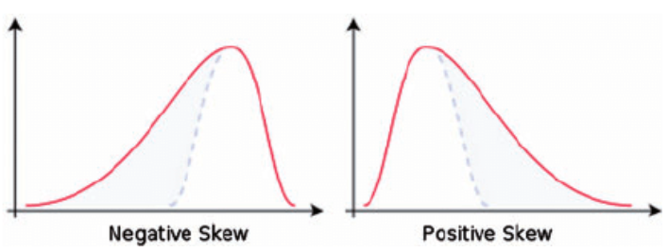  1.1 Median M ${ or Q}_{2}$  IQR, Range  $\left\{\begin{aligned} Lower Fence=Q_{1}-1.5*IQR \\ Upper Fence=Q_{3}+1.5*IQR\end{aligned}\right.$  1.1 5-figure summary: Min, $Q_{1}, Q_{2,}, Q_{3},$Max  IQR=$Q_{3}-Q_{1}$, Range=Max$-$Min
Univariate Data  Chapter 2 | Numerical variables1C | Continuous data | Boxplots 1c 1.2, Grouped Frequency Tables | Stem plot 1b, histogram 1b 1.1, log 1.2 log-histogram1.2 | Shape  Centre  Spread  Outliers  1F
Bivariate Data  Chapter 2  Chapter 7 | Two categorical variables2A |  | Segmented bar chart, two-way frequency table2a, parallel bar chart 2.1 |  | Mode/ Modal Value  Frequency types
Bivariate Data  Chapter 2  Chapter 7 | One categorical, one numerical variable 2B |  | Back-to-back stem plots, parallel dot plots, parallel box plots 2b 2.2 |  | Shape  Centre  Spread | Symmetric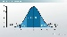  1.1 Mean $\overline{x}$  Standard Deviation S | Skewed  1.1 Median M ${ or Q}_{2}$  IQR, Range
Bivariate Data  Chapter 2  Chapter 7 | Two numerical variables 2C  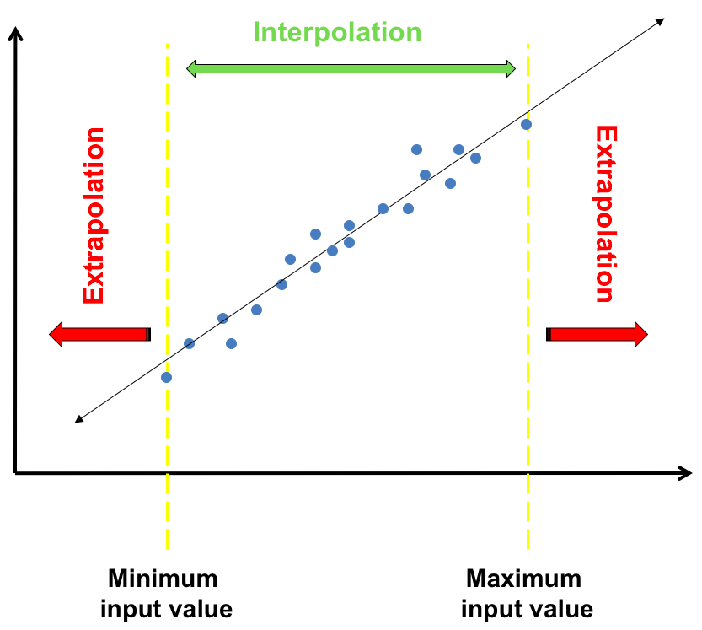 Interpolation  Extrapolation  The assumptions for fitting a least squares line  1. the data is numerical  2. the association is linear  3. there are no clear outliers. |  | Scatterplot 2c 3.2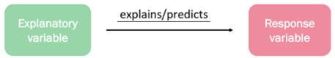  residual = actual data value y – predicted 3.3 value y  residual = y - ŷ  Nil pattern residual 3.2 plot 2f = Linear relation  Curved/ patterned residual plot$≠$linear relation |  | Strength  Direction  Form  3A 3B 3C 2e LSRL y=a+bx 3.1  2e slope 𝑏=$\frac{{rs}_{y}}{s_{x}}$  2e y-intercept  𝑎 = $\overline{y}$−𝑏$\overline{x}$ | Strong/Moderate/Weak (Check r value) 2D 3.1  Positive / Negative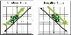  Linear / Non-linear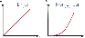  Reporting 2d on Coefficient of Determination r² 3.1  Almost [ r² in %] of [RV 𝑦] can be explained / predicted by [EV 𝑥].
Time Series 4A 4E: LSRL | Features4A | Moving smoothing 4.1 |  |  |  | Seasonal Index S.I. 4D | Deseasonalising 4D
Time Series 4A 4E: LSRL | Trend 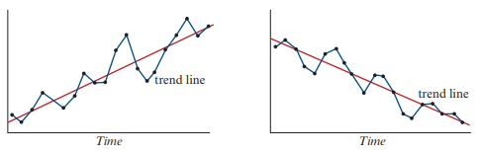  Cycles 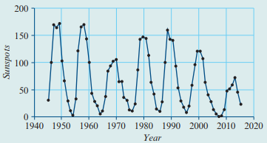  Seasonality  Structure change  Outliers 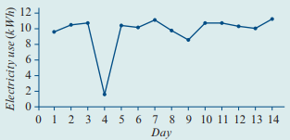 | Moving Mean 4B 4.1 |  | Moving Median 4C |  | S.I.=$\frac{Value for Season}{Yearly Average}$  Yearly Average=$\frac{Sum of Season Values}{No. of season per year}$  Correct S.I. = ($\frac{1}{S.I.}-1)×100$  + means ↑, $-$ means ↓ | Deseasonalised Figure = $\frac{Actual Figure}{S.I.}$ = $Actual Figure*\frac{1}{S.I.}$  Actual figure= Deseasonalised Figure * S.I.
Time Series 4A 4E: LSRL |  | 3/5 moving mean | 2/4 Moving mean | 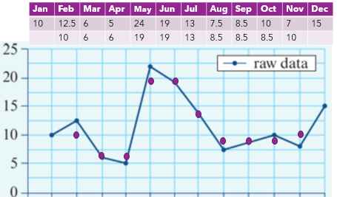
Time Series 4A 4E: LSRL |  | 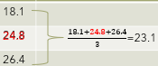 | 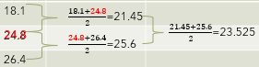
Note: Textbook Summary Notes Section #, Report Instruction Notes #. CAS Instruction Notes #
1E: The Box Plot 1.2 2D: Correlation 3.1& Causation

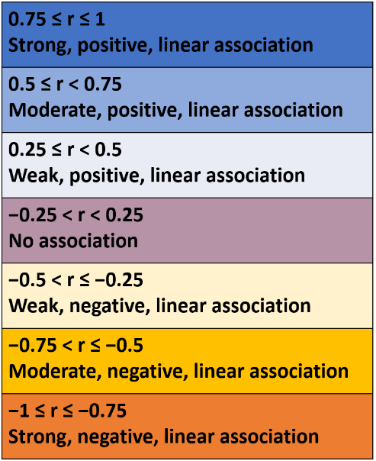
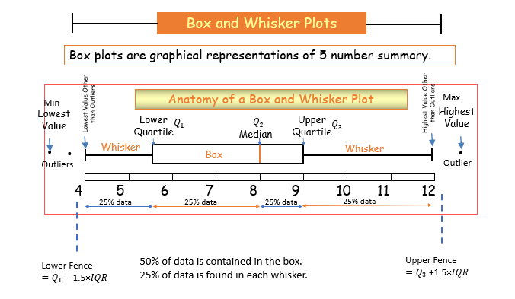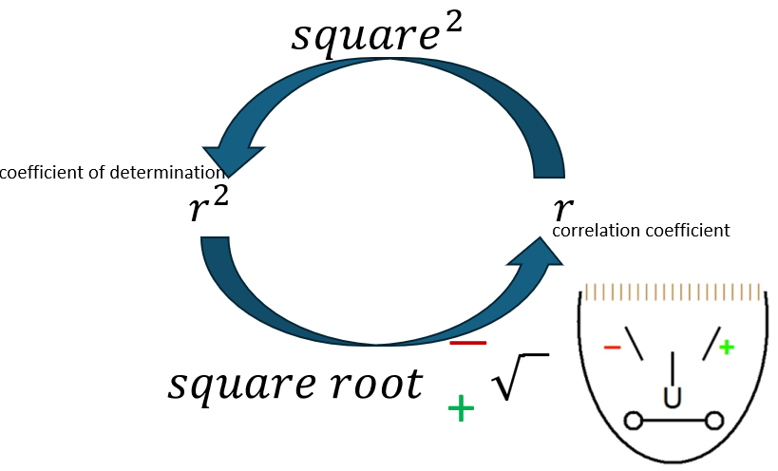
Name of Variation | Symbol of Variation | Equation of Variation | CAS
Name of Variation | Symbol of Variation | Equation of Variation | Slope/Equation | Plot/Equation
Direct Variation | $$y∝x$$ | $$y=kx$$ | 3.1 | $$y=kx+c$$
Inverse Variation | $$y∝\frac{1}{x}$$ | $$y=\frac{k}{x}$$ | 3.1 | $$y=\frac{k}{x}+c$$
Logarithm Variation | $$y∝\log{x}$$ | $$y=k\log{x}$$ | 3.1 | $$y=k\log{x}+c$$
Variation involving powers | $$y∝x^{2}$$ | $$y=kx^{2}$$ | 3.1 | $$y=kx^{2}+c$$
Other variations | $$y∝\sqrt{x}$$  $$y∝x^{3}$$  $$y∝\frac{1}{x^{2}}$$ | $$y=k\sqrt{x}$$  $$y=kx^{3}$$  $$y=\frac{k}{x^{2}}$$ | 3.1

Data Summary Notes
1A: Types of data
Categorical: characteristics/qualities
- Nominal: grouped according to characteristics
- Ordinal: can be grouped and ordered
Numerical: numbers/quantities
- Discrete: whole numbers, can be counted
- Continuous: is measured

1B: displaying categorical data
Count frequency: number of times the category appears in the data
Percentage frequency: $\frac{count frequency}{total count }×100$
Mode: most frequently occurring value or category
Frequency Table:
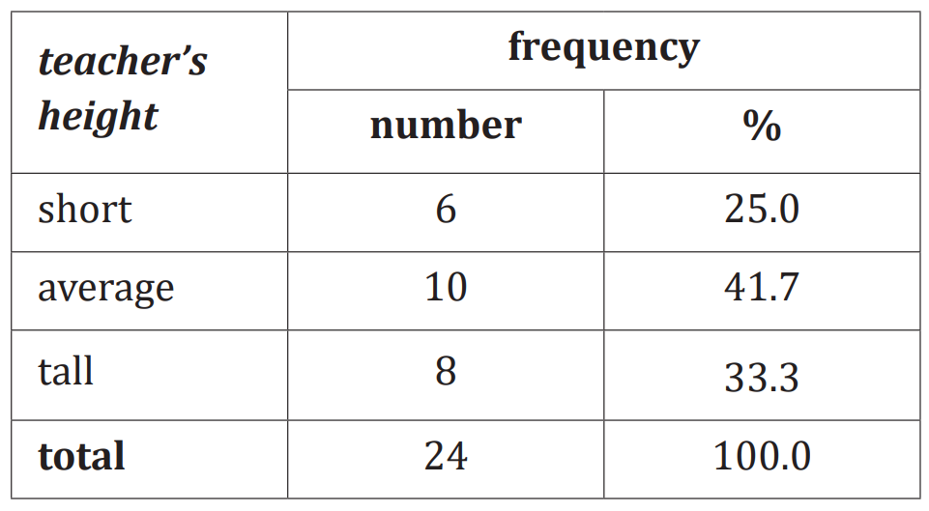
Bar chart:
- Must have gaps between bars
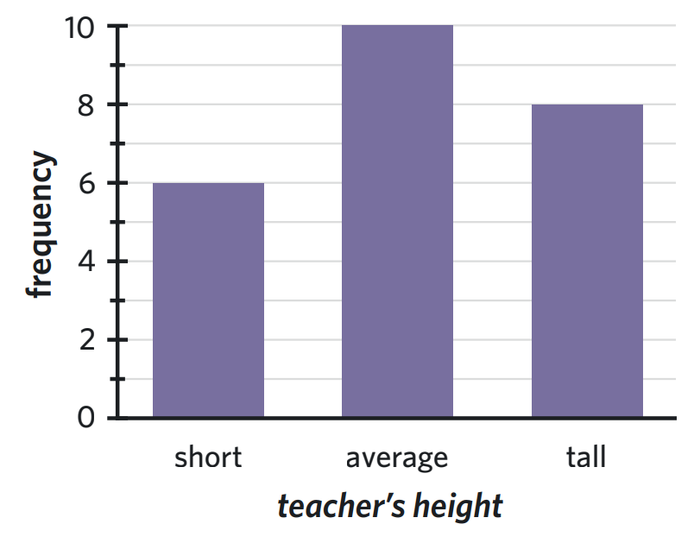
Segmented bar chart:
- Can be count or percentage frequency
- Must have a key
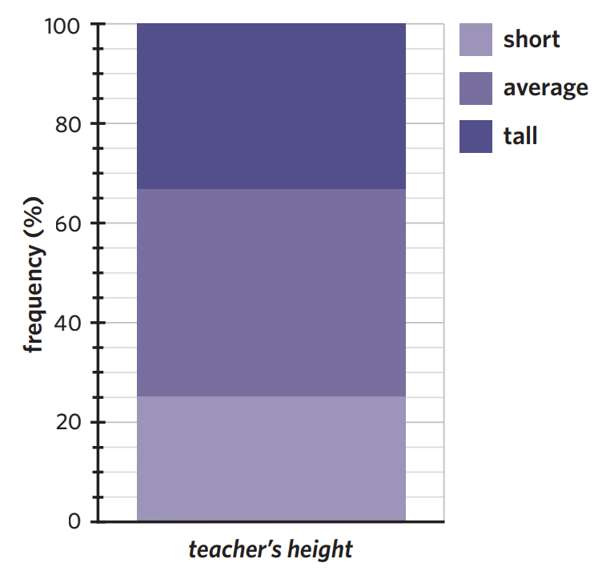

1C: Displaying Numerical data
Dot plot
- Discrete data
- Small data sets
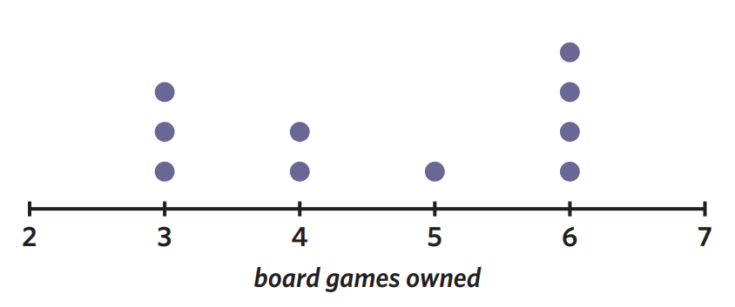

Stem and leaf plot
- Needs a key
- Can have class intervals (splitting the stem in two if it is really large)
No intervals | With class intervals of 5
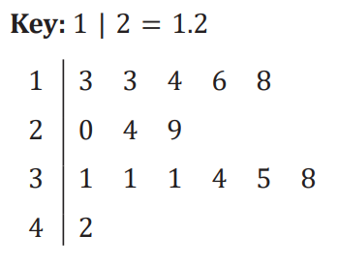 | 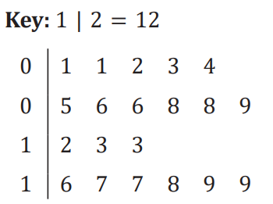

Grouped frequency tables
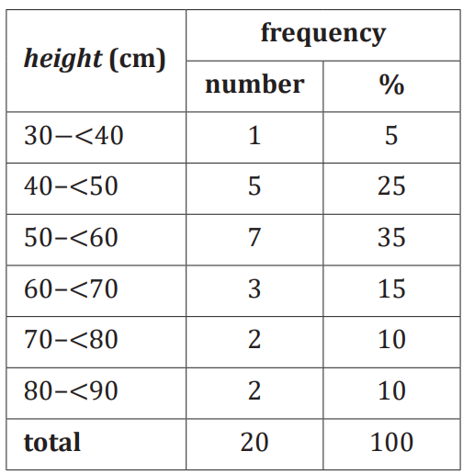
Histogram:
- Continuous data
- Intervals – no gaps between bars
- No gaps between bars
- X-axis markers are always a whole number
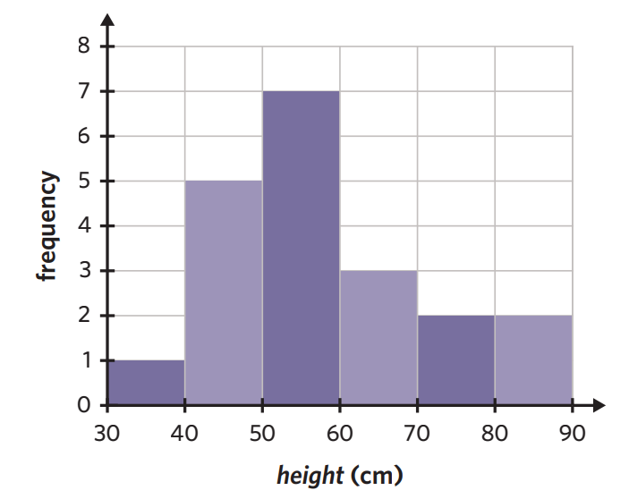

1E: the five-number summary and boxplots
5 number summary:
- Minimum: smallest value in data set
- Q1: median of the lower half
- Median: middle value in an ordered data set
- Q3: median of the upper half
- Maximum: largest value in data set
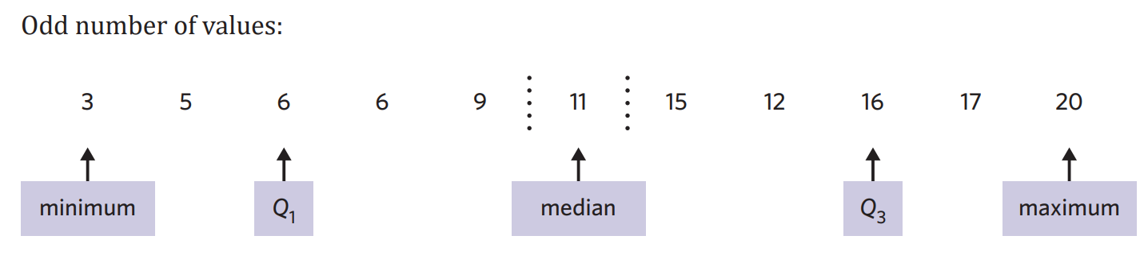
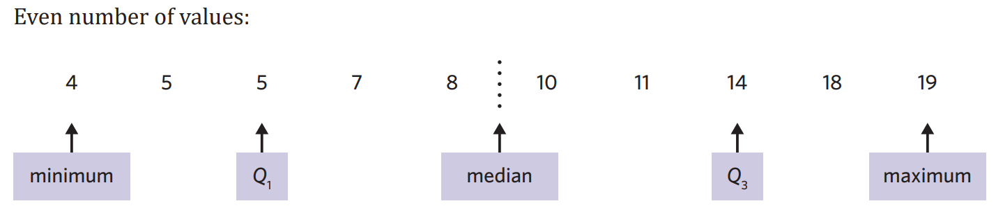
Spread: refers to how variable the data set it
Range = maximum – minimum
Interquartile range: measure of spread of the middle 50% of a data set. Accurate measure of spread when outliers are present.
IQR = Q₃ – Q₁
Outliers: values which fall outside of what is ‘normal’. Outliers are still the minimum and maximum value!
Fence: defines the boundary of what is an outlier. If a value is less than the lower fence or greater than the upper fence it is considered to be an outlier.
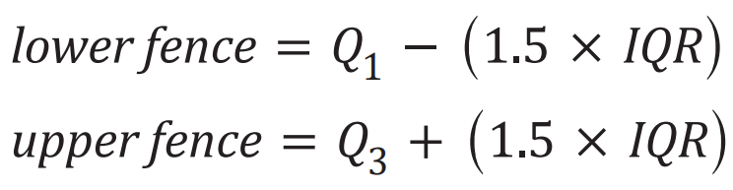
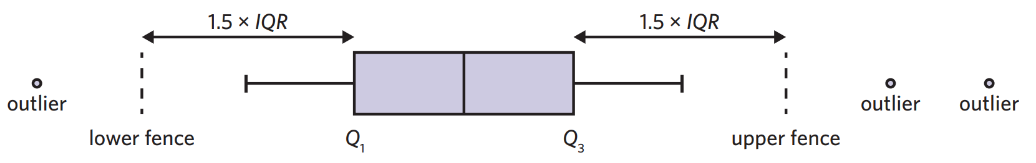

Boxplots:
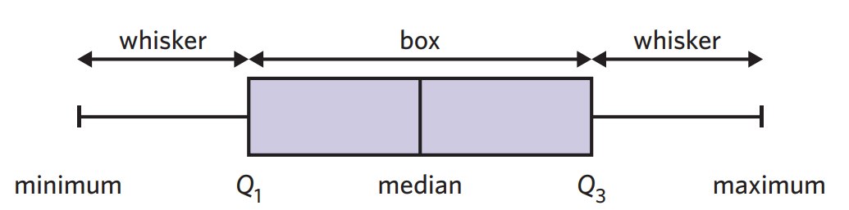
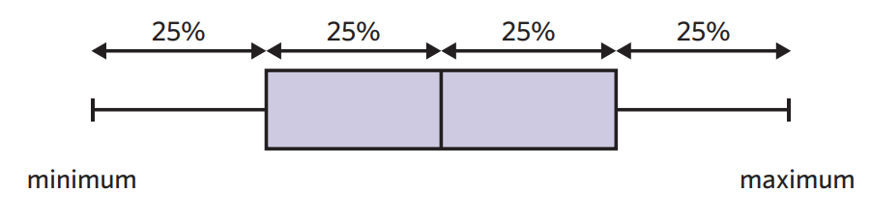

1F: describing numerical data
- Shape: is the data symmetrical, skewed or have any outliers?
- Centre: What is the median value?
- Spread: What is the range and IQR?
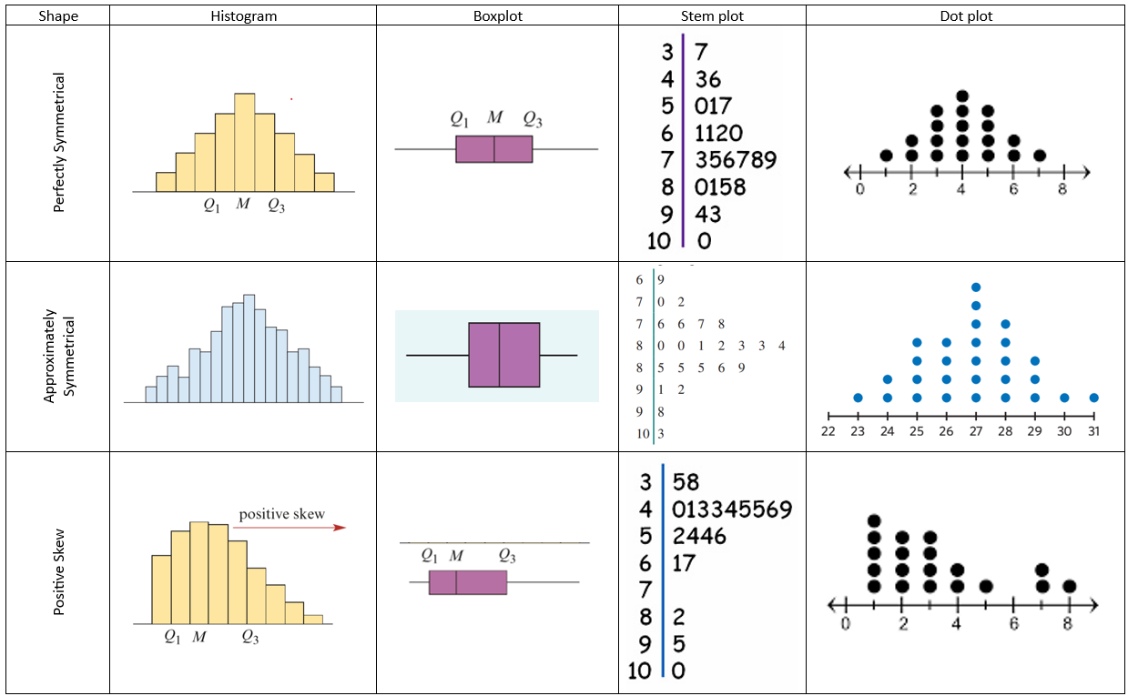
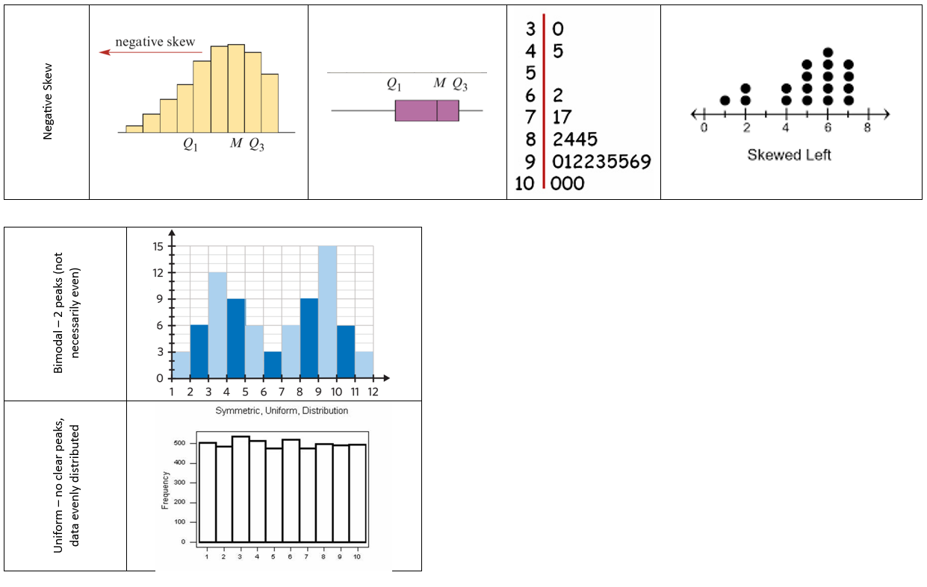
2A: association between 2 variables
Two-way frequency table:
- Columns = EV, Rows = RV
- Percentage frequency is used for greater accuracy when making comparisons if sample sizes are different
Grouped and segmented bar charts:
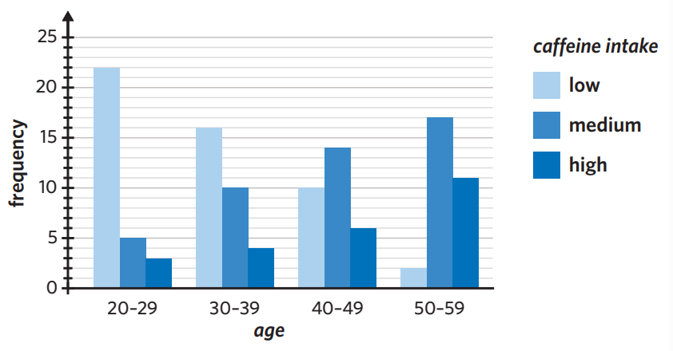
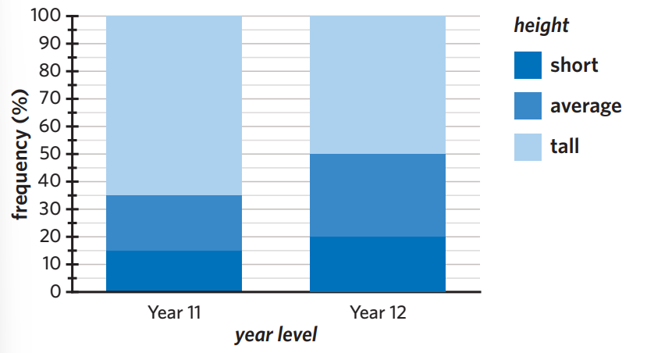
Describing the association between two variables:
- Whether or not an association between the two variables exists
- Appropriate percentages to support findings

2B: association between numerical and categorical variables
- Back to back stem plot
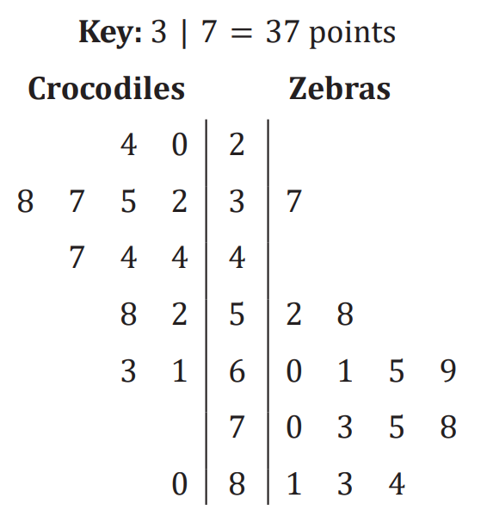
- Parallel boxplot
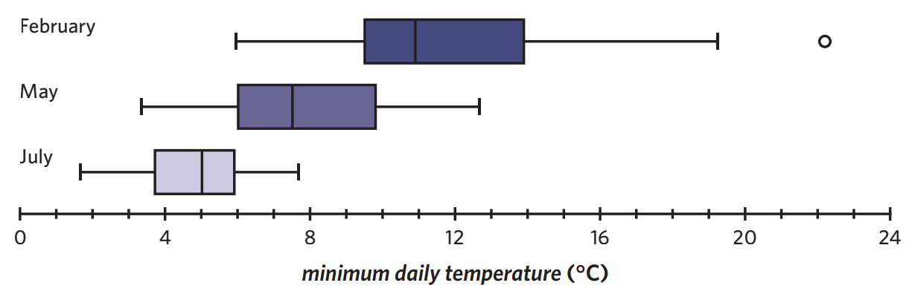
- Making comparisons: refer to 1F and compare shape, centre and spread of the two categories

2C: association between two numerical variables
Response variable: RV, may be explained or predicted by changes in the explanatory variable.
Explanatory variable: EV, used to explain or predict the changes observed in the response variable.
- ‘EV explains the RV’
Scatterplots:
- EV = x axis, RV = y axis

Describing relationship/analysing scatterplots:
- Strength: how close the data points are together
- Direction: positive or negative
 | Positive | Negative
Weak  Moderate  Strong | 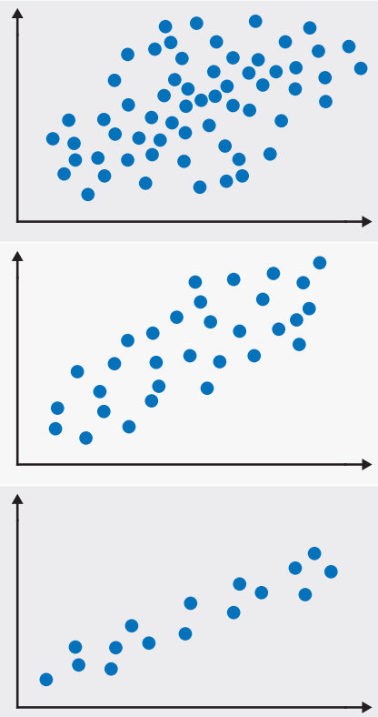 | 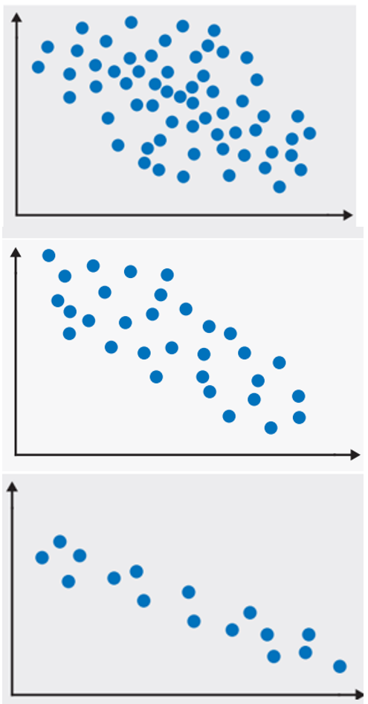

No association | Outlier
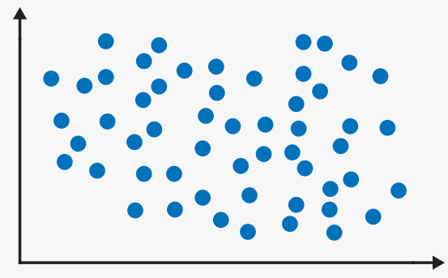 | 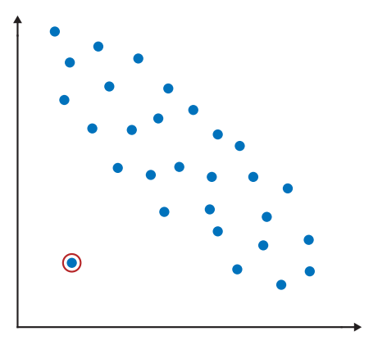
- Form: linear (straight) or non-linear (curved)
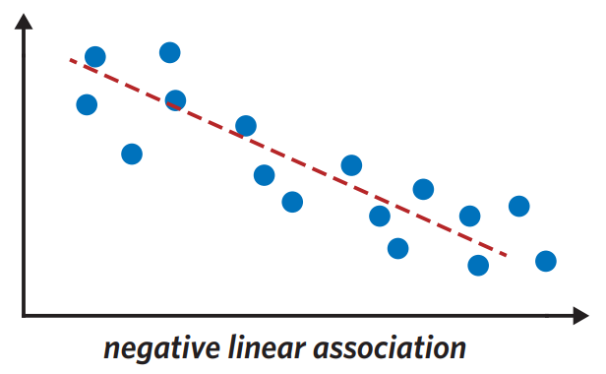 | 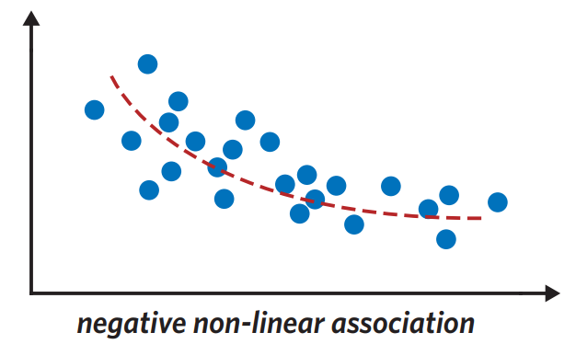
2D: Correlation and causation
Pearson’s correlation coefficient (r): numerical value that determines strength and direction between two numerical variables, assuming:
- Data is linear
- Data is numeric
- No outliers present
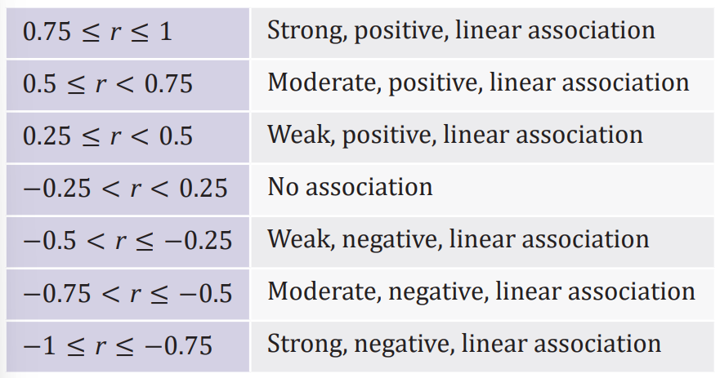

3A: fitting a least squares regression line
Least squares regression line (LSRL): is the line which creates the minimum sum of the squares of residuals. There are assumptions:
- Data is numerical
- The relationship between variables is linear
- There are no clear outliers present
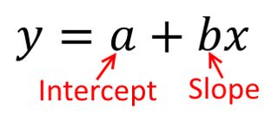
The line is used to show the general trend in the data and is given by the equation:

Determining LSRL from a graph: Find the intercept (a) and the slope (b).
- Intercept: read directly from the graph when the EV is 0
- Slope: choose two points on the line that you can clearly ready the coordinates. Use the rule:
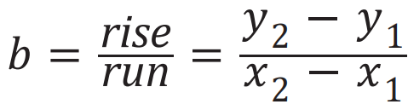

Drawing the LSRL on a graph: Sub in the first value on the x-axis and the last value on the x-axis into the equation. Plot the two points, join the line using a ruler.

3B: Interpreting LSRL: use the following statements, fill in EV and RV and values of a and b.
y-intercept: when the EV is 0, the RV is a.
Slope: for every one-unit increase in the EV, the RV increases/decreases by b. (If b is positive, increases, if b is negative, decreases)

Making predictions: the LSRL can be used to predict the value of the RV from the EV.
Interpolation: predicting within the range of data.
Extrapolation: predicting outside the range of data. Less reliable.
How to predict: sub the EV value that you are predicting for into the LSRL equation to predict the RV.

CAS reference sheet: Data
1.1 Univariate Data Statistics: to find the 5 number summary, mean and standard deviation | - Ctrl n > 4, Enter data in ‘list and spreadsheets’ (ensure a title)  - Menu > 4 > 1 > 1 OR ctrl i > 1 > menu > 6 > 1 > 1 in a new page  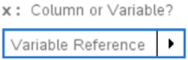  - Select the title you gave the data in the ‘X-List’  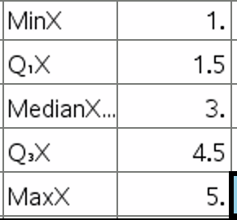  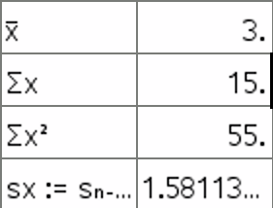
1.2 Graphing Univariate Data: dot plot, boxplots, histograms | - Ctrl n > 4, Enter data in ‘list and spreadsheets’ (ensure a title)  - Ctrl doc OR ctrl i OR home menu > 5 to open a new page and select ‘data and statistics’  - Click to add data to the x-axis  - Menu > 1: choose the plot type you are after  Histogram settings:  - Menu > 2 > 2 > 2 > 1  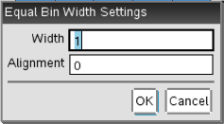  - Width is where you put your interval size. Alignment is where the graph will start on the x-axis  - Zoom: menu > 5 > 2  - Frequency or Percent: menu > 2 > 2 > 1
2.1 Graphing Bivariate Data: Grouped Bar Chart | - Create first Bar Chart  Menu > 2 > 9 > select second set of data
2.2 Graphing Bivariate Data: parallel boxplots | - Create first boxplot  - Menu > 2 > 5 > select second set of data
3.1 Bivariate Data Statistics: a, b, r, r² | - Ctrl n > 4, Enter data in ‘list and spreadsheets’(ensure you give both columns a title)  - Menu > 4 > 1 > 4 (Spreadsheets) OR ctrl i > 1 > Menu > 6 > 1 > 4 (Calculator)  - Select your EV in the ‘X-List’ and your RV in the ‘Y-List’  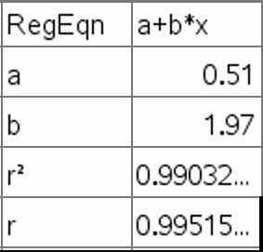  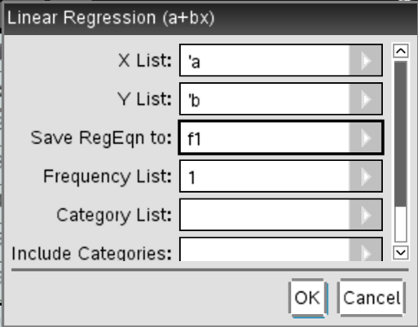
3.2 Scatterplots | - Ctrl n > 4, Enter data in ‘list and spreadsheets’ (ensure you give both columns a title)  - Ctrl doc OR ctrl i OR home menu > 5 to open a new page and select ‘data and statistics’  - Click to add the EV to the x-axis and the RV to the y-axis  Scatterplot Least Squares Regression Line:  - Menu 4 > 6 > 2 OR ctrl i > 1 > Menu > 6 > 1 > 4 (Calculator)  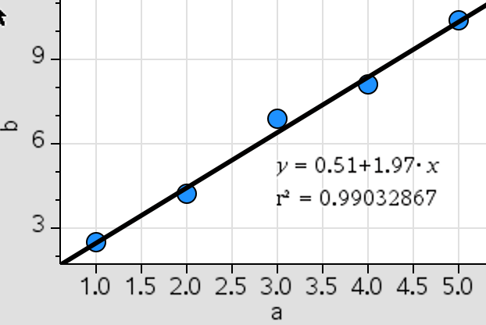
3.3 Prediction by LSRL | - Above 3.2 step1-3 to entre EV and RV.  - ctrl i > 1 > Menu > 6 > 1 > 4 (Calculator)  - var > stat.regeqn > x value ↵  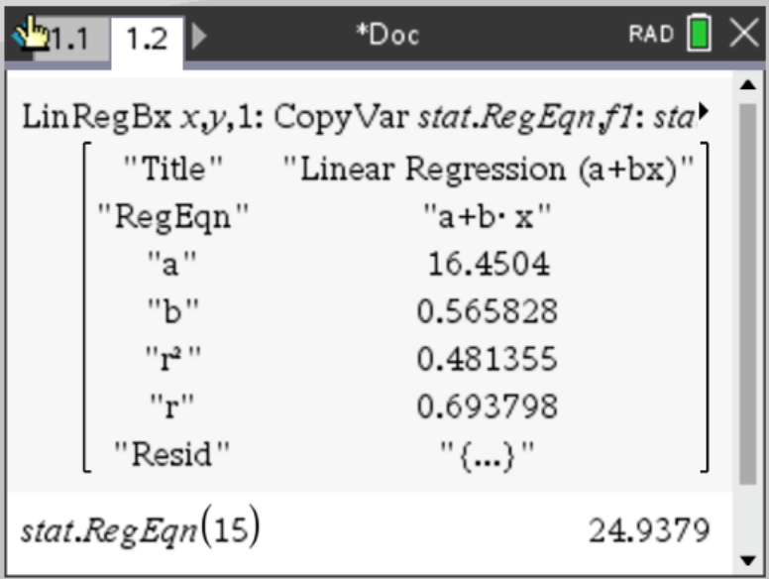
4.2 Solve | - Calculator Page  - Menu > 3 > 1  - You write inside the brackets, there must be an equals sign (=), you must choose a variable (x) and then use the same variable at the end and do ‘comma variable’ (,x)
4.3 Back to top of List | Ctrl > 7

