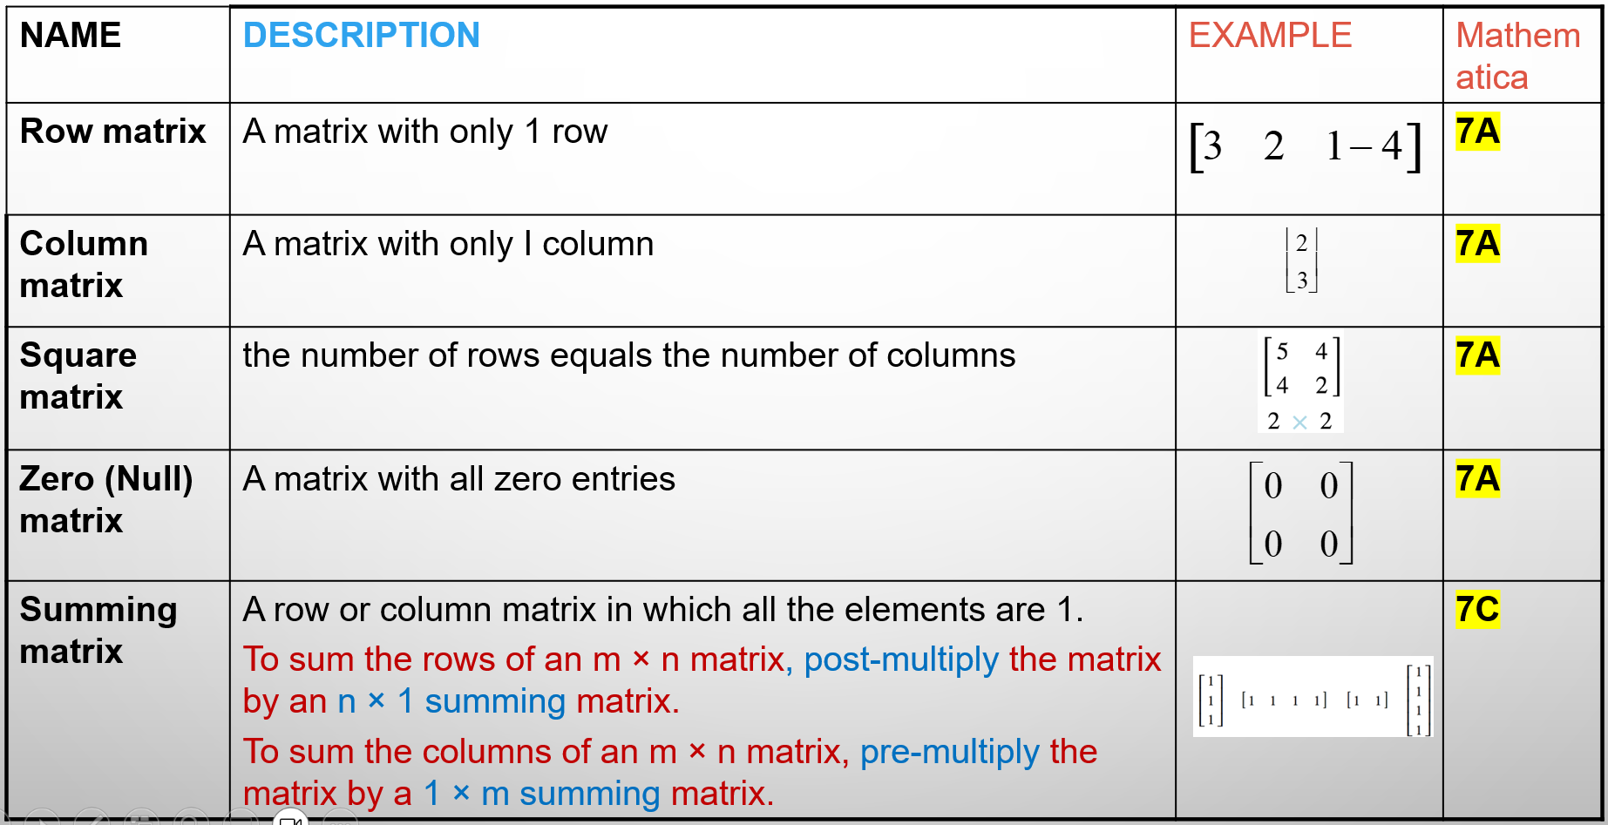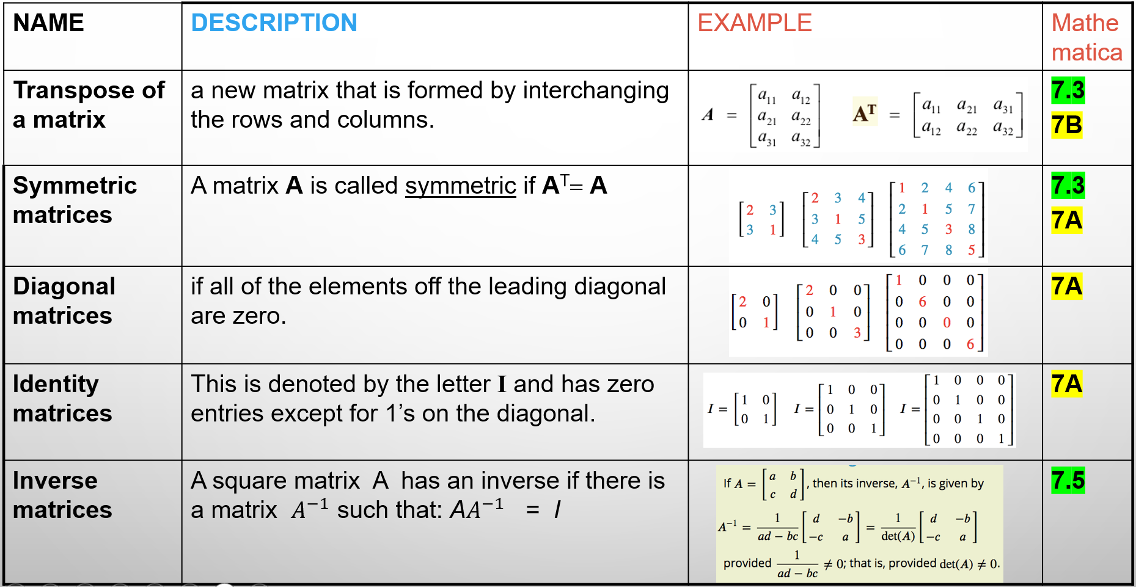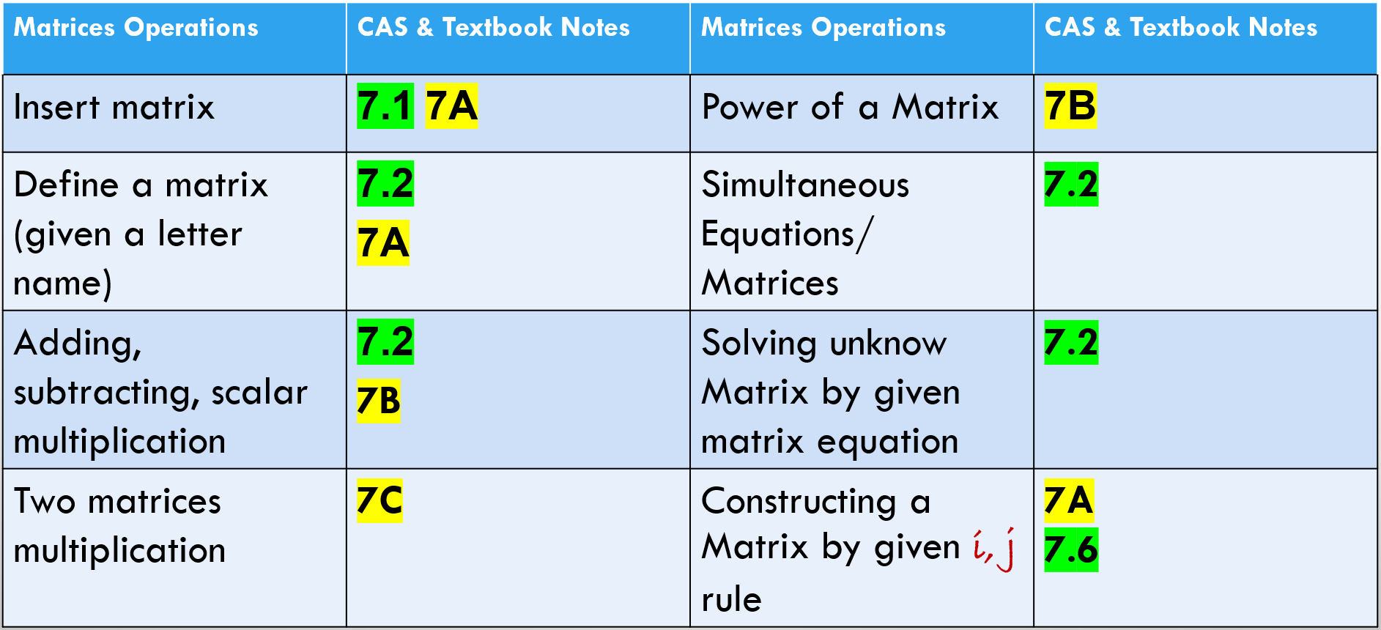
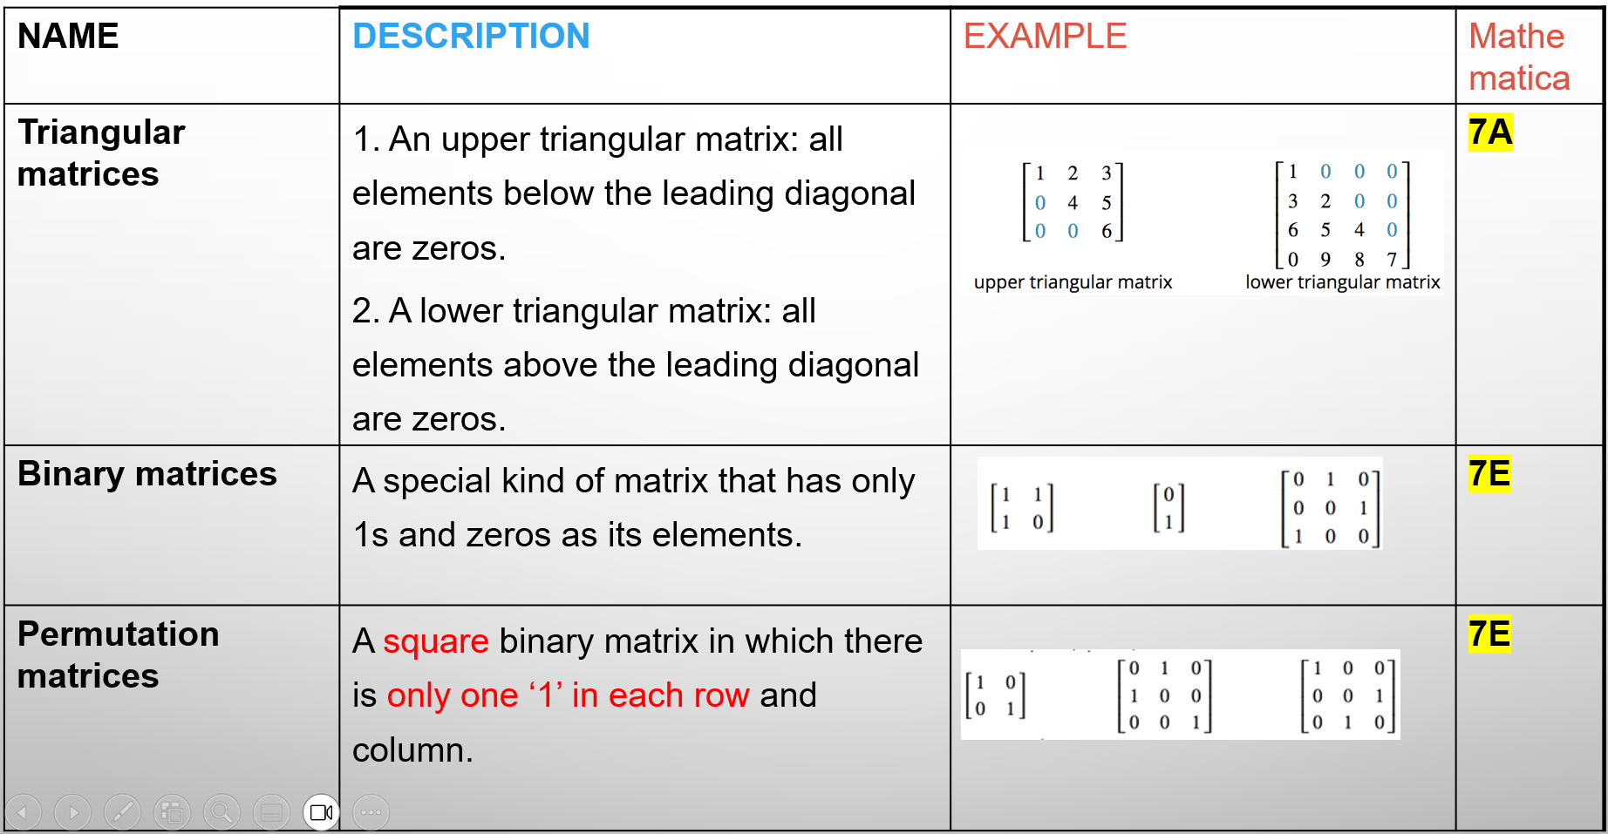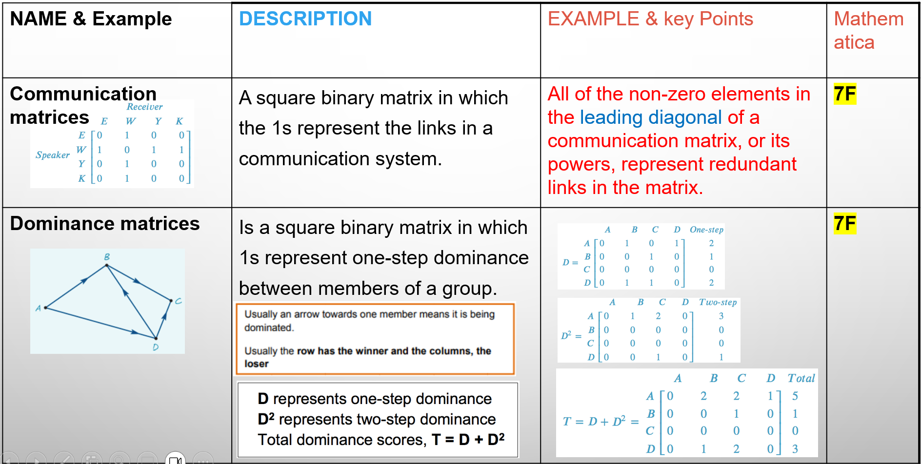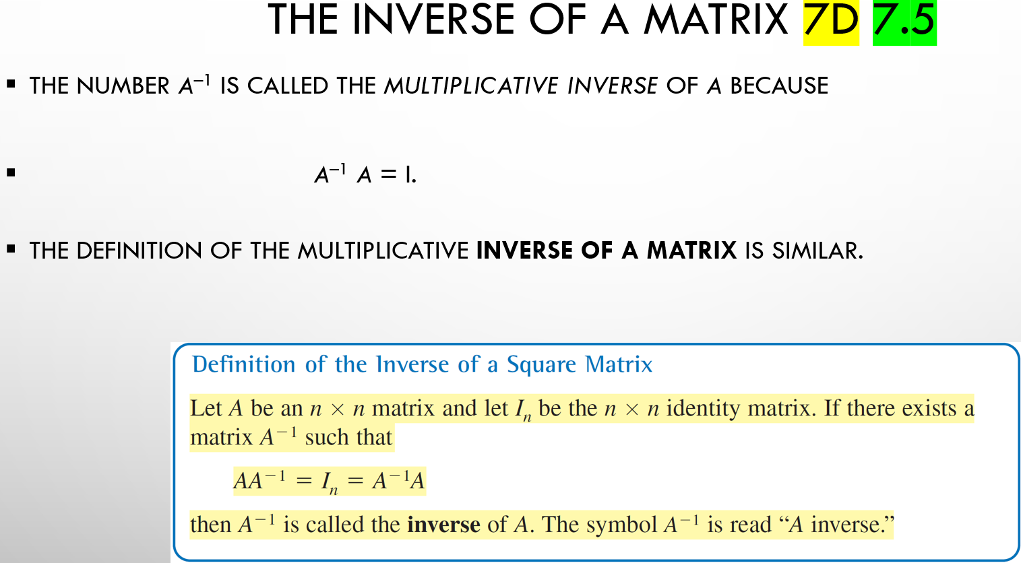
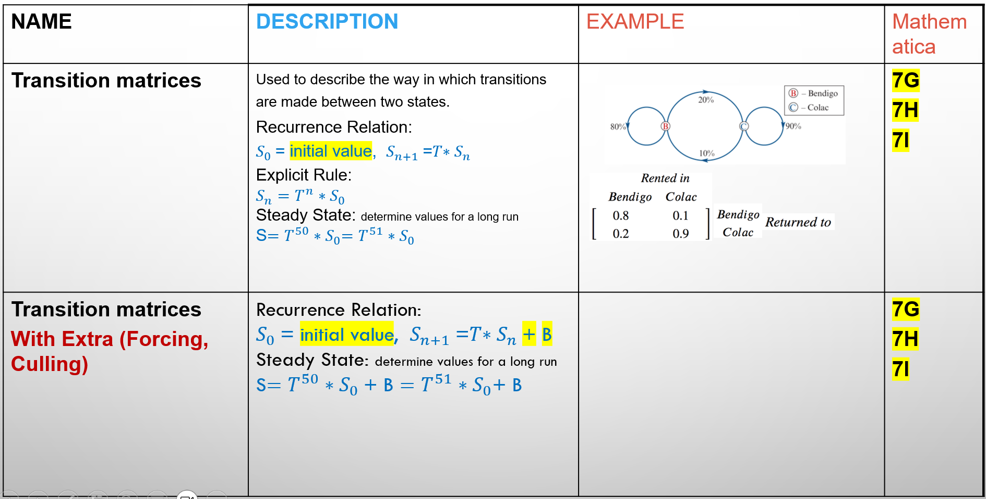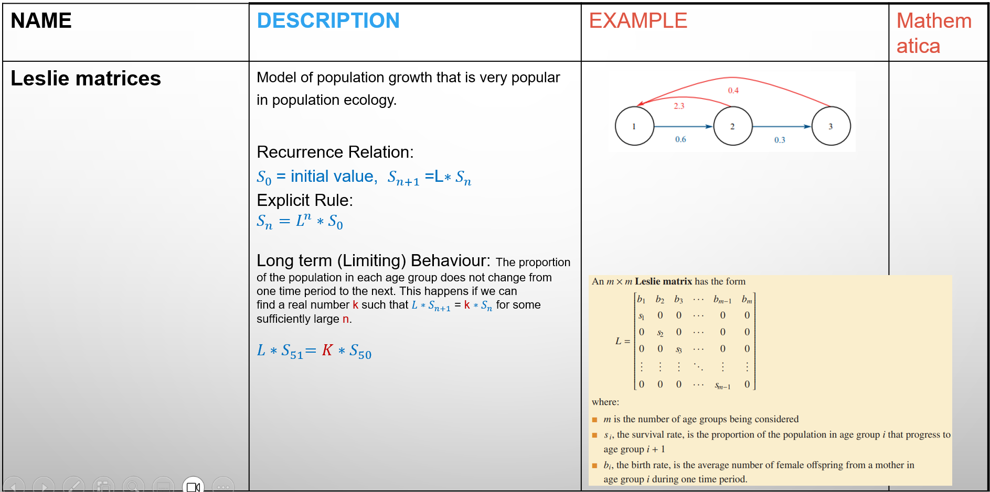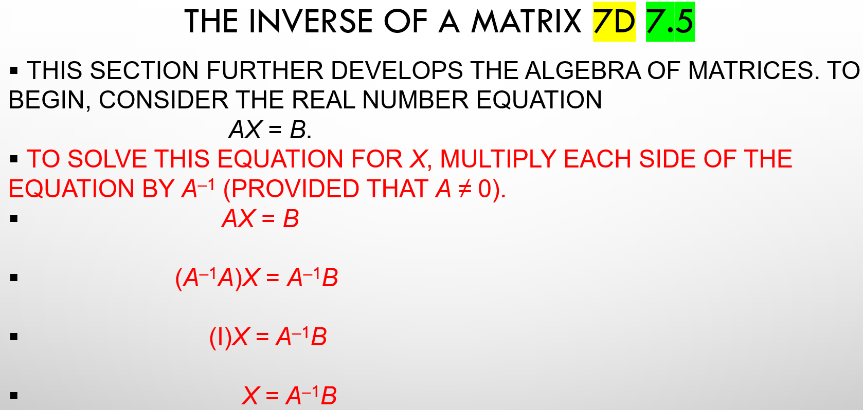

7A: introduction to matrices
A matrix is an array of numerical values
- Values are arranged into ROWS and COLUMNS
ROWS: are horizontal
- Number rows from top to bottom
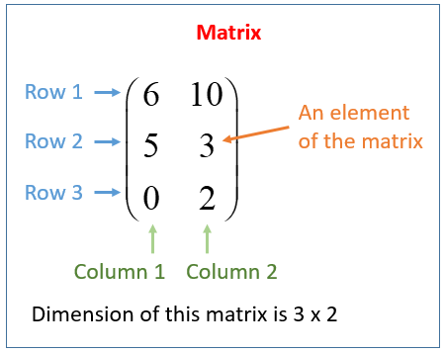
COLUMNS: are vertical
- Number columns from left to right
ORDER OF A MATRIX:
- Way to describe the dimensions (size) of a matrix
ORDER = ROWS × COLUMNS
- × is ‘by’

Types of Matrices:
Column: only one column, any number of rows | Row: only one row, any number of columns | Zero: every element is ‘0’. Can be any size
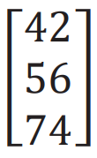 | 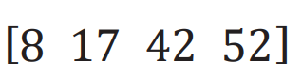 | 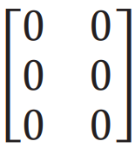

Square matrices: have the same number of rows and columns.
Diagonal matrix: all values apart from the leading diagonal are zero | 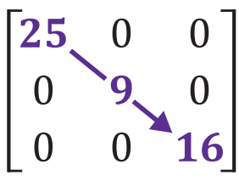
Identity matrix: diagonal matrix, where the leading diagonals elements are all ‘1’ | 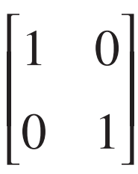
Symmetric matrix: unchanged by transposition, the elements above the leading diagonal are a mirror image of the elements below | 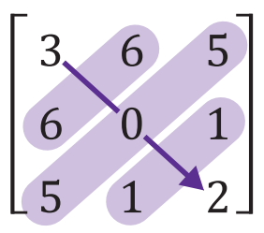
Upper triangular matrix: all elements below the leading diagonal are zero | 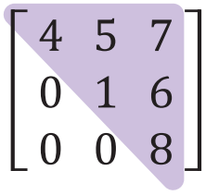
Lower triangular matrix: all elements above the leading diagonal are zero | 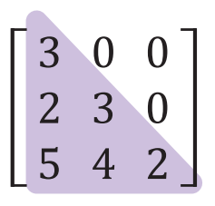

Elements and notation:
- Matrices are labelled with a capital letter
- The values within a matrix are called elements
- Elements are labelled with lowercase letters
- For matrix A, element a_{mn} refers to the entry in the m^{th} row and n^{th} column

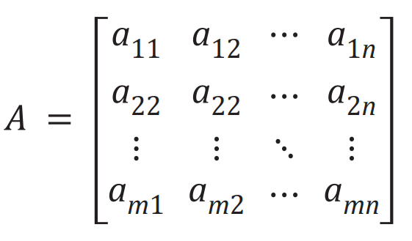 | 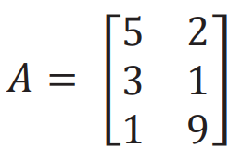  Eg. Element a₂₁ = 3

x^{ij} – matrices can be constructed using element rules.
Eg. Matrix C is a 2×2 matrix with the element rule
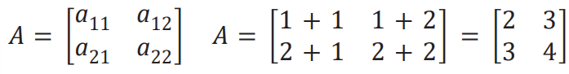
c_{ij} = i+j. Create the matrix.

7B Operations with matrices
ADDITION AND SUBTRACTION:
- Matrices must have the same order
- Add/subtract elements in the same position

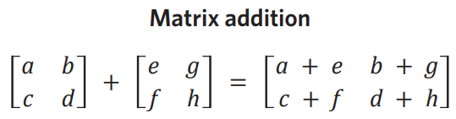
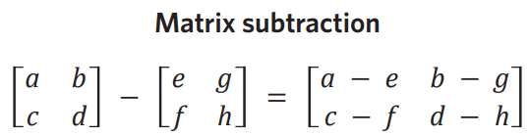

SCALAR MULTIPLICATION:
- Multiply each element in the matrix by a scalar
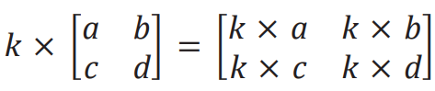

Transpose: swapping a matrices rows and columns. The transpose of matrix A is A^{T}. First row becomes first columns, etc.
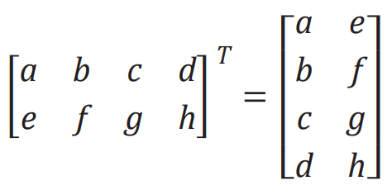
7C: Advanced operations with matrices
MATRIX MULTIPLICATION: Involves both multiplication and addition
- Post multiplication: AB, matrix A is ‘post multiplied’ by matrix B
- Pre multiplication: AB, matrix B is ‘pre multiplied’ by matrix A

You must check that matrices can be multiplied first:
- Multiplication criteria: the number of columns in the first matrix MUST EQUAL the number of rows in the second matrix.
  - ‘defined’ = can be multiplied
  - ‘undefined’ = cant be multiplied
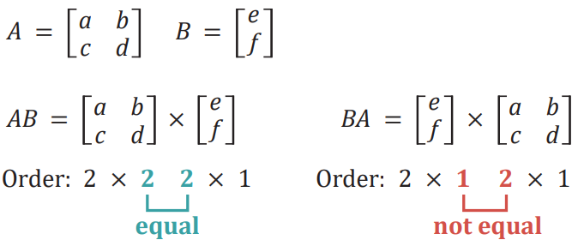
AB is defined, BA is not defined.

Matrix product: the resulting matrix when two or more matrices are multiplied. The size of this matrix is determined by the outside numbers when writing the matrices orders. AB will produce a 2×1
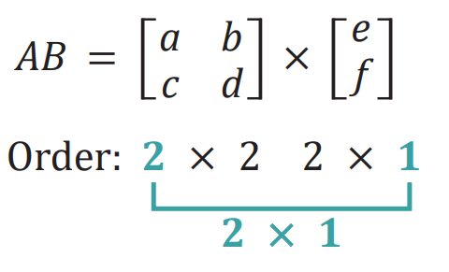
Multiplication by hand: multiply the rows of the first matrix by the columns of the second matrix.
Summing matrices: a row or column matrix where all elements are 1.
- To sum the rows of an m×n matrix, post multiply by an n×1 summing matrix
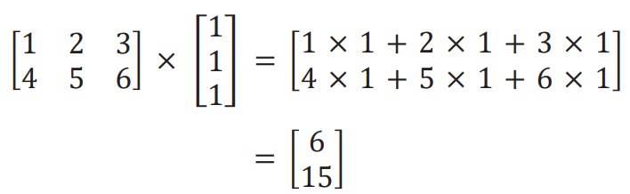
- To sum the columns of an m×n matrix, pre multiply by a 1×m summing matrix
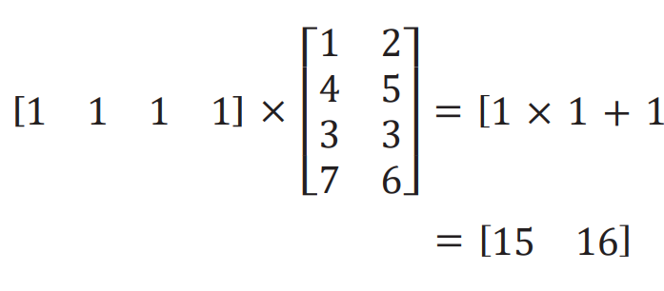
Raising matrices to a power: only SQUARE matrices can be raised to a power. The power indicates how many times the matrix is multiplied by itself.

7D: Inverse Matrices
The determinant:
- Used to identify if an inverse exists
- Must be a positive or negative number
- If the determinant equals ZERO, there is no inverse and the matrix is said to be ‘singular’
Calculating the determinant (2x2 by hand):
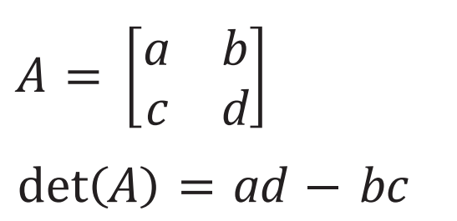
The inverse:
- Only square matrices have an inverse
- Inverse means opposite
- Something multiplied by its inverse is equal to 1, in this case, the IDENTITY MATRIX
- A⁻¹ = the inverse of matrix A
- A × A⁻¹ = I (identity matrix)
Calculating the inverse:
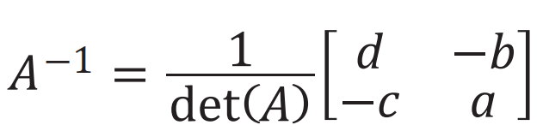
- b and c multiply by -1
- a and d swap positions
- Multiply by the scalar so that the answer is just the matrix
**if you are given the inverse of a matrix and need to find the original**
- Put the inverse to the power of -1
- (A⁻¹)⁻¹ = A

7E: Binary and Permutation Matrices
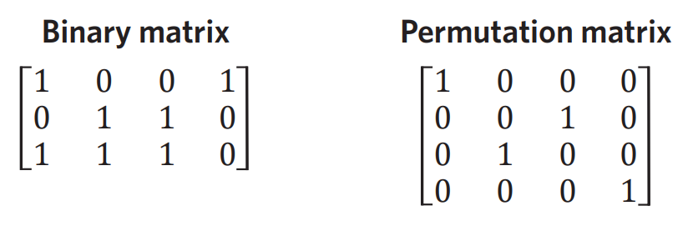
Binary: only has 1’s and 0’s as its elements (any size)
Permutation matrix: a type of binary matrix that has only one 1 in each row and column. It is always square and is used to rearrange elements.
- Column permutation: rearranges columns.
  - Post multiply (Q × P)
- Row permutation: rearranges rows.
  - Pre multiply (P× Q)

7F: Communication and Dominance Matrices
Communication: square binary matrix
- 1’s represent a direct line of communication
- Communication goes both ways
- C = one step (direct communication)
- C2 = two step (communication via someone else)
- C + C2 = TC (total communication, showing all one and two step links)
Dominance:
- Used to display hierarchy
- One-way connections
- 1’s are used for ‘winners’, 0’s for ‘losers’
- D = one step
- D2 = two step
- D + D2 = TD (total dominance)
- Directed, arrows point to loser
Determining dominance when given the sum of one step and two step dominance:
- One step dominance tells you how many times they won
- Two step dominance tells you the total sum of the one step dominances

7G: Introduction to transition matrices
State matrix S_{n}
- Column matrix
- Population at a given time
Initial state matrix
- Starting population
- S₀
Transition matrix
- Square matrix
- Studies change over time
- Elements are decimal numbers (0-1) that represent percentages
- Each column must sum to 1
- Other language: ‘now/next’, ‘today/tomorrow’, ‘from/to’
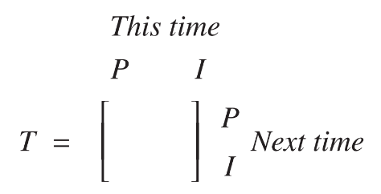

Calculating state matrices:
- Used to find the next state
- Use recursion (step by step)
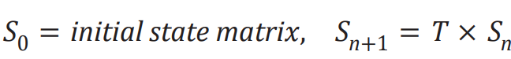
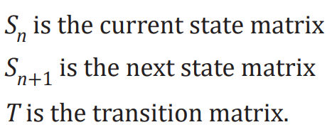

- Use the rule (find future values, n, faster)
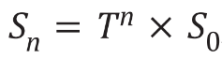

***Note: Finding a previous state: say you are given T and S₄, how could you find a previous state? For example, if you need to find S₃ take the inverse of T and multiply is by S₄.

7H: The Equilibrium matrix
- ‘Steady state’
- ‘In the long term’
- Over time the populations settle to where there is no visible change
- This is when two consecutive matrices are equal (2dp for accuracy)
- Consecutive means finding S₁₇ and S₁₈ to be the same

7I: Applications of transition matrices
Transition diagram: a visual representation of how a transition matrix functions.
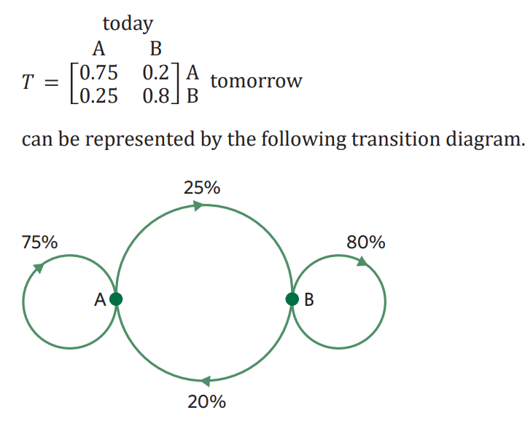
Culling and Restocking:
- Populations are subject to change over time
- Considers external forces affecting the population
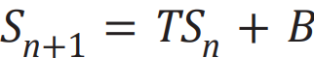

Culling: reduction/removed, negative number in matrix B
Restocking: addition, positive number in matrix B
Keeping a population constant: all future state matrices are equal to the initial. This can be determined by calculating S₀ – S₁

CAS reference sheet: Matrices
7.1 Enter a Matrix | - Ctrl N > 1 >  ↵  - OR Ctrl N > 1 > Ctrl > Menu > 8 ↵  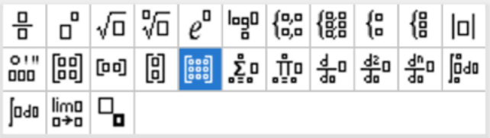  - Select No. of rows & columns ↵  - Type each element, using [tab] to move.
7.2 Define a Matrix | - Name of the matrix > ctrl > > enter full matrix ↵  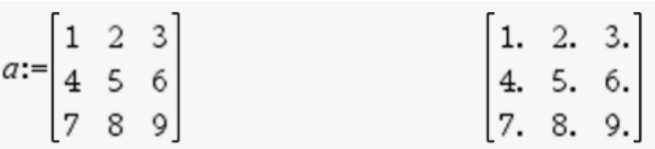  - OR Enter full matrix > 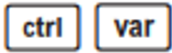 > name of the matrix↵  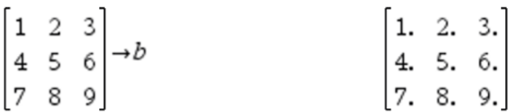
7.3 Transpose Matrix | - Name of the matrix > Menu > 7> 2↵  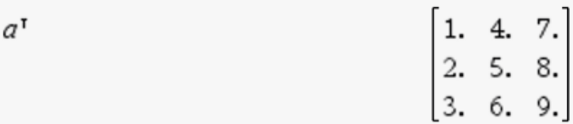
7.4 Determinant | 1. Menu > 7 > 3> name of the matrix↵
7.5 Inverse | - Name of the matrix > Ʌ > Negation key (-) > 1 ↵  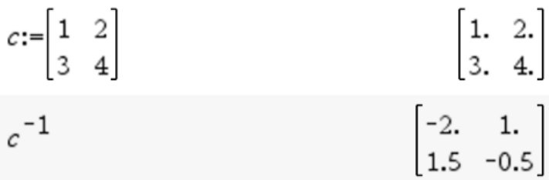  - Decimal → fraction  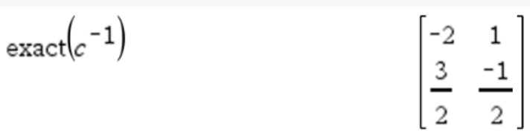
7.6 Forming matrix by i, j rule | 1. Menu > 7 > 1 >A > ij rule, i, j, row size, column size ↵  