Networks
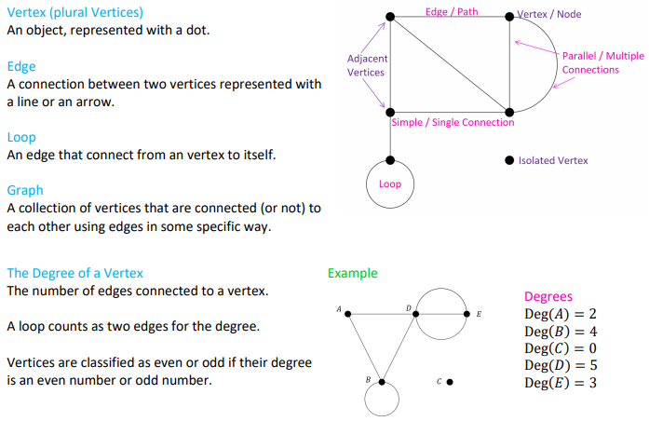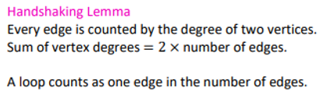
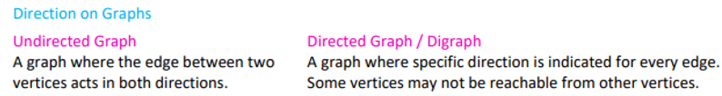
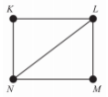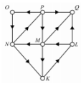
Undirected Graphs
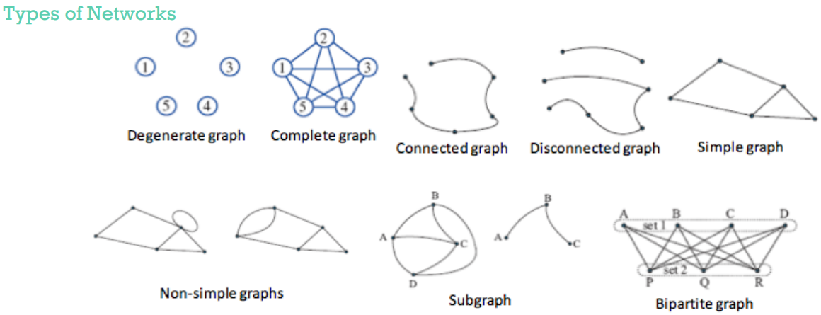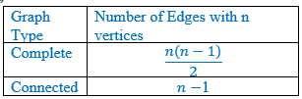

Adjacency Matrix Representation
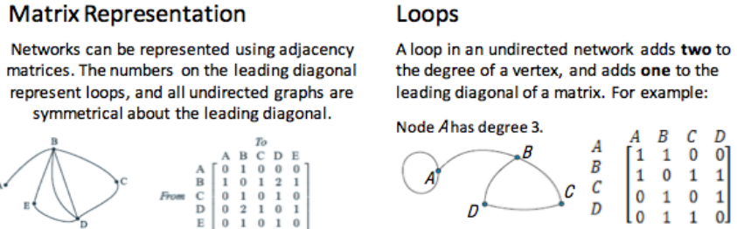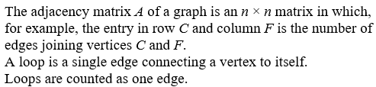

Planar Graphs & Euler’s Formula
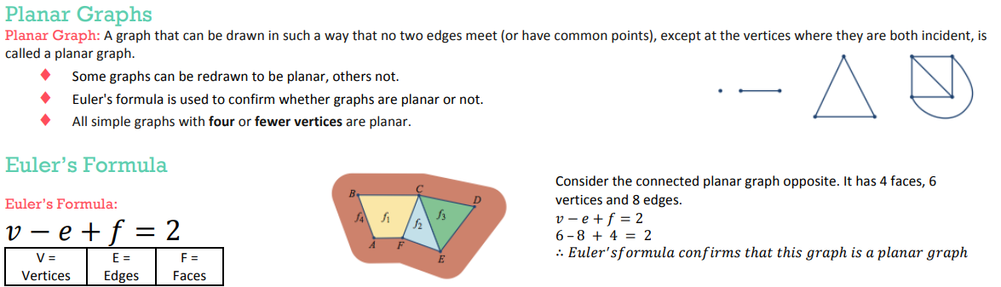
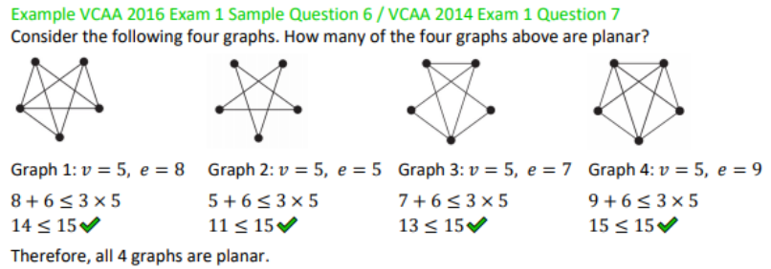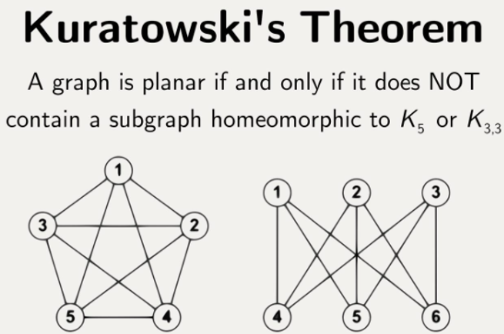

Euler & Hamilton
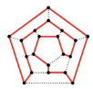
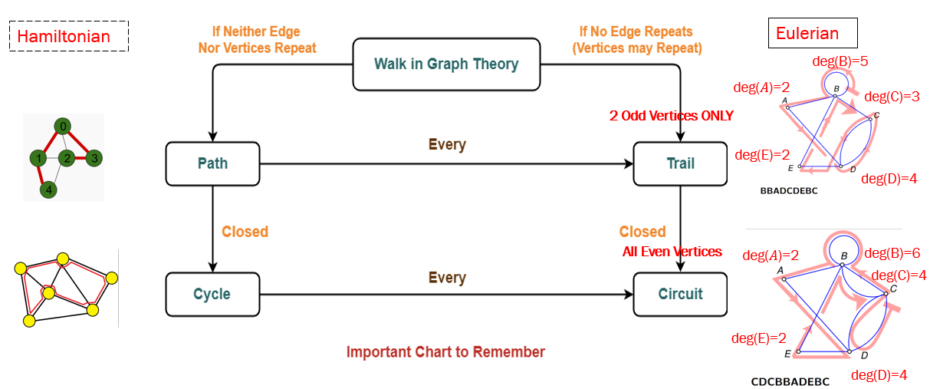

Weighted Graphs
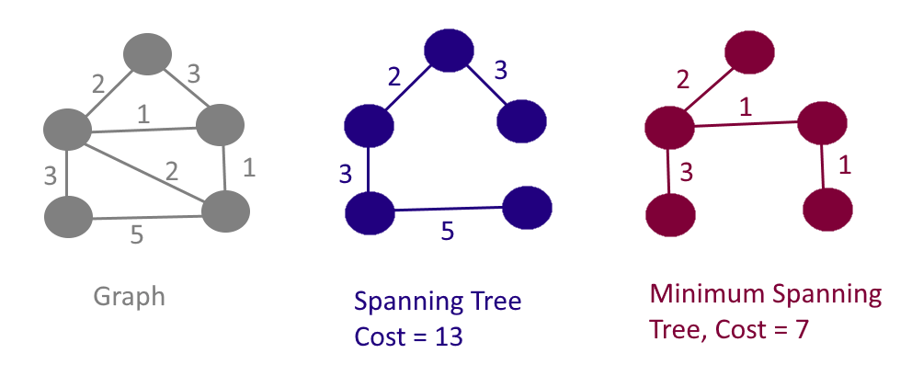


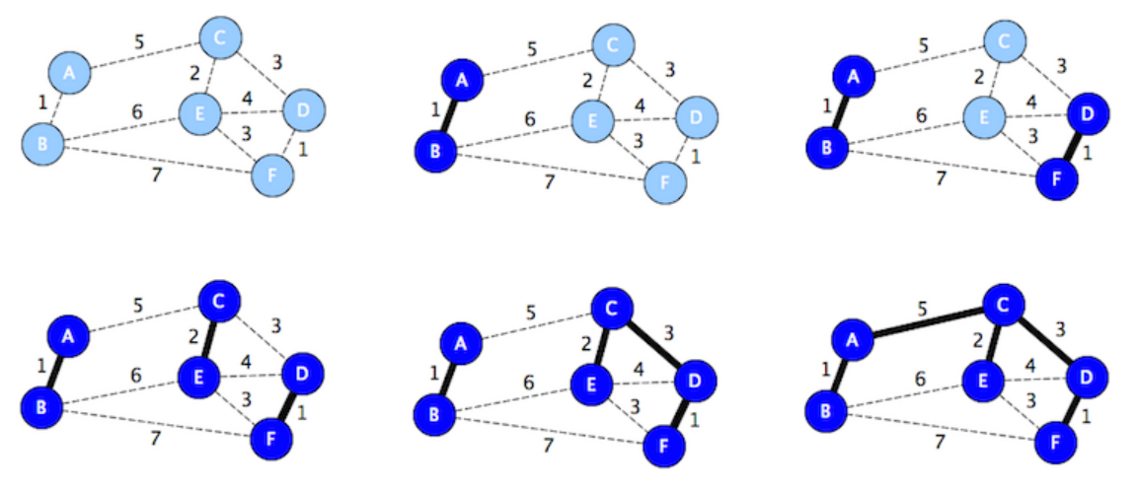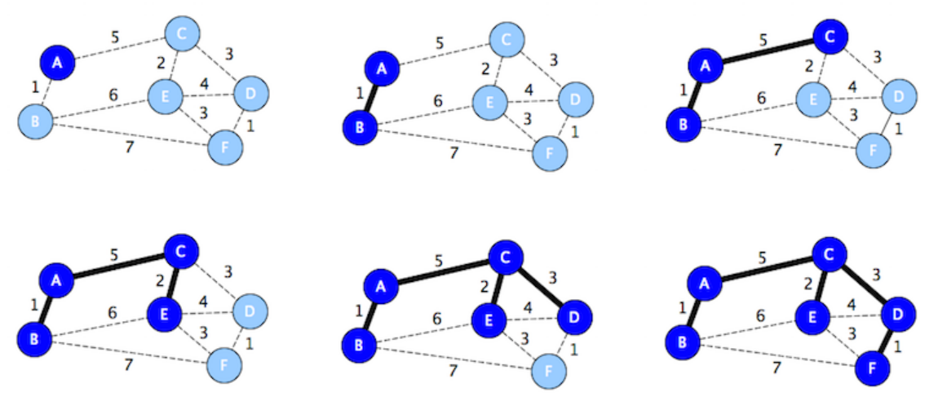

Different Types of Greedy Algorithm
Prim's Minimal Spanning Tree Algorithm
Kruskal’s Minimal Spanning Tree algorithm
Dijkstra's Shortest Path Algorithm
Ford-Fulkerson Networks Flows Algorithm
Hungarian Algorithm

Mathematical Terminologies
Undirected Graphs |  | Directed Graphs
Terminologies | Algorithm | Terminologies | Algorithm
Eulerian trails | Exactly 2 vertices of an odd degree | The Maximum Flow | Ford-Fulkerson Algorithm
Eulerian circuits | All vertices even degree | The Shortest Path | Dijkstra's Algorithm
Hamiltonian paths | Visits all of the vertices in a graph only once | Matching & Allocation Problems | Hungarian Algorithm 8.1
Hamiltonian cycles | Visit All vertices, begin & end @ the same vertex | Critical Path Problems | Forward scanning = Biggest Number  Backward scanning = Smallest Number  Float = LST―EST
Minimal Spanning Tree | Prim's Algorithm, Kruskal’s Algorithm | Critical Path Problems

8A: Introduction to graphs and networks
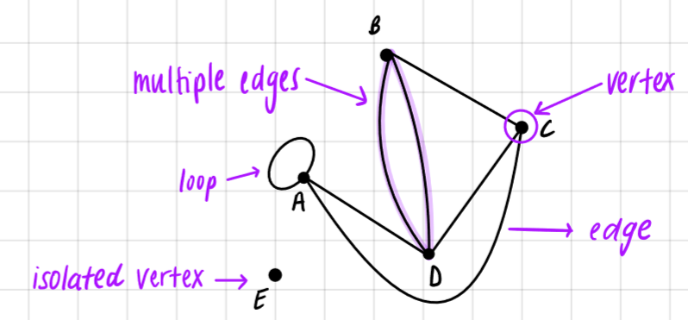
- Graph: a diagram used to show connections between groups of things, people of activities.
- Vertex: the dots
- Edge: line that connects two vertices
- Isolated vertex: a vertex that is not connected to an edge
- Multiple edges: connects the same vertex using more than one edge
- Loop: attach twice to a vertex
- Degree of a vertex: the number of edges that attach to a vertex. The degree of vertex D is 4.

Types of graphs:
Simple graph: no loops or multiple edges
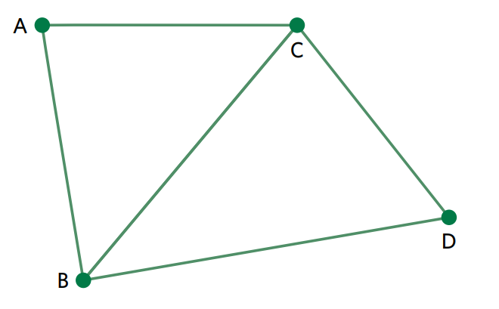
Degenerate graph: all vertices are isolated, there are no edges
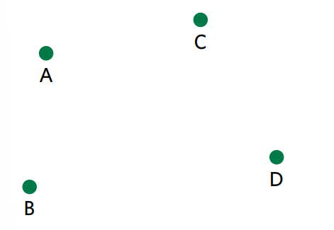
Connected graph: every vertex is connected to every other vertex, either directly or indirectly
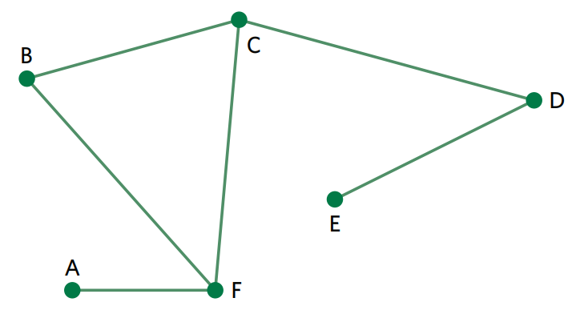
Bridge: an edge in a connected graph, that if removed will cause the graph to be disconnected. Edge C to E is a bridge
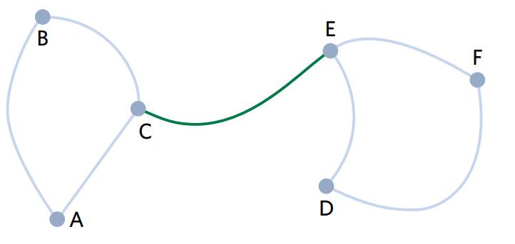
Complete graph: every vertex is connected to every other vertex
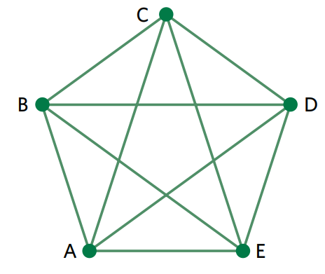
Subgraph: a tree, a part of a larger graph

Equivalent/isomorphic graph: graphs that contain the EXACT same information, vertices and the connections between them, they are just drawn differently
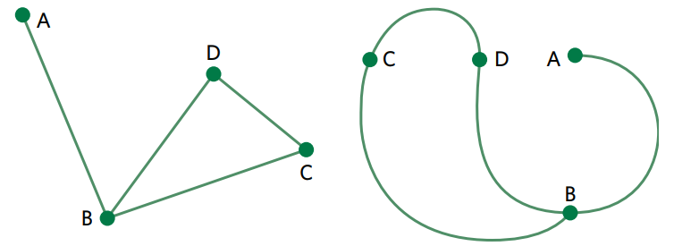
Planar graph: a graph that can be re-drawn without any overlapping edges. If it cannot be re-drawn and has overlapping edges, the graph is non-planar.
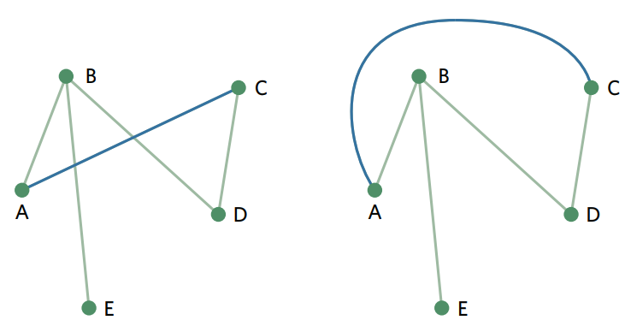
Faces: faces are found in planar graphs and are the sections enclosed by edges. There is an infinite face outside of the graph. There is an infinite face outside of the graph.
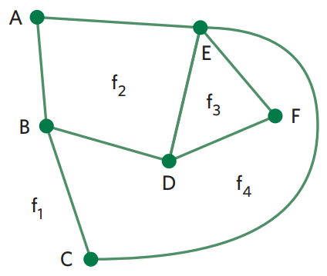
Euler’s rule: there is a relationship between the number of vertices (v), edges (e) and faces (f) in a connected planar graph.
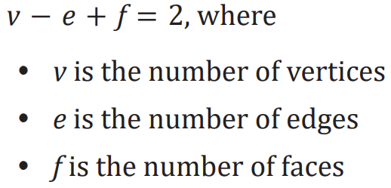

8B: Graphs, networks and matrices
Adjacency matrix: a matrix that records the number of connections between vertices. The number of vertices on the graph tells you how many rows and columns you need. A ‘0’ mean no direct connection, a ‘1’ means one connecting edge etc. Ensure you label the matrix with the vertex letters.
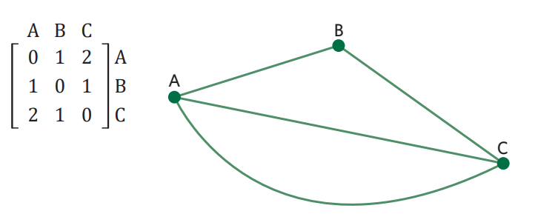
Representing directed graphs: this is a network containing arrows on each edge, signalling one direction. These matrices need to be labelled with ‘from’ and ‘to’.

8C: Travelling
Identifying types of walks: A route is a list of the vertices travelled through, in order, when moving from one vertex to another.
Walk: a continuous sequence of edges that pass through any number of vertices, in any order, starting and finishing at any vertex.
Trail: a walk with no repeated edges. The same vertex can be visited multiple times.
Path: a walk with no repeated edges or vertices.
Circuit: a trail beginning and ending at the same vertex.
Cycle: a path beginning and ending at the same vertex.

Eulerian trails: a walk that includes every edge in a graph exactly once. It must:
- Exactly two vertices of odd degree, the rest are even
- Start and finish at a vertices of odd degree
Eulerian circuit: an Eulerian trail that starts and ends at the same vertex. It must:
- Have all vertices of even degree

Hamiltonian paths: a walk that includes every vertex exactly once, with no repeated edges. Every edge does not need to be included.
Hamiltonian cycle: a Hamiltonian path that starts and ends at the same vertex.

8D: Minium connector problems
Weighted graph: numerical information attached to each edge of a graph. ‘Weights’ often represent time or distance.

Tree: type of connected graph that has no loops, duplicate edges or cycles. It uses the least number of edges to connect the vertices.
- The number of edges in a tree is always one less than the number of vertices
- e = v – 1
- A tree can be a subgraph and so not all vertices in the larger graph need to be included.

Spanning tree: a tree which connects ALL vertices in the original graph.
- There are often multiple spanning trees for the one graph

Minimum spanning tree: a spanning tree with the LOWEST TOTAL WEIGHT.
- Prim’s algorithm can be used to find the minimum spanning tree.

