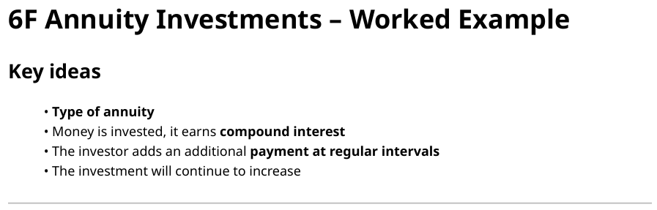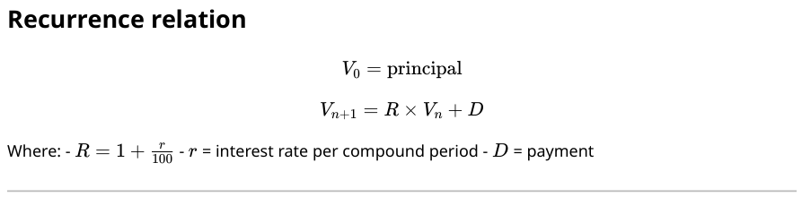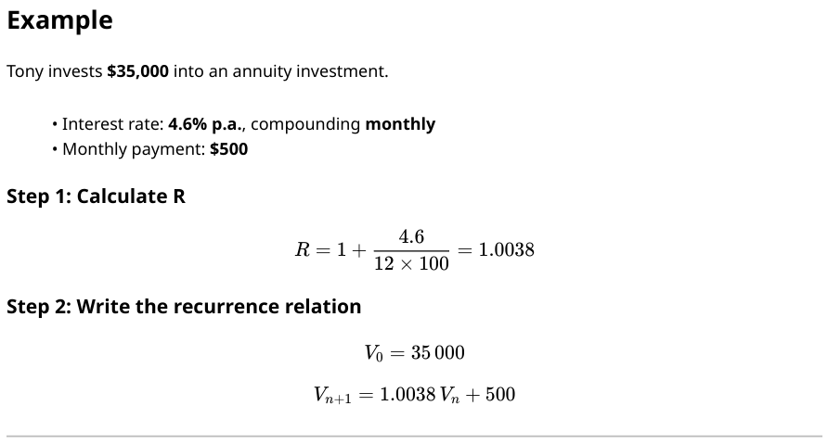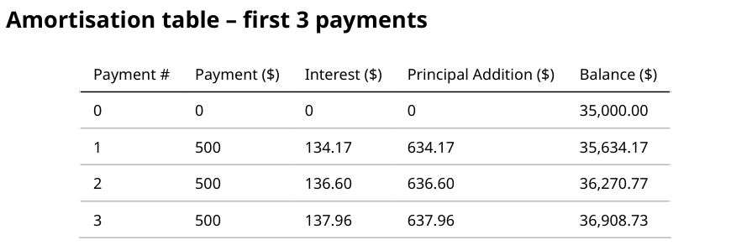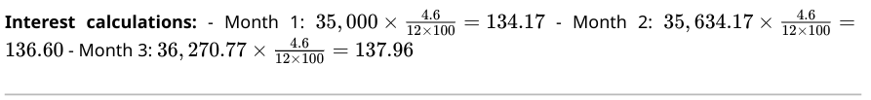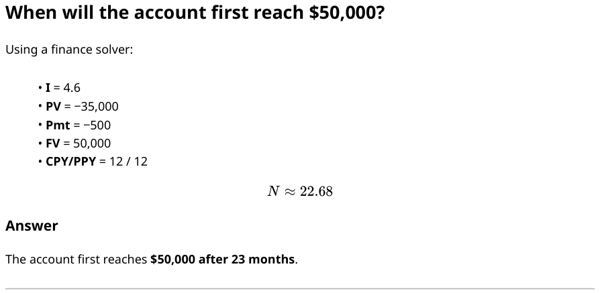
Annuity Investment formulas (deposit + growth)
1. Interest earned=Monthly rate × Previous balance $\text{\$ }\text{Interest}=r_{m}×V_{n}$
Example monthly rate: $4.6\%÷12=0.383\%=0.00383$
$$\text{Interest}=0.00383×V_{n}$$
2. Principal addition = Payment + Interest
Example: $\text{Principal addition}=500+\text{Interest}$
3. New balance =Previous balance + Principal addition
$$V_{n+1}=V_{n}+\text{Principal addition}$$

Side-by-side Amortisation Formulas
Reduced balance Loans | Annuity Investments
Interest =$r_{m}$ × Vₙ | Interest = $r_{m}$× Vₙ
Principal reduction = Payment − Interest | Principal addition = Payment + Interest
Vₙ₊₁ = Vₙ − reduction | Vₙ₊₁ = Vₙ + addition

