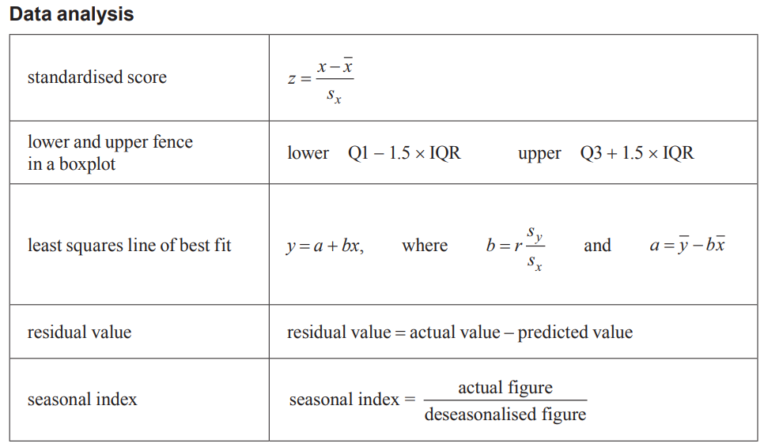
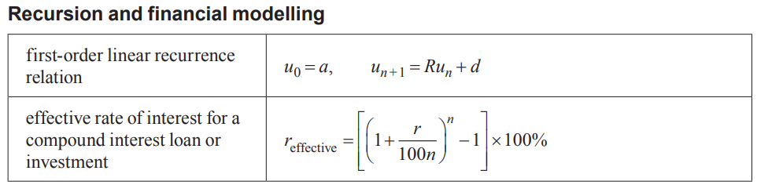
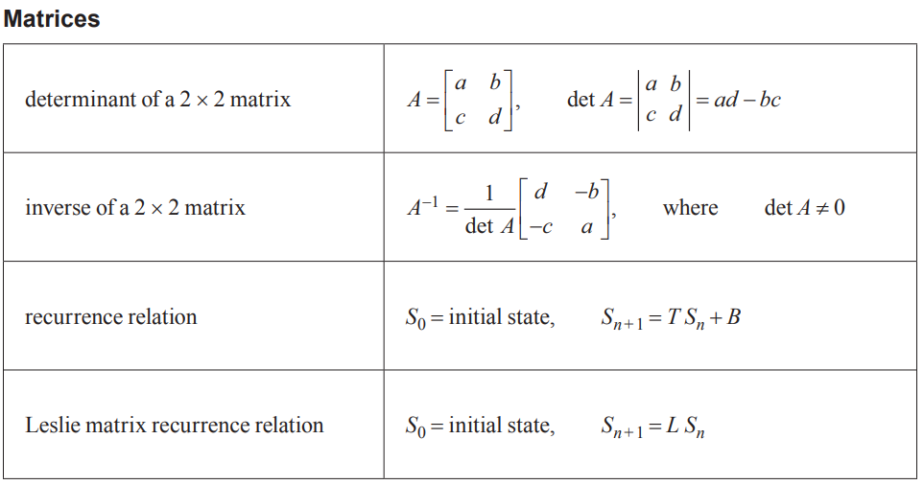
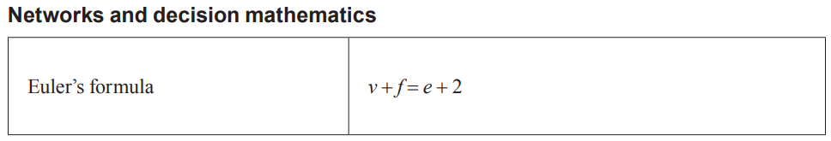
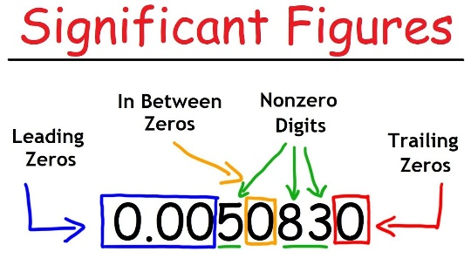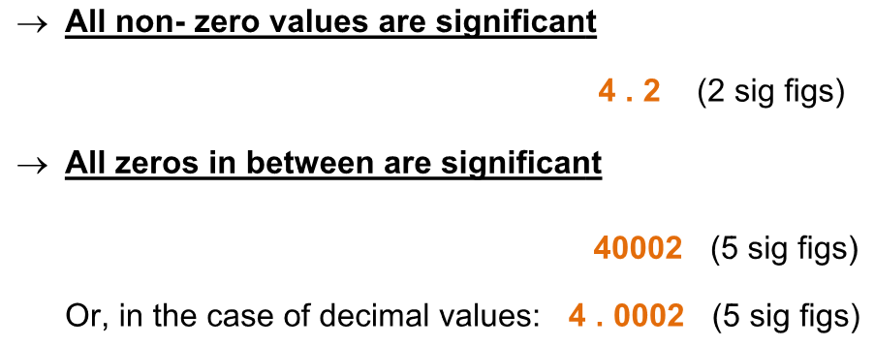

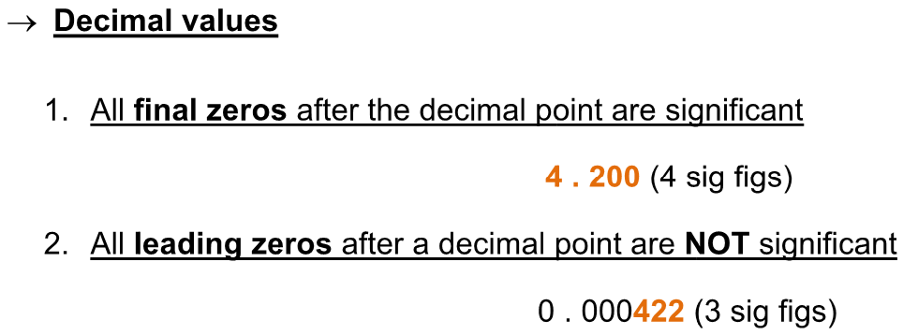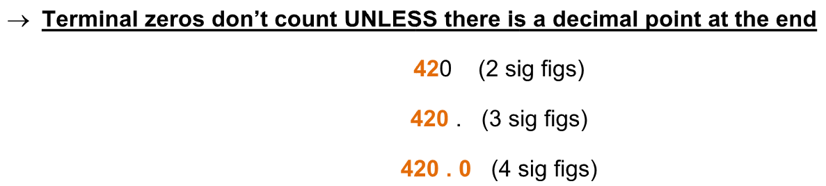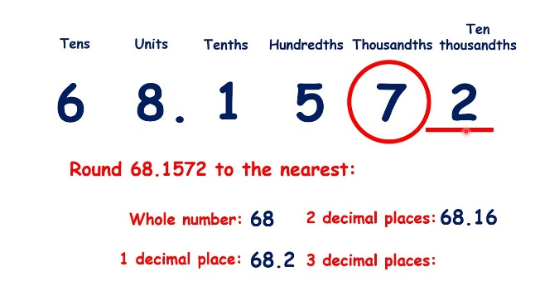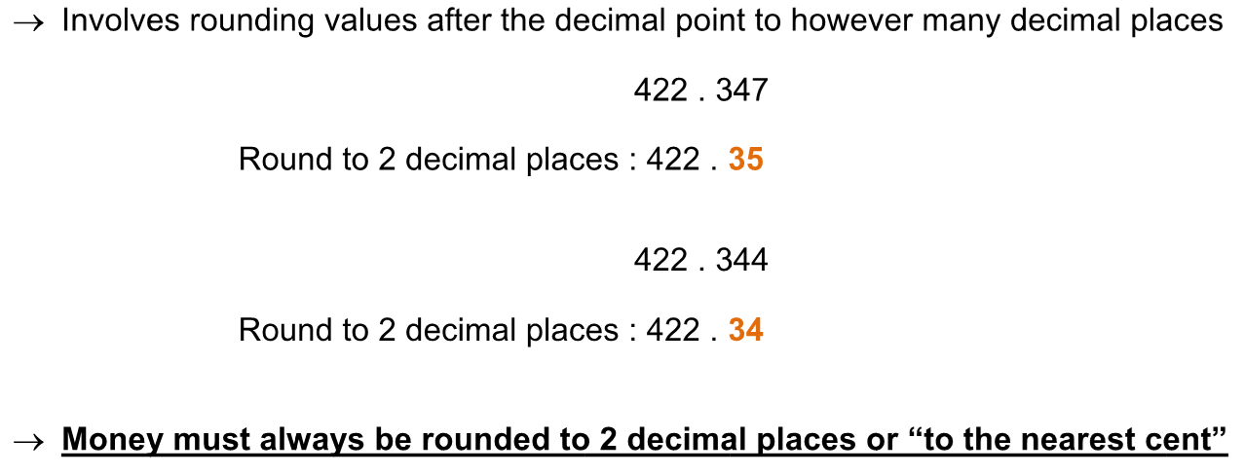

1
Topics | Data Types 1A |  | Display/Analyse Tools |  | Report/Explain/Interpret/Describe
Univariate Data | Categorical variables1B | Nominal data | Bar chart, Pie Chart, Frequency Table1a, Segmented bar chart |  | Mode/ Modal Value  Frequency types, Frequency % = $\frac{Count}{Total Count}×100\%$
Univariate Data | Categorical variables1B | Ordinal data
Univariate Data | Numerical variables1C | Discrete data | Boxplots 1c 1.2, Grouped Frequency Tables | Stem plot 1b, dot plot 1b 1.2 | Shape  Centre  Spread  Outliers  1F | Symmetric 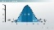  Mean $\overline{x}$ 1.1  Standard Deviation S 1G 1.1  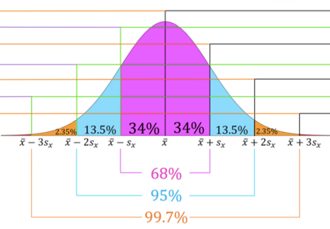  68-95-99.7% rule 1H  1I Z-score=Z=$\frac{x-\overline{x}}{S}$  1I $x$ = $\overline{x}+Z*S$ | Skewed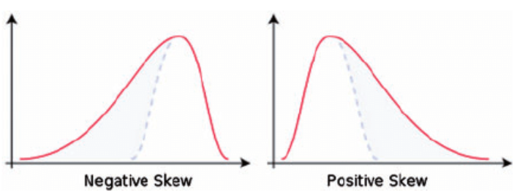  1.1 Median M ${ or Q}_{2}$  IQR, Range  $\left\{\begin{aligned} Lower Fence=Q_{1}-1.5*IQR \\ Upper Fence=Q_{3}+1.5*IQR\end{aligned}\right.$  1.1 5-figure summary: Min, $Q_{1}, Q_{2,}, Q_{3},$Max  IQR=$Q_{3}-Q_{1}$, Range=Max$-$Min
Univariate Data | Numerical variables1C | Continuous data | Boxplots 1c 1.2, Grouped Frequency Tables | Stem plot 1b, histogram 1b 1.1, log 1.2 log-histogram1.2 | Shape  Centre  Spread  Outliers  1F
Bivariate Data | Two categorical variables2A |  | Segmented bar chart, two-way frequency table2a, parallel bar chart 2.1 |  | Mode/ Modal Value  Frequency types
Bivariate Data | One categorical, one numerical variable 2B |  | Back-to-back stem plots, parallel dot plots, parallel box plots 2b 2.2 |  | Shape  Centre  Spread | Symmetric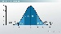  1.1 Mean $\overline{x}$  Standard Deviation S | Skewed  1.1 Median M ${ or Q}_{2}$  IQR, Range
Bivariate Data | Two numerical variables 2C  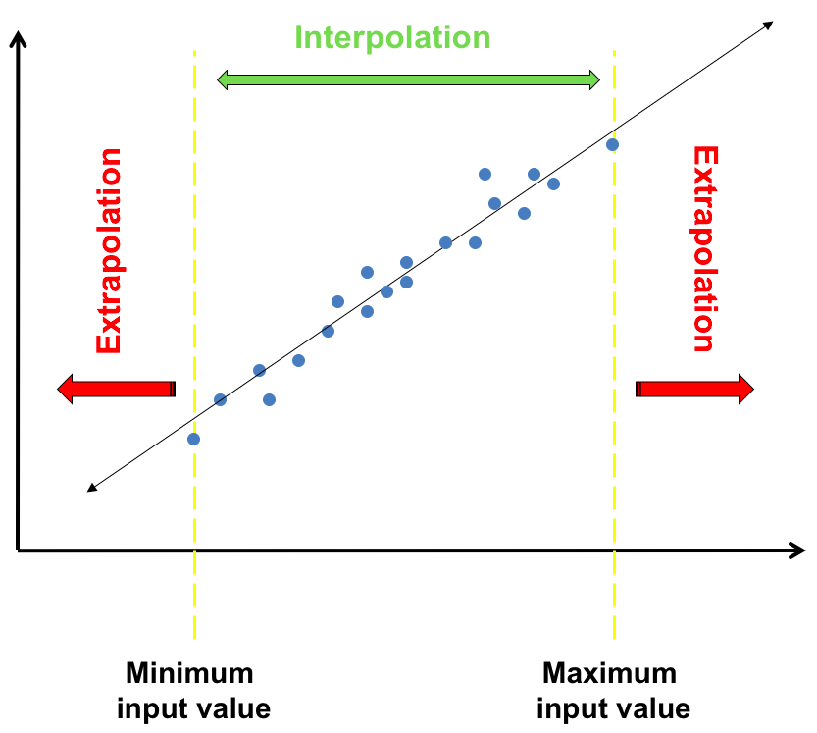 Interpolation  Extrapolation  The assumptions for fitting a least squares line  1. the data is numerical  2. the association is linear  3. there are no clear outliers. |  | Scatterplot 2c 3.2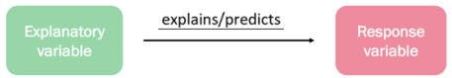  residual = actual data value y – predicted 3.3 value y  residual = y - ŷ  Nil pattern residual 3.2 plot 2f = Linear relation  Curved/ patterned residual plot$≠$linear relation |  | Strength  Direction  Form  3A 3B 3C 2e LSRL y=a+bx 3.1  2e slope 𝑏=$\frac{{rs}_{y}}{s_{x}}$  2e y-intercept  𝑎 = $\overline{y}$−𝑏$\overline{x}$ | Strong/Moderate/Weak (Check r value) 2D 3.1  Positive / Negative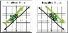  Linear / Non-linear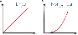  Reporting 2d on Coefficient of Determination r² 3.1  Almost [ r² in %] of [RV 𝑦] can be explained / predicted by [EV 𝑥].
Time Series 4A 4E: LSRL | Features4A | Moving smoothing 4.1 |  |  |  | Seasonal Index S.I. 4D | Deseasonalising 4D
Time Series 4A 4E: LSRL | Trend 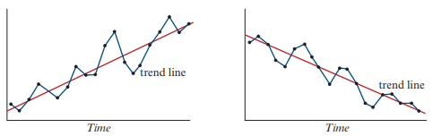  Cycles 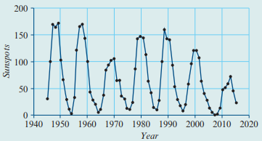  Seasonality  Structure change  Outliers 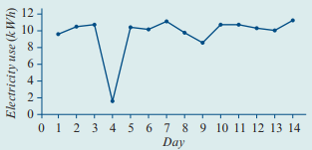 | Moving Mean 4B 4.1 |  | Moving Median 4C |  | S.I.=$\frac{Value for Season}{Yearly Average}$  Yearly Average=$\frac{Sum of Season Values}{No. of season per year}$  Correct S.I. = ($\frac{1}{S.I.}-1)×100$  + means ↑, $-$ means ↓ | Deseasonalised Figure = $\frac{Actual Figure}{S.I.}$ = $Actual Figure*\frac{1}{S.I.}$  Actual figure= Deseasonalised Figure * S.I.
Time Series 4A 4E: LSRL |  | 3/5 moving mean | 2/4 Moving mean | 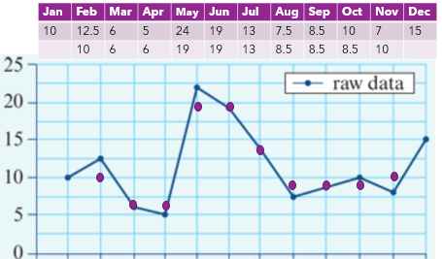
Time Series 4A 4E: LSRL |  | 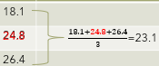 | 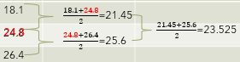
Note: Textbook Summary Notes Section #, Report Instruction Notes #. CAS Instruction Notes #
3D: Data Transformation & 3E 3.4
• Best transformation: strongest r/$r^{2}$ value
Types of transformations:
• Log: compresses the data
• Square: stretches the data
• Reciprocal: compresses values greater than 1, stretches values less than 1.
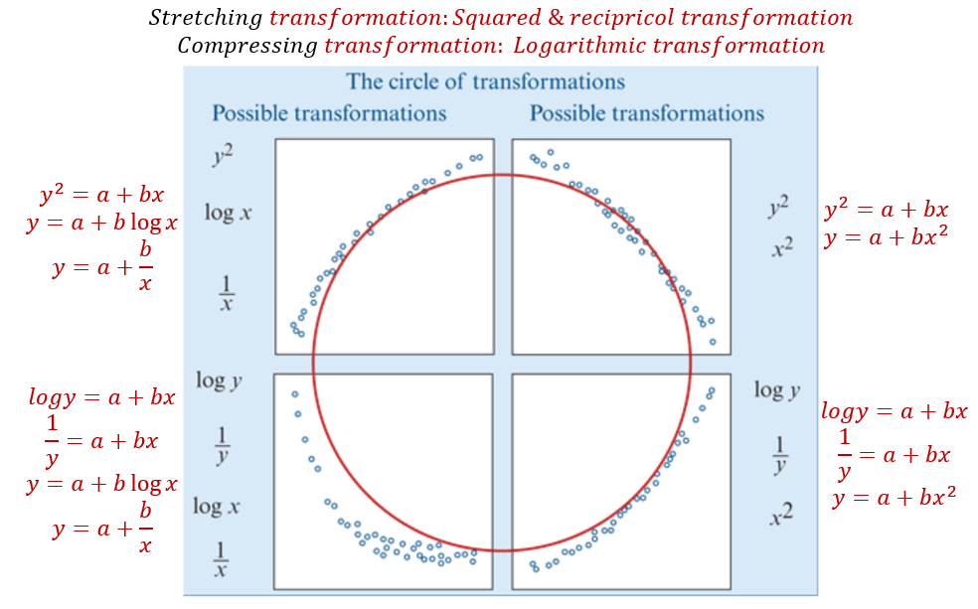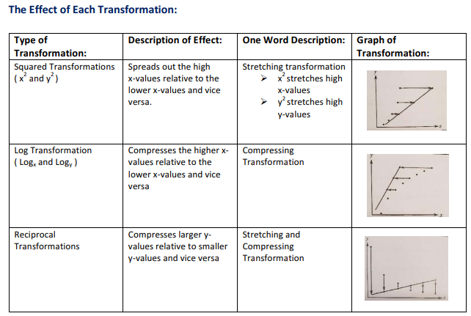 1D Log Scales & Graphs
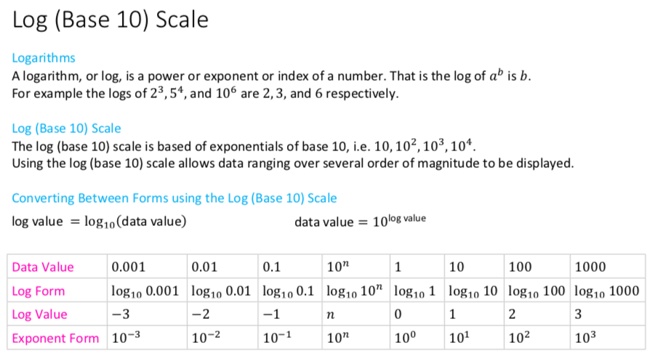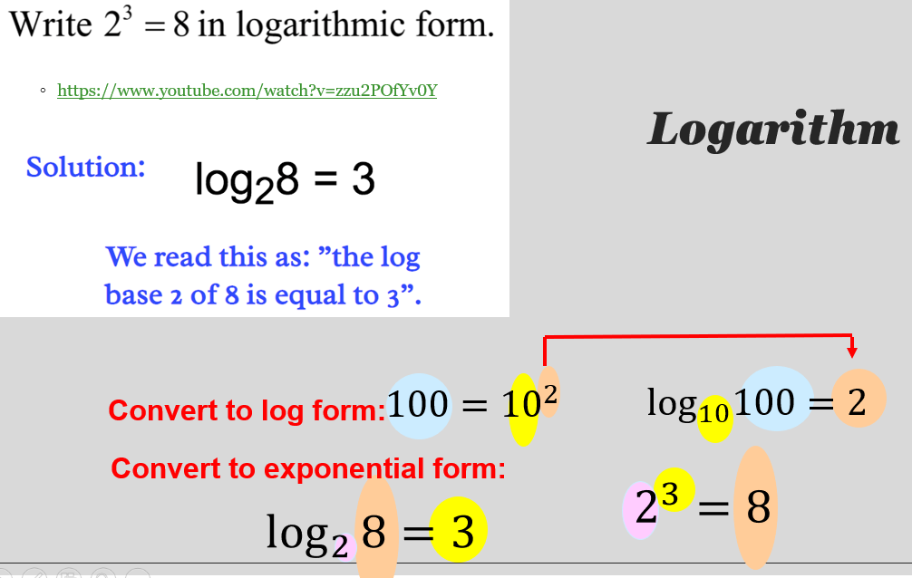
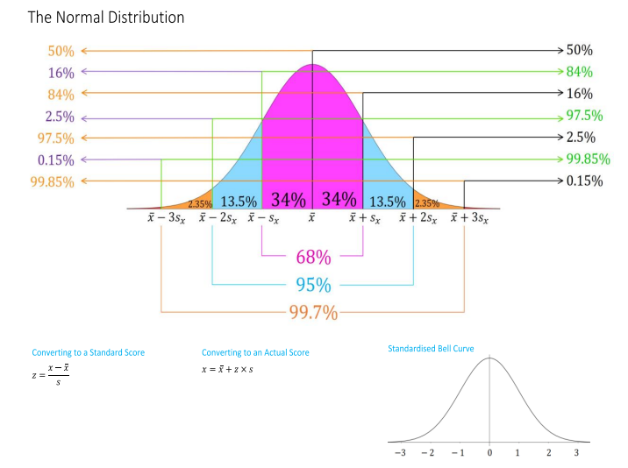
1H
1E: The Box Plot 1.2 2D: Correlation 3.1& Causation
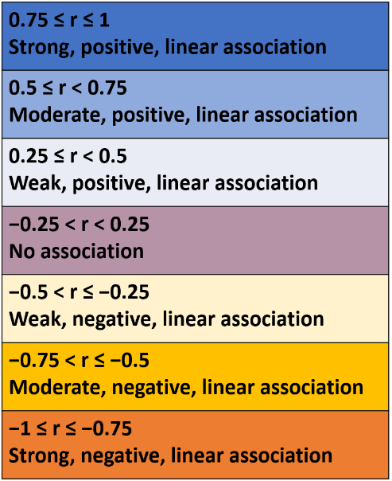
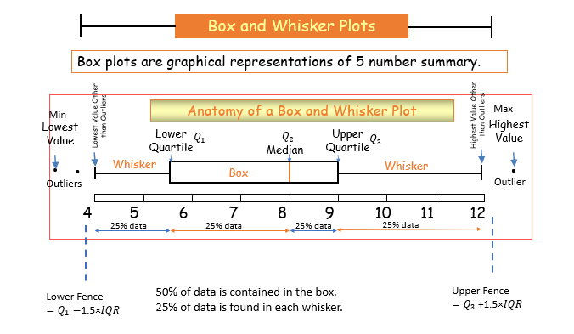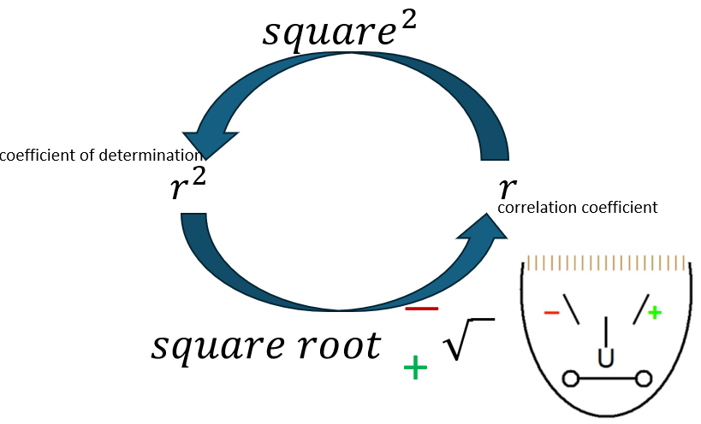

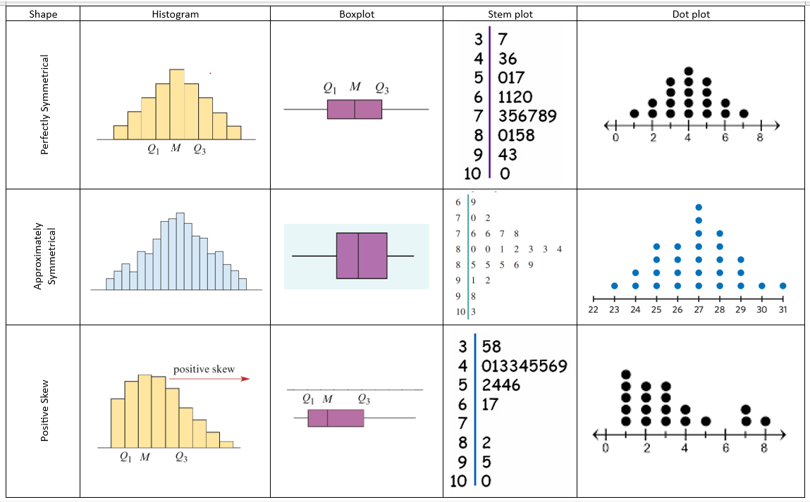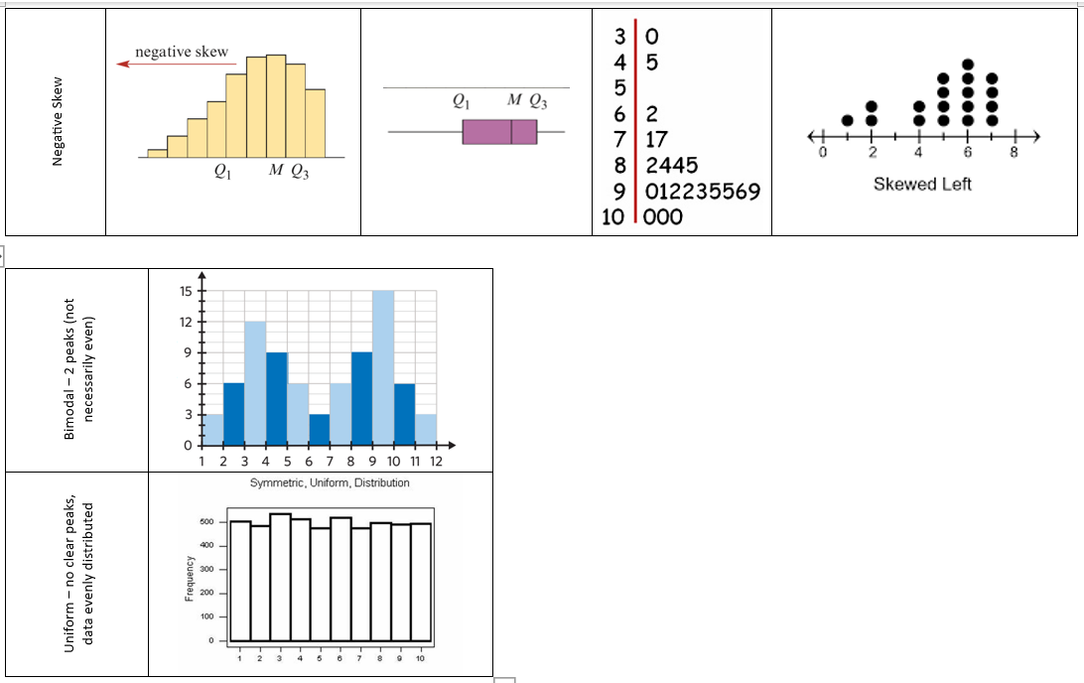

Data Summary Notes
1A: Types of data
Categorical: characteristics/qualities
- Nominal: grouped according to characteristics
- Ordinal: can be grouped and ordered
Numerical: numbers/quantities
- Discrete: whole numbers, can be counted
- Continuous: is measured

1B: displaying categorical data
Count frequency: number of times the category appears in the data
Percentage frequency: $\frac{count frequency}{total count }×100$
Mode: most frequently occurring value or category
Frequency Table:
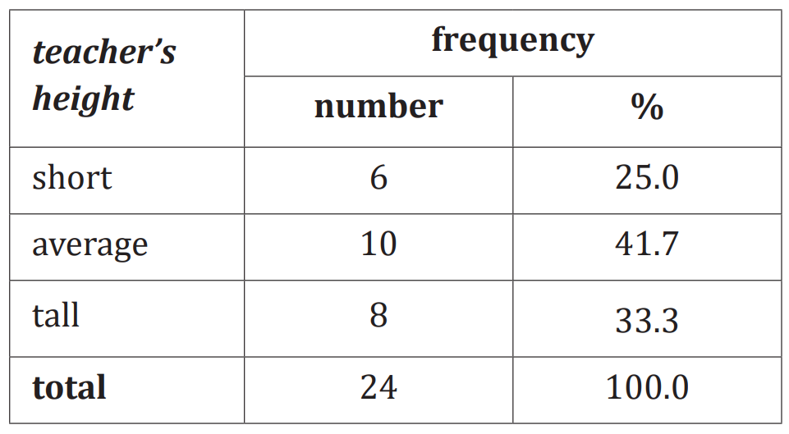
Bar chart:
- Must have gaps between bars
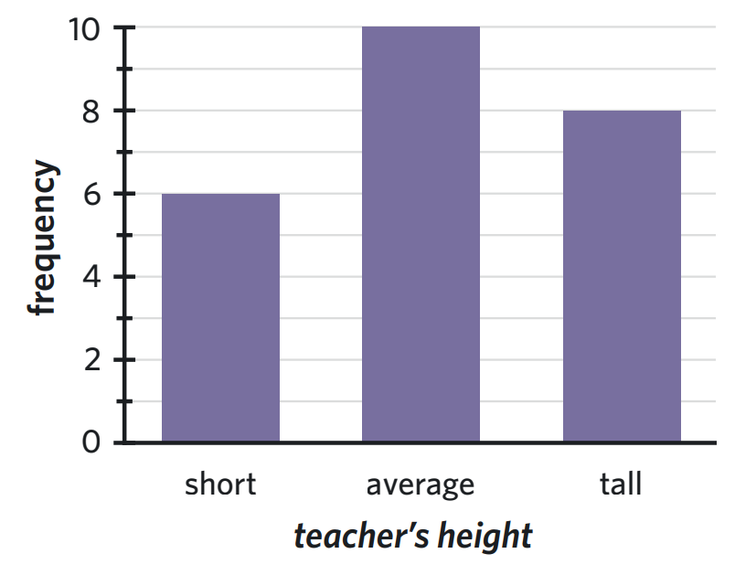
Segmented bar chart:
- Can be count or percentage frequency
- Must have a key
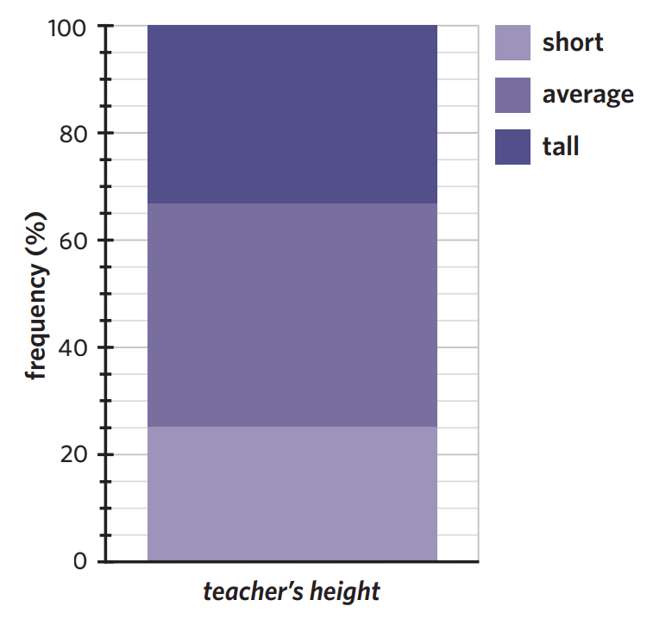

1C: Displaying Numerical data
Dot plot
- Discrete data
- Small data sets
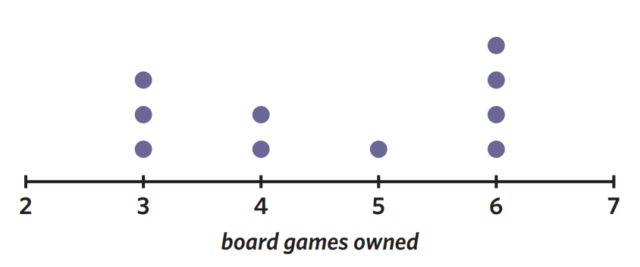

Stem and leaf plot
- Needs a key
- Can have class intervals (splitting the stem in two if it is really large)
No intervals | With class intervals of 5
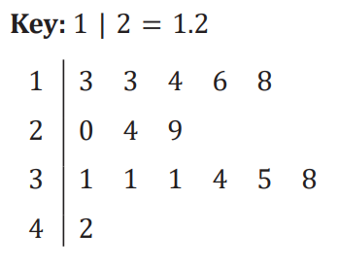 | 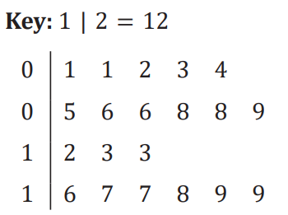

Grouped frequency tables
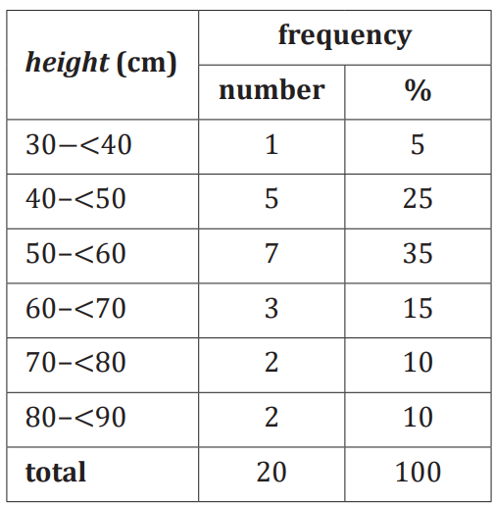
Histogram:
- Continuous data
- Intervals – no gaps between bars
- No gaps between bars
- X-axis markers are always a whole number
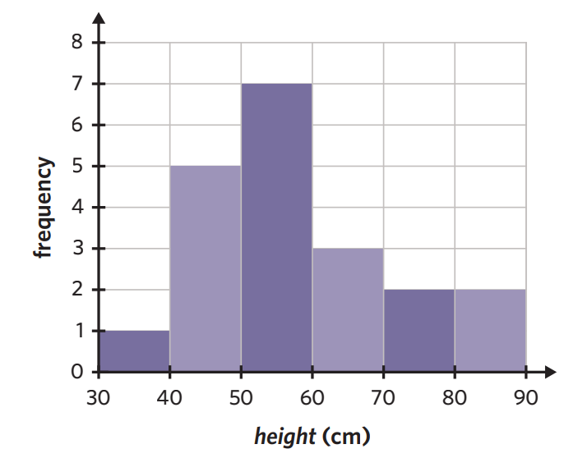

1D: Log scales and graphs
- Log scales are used to compress data that has a large range, making it more even and able to be displayed on the same set of axes.
- The base is always 10
- When undoing the log scale do ten to the power of the scale (eg. ${10}^{2.2}=158.5$)
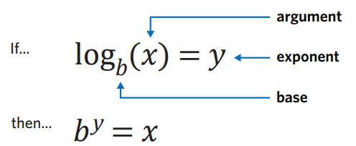

From…
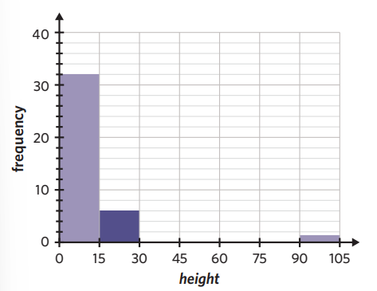
To…
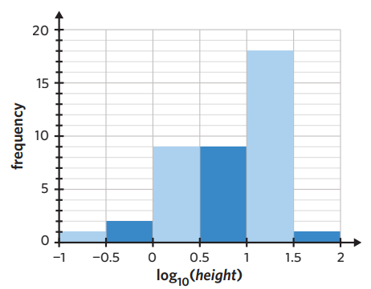

1E: the five-number summary and boxplots
5 number summary:
- Minimum: smallest value in data set
- Q1: median of the lower half
- Median: middle value in an ordered data set
- Q3: median of the upper half
- Maximum: largest value in data set
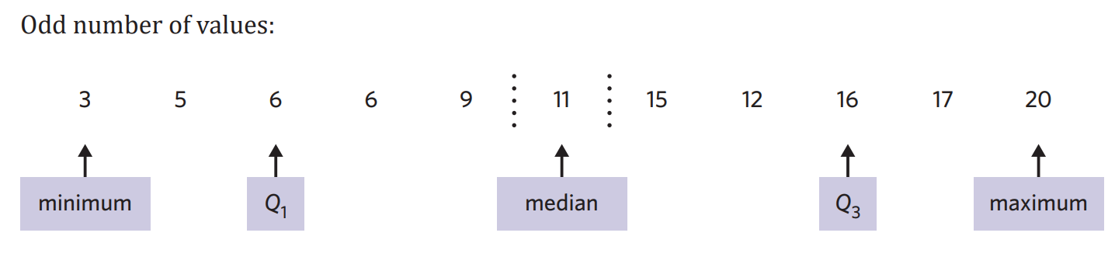
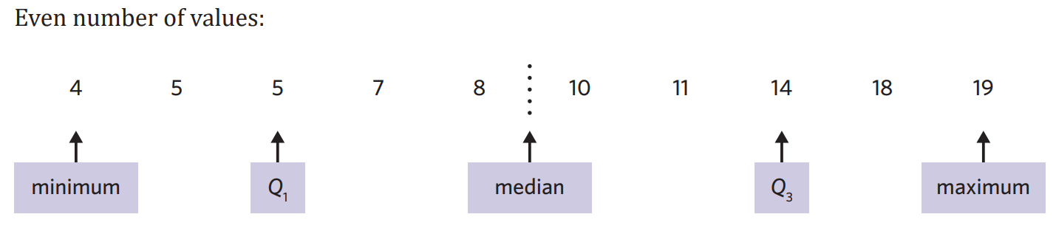
Spread: refers to how variable the data set it
Range = maximum – minimum
Interquartile range: measure of spread of the middle 50% of a data set. Accurate measure of spread when outliers are present.
IQR = Q₃ – Q₁
Outliers: values which fall outside of what is ‘normal’. Outliers are still the minimum and maximum value!
Fence: defines the boundary of what is an outlier. If a value is less than the lower fence or greater than the upper fence it is considered to be an outlier.
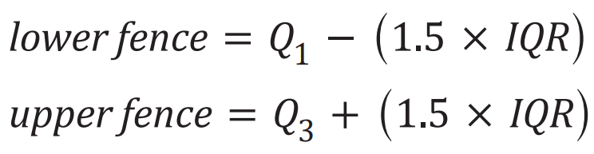
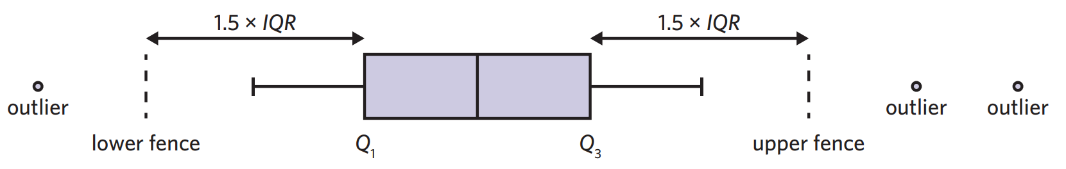

Boxplots:
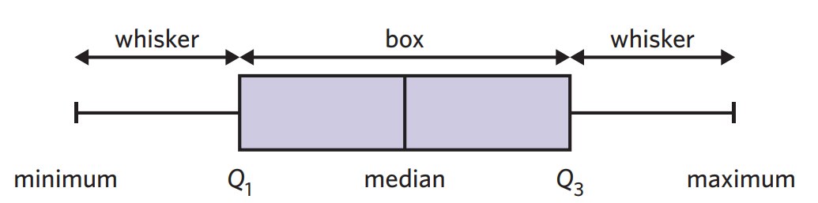
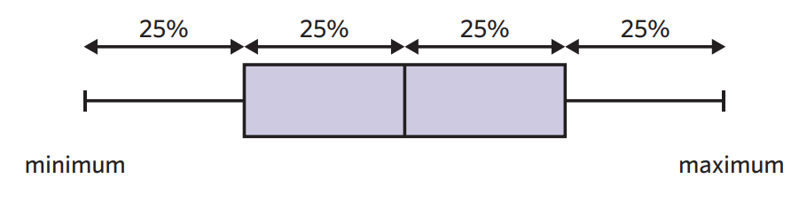

1F: describing numerical data
- Shape: is the data symmetrical, skewed or have any outliers?
- Centre: What is the median value?
- Spread: What is the range and IQR?
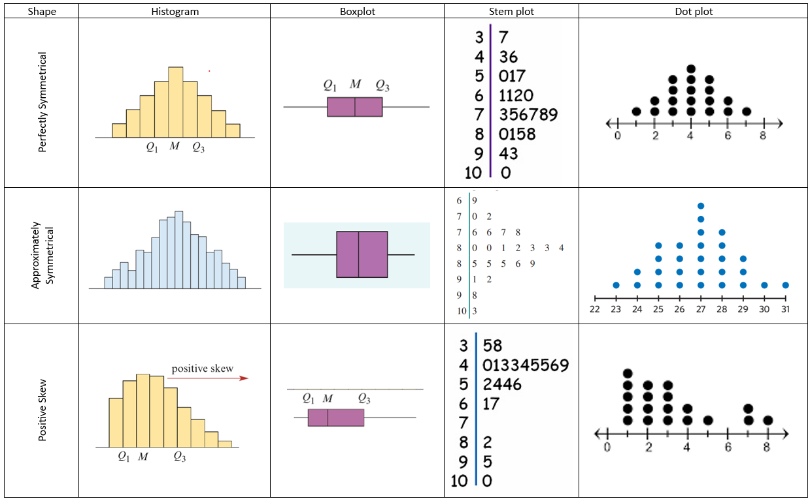
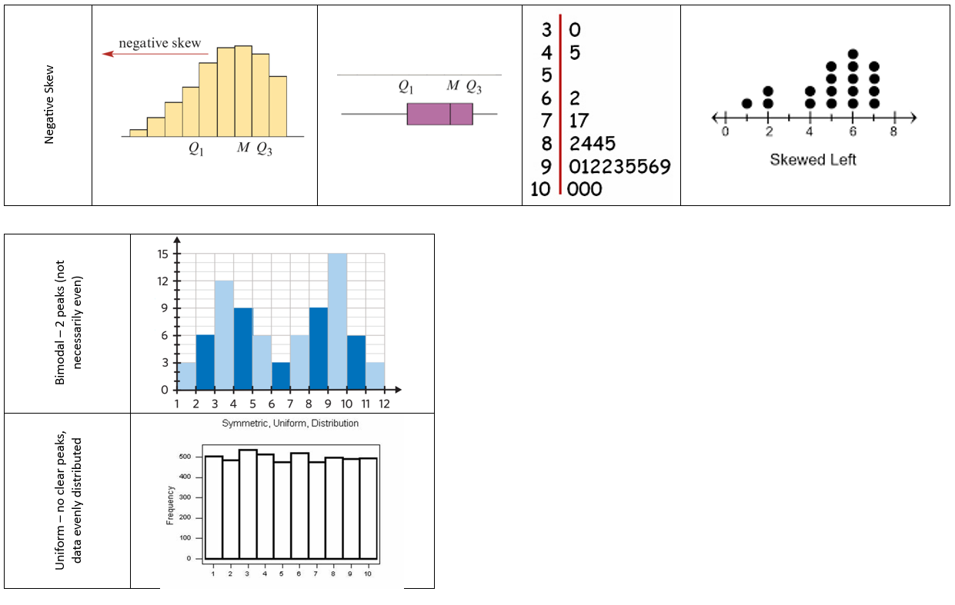

1G: Standard deviation
Population: the entire group is used to collect data.
Sample: smaller subset of the population (this is usually what is used).
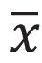
Mean: measure of centre – the AVERAGE.
- Calculated by adding all the data values together and then dividing by the number of values.

Standard deviation: measure of spread based on the average deviation of each data point compared to the mean. It can be calculated by hand but please use CAS.
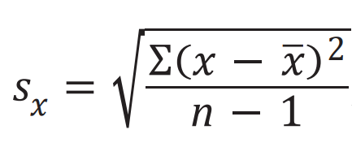

1H: The Normal Distribution
Normal Distribution: is a symmetrical (or approximately) numerical data set centred around the mean.
- Bell shaped
- Mean and median are equal

68-95-99.7% rule:
- 68% of the data lies within one standard deviation of the mean
- 95% of the data lies within two standard deviations of the mean
- 99.7% of the data lies within three standard deviations of the mean

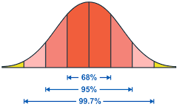
The bell curve can be broken into each section:
- The mean lies in the centre (0)
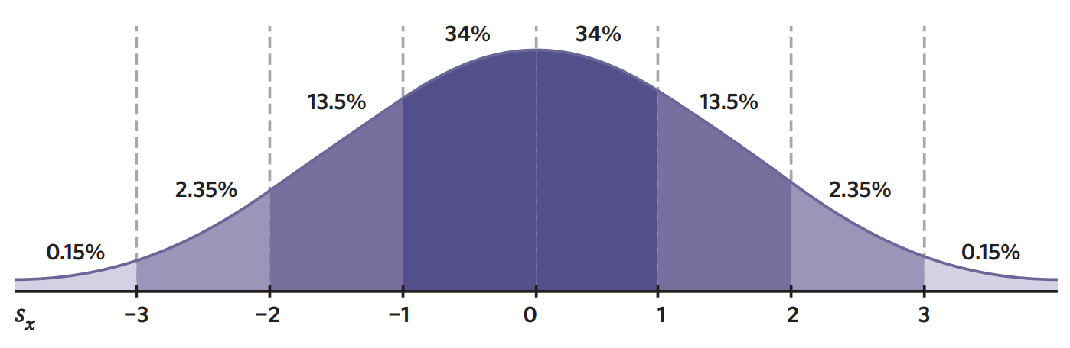

1I: z-scores
Standardised score:
- Z-score
- Measure of the number of standard deviations between the mean and a data value
- Each data value is an ‘actual score’
- Positive = above mean, negative = below mean, zero = equal to mean
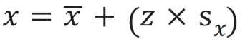
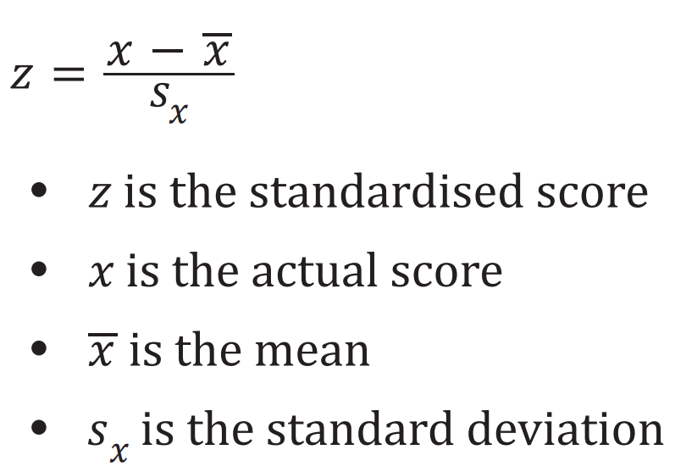
Actual score:

2A: association between 2 variables
Two-way frequency table:
- Columns = EV, Rows = RV
- Percentage frequency is used for greater accuracy when making comparisons if sample sizes are different
Grouped and segmented bar charts:
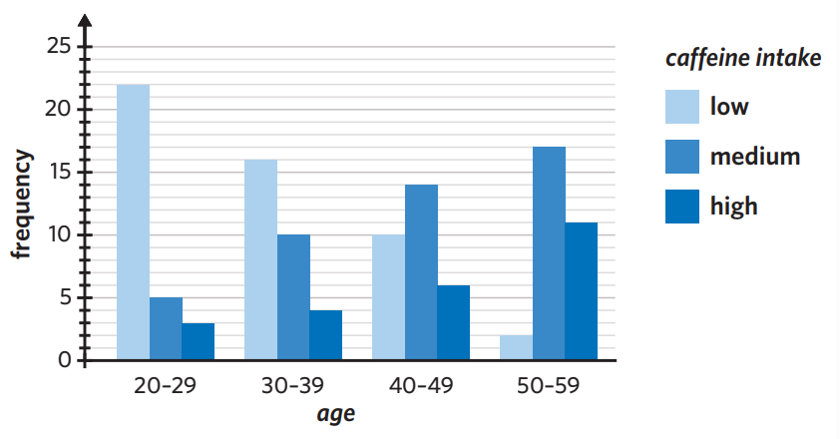
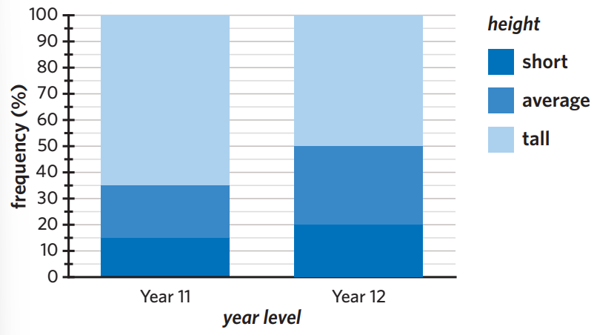
Describing the association between two variables:
- Whether or not an association between the two variables exists
- Appropriate percentages to support findings

2B: association between numerical and categorical variables
- Back to back stem plot
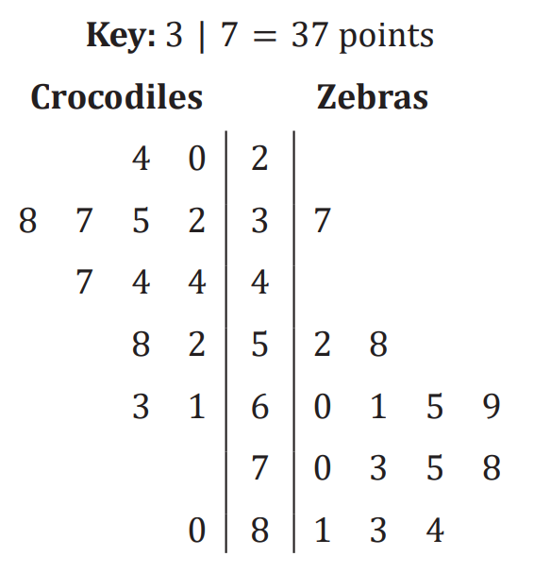
- Parallel boxplot
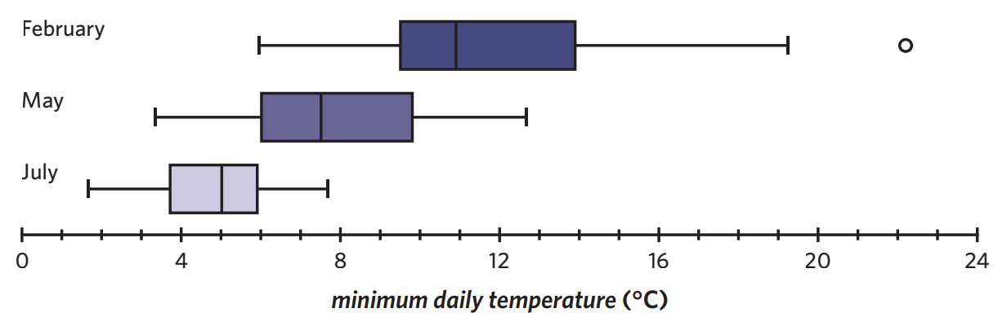
- Making comparisons: refer to 1F and compare shape, centre and spread of the two categories

2C: association between two numerical variables
Response variable: RV, may be explained or predicted by changes in the explanatory variable.
Explanatory variable: EV, used to explain or predict the changes observed in the response variable.
- ‘EV explains the RV’
Scatterplots:
- EV = x axis, RV = y axis

Describing relationship/analysing scatterplots:
- Strength: how close the data points are together
- Direction: positive or negative
 | Positive | Negative
Weak  Moderate  Strong | 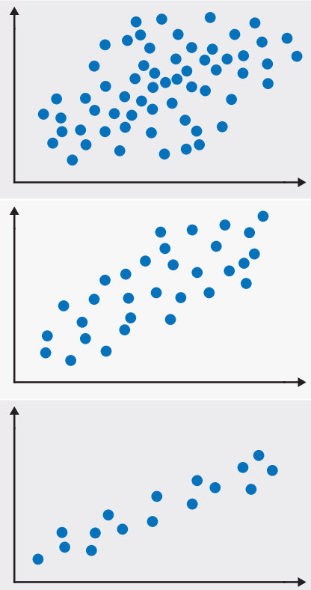 | 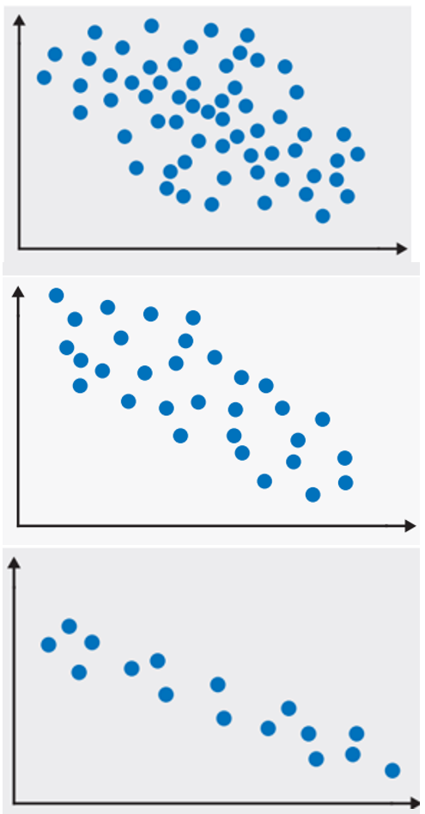

No association | Outlier
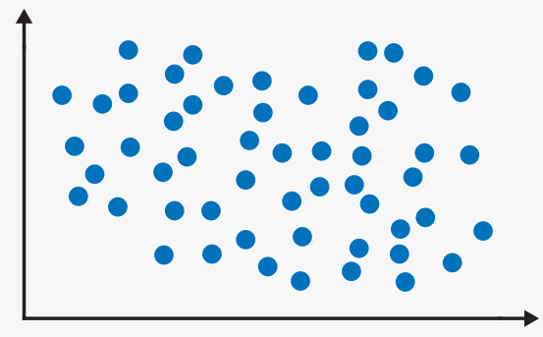 | 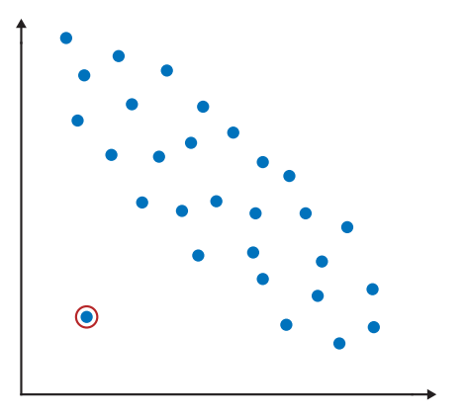
- Form: linear (straight) or non-linear (curved)
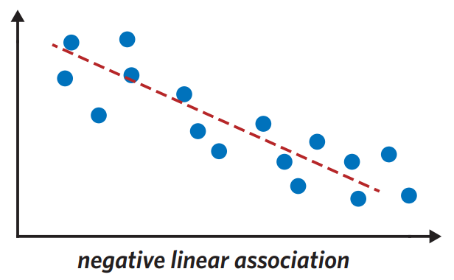 | 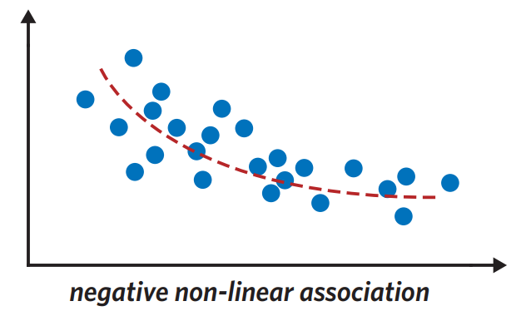
2D: Correlation and causation
Pearson’s correlation coefficient (r): numerical value that determines strength and direction between two numerical variables, assuming:
- Data is linear
- Data is numeric
- No outliers present
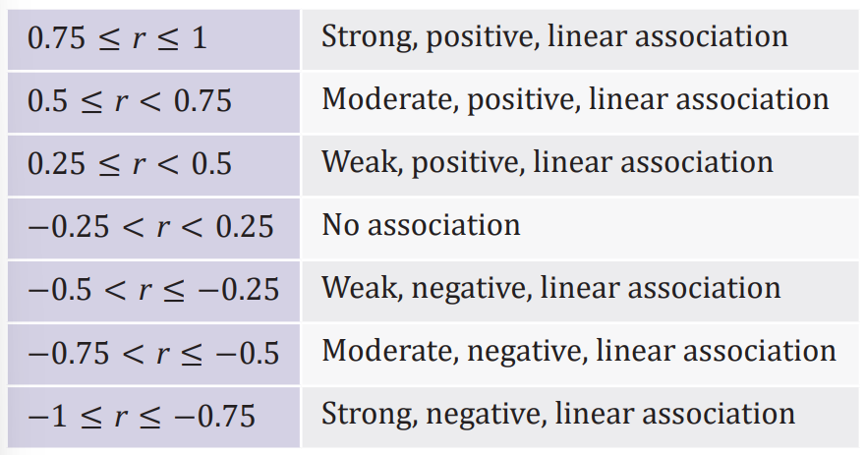
Correlation and Causation: just because two variables have a high correlation, it doesn’t mean that one causes the change in the other. Some explanations:
- Common response: a third variable that is the likely cause of correlation, acting on both variables. Eg. Number of people wearing sunscreen and feinting the sunscreen isn’t causing people to feint… the third variable would be temperature. This is common cause as temperature affects both variables.
- Confounding variable: external variable that can also produce a change to the RV. Eg. Plant height and water intake. Water intake does effect plant height (RV) but so does sun, soil quality, buys, season, temperature…
- Coincidence: two variables correlate but have no relation to each other. Pure chance. No logical explanation.

3A: fitting a least squares regression line
Least squares regression line (LSRL): is the line which creates the minimum sum of the squares of residuals. There are assumptions:
- Data is numerical
- The relationship between variables is linear
- There are no clear outliers present
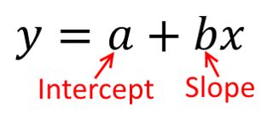
The line is used to show the general trend in the data and is given by the equation:

Determining LSRL from a graph: Find the intercept (a) and the slope (b).
- Intercept: read directly from the graph when the EV is 0
- Slope: choose two points on the line that you can clearly ready the coordinates. Use the rule:
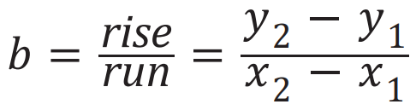
Calculating the LSRL from summary statistics:
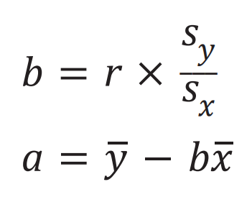
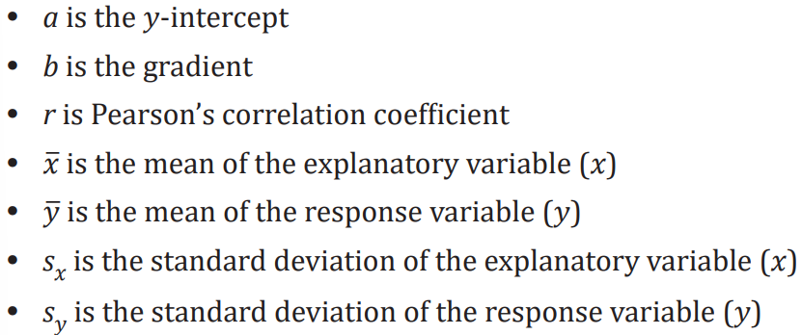

Drawing the LSRL on a graph: Sub in the first value on the x-axis and the last value on the x-axis into the equation. Plot the two points, join the line using a ruler.

3B: Interpreting LSRL: use the following statements, fill in EV and RV and values of a and b.
y-intercept: when the EV is 0, the RV is a.
Slope: for every one-unit increase in the EV, the RV increases/decreases by b. (If b is positive, increases, if b is negative, decreases)

Making predictions: the LSRL can be used to predict the value of the RV from the EV.
Interpolation: predicting within the range of data.
Extrapolation: predicting outside the range of data. Less reliable.
How to predict: sub the EV value that you are predicting for into the LSRL equation to predict the RV.

3C: Performing a regression analysis:
Coefficient of determination (r²): calculated by squaring the r value. It is turned into a percentage (×100) then interpreted. Use the statement by inputting the variable names and percentages:
- r² % of the variation in the RV can be explained by the variation in the EV. The remaining % can be explained by other factors.
Residuals: residuals are the vertical distances between the data point and the LSRL.
- Actual value: found in the question/table of data
- Predicted value: must use the LSRL to predict the RV from the EV
- Positive residual = data point above LSRL, negative residual = data point below LSRL, zero residual = data point on the LSRL.
Residual plots:
Random scattering of points in the residual plot, supports the assumption of linearity | Clear curved pattern in the residual plot, does not support the assumption of linearity
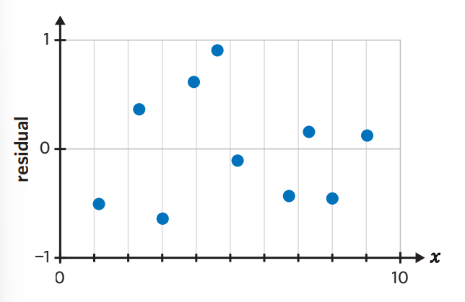 | 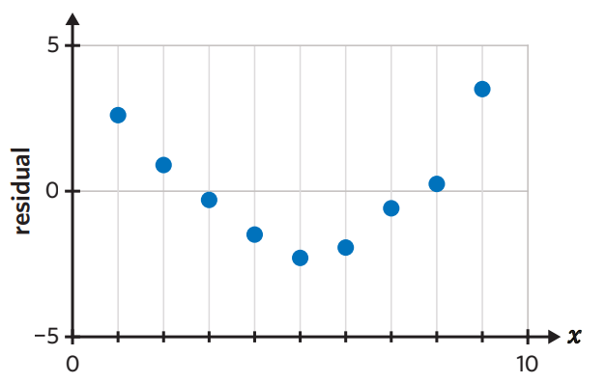

3D: Data Transformations: You shouldn’t perform a linear regression analysis for data that is nonlinear. Therefore, nonlinear data is transformed.
- Transformation linearise data so that regression analysis can be performed accurately.
- Match the nonlinear scatterplot with one in the diagram to help you determine the best transformation.
- Best transformation: strongest r/r² value
Types of transformations:
- Log: compresses the data
- Square: stretches the data
- Reciprocal: compresses values greater than 1, stretches values less than 1.
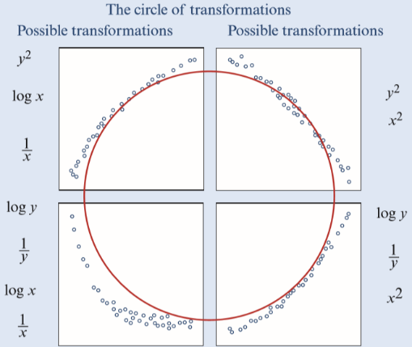

3E: Data transformations – applications
LSRL: once you have transformed your data you must create a new LSRL equation and include the transformation in the rules.
Eg. From
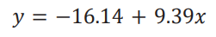
To
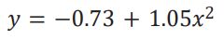
Making predictions: the limits of extrapolation are still present. When calculating, use solve as this will undo the transformation for you.

4A: Time series data and their graphs
Trends: general upwards (increasing) or downwards (decreasing) movement over time. Trend lines can be fitted directly to trends. There can be multiple trend lines.
Increasing trend Decreasing trend
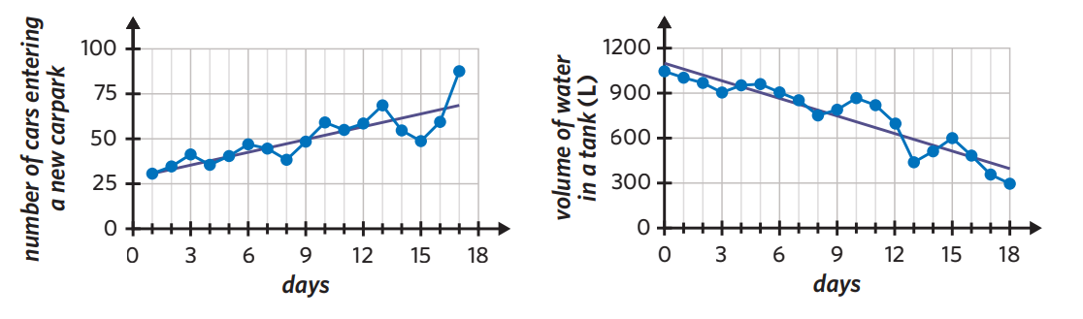
Cycles/cyclical variation: periodic movements over a period greater than 1 year. Peaks of cycles occur at approximately the same intervals, cycles can have a period which changes slightly between peaks.
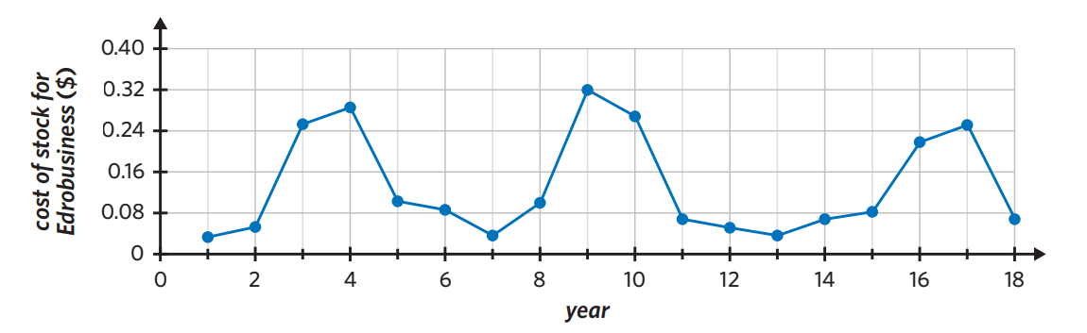

Seasonality: cyclical variation within a calendar-related period (week, month, quarter). A seasonal time series plot has regular peaks and troughs that occur at the same time each period and the length of the period must be a year or less.
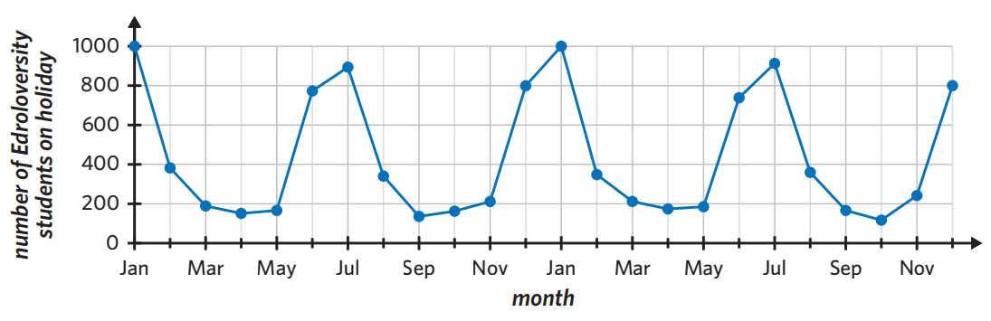
Structural Change: When an established pattern is suddenly altered. The graph then continues on the same level post structural change.
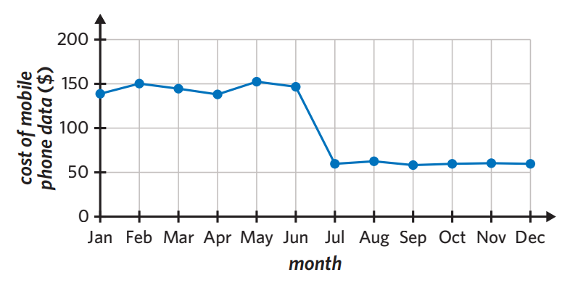
Irregular fluctuations: random variations that cannot be explained by trend, seasonality, cycles or structural change.
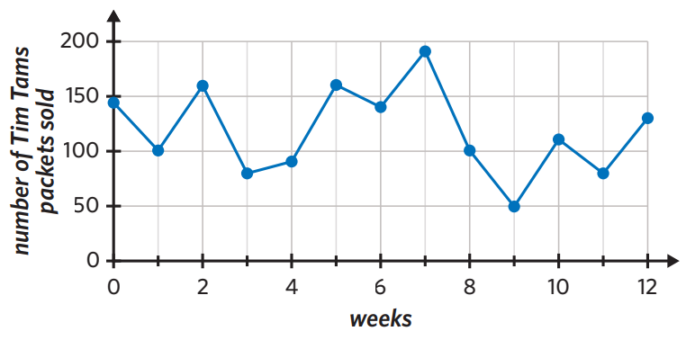
Outliers: stands out from the general body of data. It then returns to follow the original pattern/trend
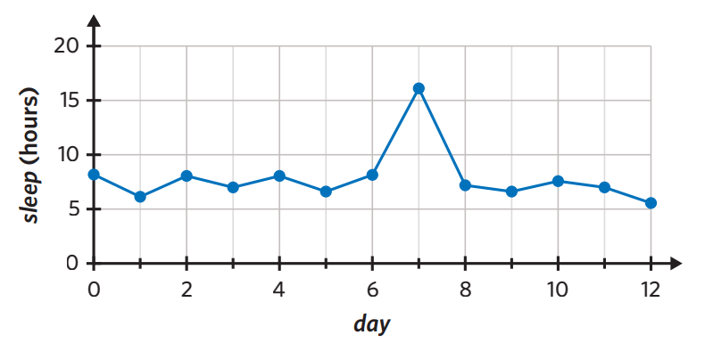
4B: Smoothing – moving means
Smoothing: evens out fluctuations to help identify any underlying trends
- Only smooth the RV
- The larger the mean smooth, the more effective (5 more effective than 3)
3 mean: use 3 values and find the mean
5 mean: use 5 values and find the mean
- Always centred around the value you are trying to smooth
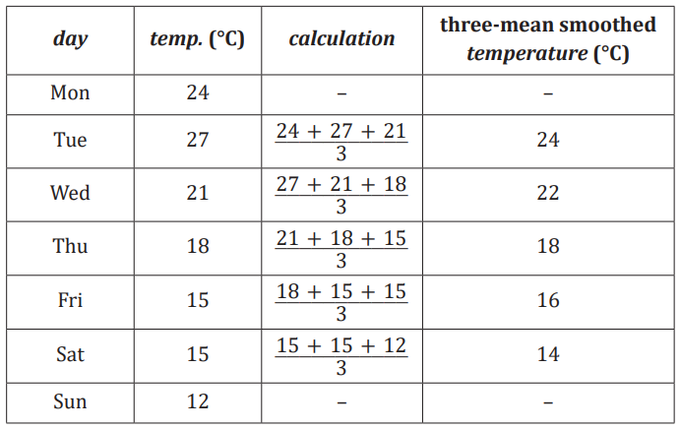

Smoothing with centring: an additional step when smoothing with an even number of points. Finding the mean of two non-centred means.
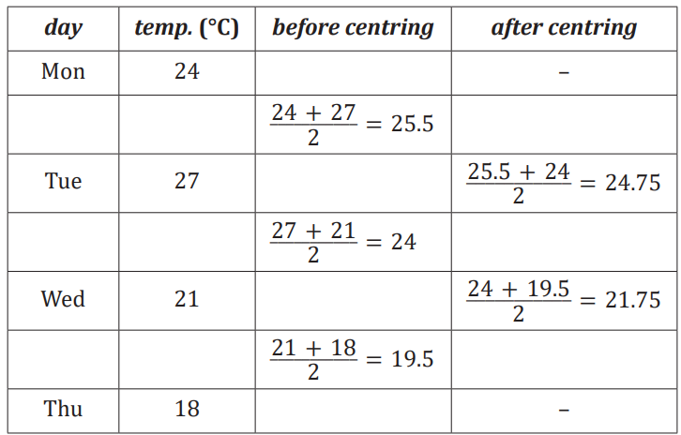

4C Smoothing – moving medians
- Smoothed directly on the graph
- Median smoothing only uses and odd number of points
- Smooth the RV
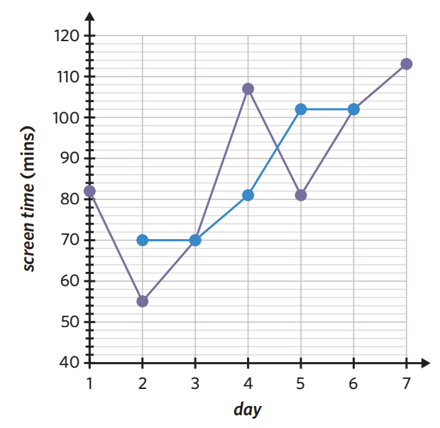
4D: Seasonal adjustments:
- Seasonal fluctuations exist.
- Seasonal indices (SI) are used to de-seasonalise the data to minimise the effects of seasonality. This allows trends to be more easily observed.

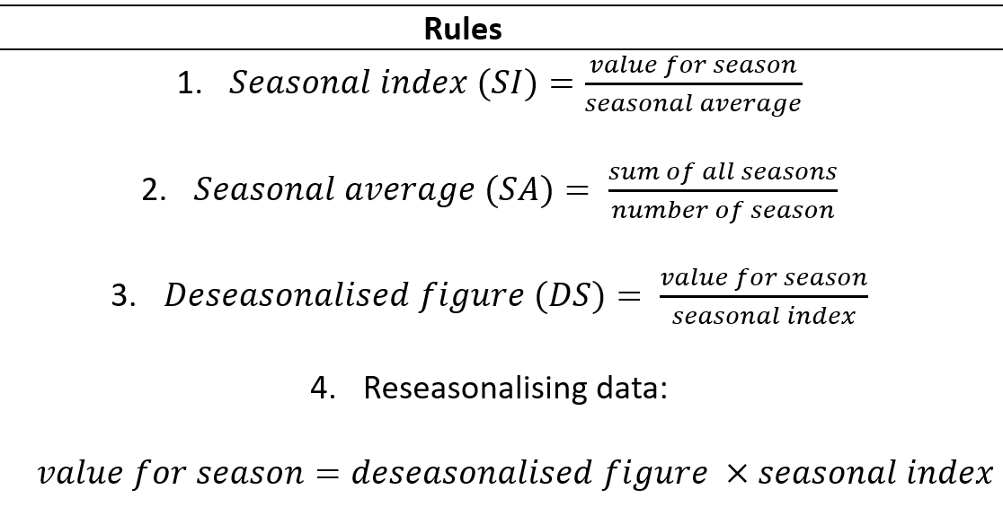
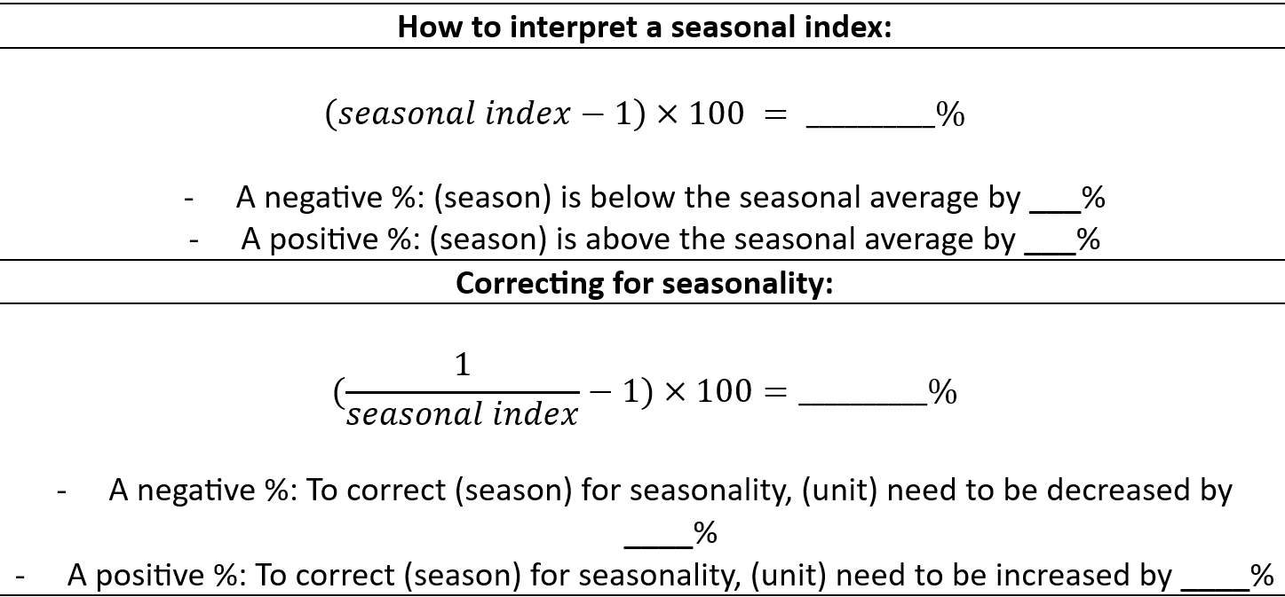
Notes:
- The sum of the seasonal indices is equal to the number of seasons (if you are working with months of the year there are 12 seasons and therefore the seasonal indices will sum to 12)
- If there were no fluctuations, the seasonal average is 1

4E: Time series data and LSRL modelling:
Trend lines: can be fitted to time series plots if there appears to be an increasing or decreasing trend.
- The LSRL is used
- If seasonality is present, data needs to be deseasonalised first before fitting the LSRL to the deseasonalised values
Forecasting: making a prediction for the future
- You need to re-seasonalise the value if the prediction was made from a deseasonalised LSRL

1a. Univariate Categorical Data: Frequency Table
The [types of categories] of [total frequency] [frequency type] were classified as [list of categories].
Modal Category
The majority of [frequency type], [modal percentage], were found to be [modal category].
Of the remaining [frequency types], [percentage X] were found to be [category X], while [percentage Y] were found to be [category Y], and while [etc.].
Equal Categories
The [frequency types] all had roughly the same percentages where [category X] had [percentage X], [category Y] had [percentage Y], [etc.].

1b. Univariate Numerical Data: Histogram, Dot Plot, Stem Plot
The shape of the distribution is [symmetric/positively skewed/negatively skewed] Refer to 1F: Describing numerical data
The distribution has a [standard dev./range/IQR] of [value]
The distribution has a [mean/median/mode] of [value]
The distribution [has #/has no] outliers.

1c. Univariate Numerical Data: Box Plot
The distribution is [positively skewed/negatively skewed] with [outliers/no outliers]. The distribution is centred at [value], the median value. The spread of the distribution, is measured by the IQR, is [value] and, as measured by the range [value]. If outliers present: There are [value] many outliers: [list of outliers]

2a. Bivariate Data (Both Categorical): Two-way Frequency Table
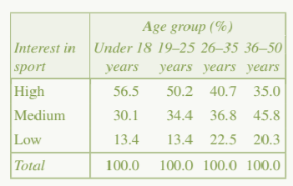
Worked example: Is there an association between interest in sports and age group?
Yes, the percentage of males with a high level of interest in sport steadily decreases
with age group from 56.5 % for the ‘under 18 years’ age group, to 35.0% for the ’36-
50 years’ age group.

2b. Bivariate Data (one categorical, One Numerical): Comparing two boxplots:
The distributions at [variable name] are [symmetric/positively skewed/negatively skewed] for both [boxplot variables]. There [are/are no] outliers. The median [variable name] is higher for [boxplot 1], (M= value), than [boxplot 2], (M= value). The IQR is also greater for [boxplot 1], (IQR= value), than [boxplot 2], (IQR= value). The range of [variable name] is also greater for [boxplot 1], (R= value), than [boxplot 2], (R= value). Yes, there is an association between [variable name1] [variable name 2] as their median change from (M= value) to (M= value).

2c. Bivariate Data (Both Numerical): Scatter Plot
There is a [strong/moderate/weak], [positive/negative], [linear/non-linear] relationship between [response variable y] and [explanatory variable x]. There [are/are no] clear outliers.

2d. The coefficient of determination (r²):
The coefficient of determination indicates that [r² x 100] % of the variation in [response variable] is explained by the variation in [explanatory variable] and [remaining %] is explained by other factors and not explained by [explanatory variable].

2e. Least squares line:
The equation of the regression line is: [response variable] = [a] + [b] x [explanatory variable]

Slope (b):
On average, [response variable] [increases/decreases] by [b units] for every one [unit] increase in [explanatory variable].

y- intercept (a):
When [explanatory variable] is 0, [response variable] is predicted to be [a units].

2f. Residual Plot
The residual plot shows a [random scatter/ curved pattern] indicating there is a [linear/non- linear] relationship between [response variable] and [explanatory variable].

2g. Prediction Reliability
The prediction using [explanatory variable] of [value of EV] is [reliable/ unreliable] as it is [within/ outside] the date range and is therefore [interpolation/extrapolation].

2h. The appropriateness of fitting a transformed regression analysis
Transformations are [appropriate/ not appropriate] as the original data produces a [non-linear/ linear] scatterplot, confirmed with a clear [curved pattern/ random scatter] in the residual plot.
[Log [EV]/Reciprocal [EV]/[EV]Squared/ Log[RV]/Reciprocal[RV]/[RV]Squared] is the most appropriate transformation, given it has the strongest coefficient of determination r² of [r² x 100] %, compared with [r² x 100] % and [r² x 100] %.
2i. A residual analysis on the number
The residual value is [positive/ negative], [above/ below] the LSRL or the LSRL is an [under prediction/ over prediction].
2j. Confounding variables
Since the correlation coefficient [r value] indicates a [strong/moderate/weak] association. Therefore, factors (confounding variables) other than the [explanatory variable] must be considered. Some of these factors include [list potential reasons here].
2k. Reason for smoothing Time Series Plot
Reduce Random Fluctuations; Highlight the Underlying Trend; Identify Seasonal Patterns; Prepare for Forecasting; Outlier Detection.
CAS reference sheet: Data
1.1 Univariate Data Statistics: to find the 5 number summary, mean and standard deviation | - Ctrl n > 4, Enter data in ‘list and spreadsheets’ (ensure a title)  - Menu > 4 > 1 > 1 OR ctrl i > 1 > menu > 6 > 1 > 1 in a new page  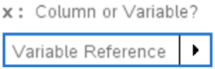  - Select the title you gave the data in the ‘X-List’  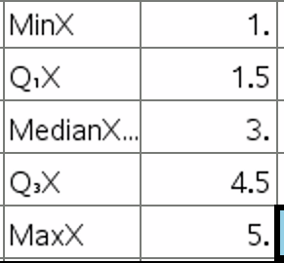  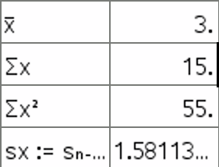
1.2 Graphing Univariate Data: dot plot, boxplots, histograms | - Ctrl n > 4, Enter data in ‘list and spreadsheets’ (ensure a title)  - Ctrl doc OR ctrl i OR home menu > 5 to open a new page and select ‘data and statistics’  - Click to add data to the x-axis  - Menu > 1: choose the plot type you are after  Histogram settings:  - Menu > 2 > 2 > 2 > 1  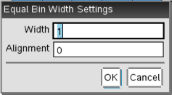  - Width is where you put your interval size. Alignment is where the graph will start on the x-axis  - Zoom: menu > 5 > 2  - Frequency or Percent: menu > 2 > 2 > 1
2.1 Graphing Bivariate Data: Grouped Bar Chart | - Create first Bar Chart  Menu > 2 > 9 > select second set of data
2.2 Graphing Bivariate Data: parallel boxplots | - Create first boxplot  - Menu > 2 > 5 > select second set of data
3.1 Bivariate Data Statistics: a, b, r, r² | - Ctrl n > 4, Enter data in ‘list and spreadsheets’(ensure you give both columns a title)  - Menu > 4 > 1 > 4 (Spreadsheets) OR ctrl i > 1 > Menu > 6 > 1 > 4 (Calculator)  - Select your EV in the ‘X-List’ and your RV in the ‘Y-List’  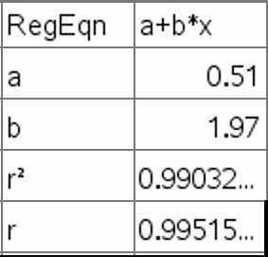  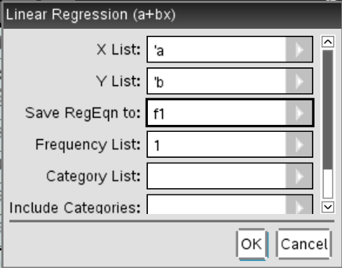
3.2 Scatterplots | - Ctrl n > 4, Enter data in ‘list and spreadsheets’ (ensure you give both columns a title)  - Ctrl doc OR ctrl i OR home menu > 5 to open a new page and select ‘data and statistics’  - Click to add the EV to the x-axis and the RV to the y-axis  Scatterplot Least Squares Regression Line:  - Menu 4 > 6 > 2 OR ctrl i > 1 > Menu > 6 > 1 > 4 (Calculator)  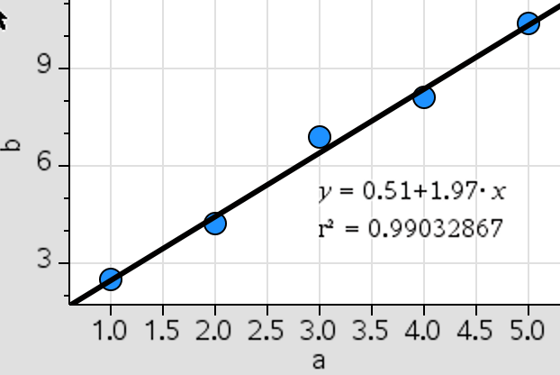  Residual Plot:  - Menu 4 > 7 > 2  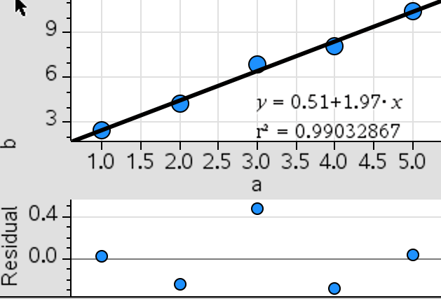  Timeseries line:  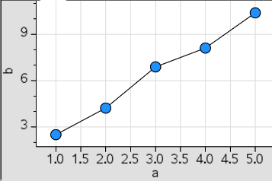  - Menu > 2 > 1
3.3 Prediction by LSRL | - Above 3.2 step1-3 to entre EV and RV.  - ctrl i > 1 > Menu > 6 > 1 > 4 (Calculator)  - var > stat.regeqn > x value ↵  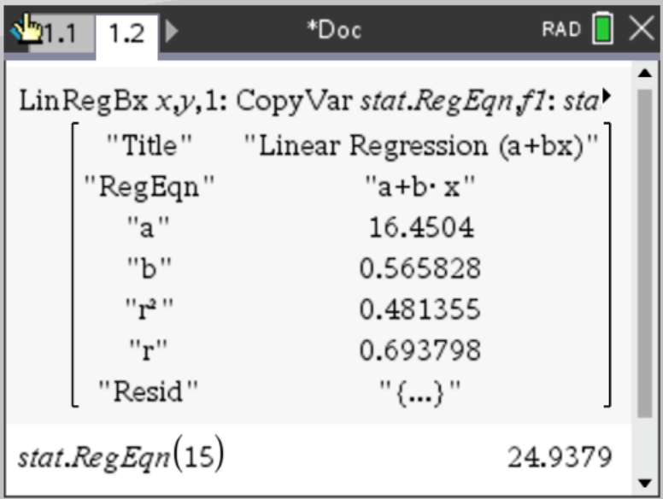
3.4 Transformations | - Enter data in ‘list and spreadsheets’ (ensure you give both columns a title)  - In a new column title the transformation you are completing by using:  - In the second row of this column (grey shaded) you are going to put the transformation in by:  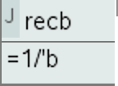  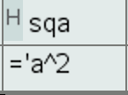  - From here you can get the ‘Bivariate Data statistics’ and create a ‘scatterplot’ – remember that you only use one transformation at a time. So if you transform x you use the original y when calculating statistics and graphing (vice versa).
  Square transformation | sq(variable name)
  Log transformation | log(variable name)
  Reciprocal transformation | rec(variable name)
  Square transformation | =(variable name)²
  Log transformation | =log₁₀(variable name)
  Reciprocal transformation | =1/(variable name)
4.1 Mean Smoothing | - Enter values into list and spreadsheet in column A  - If 2 or 3 mean smoothing start in column B cell 2. If 4 or 5 mean smoothing start in column B cell 3  - Write  - 2 mean =(a1+2a2+a3)/4  - 3 mean =(a1+a2+a3)/3  - 4 mean =(a1+2a2+2a3+2a4+a5)/8  - 5 mean =(a1+a2+a3+a4+a5)/5  - Hover over the cell in the bottom right corner until the plus appears, click and drag and it will fill the values for you.  - Comparing time series plots: Menu > 2 > 6  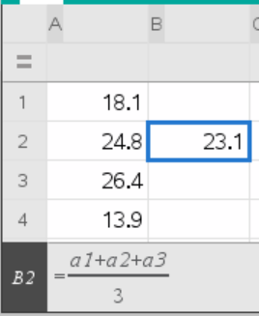
4.2 Solve | - Calculator Page  - Menu > 3 > 1  - You write inside the brackets, there must be an equals sign (=), you must choose a variable (x) and then use the same variable at the end and do ‘comma variable’ (,x)
4.3 Back to top of List | Ctrl > 7

Board Notes
