Financial Math 6.2 Amortisation FV↓ 5.3 Effective Interest Rate
 | Recurrence Relation | Application | Explicit Rules | Graphs | CAS Notes #
Arithmetic Sequences  D  Common difference | $v_{0}=principal,v_{n+1}=v_{n}+D$  D =$\frac{r}{100*p}×v_{0}$ | Simple Interest | $v_{n}=v_{0}+n*D$ | 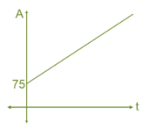 | 5.2 Interest in $  5.1 Sequence list  5.2 Future Value
Arithmetic Sequences  D  Common difference | $v_{0}=Initial Value,v_{n+1}=v_{n}― D$  D =$\frac{r}{100}×v_{0}$ | Flat Rate Depreciation | $v_{n}=v_{0} ― n*D$ | 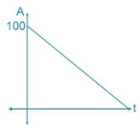 | 5.2 depreciate $  5.1 Sequence list  5.2 Future Value
Arithmetic Sequences  D  Common difference | $$v_{0}=Initial Value,v_{n+1}=v_{n}―D$$  D =$Unit cost in dollars$ | Unit Cost Depreciation | $v_{n}=v_{0} ― n*D$ | 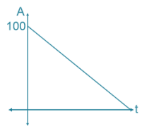 | 5.1 Sequence list  5.2 Future Value
Geometric Sequences  R  Common Ratio  Growth Factor  Decay factor | $$v_{0}=principal,v_{n+1}={R*v}_{n}$$  $R=1+\frac{r}{100*p}$, $r_{a}=\left(R-1\right)*100*p$ | Compound Interest | $$v_{n}= R^{n}*v_{0}$$ | 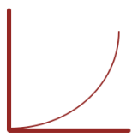 | 5.2 Common Ratio  5.1 Sequence list  5.2 Future Value  5.2 Find r  5.2 Find n
 | $$v_{0}=Initial Value,v_{n+1}={R*v}_{n}$$  $R=1 ―\frac{r}{100}$, $r=\left(1-R\right)*100$ | Reduced Balance Depreciation | $$v_{n}= R^{n}*v_{0}$$ | 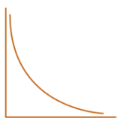 | 5.2 Common Ratio  5.1 Sequence list  5.2 Future Value  5.2 Find r  5.2 Find n
Combined Arithmetic  &  Geometric  Sequences  R  Growth Factor  D  Repayment | $$v_{0}=Initial Value,v_{n+1}={R*v}_{n} ― D$$  $R=1+\frac{r}{100*p},$ D = $\frac{r}{ 100*p}×v_{0}$, $D=\left(R-1\right)*V_{0}$ | FV → Interest Only Loan  /Perpetuities |  | 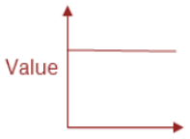 | 5.2 Common Ratio  6.1 Sequence list  5.2 Interest only  5.2 Perpetuities
 | $$v_{0}=Initial Value,v_{n+1}={R*v}_{n} ― D$$  $R=1 + \frac{r}{100*p} ,$ $r_{a}=\left(R-1\right)*100*p$ | FV↓ Reduced Balance Loans  /Annuities | Compound Interest loan extra payment | 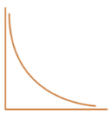 | 5.2 Common Ratio  5.1 Sequence list  6.1 Financial Solver  6.1 Analyse Loan  6.1 Analyse Annuities  6.1 Condition change
 | $$v_{0}=Initial Value,v_{n+1}={R*v}_{n} + D$$  $R=1+\frac{r}{100*p}, ,$ $r_{a}=\left(R-1\right)*100*p$ | FV↑ Compound Interest Investment  Annuity Investment |  |  | 5.2 Common Ratio  6.1 Sequence list  6.1 Analyse investment  6.1 Condition change
Note: Yellow parts need real number, blue parts are formula to calculate, Letter P indicates Compounding monthly etc. Needing rate per month, Monthly Ratio etc. Green CAS Notes
 | SIMPLE INTEREST | FLAT RATE DEPRECIATION | UNIT COST DEPRECIATION | COMPOUND INTEREST | REDUCING BALANCE DEPRECIATION
Description | A constant amount of interest that is added to the principal at regular time periods. It is calculated as a percentage of the principal. | The value of an asset decreases by a constant amount each time period. This amount is a percentage of the initial value. | The value of an asset uses value after each unit of use. | Takes into account both the principal and any accumulated interest earned in previous periods. The value of the investment grows with increasing amounts each time period. | The value of an asset depreciated by a set percentage, rather than a set amount. The amount of depreciation decreases each time period.
Reccurence relation | V₀ = principal, V_{n+1} = V_{n} + D  D = r/100 x V₀ | V₀ = initial value of asset, V_{n+1} = V_{n} - D  D = r/100 x V₀ | V₀ = initial value of asset, V_{n+1} = V_{n} - D  D = the depreciation (cost) per unit of use | V₀ = principal, V_{n+1} = RV_{n}  R = 1 + r/100 x CP | V₀ = principal, V_{n+1} = RV_{n}  R = 1 - r/100 x CP
Rule | V_{n} = V₀ + nD  D = r/100 x V₀ | V_{n} = V₀ - nD  D = r/100 x V₀ | V_{n} = V₀ - nD  D = the depreciation (cost) per unit of use | V_{n} = R^{n} x V₀  R = 1 + r/100 x CP | V_{n} = R^{n} x V₀  R = 1 - r/100 x CP
Graph | 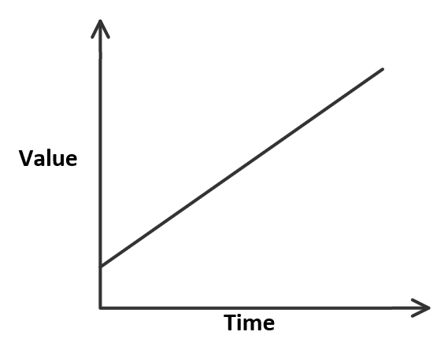 | 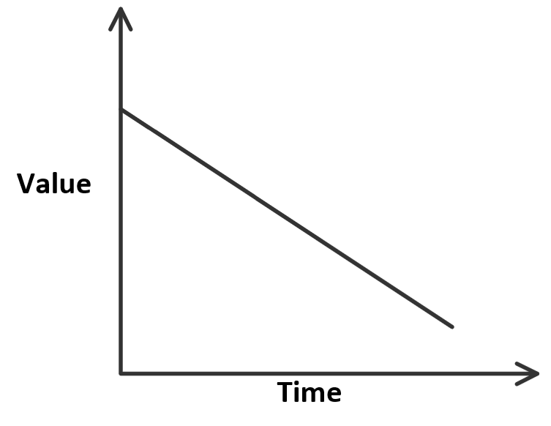 | 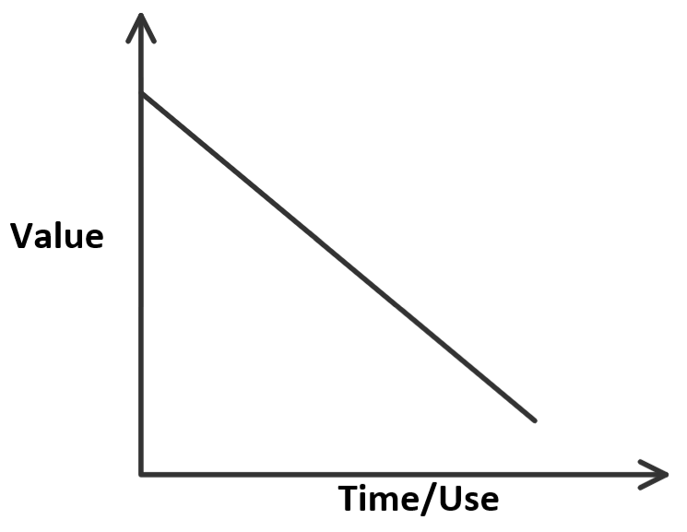 | 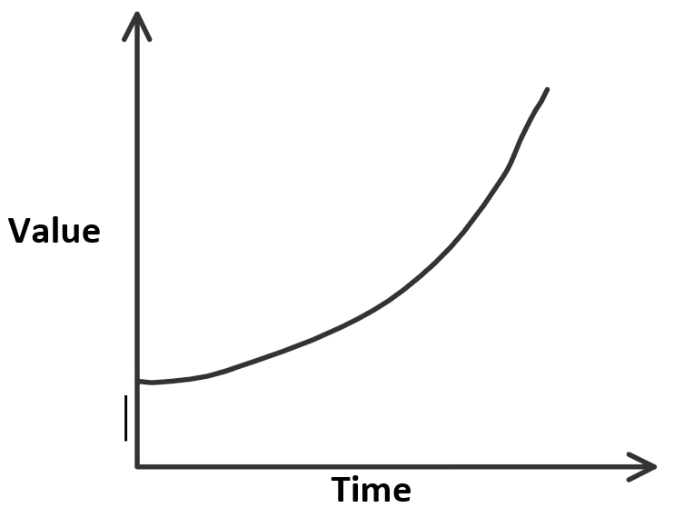 | 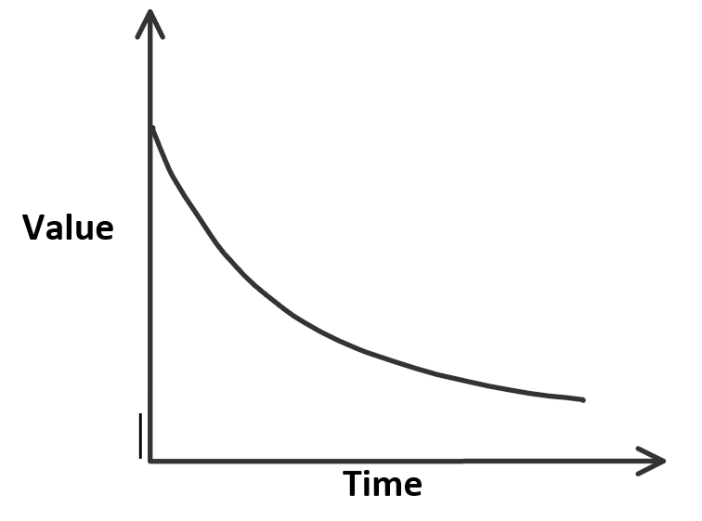
r = interest rate per annum.
CP/P = compound period. If there are no compound periods, then CP = 1
Recurrence relation: step by step process.
Rule: find values in the future in one step.

Standard compound periods:
1 = yearly
2 = biannually
4 = quarterly
6 = half yearly
12 = monthly
26 = fortnightly
52 = weekly
365 = daily

 | REDUCING BALANCE LOANS | INTEREST ONLY LOANS | ANNUITY | PERPETUITY | ANNUITY INVESTMENT
Description | Has compound interest but also requires a fixed amount to be paid at regular intervals. | The borrower only repays interest that is charged. As a result, the principal must be paid back at the termination of the loan. | A form of investment, where compound interest is earned, and a fixed sum is paid to the investor periodically until the investment reaches $0. | Type of annuity that lasts indefinitely. The amount of money invested remains the same as the regular payment to the investor is only the interest earned. | An investment where interest is received, and regular payments are made. Money is not being paid out to the investor; the account is growing.
Recurrence Relation | V₀ = principal, V_{n+1} = RV_{n} - D  R = 1 + r/100 x CP  D = regular payment | D = r/100 x V₀  D = payment | V₀ = principal, V_{n+1} = RV_{n} - D  R = 1 + r/100 x CP  D = regular payment | D = r/100 x V₀  D = payment | V₀ = principal, V_{n+1} = RV_{n} + D  R = 1 + r/100 x CP  D = regular payment
Graph | 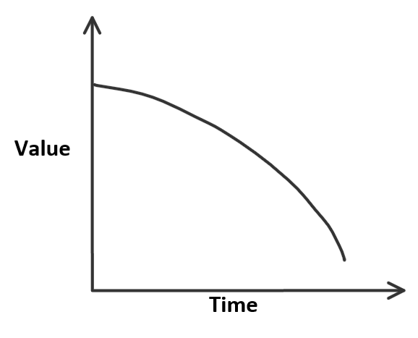 | 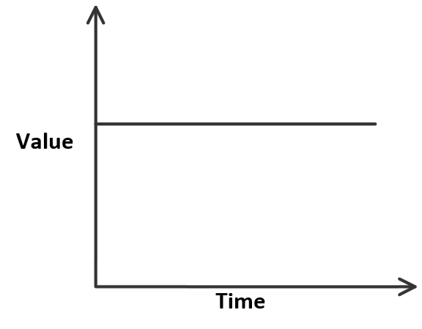
Finance Solver
  N
  I(%)
  PV | Positive
  Pmt | Negative
  FV | Positive  Negative  Zero
  PpY
  CpY
  N | 1
  I(%)
  PV | Positive
  Pmt | Negative
  FV | Negative value of the PV
  PpY
  CpY
  N
  I(%)
  PV | Negative
  Pmt | Positive
  FV | Positive  Zero
  PpY
  CpY
  N | 1
  I(%)
  PV | Negative
  Pmt | Positive
  FV | Positive value of the PV
  PpY
  CpY
  N
  I(%)
  PV | Negative
  Pmt | Negative
  FV | Positive
  PpY
  CpY

CAS reference sheet: Finance
5.1 Using a calculator to generate a sequence of numbers from a rule | - Ctrl N > 1 ↵  - Enter initial data ↵  - Enter the rule ↵ ↵ ↵ ↵ ↵ to show more terms
5.2 Solve | - Calculator Page  - Menu > 3 > 1 ↵  - You write inside the brackets, there must be an equals sign (=), you must choose a variable (x) and then use the same variable at the end and do ‘comma variable’ (,x)
5.3 Effective Interest Rate | - Nominal Interest Rate → Effective Interest Rate  - Menu > 8 > 5 > 2 ↵  - eff (Nominal Interest Rate, Compounding periods)  - Effective Interest Rate → Nominal Interest Rate  - Menu > 8 > 5 > 1 ↵  - nom (Effective Interest Rate, Compounding periods)
6.1 Financial Solver | 1. Ctrl N > 1 > Menu > 8 > 1 ↵
6.2 Amortisation Table  “Amortloan” | - var > Amortloan()↵  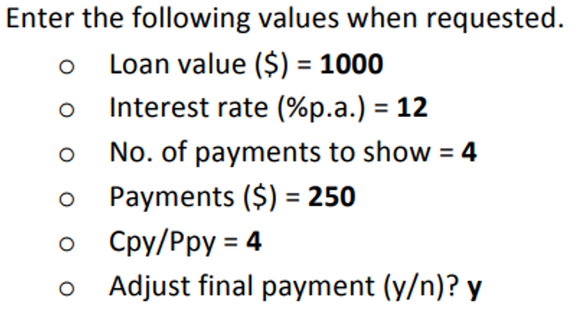  - sum(interest) ↵ to calculate total interests  - sum(prinreduct) ↵ to calculate total principal reduction  - sum (pmt) ↵ to calculate total payment  