Trends: general upwards (increasing) or downwards (decreasing) movement over time. Trend lines can be fitted directly to trends. There can be multiple trend lines.
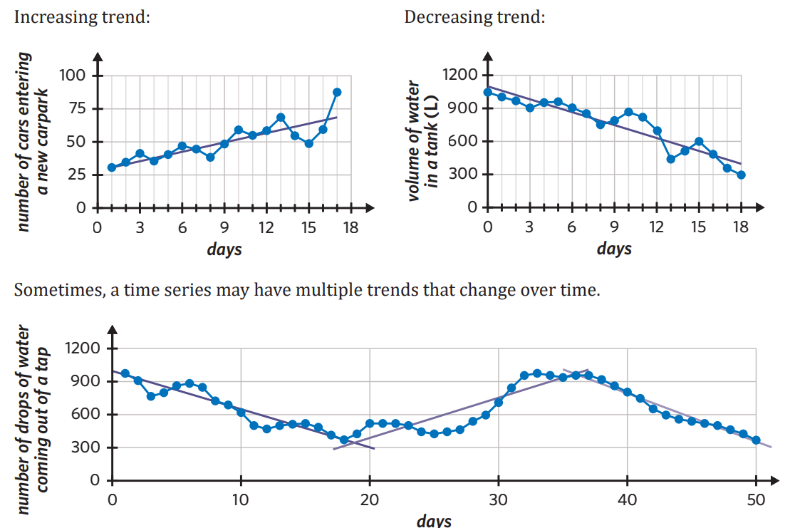
Cycles/cyclical variation: periodic movements over a period greater than 1 year. Peaks of cycles occur at approximately the same intervals, cycles can have a period which changes slightly between peaks.
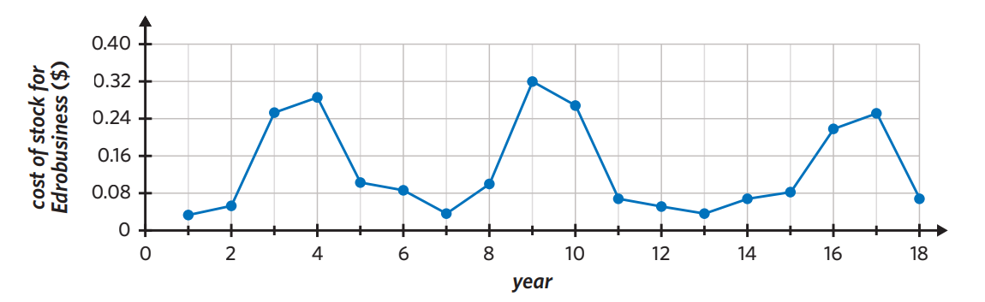
Seasonality: cyclical variation within a calendar-related period (week, month, quarter). A seasonal time series plot has regular peaks and troughs that occur at the same time each period and the length of the period must be a year or less.
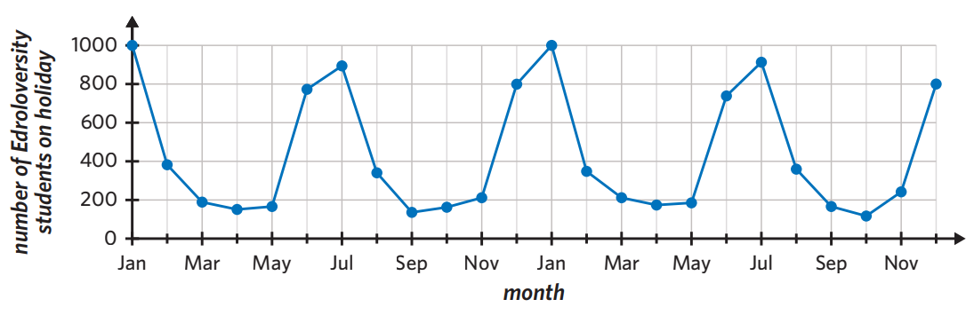
Structural Change: When an established pattern is suddenly altered. The graph then continues on the same level post structural change.
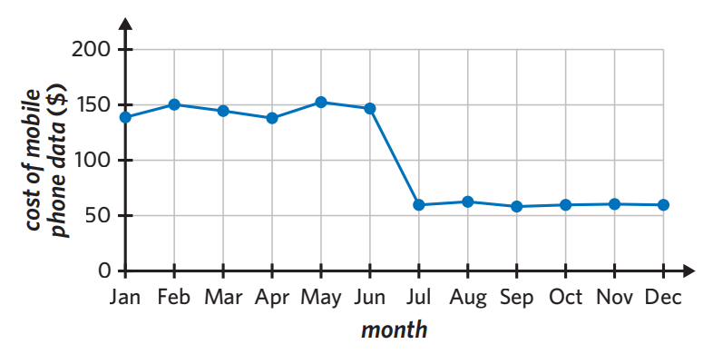
Irregular fluctuations: random variations that cannot be explained by trend, seasonality, cycles or structural change.
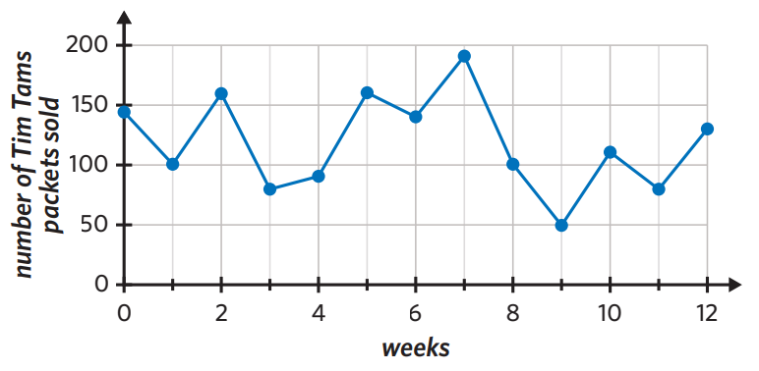
Outliers: stands out from the general body of data. It then returns to follow the original pattern/trend
