Seasonal Indices:
- Seasonal fluctuations exist.
- Seasonal indices (SI) are used to de-seasonalise the data to minimise the effects of seasonality. This allows trends to be more easily observed.
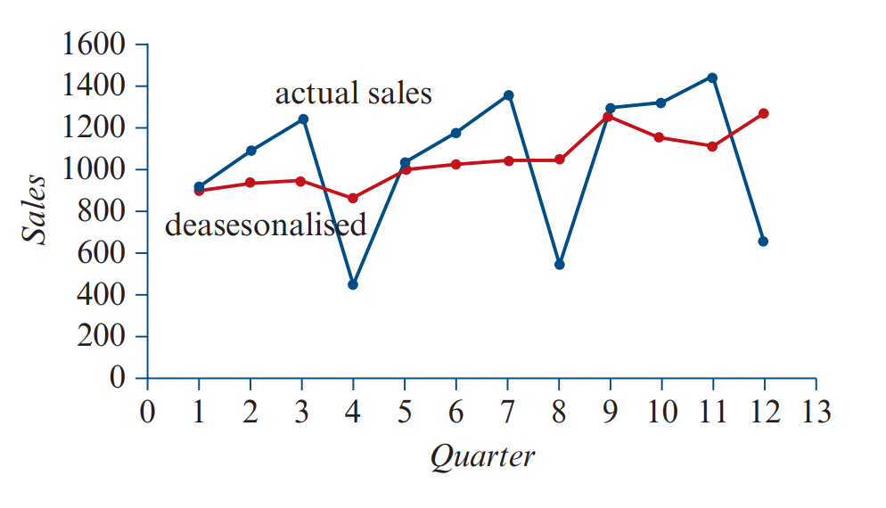
Rules
- $Seasonal index (SI)=\frac{value for season}{seasonal average}$
- $Seasonal average (SA)= \frac{sum of all seasons}{number of season}$
- $Deseasonalised figure (DS)= \frac{value for season}{seasonal index}$
- Reseasonalising data:
$$value for season=deseasonalised figure ×seasonal index$$
How to interpret a seasonal index:
$$\left(seasonal index-1\right)×100 = __________\%$$

- A negative %: (season) is below the seasonal average by ___%
- A positive %: (season) is above the seasonal average by ___%
Correcting for seasonality:
$$(\frac{1}{seasonal index}-1)×100=__________\%$$

- A negative %: To correct (season) for seasonality, (unit) need to be decreased by ____%
- A positive %: To correct (season) for seasonality, (unit) need to be increased by ____%
Notes:
- The sum of seasonal indices is equal to the number of seasons (if you are working with months of a year there are 12 seasons and therefore the seasonal indices should add to 12)
- The seasonal average is 1
Seasonal Indices:
- Seasonal fluctuations exist.
- Seasonal indices (SI) are used to de-seasonalise the data to minimise the effects of seasonality. This allows trends to be more easily observed.
Rules
- $Seasonal index (SI)=\frac{value for season}{seasonal average}$
- $Seasonal average (SA)= \frac{sum of all seasons}{number of season}$
- $Deseasonalised figure (DS)= \frac{value for season}{seasonal index}$
- Reseasonalising data:
$$value for season=deseasonalised figure ×seasonal index$$
How to interpret a seasonal index:
$$\left(seasonal index-1\right)×100 = __________\%$$

- A negative %: (season) is below the seasonal average by ___%
- A positive %: (season) is above the seasonal average by ___%
Correcting for seasonality:
$$(\frac{1}{seasonal index}-1)×100=__________\%$$

- A negative %: To correct (season) for seasonality, (unit) need to be decreased by ____%
- A positive %: To correct (season) for seasonality, (unit) need to be increased by ____%
Notes:
- The sum of seasonal indices is equal to the number of seasons (if you are working with months of a year there are 12 seasons and therefore the seasonal indices should add to 12)
- The seasonal average is 1

