The relationship between the war and photography

CAI ZESHA 18445970

The whole world can be said to be quite unstable recently. A few weeks ago, Russia's army massed on the Ukrainian border and finally invaded Ukraine. The United States and NATO countries began to officially launch economic sanctions against Russia. At this moment, as I am writing this article, the war between Ukraine and Russia is still in full swing, in this kind of situation, I want to discuss the relationship between the war and photography through this essay.

Whereas, before I start writing this essay, I have to declare that- I am not a war fan, I do not support the war, the reason why I want to write this essay is that I have a strong interest in the military. During the same period, we can not ignore the truth that the role of war in promoting human technology, here is a sentence that comes from The National WW2 Museum: “Of the enduring legacies from a war that changed all aspects of life—from economics to justice, to the nature of warfare itself—the scientific and technological legacies of World War II had a profound and permanent effect on life after 1945. ” （Kristen D.Burton, Ph.D. 2013, Paragraph1 ）In my opinion, war can enhance the development of photography, but meanwhile, photography can stop or at least affect the progress of the war.

First of all, here is a question- “what is war?” According to German military theorist Clausewitz: "War is a continuation of politics."( Karl von Clausewitz, 1827, chapter1) however, as far as I am concerned, we do not have to complex the war, what is the purpose of the war? To achieve something politician ambitious, that can be land, money, and some specific nature materials. Then 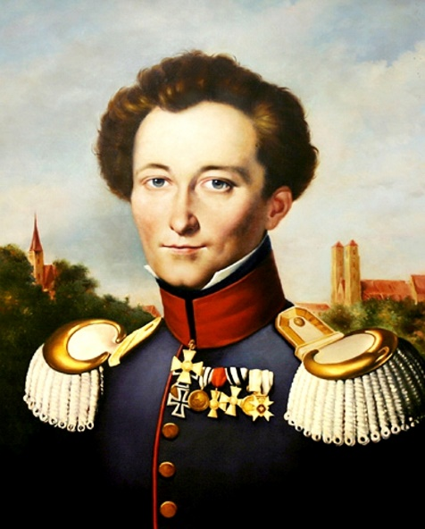how should we win a war? We should win this war through military technology, here is a famous saying from a UK military officer whose name is called Col. J.J. Graham: “If we would conceive as a unit the countless number of duels which make up a War, we shall do so best by supposing to ourselves two wrestlers. Each strives by physical force to compel the other to submit to his will: each endeavor to throw his adversary, and thus render him incapable of further resistance. War, therefore, is an act of violence intended to compel our opponent to fulfill our will*.* Violence arms itself with the inventions of

P.1 figure1. Author unknown (time unknown) *A portrait of Clausewitz*

Art and Science to contend against violence. ” ( Graham, 1918, Definition) According to his theory, we can understand that war is the competition between military science and technology between two countries, but at the same time, the development of military science and technology is without exception closely related to non-military technology. In many cases, the development of military technology depends on non-military technology, and in turn, the development of military technology will help the development of non-military technology.

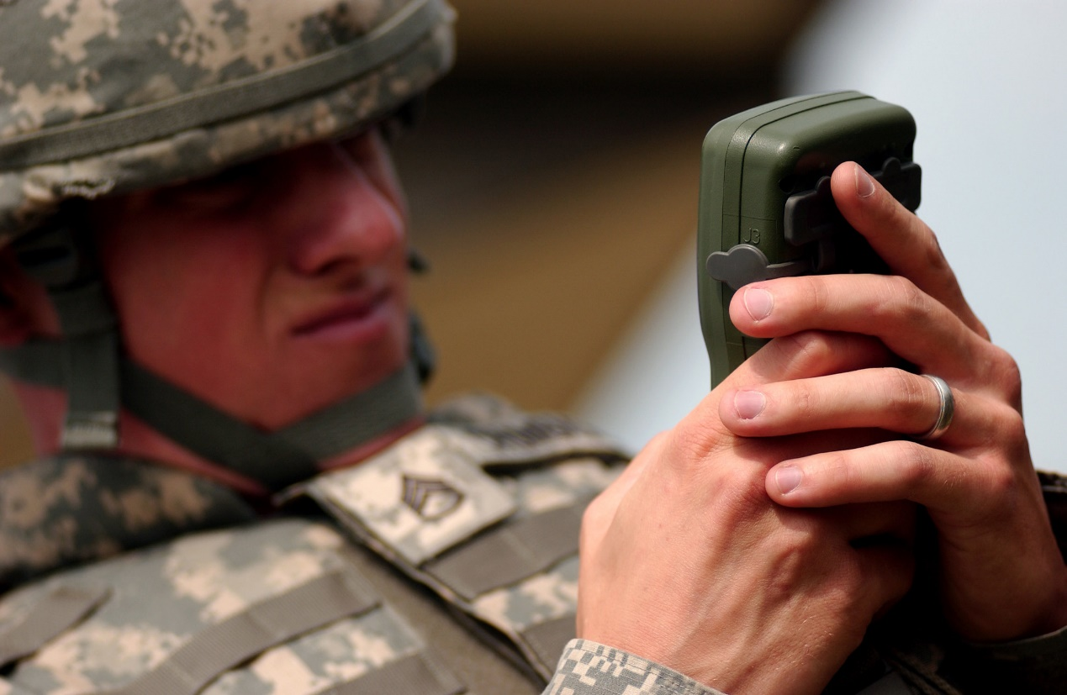

P.2 figure 2. US Army (2020) *An Army soldier uses GPS receivers*

Tons of examples can be used to prove this theory, here are several obvious examples. First of all, GPS, nowadays, when you driving the car, travel in the city, try to find out if there any good restaurants nearby, you will always choose some GPS applications like Google map. But where did GPS come from? Here is the answer: “GPS has its origins in the Sputnik era when scientists were able to track the satellite with shifts in its radio signal known as the "Doppler Effect." The United States Navy conducted satellite navigation experiments in the mid-1960s to track US submarines carrying nuclear missiles. With six satellites orbiting the poles, submarines were able to observe the satellite changes in Doppler and pinpoint the submarine's location within a matter of minutes. In the early 1970s, the Department of Defense (DoD) wanted to ensure a robust, stable satellite navigation system would be available. Embracing previous ideas from Navy scientists, the DoD decided to use satellites to support their proposed navigation system. DoD then followed through and launched its first Navigation System with Timing and Ranging (NAVSTAR) satellite in 1978. The 24 satellite system became fully operational in 1993.” (NASA, 2012, Global Positioning System History) Due to military purposes, GPS come out, and after military units used for dozens of years, it affect the daily life of a normal citizen, become an essential part of our daily life.

After I talked about some much information about war and technology, some people may ask: “What does this have to do with photography?”. Well, just like what has been mentioned before, war can enhance the development of photography, but meanwhile, photography can stop or at least affect the progress of the war.

Here are several examples, first of all, well-known camera lens manufacturer, Zeiss AG, Germany, we all know that Zeiss is famous for its lens production, but how did it develop? How did it get so many experiences about producing high-quality camera lenses? Thanks to the German military and WW1 and WW2. Here is a sentence from Zeiss’s website: “Carl Zeiss began producing optronic instruments for military and civilian applications in the 1890s. The first telescopic sights and stereoscopic rangefinders were developed in 1895. The Military division was founded shortly thereafter when prism binoculars were delivered to the Prussian Army. Instruments for 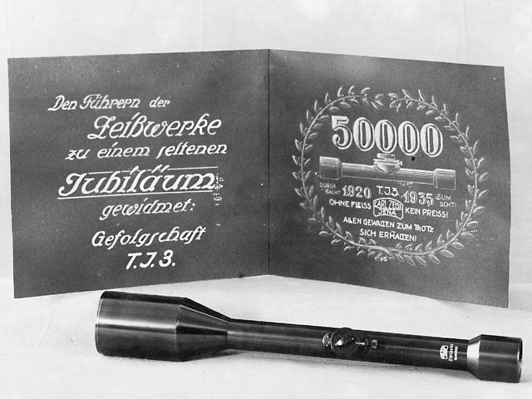

P.3 figure 3. ZEISS website (1892) *The first riflescopes (based on the Beaulieu Marconnay design) were built for sniper rifles and machine guns*

the navy was also developed early on. The periscope for the experimental German submarine Forelle was delivered in 1903. During World Wars I and II, Carl Zeiss focused almost exclusively on manufacturing military optics. In the 1960s and 1970s, the company made waves with numerous innovations such as high-resolution thermal imagers and the well-known periscope Peri R12.” (ZEISS website, 2013, History of Defense System) After the Second World War, Zeiss's military lens manufacturing process accumulated during the war also laid the foundation for Zeiss's success in the civilian field, including Zeiss' lenses for cameras.

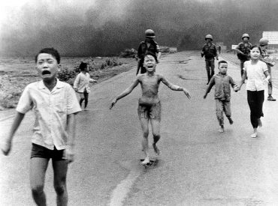P.4 figure 4. Courtesy of Flickr (1972) *South Vietnamese forces flee with civilians after napalm is accidentally dropped on a friendly village*

From the above examples, we can see that the development of military technology can increase the development of photography, meanwhile, as previously mentioned, photography can also affect the progress of the war. For a long time, no matter is the professional photographer or just normal citizens, we always believe one truth, that is “seeing is believing.” During the early period, due to the technology level, normal citizens can not have a full understanding like what is the war situation, how is a war going on on the battlefields. Although you can still send a journalist to the battlefields and find out what is going on, since war photography join the US civil war, this situation just change forever. Finally, in this time, we can use our eyes to know what is going on during the war, after that, with technology development, including radio contact, satellite communication (all those things were developed during the first world war and cold war), a picture can be known and put it on the television screen in a very short time, the most obvious example is the second Vietnam war. During that period, although the battlefields were far away from the US, US citizens can still know what is going on through photos in the newspaper, magazines, or watching live TV shows on the television, it is during this time, lots of pictures which called “The Picture That Ended the Vietnam War” came out. The most famous picture is*Courtesy of Flickr,* his work < *South Vietnamese forces flee with civilians after napalm is accidentally dropped on a friendly village*> was called “To be one of the most memorable photographs of the 20th Century.” (Martin, 2019, Story Behind The The Terror of War: Nick Ut’s "Napalm Girl") There were also some famous pictures taken during the second Vietnam war, for example, *Don McCullin <* *Shell-shocked US Marine >, Gilles Caron <Battle of Dak >, and Philip Jones Griffiths <* *An armed American soldier tries to talk to a Vietnamese woman holding her child >.* Thanks to all those pictures and journalists, US citizens gradually know what is going on in Vietnam, and they were walking on the street, joint strike and fighting against war. With the growing domestic opposition to the Vietnam War, the US president finally made a compromise, In 1973, with public support overwhelmingly against the war in Vietnam, the United States signed the Paris Agreement that led to the withdrawal of all American troops, this war was finally over. And after this war, when Horst Faas (one of the war photographers) invented to talk about their pictures, they just said: “I don’t think we influenced the war… [he believed simply that the job of a journalist was to] record the suffering, the emotions and the sacrifices of both the Americans and the Vietnamese…” Their work allowed for the false reality America was living to fall apart. As Americans lived, worked, and played, the very basic rights all humans are entitled to be violated by both sides.” They did use their photos to stop the war. (Jose Sanchez, 2018, The Picture That Ended the Vietnam War)

After we talk about so many examples, I think we can do come up with a conclusion that the war can increase the development of technology, because the war is the competition between two countries’ military technology levels. However, we can not ignore that the development of military technology also affects photography at the same time, and photography can also affect the war, just like it always does, and the war between Russia and Ukraine proves this theory. Now, we are entering a tough period, because the war between Russia and Ukraine is still going on, and we hope during this war, there will be some brave photographers on the battlefields and use their pictures to record this historical moment and stop the war.

Bibliography:

Kristen D.Burton, Ph.D. (2013) *The Scientific and Technological Advances of World War II.* Available from: https://www.nationalww2museum.org/war/articles/scientific-and-technological-advances-world-war-ii

Karl von Clausewitz. (1827) *On War,* London: Independently published

Col. J.J. Graham. (1918) *Clausewitz: War as Politics by Other Means, Introduction,* Available from: <https://oll.libertyfund.org/page/clausewitz-war-as-politics-by-other-means>

NASA, (2012), *Global Positioning System History, Paragraph 1 and Paragraph 2* Available from: <https://www.nasa.gov/directorates/heo/scan/communications/policy/GPS_History.html>

ZEISS website, (2013), *History of Defense System, paragraph1*

Available from: <https://www.zeiss.com/corporate/int/aboutzeiss/history/technological-milestones/defense-systems.html>

Jose Sanchez, (2018), *The Picture That Ended the Vietnam War, Last Paragraph*

Available from: <https://stmuscholars.org/a-picture-is-worth-an-ended-war/>

Author unknown, (time unknown) *A portrait of Clausewitz*

Available from: <https://en.wikipedia.org/wiki/Carl_von_Clausewitz>

US Army (2020) *An Army soldier uses GPS receivers*

Available from: <https://spacenews.com/three-companies-selected-to-develop-military-gps-handheld-devices/>

ZEISS website (1892) *The first riflescopes (based on the Beaulieu Marconnay design) were built for sniper rifles and machine guns*

Available from: <https://www.zeiss.com/corporate/int/aboutzeiss/history/technological-milestones/defense-systems.html>

Courtesy of Flickr (1972) *South Vietnamese forces flee with civilians after napalm is accidentally dropped on a friendly village*

Available from: https://stmuscholars.org/a-picture-is-worth-an-ended-war/