*Hi, guys, please let me introduce myself, my name is Tom, and I am a photography major student who is doing a BA Photographic Arts at the University of Westminster Harrow campus. I am currently doing an internship at the Gate Darkroom as part of my course.  
Today, let me ask you a question: do you have an interest in knowing how photographers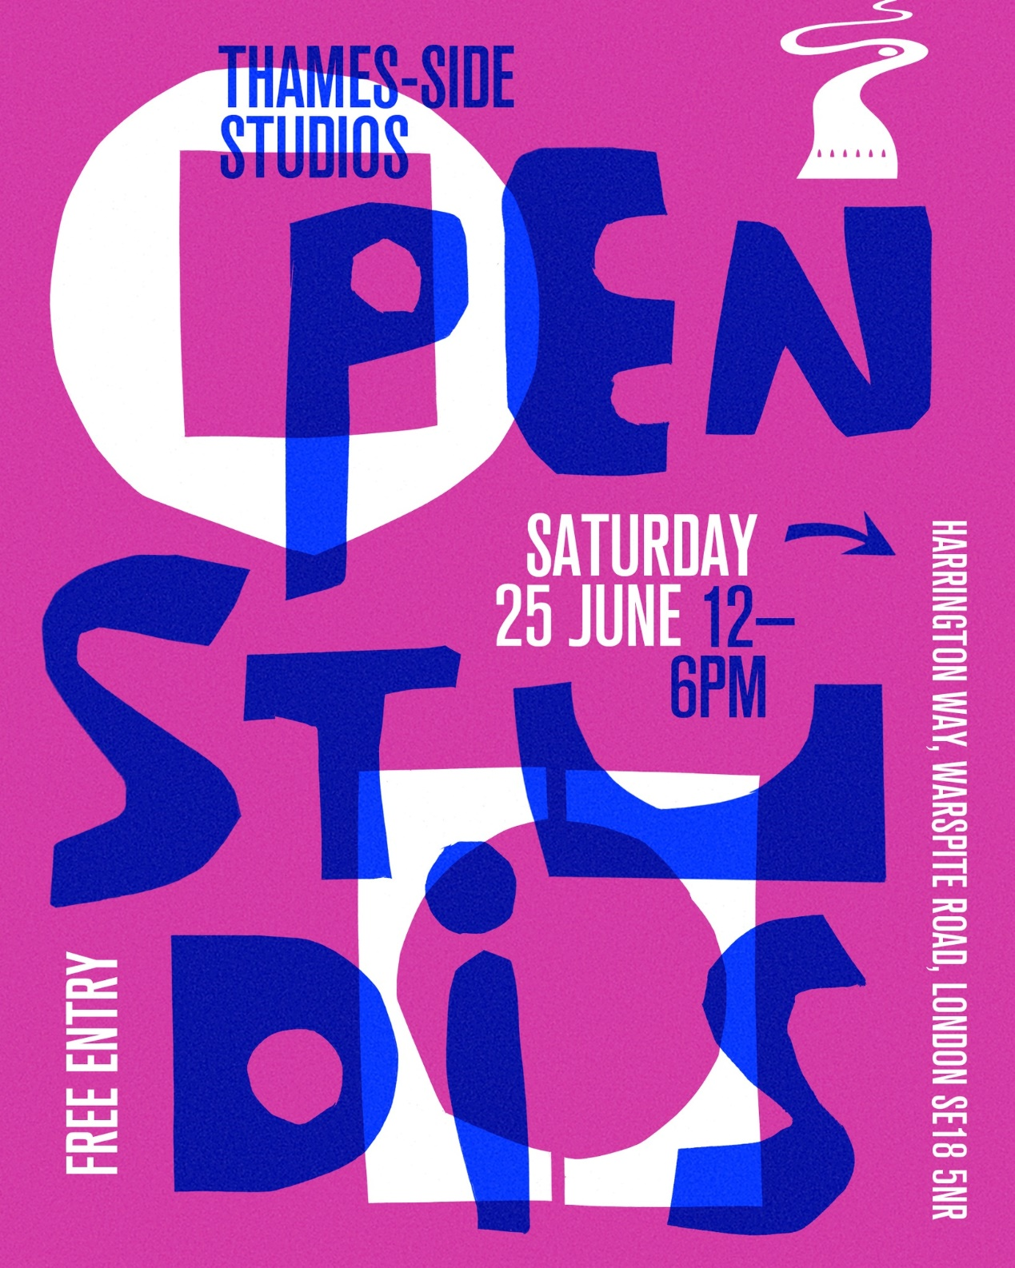 develop film? Or in knowing how photographers print  
pictures from film to paper? Then, congratulations, today you get a chance to know some answers! Please  
let me tell you about the Gate Darkroom Open Studioday, an opportunity to see the darkroom in action!*

*This is also an opportunity to meet some of the artists and photographers of the Gate Darkroom, who will share about their work and printing practice.*

*We will also tell the world about our collective show coming up in September!  
Interested? Then why not visit us on Saturday 25th June 12 pm-6 pm.*

*03, Thames-Side Studios, Studio U0, Harrington Way, Warspite Rd, London SE18 5NR*

* A short introduction about my project The Space City: Have you ever had a feeling like this- You hate your life? To be honest, sometimes, I am just be bored with my life, my lifestyle is simple, make a timetable, then go to sleep, get up at 6:30 AM, go to wash my face and teeth, move to the classroom, have lunch, continue the move to the classroom, have dinner, play a video game, make a timetable, then go to sleep, after that, do all those things again.
* Sometimes, I was thinking whether I can escape from earth, you know, maybe move to a space station. Because space is the several places which make me feel calm and at peace, image when you wake up in the morning, when you open the window, you can just see the earth instead of high buildings. That is the reason why I want to create this work.

Want to see more pictures which I took? Please follow my website link: https://61a24fcca6c5c.site123.me/