# **Game Design Document**

**Game Name:**

Addicat

**Game Concept:**

In the game the player plays a detective, in a case 10 years ago, he lost his beloved wife. In these 10 years, he chose to take drugs to relieve his grief, so he became seriously addicted to drugs. However, a sudden anonymous letter, broke his life, the letter revealed a lot of details of the case 10 years ago, and all the clues point to the old house where the detective used to live when he was young. So the detective in order to explore the truth of the case and the real whereabouts of his wife, embarked on a journey to investigate the old house. However, the truth of the whole matter does not seem to be so simple.

**Team Members**

Yuang Li ;

Jinju Liu ;

Zhongliang Wang ;

Lihan Zhao ;

Chuansong Zhao ;

# **1.Game Overview**

The game takes place in a modern society made up of and governed by animals. In this society, there are also problems such as drug and alcohol addiction. The player takes on the role of a cat detective who is addicted to drugs due to the loss of his wife and returns to the old house where he used to live in order to investigate the suspicious case of his wife's disappearance 10 years ago. Players need to collect various clues in the old house, and according to the clues collected, to piece together the truth of the whole incident. At the same time, he also needs to face his own drug addiction at any time. The ultimate goal is to complete the exploration of the old house according to the information provided in the letter and get the real truth of the whole incident.

**1.1 Features List:**

● **Core Mechanic:** Puzzle

● **Setting:** The modern animals anthropomorphic society

● **Player Character:** Detective

● **Enemies:** Addiction

● **Tone:** Darkness, serious

● **Starting Location:** Detective's own house 10 years ago

● **Progression Mechanic:** Interact with items in the house, collect and organize clues

● **Goal:**Get the truth about wife's disappearance and find her

● **Game Structure:** 2D

● **Differentiators (selling Points):** unreliable narrator

## **1.2 Outline:**

● **Style**

○ 2D

○ pixel art style with dark themes

○ Modern environments

● **Setting**

○ The story takes place in a society composed and managed by animals

○ There is also a serious problem of drug addiction in this society

○ Players mainly in an old house to complete the collection and organization of clues. The house is in the style of a classical European villa.

● **Character**

○ A fallen detective who lost his wife and became addicted to drugs

○ The game begins with the detective before the addiction, with a full detective ability. After the addiction of the detective, all aspects of ability will be affected.

● **Mechanics**

○ Clue gathering, information organization, interaction with items

○ The negative impact of drug addiction on the character

● **Game Genre**

○ 2D

○ Animal anthropomorphization

○ Puzzle

## **1.3 Game Flow Summary:**

● **Intro**

The introduction of animals anthropomorphic worldview, show the health detective 10 years ago.

**● Tutorial**

a.Learn the game mechanics of clue gathering and information organization.

b.The detective is at home, looking for his wife's missing clues, showing the complete ability mechanism of the detective's sober state, which eventually leads to the subsequent story.

**● Level / Narrative**

a.Linearity tells the whole story.

b.The player wakes up from a state of alcoholism and drug addiction.

c.Players return to the old mansion to start investigating the case, but will be affected by drug withdrawal reactions halfway through.

d.After investigating all the clues from the old mansion, come up with the truth of the case.

**● Ending**

The player learns the whole story.

## **1.4 Look and feel:**



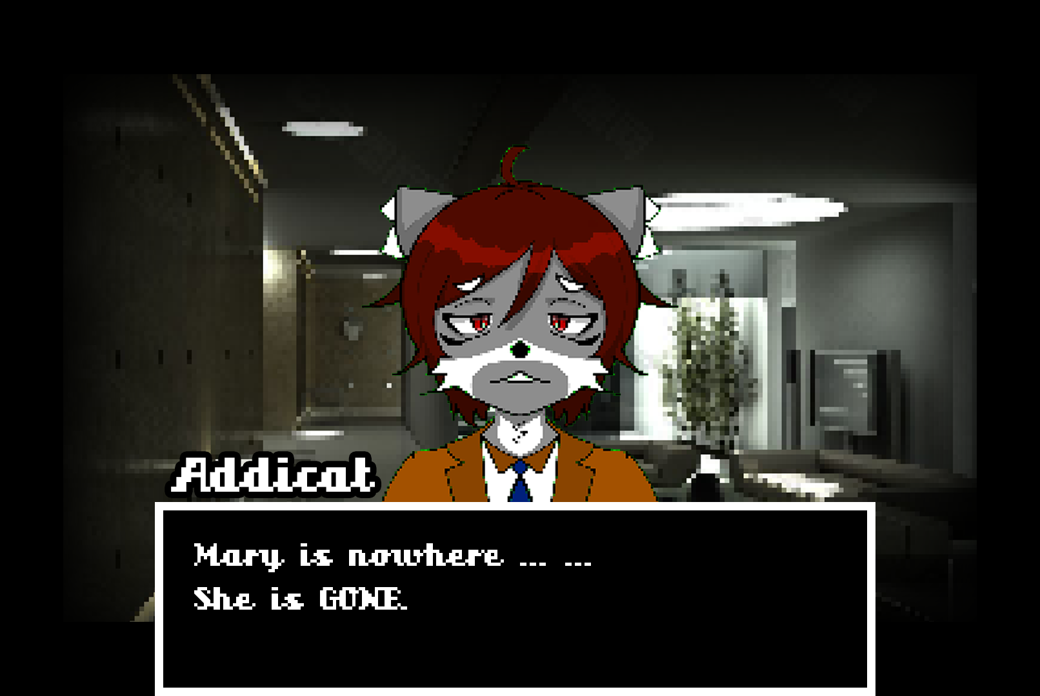

# **2. Gameplay & Mechanics**

**2.1 Overview**

The game uses puzzle solving as the main gameplay. The game process is a linear narrative investigation main task, which can promote the switching between plots and scenes by collecting clues, obtaining key items, and sorting out clues (refer to the Sherlock Holmes series of games). In addition to the normal timeline, Addicat can jump out of the normal timeline through his ability, enter the "Detective Thinking", sort out all the clues collected, and obtain the qualification to the next scene or level.

**2.2 Gameplay Description**

The game is divided into three parts: "What's past is prologue", "Into the Maze" and "To be, or not to be".

***The main gameplay of “What’s past is prologue” part is as follow：***

The player's perspective is the third-person perspective, which is achieved through the function of the camera following the movement of the protagonist."What's past is prologue" is the first level, the purpose is to let the player know how to play this game. The story will take place in the new house where he married his wife. This level has two scenes. At the beginning of the game, the player exploration area has only the first scene. Players can explore in the scene where they are, and obtain the qualifications to enter the second scene after arranging the clues obtained in the exploration area in the correct order. At the same time expand the scope of exploration. Players must complete the collection of clues for each scene in turn and make the correct order to enter the next scene. The way to enter the next scene is to take the stairs, turn through the windows, use key items, and flashback memories. With all the information, the detective will sort out all the thoughts and clues in his head. In this process, players can help detectives understand the truth of the whole case by sorting out clues.

***The main gameplay of “Into the Maze” part is as follow：***

The player's perspective is the third-person perspective, which is achieved through the function of the camera following the movement of the protagonist. "Into the maze" is the second level of the game and the main storyline of the game. Ten years after the time line came to the first level, due to Addicat's long-term drug use, the physical skills have not been as good as before. Players need to overcome the drug withdrawal symptoms to complete the puzzle. The drug withdrawal symptoms include, but are not limited to, stop and take drugs, blurred vision, and visionary hallucinations. Players will start the game from the garden of the old house, and they need to find the correct way to enter the old house and expand the scope of exploration. At the same time, players need to search for the clues obtained in each scene, and arrange them in the correct order to obtain the qualification to enter the second scene, while expanding the scope of exploration. Players must complete the collection of clues for each scene in turn and make the correct order to enter the next scene. The way to enter the next scene is to take the stairs, turn through the windows, use key items, and flashback memories. With all the information, the detective will sort out all the thoughts and clues in his head. In this process, players can help detectives understand the truth of the whole case by sorting out clues.

***The main gameplay of “To be, or not to be” part is as follow：***

The player's perspective is the third-person perspective, which is achieved through the function of the camera following the movement of the protagonist. "To be, or not to be '' is the third and final level of the game. The process of this level is very short, the player needs to control Addicat walk to his wife to complete this level. In this level, the way of the character movement has been changed. No matter what the player presses any movement key, it will make Addicat go to his wife. The moment Addicat meets his wife, the scene will switch and Addicat will fall from the roof. During the fall, players will see a list of development team members.

**2.3 Game Mechanics:**

**Detective Thinking：**When Addicat starts to think about the case, all clues will appear in the thinking hall (independent page), and players need to get new clues or qualify for the next scene by sorting the clue slips.

**Mind Palace：**Before getting to the next level, players will have to finish the Mind Palace, providing the required clues and then tried to find out the truth of the level.

Stage 1: Choosing the clues. Hints will be provided to show what to choose.

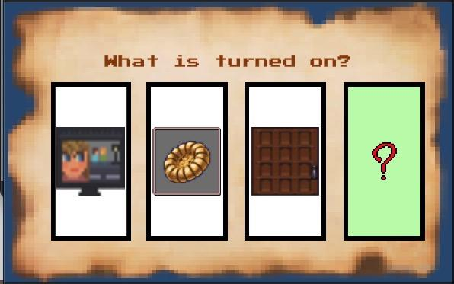

Stage 2: Ideas made by Addicat will show in the screen randomly. Players will have to use the ideas generated by their clues as bullet to shoot the ideas shown in the screen so as to convert the idea into the truth.

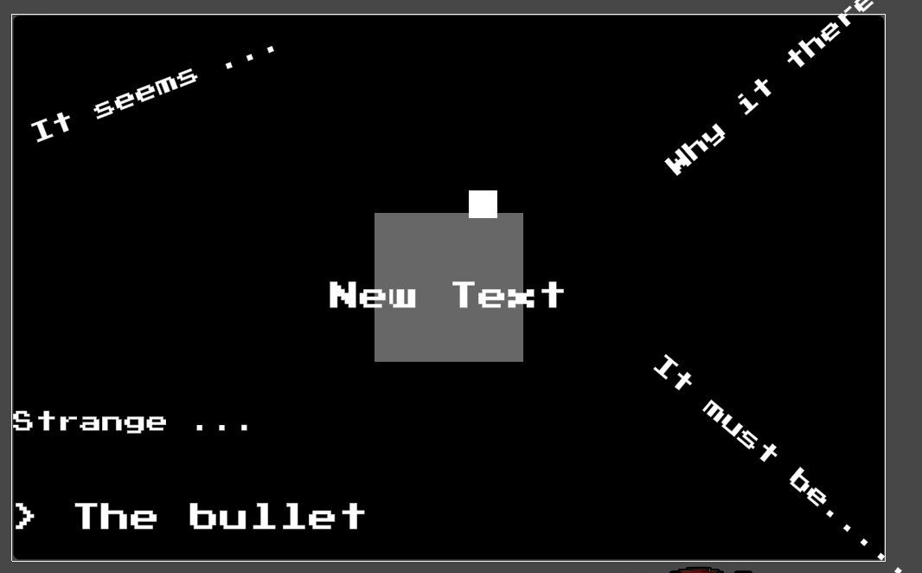

**Detective’s Movement：**Simple physical system, players can control the Addicat through the keyboard through different scenes, including but not limited to walking and jumping.

**The Sixth Sense：**Addicat will see some key props, Addicat's sixth sense can realize whether the props are useful, and through the sixth sense these props will be highlighted when approaching. At the same time, under certain conditions, there will be hints to help players, so that players will not be so frustrated and give up the game.

**Backpack:** Simple backpack system. Addicat's backpack, which can hold a lot of things. This backpack is used to collect all game props.

**Puzzle Mini-game：**Players need to play some simple puzzle mini-games to collect in-game clues (refer to the Sherlock Holmes series of games).

**2.4 Game Controls:**

W：Move up

S: Move down

A: Move left

D: Move right

Space: Jump

E: Interact

J：Mind Palace

Mouse: Lead Wiring and Setup Interaction

# **MDA MODEL**

| **Aesthetics:** The emotional outcomes the game strives for | **Dynamics:** The gameplay that will lead to the intended aesthetics | **Mechanics:** The rules and features that will lead to the intended dynamics |
| --- | --- | --- |
| **Challenges:** in the sense of accomplishment after solving challenges (puzzles in the form of spatial or texts) | The player will traverse the scenes to find the clues in different positions.  The player can find the hidden information of a clue and the links between pieces of clues.  The player can recover the story of the game by collecting enough messages from the clues. | A simple physics system that player will use to traverse the scene including walking and jumping.  A interaction system that player can interact with the items including changing the items’ positions and getting hints from the items.  A memory collection system that player can drag the clue (will be presented in the form as broken pieces of papers writing clues on them) to find the links between different clues, and if there are connections between them the player can get a new clue. |
| **Curiosity:** in the sense of wondering what will happen next in the following process of playing games. | The player will need to find enough and necessary hints under the clues to knock together a complete story.  The player will learn from the tutorial level not only the basic operations but also together with an incomplete story with a start. | There will be different sub-scenes in the whole scene, and player is not allowed to enter the next scene unless he found all the necessary clues in the previous sub-scene. |
| **Fantasy:** in the sense of immersing the player himself/herself in a fancied and cartoonlish world. | Everything of this gamehappened in a world in which the society is a 1980-liked society governed by animals.  As a detective our hero will have a special power that is good for detecting cases but seems impossible in reality. | The hero is set to be a cat detective with the ability of collating and inferring clues in a very short period of time. |
| **Masochism (**in the sense of experiencing tough puzzles and the frustration of failing to solve the puzzles, together with the overall dark and depressed style of the game that the player has to experience**)** | In some levels of the games there will be some pretty hard puzzles and the player may need to spend long time to solve them.  The whole playing process is under a sad and depressing atmosphere with a detective story. | There will be many scenes and many items in the scenes and player need to select the ones that are useful to finishing the level.  Some of the puzzles require a lot of information and player need to grasp the necessary ones for themselves, and player also need to ）find the links between different clues, so there will be hints that help player to make them not so frustrated. |
| **Unpredictable (**in the sense of being surprised with the outcome of a story and got no idea of what the result will be before seeing the result**)** | The player will collect the truth of the story by himself and through the progress of the story the player will find at the end of the game the story is not what the player thought it should be. | There will be information collected after getting an item or solving a puzzle, the player need to recover the truth based on the clues. |
| **Suspense (**in the sense of a state of excitement or anxiety about something that is going to happen very soon**)** | The player will feel a strange atmosphere with unknown mysteries through the progress of the game. | The collected information will remain some blurry information to imply the truth behind the story. |

# **4. Story and Narrative**

The beginning of the story takes place in the detective's own home, he came home from work one day to find his wife missing, through his skills to collect all the clues, came to a conclusion that his wife was kidnapped by intruders, but there is no evidence left at the scene. Subsequently through the form of slides to show the subsequent ten years of the detective gradually degenerate changes, until ten years later, the detective received an anonymous letter.

The letter reads, "Want to know about your wife, go back to the place where you lived when you were young". Although 10 years had passed, the detective was still able to recognize that this was his wife's script, so he immediately set off for the old house where he had lived for many years in his youth.

As a result of continued years of alcohol and drug abuse, the detective's body functions and brain are not as good as they used to be, his thinking speed is greatly reduced, and he even makes bad decisions at times. The process of investigation may involuntarily begin to smoke catnip drugs, when a period of time without smoking, he will have a severe withdrawal reaction, vision becomes blurred, hallucinations before his eyes.

After an in-depth investigation of every house in the old house, the detective gradually recalled the real situation of that incident 10 years ago. It turned out that as early as that time, he had already been addicted to drugs, but at the same time his wife was suffering from a serious illness. He spent a lot of savings buying drugs and could not continue to support his wife's treatment costs. At that time, his heart was full of guilt towards his wife, but he had no way to control his dependence on drugs at the beginning of his addiction. These two factors intertwined in his mind and eventually made him package the whole thing in his subconscious as a story of his wife being kidnapped and taken away by intruders. He completely sealed the story of abandoning his wife 10 years ago in the depths of his heart so that he would not have to face it and let himself suffer inside.

He realized that his wife did not die, but just chose to leave 10 years ago so as not to drag herself down, and the letter he received earlier was the best proof of that. So he picked up his spirit again and continued to search for clues in the old house, trying to find the real whereabouts of his wife.

After the investigation of the ancient mansion is over, the protagonist finds his wife, who was once abandoned by himself, and he is grateful that God can give himself a second chance to come back, and he walks towards his wife full of happiness. At this point the game screen gradually blurred, it turns out that everything that happened in the old house is also a hallucination after the detective overdosed on drugs. The detective's wife passed away long ago due to illness, and the habit of taking drugs for years and years has long destroyed the detective's mind and body completely.

In reality, the detective has long been on the roof of the apartment, while in the illusion, his wife is waving to himself in front. Reality and fantasy dreams alternate, the detective uncontrollably towards the edge of the roof of the building. Then in the fall, the story ends.

# **5. Character**

**Addicat:**

● Losing hope in life.

● The only motivation to live is to find his wife.

● A lifelong alcoholic and drug addict.

● 10 years ago he was an excellent detective, with strong criminal investigation ability.

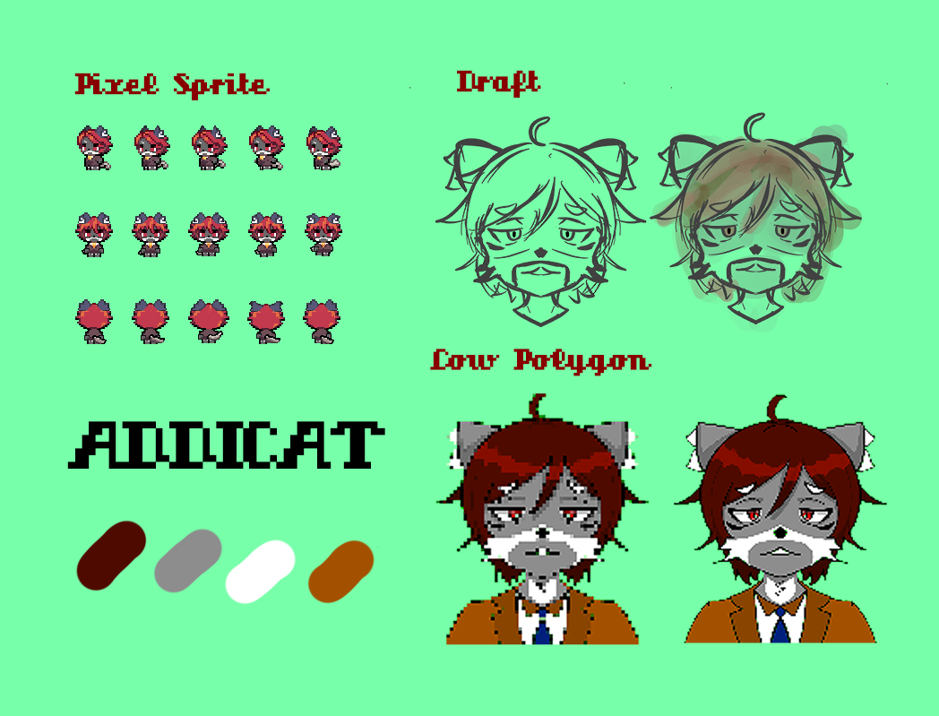

**6. Tutorial**

The detective returned to his home and found his wife missing, so he launched a reconnaissance in his home to find clues, allowing players to become familiar with the character controls and the basic mechanics of the game.

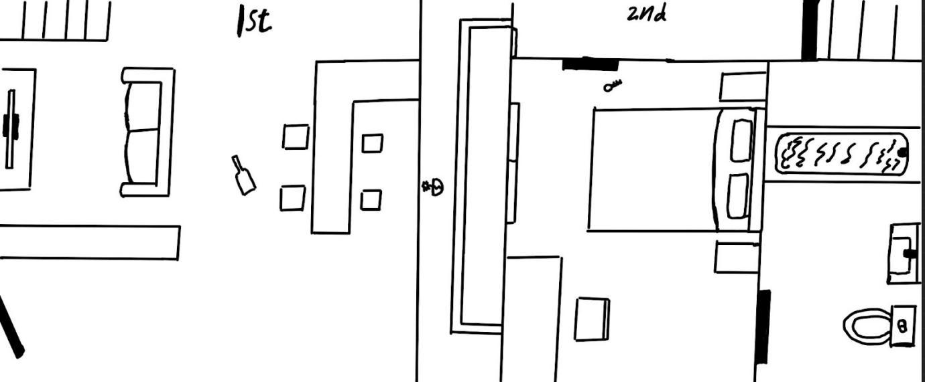

The detective first observed that the door of the house is hidden and not closed tightly, get [clue: hidden door, related association: the wife went out and forgot to close / someone into the house]. The clues obtained will be presented directly in a separate page, so that players know that this is the detective's ability to collect and organize clues (Mind Palace).

Entering the first floor, observe that there are cut vegetables but not yet cooked in the kitchen and a bottle of red wine spilled on the floor. Get [clue: messy kitchen, related association: there was a conflict here / wife's negligence]. At this point in the mind palace, two clues are highlighted, suggesting that players can interact to generate new conclusions. Players need to choose "someone into the house" and "there was a conflict" these two associations, you can get a new conclusion - someone broke into the home and a conflict with the wife. If the correct option is not selected, then the player will be a wrong branch and in the end find that such a choice does not seem to allow the game to continue.

In the living room, the TV is on, showing a variety show that the wife doesn't like, and the sound is turned up. After interacting with this scene, the detective would conclude on his own that someone was trying to cover up the sound of the conflict through the TV sound.

Finally, the two conclusions are combined with two unassociated clues to restore the whole event. Someone entered the home from the first floor, clashed with the wife in the kitchen and took her away.

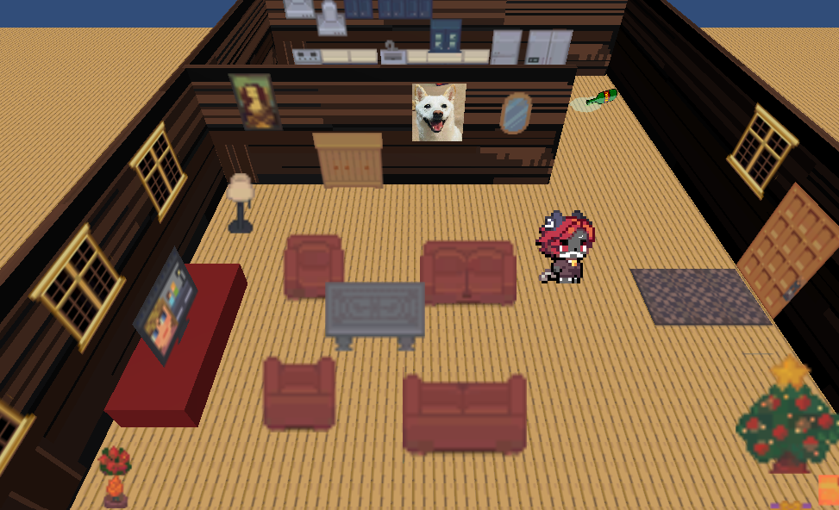

# **7. Levels**

**7.1 Levels overview**

**Main scenes:** old house

**Secondary scenes:** living room, bedroom, study room,attic, roof

As the player finishes the tutorial, the player will start at the old house garden. There will be only one house right in front of the player, it will make the player think that’s the only way to enter the house. The player can not enter the house because the door was locked, then a text window will show up to hint to the player where is the key.

As the player enters the house, the first scene is the living room and kitchen. It is a messy old house. The first thing the player will notice is a twinkling on the living room table, it will lead the player to find the first clue, that tells the player what to do next.

After the player reaches the second clue, it will guide the player to go to the second bedroom. The second room is located on the first floor. However, the door was jammed by a wood stick that blocks the door handle, the player needs to find something that can push the wood stick away.

The player will be guided to the master bedroom which is located on the second floor. Unfortunately, the room was locked, and then it will hint the player about the possible way to get into the master bedroom.

**7.2 Living Room**

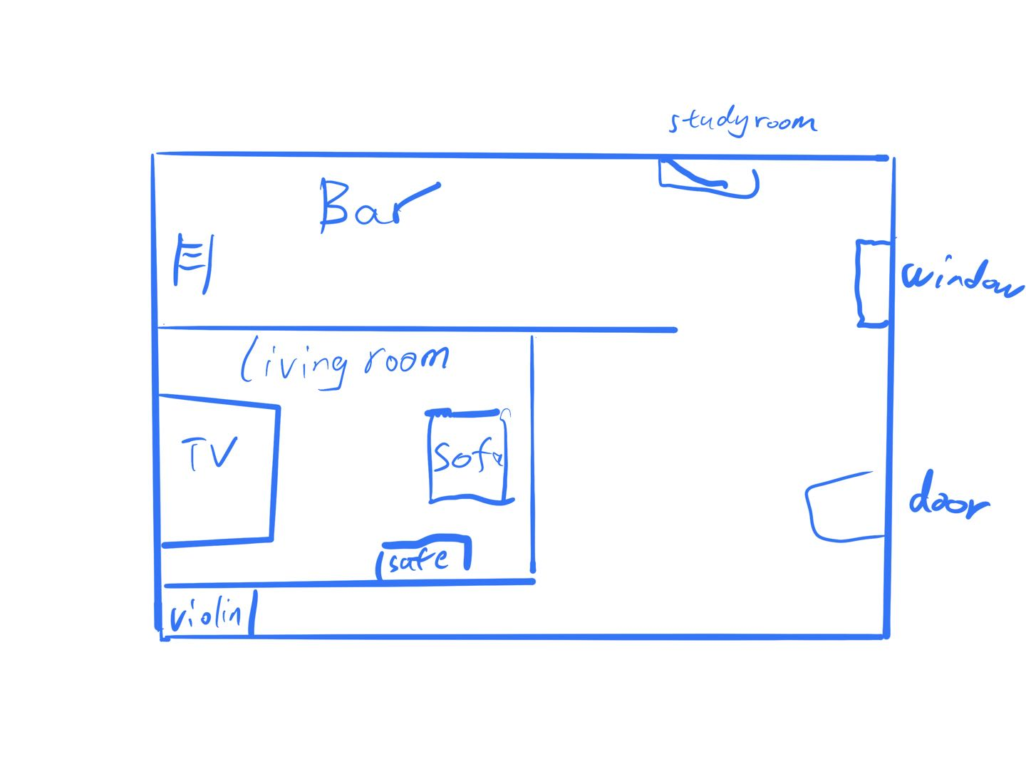

After turning over the window, addicat came to the living room. The layout of the living room was the same as it was ten years ago, but because no one lived for a long time, the house was very dusty. There is a thick layer of dust on the bar on the right, the books on the bookshelf on the left are still neatly arranged, there are some spider webs on the phonograph, the TV on the TV cabinet can no longer be turned on, and there is a broken violin next to the TV cabinet. The safe, addicat has forgotten what was in it. (Explore living room)

Bar: 'Oh my God, how long has it been since I've been back', addicat said to himself. Looking at the expired wines on the wine cabinet, addi's thoughts seemed to return to his original life. 'I almost forgot how her favorite wine is made, let me find the wine list'. addicat looked at the grey wine book on the bar, I should make a glass of wine.

Wine spectrum:

Margaritas ''consisting of tequila, orange zest, lemon juice, shake, and salted in a margarita glass''. Margaret commemorates the bartender's girlfriend, tequila and lemon juice represent the passion and bitterness of the love period, and the salt on the glass represents the lover's tears. tip: I like this story, but I don't like the tears of a lover.

Jack Wells: ''Vodka, lime juice, ginger beer, served in a copper cup. '' Jack Wells, Legendary City: The Big Shots of Night City, Legend. Most people like it as one of afterlife's signature drinks, because Jack said the most important thing is to add a little love.

David Martinez: ''Vodka, Coke'' bullet glass served with ice. David Martinez, the legendary city: one of the legends of the night city, the leader of the cyberpunk squad, once the top student in the school, and later became the legend of the night city, Coke represents the lover Lucy, As the drinkers in afterlife say: life is great, death is glorious.

Wine Cabinet: Choose the wine you want to blend:

Margaret --- Get the clue "Lover's Tears"

Addicat's wife's favorite cocktail ever. Ten years ago, Addi often made cocktails at home with his wife. Because Addi was a detective, he liked to write some interesting messages under different wine bottles for his wife to solve puzzles. And the message left at the bottom of the bottles that made these bottles was "Go to the safe and the bookshelf for information"

Jack Wells - Jack, you are the big man in Night City

David Martinez - David, sorry to not see you on the moon together

Safe:

Addicat looked at the safe and said to himself 'Oh, the password to the safe, on the bookshelf, I remember the clues are on the bookshelf, this is a little game we play a lot. "

Lock-Foxmes is printed on the safe, there is a screen and a small keyboard above the Lock, choose the password "sher", "big", "time", "tea" you want to enter.

sher - safe open, get clue 'empty ring box'

big - no response

time - no response

tea——no response

bookshelf:

There are all kinds of books on the shelves, and detective novels can always give you a different inspiration. Look at these familiar books: Acattha's Puppy under the sun, Conan Dogge's Sherlock-Foxmes series. Addi thought he already knew the password to the safe. Get clues Acattha, Conan Dogge, sherlock-foxmes - jump to safe page

TV cabinet: There is an old cd on the TV cabinet, which is addi's favorite movie 'Murder in the panda restaurant'. I used to like to watch this movie on the sofa with my wife after dinner.' I like the human thinking in it, ' addicat said to himself. He recalled that his wife didn't like this kind of human thinking because she believed that love can't be changed by anything. Get clues: The Panda Restaurant Murder.

Violin: This is my wife's favorite instrument, she likes to drink at home and play the violin. Maybe the strings of the violin have been broken because they have not been maintained for too long. Get clues - violin with broken strings.

Gramophone: This is addi's favorite gramophone, a gift from his wife to addi. He used to like to drink while listening to the music of the gramophone and dancing. Get clues ---- record end of the world.

Story: The living room used to be a place where Addicat and his wife often played together. They used to drink here and dance in the living room listening to songs. Occasionally on holiday afternoons, Addi would watch TV with his wife on the sofa, occasionally tell his wife about his favorite novels, or listen to his wife play the violin. "It used to be a good time," Addi said. "I just don't know where I can go next...

Suddenly Addi noticed a small black box in the safe box, and he found a small key. This is the key to the bedroom. . . There is a note under the key "I hope you will search for clues a little bit to unlock the secret of this old house, and you will know where I am." It is still a note from the wife

Addi looked at the key in his hand, he knew it was time to explore the bedroom.

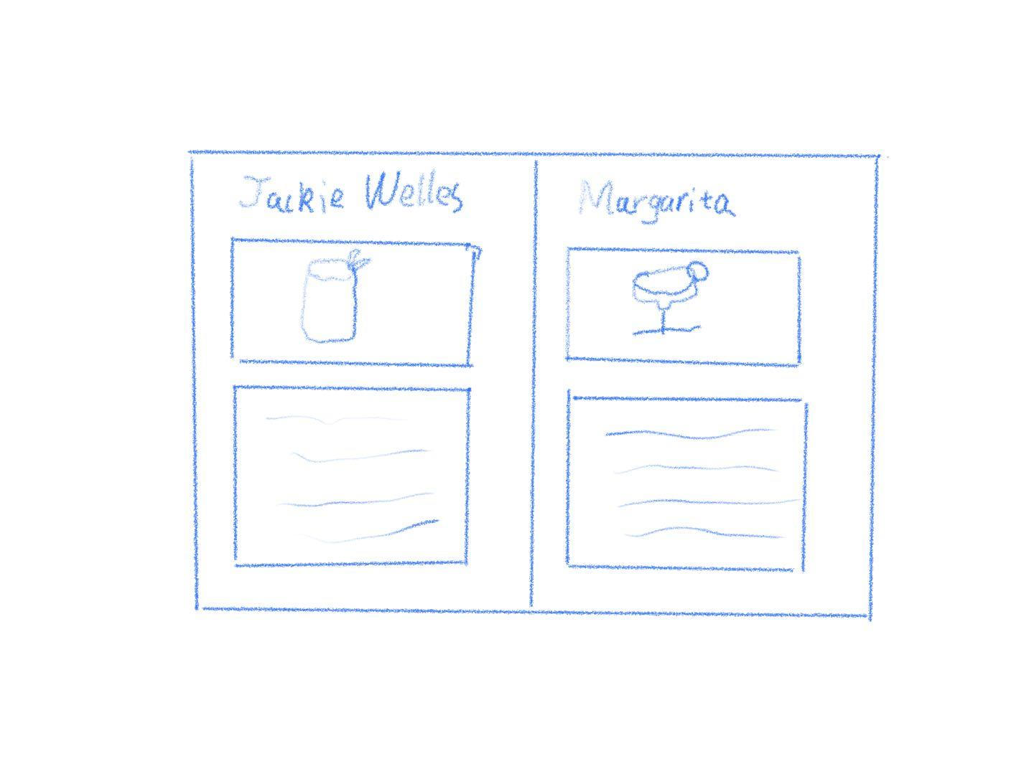

**7.3 Bed Room**

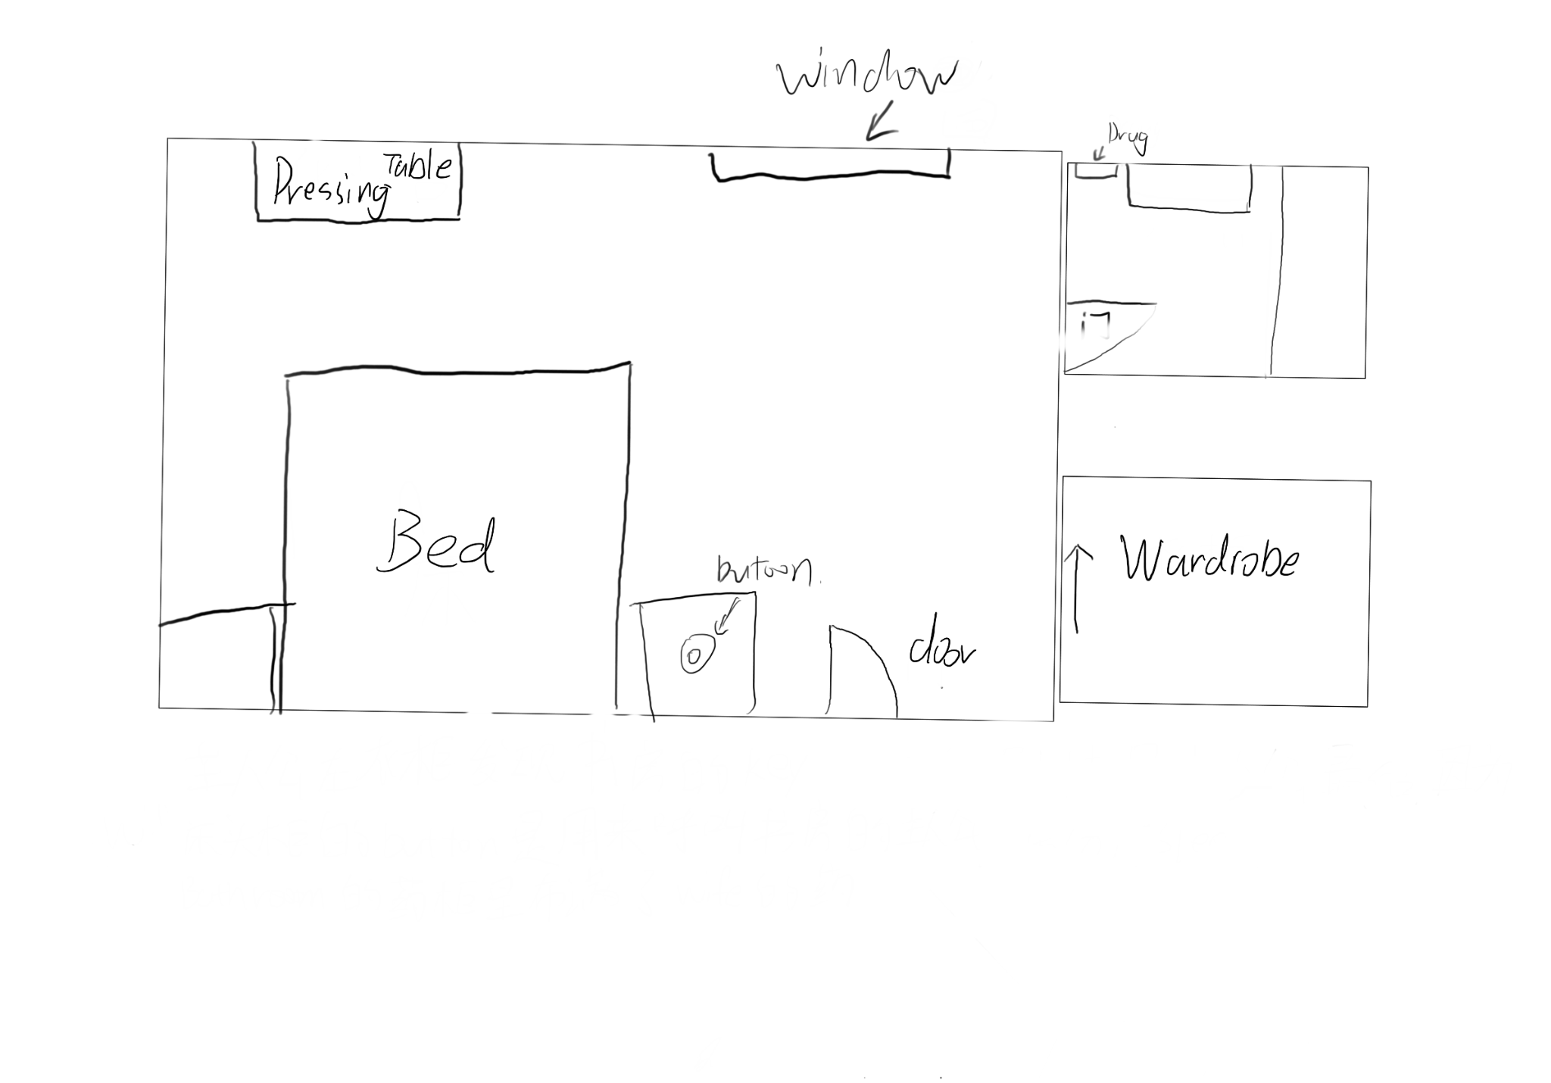

After exploring the living room, Addicat came to the room where he and his wife spent the most time together, their bedroom. As soon as he entered the door, Addicat found that their sweet room no longer existed because the room had been abandoned for a long time. Although the appearance of the room can no longer see as the scene of the old time but everything remains as it is. What caught Addicat's attention the most was his wife's favorite pink dressing table, behind which was the bedroom's double bed. On either side of the double bed are bedside tables. This is the main area of the bedroom. On the upper right side of the room is the bathroom, and on the lower right side is the wardrobe for them. (Explore the Master Bedroom).

Living Room: Go back to the previous scene.

Bedside tables: "There's a red button on it, and I've forgotten what this thing does." Addicat wondered.

Sweet Room: "What a nostalgic room. The time with my wife was the only bright spot in my life. At that time, we often watched detective movies in the bedroom, and she often complained about me because I liked to give her riddles during the movie. Ha-ha, it was a wonderful time to think about it now. " While Addicat was talking to himself, he looked at the pink dressing table that couldn't be ignored.

Pink Dressing table: "I miss this dressing table, there were not so many cosmetics in the past, and now there are still so many bottles of cosmetics left on the table. I also often laugh at her poor makeup skills lol. " Slowly, Addicat's expression darkened, perhaps thinking of something. "This obvious dressing table is a check-in gift that I bought for her, and it is still well-preserved right now."

Bottles: Addicat noticed these cosmetic bottles on the table and involuntarily picked them up. "How come there are numbers on these bottles? Maybe a clue."

Numbers: There are a total of 5 bottles with different numbers and different dates on each bottle.

Toner: 4, Oct

Setting Powder: 1, Aug

Lipstick: 5, Jan

Cream: 2, Mar

Lotion: 8, Dec

Bathroom: Addicat went into the bathroom, saw the medicine cabinet, and exclaimed, "What kind of medicine is left there?"

Medicine cabinet: "So many medicines are for my wife, and later buying medicine for my wife became part of my life." There are many empty bottles with different names of medicines, and the most obvious medicines are painkillers. I feel very sad for some reason.

("It's nothing else here, I remember there was a mechanism in the closet for me to hide things.")

Wardrobe: "There are still hangers here, wait, I remember that these hangers seem to be different from the ones I designed before, and the numbers on them have also changed."

Hanger: There are different numbers on the hangers 2, 5, 8, 4, and 1 in order. "This should be my mechanism, but the number and the number of hangers is different. Where have I seen these numbers before?" Addicat said this thoughtfully. "Although the mechanism is not the same as before, it should still be the same as my previous design. As long as the mechanism is arranged in the correct order, the mechanism can be activated." Addicat said it with certainty.

25481 - No response

85124 - No response

48215 - No response

52148 - Mechanism activated.

There is a key in the mechanism. It says for my study room.

Storyline: This bedroom is where Addicat and his wife lived together for a long time, and the two have countless memories in this bedroom. Some are sweet and some are bitter. When I just moved into this house, I gave my wife a pink dressing table as a check-in gift. Although my wife's makeup skills are not very good, she is still very happy. We often watch detective movies together in the bedroom. I also often gave her some little riddles while watching movies. Although she liked these riddles very much, she often said that I affected the look and feel of the movie in this way. When we found out that my wife was terminally ill during a medical examination, my wife's mood began to become lower and lower, and she stopped her hobby of the violin. My wife's complexion has become worse and worse. And she tried to use makeup to cover up the complexion caused by drugs and chemotherapy. More and more medicines no longer fit in the medicine cabinet in the bathroom. I went into the wardrobe and opened the mechanism that was hiding my notepad, thinking I thought I should sleep in a different room so my wife could have a better resting environment.

**7.4 Study Room**

The detective gets the key to the study room from the master bedroom, returns to the first floor, and enters the study room.

There was a trash can on the floor of the study, filled with catnip cigarette boxes, and an unfinished box of catnip scattered on the floor next to it. The detective walked over to check, very puzzled muttering to himself: "Why is there catnip here, when I lived here, I obviously did not have ..., forget it, it just so happens that the cigarettes I brought also smoked out, take this pack with you." Get the prop, catnip.

The detective then saw his computer, opened it and found that he needed a password, and the password prompt was: the day I realized my dream. The detective said to himself, "Damn, how come I can't even remember my password, time to look elsewhere for clues." Then looking through the bookcase, on the bookcase found his badge when he was a detective, with the time he became a police officer: 2010.10.1 The detective then said to himself, "Becoming a police officer has always been my dream as a child."

The computer password is 2010101, after entering the correct password, the detective can open the computer. The browsing record of the computer shows in order:

2012.4.23 XX disease treatment expenses

NEXT

2012.4.24 Chance of recovery from XX disease

NEXT

2012.5.15 Antidepressants

NEXT

2012.5.20 How to quit Catnip

NEXT

2012.6.2 Catnip purchase channels

FINISH

After reading all the browsing records, the detective fell into deep thought: "Impossible, this is absolutely not true, I should not have been addicted to drugs at that time, all my efforts are to cure my wife, how can I be on drugs!"

At that moment there was a crisp sound from the bed behind him, as if something had fallen to the floor. The detective found the key to the attic by the bed. "This should be the key to the attic, I'm going up there to find out what's going on, the whole thing is really bizarre, damn it!"

Study room interactable content.

1. Catnip next to the garbage can

Text box: "Why is there catnip here? When I lived here, I obviously didn't have any..., forget it, it just so happens that I'm done with the cigarettes I brought with me, so take this pack with you."

Catnip enters the backpack system.

2. Computer

UI: Please enter your password; Password prompt

Password prompt when clicked: the day the dream comes true

Text box: "Damn, how come I can't even remember my password, time to look for clues somewhere else."

3. Bookshlef

Police badge: 2010.10.1

Textbox: "Becoming a police officer was always my dream when I was a kid."

4. Next

Click to show the next browsing record

5.Finish

Click to show text box "Impossible, this is absolutely not true, I shouldn't have been addicted to drugs at that time, all my efforts were only to cure my wife, how could I have taken drugs!"

6. The key to the attic

Text box: "This should be the key to the attic, I'm going up there to find out what's going on, the whole thing is really bizarre, damn it!"

The attic key enters the backpack system.

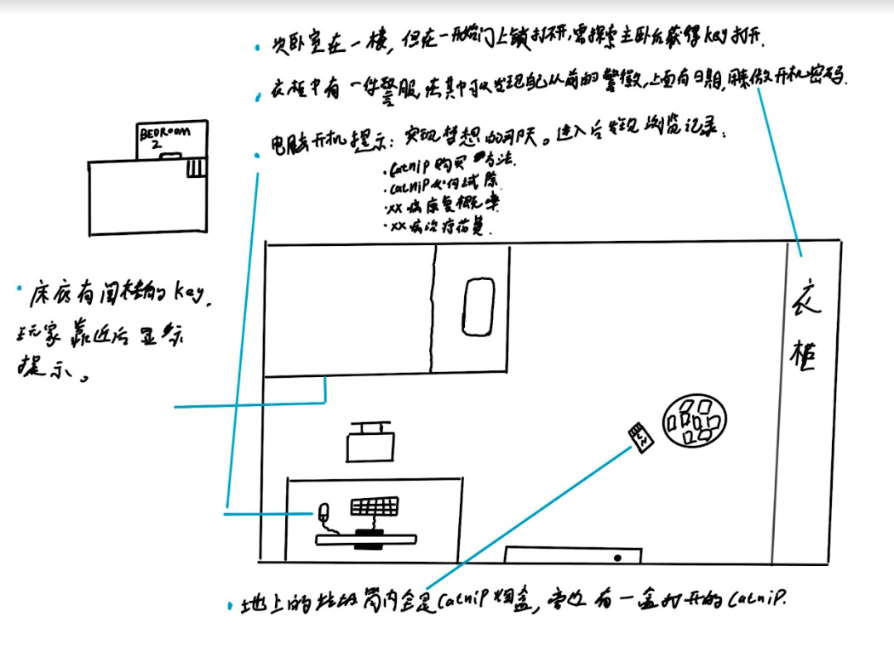

**7.5 Attic**

Addi took the ladder to the attic, where nothing changed. The attic used to be where Addi worked. Addi often came to the attic to work by himself. Every time he handled a case, he would sort out every detail on the [[whiteboard]] on the right. There is a [[desk]] and a chair next to the whiteboard, which Addi uses for office work. There is a row of clocks on the table, and one of Addi's toy games. On the left side of the attic is another [[safe box]], and Addi doesn't know what is in it.

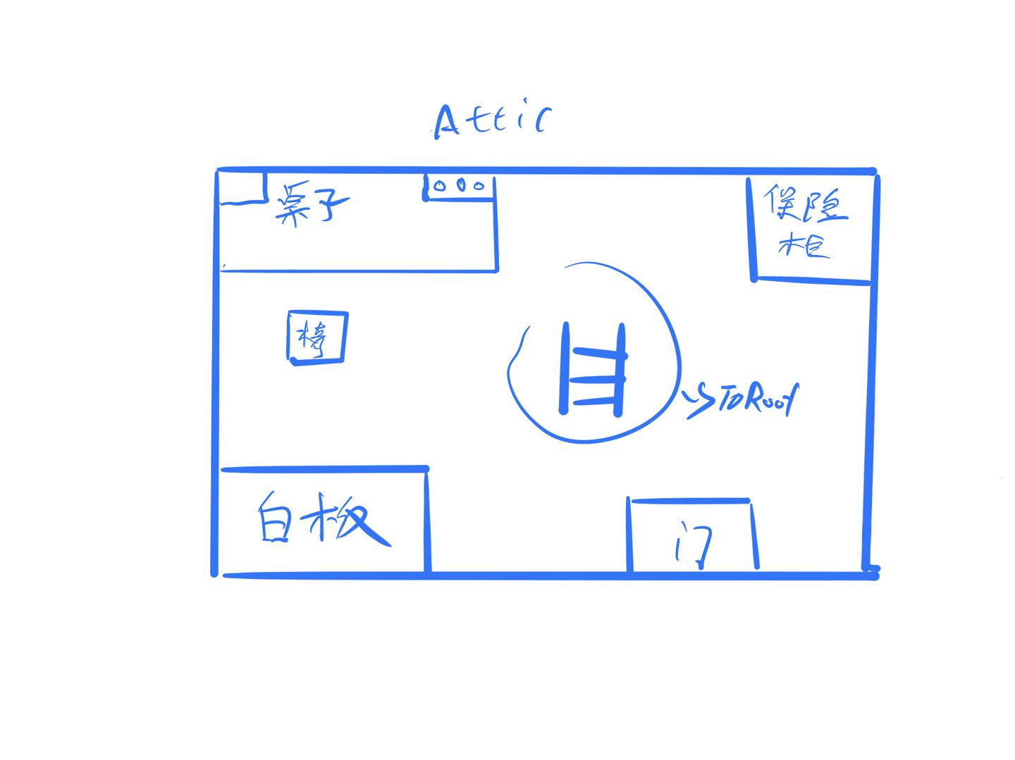

Whiteboard: It's been too long, and the words on the whiteboard can no longer be read clearly. There is only a photo of Detective Nunu, with a good friend written on the back of the photo.Get clues: "Detective Nunu"

Desk: There is a row of clocks and a [[small toy game]] on the desk

Clock: There are four clocks in total, which are the time of four different cities around, which may represent some special meaning. The four watches are no longer running, the time on each clock is 1 o'clock, 4 o'clock, 8 o'clock and 9 o'clock.

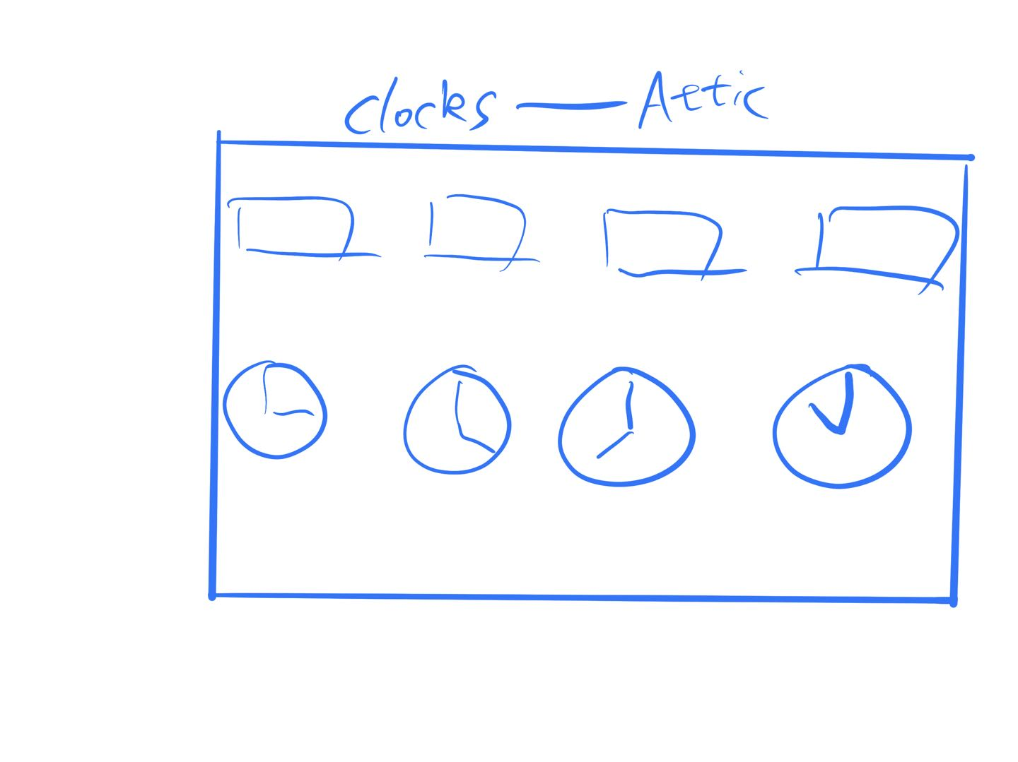

Small toy: A small puzzle toy, after unlocking the puzzle toy, there is a phrase

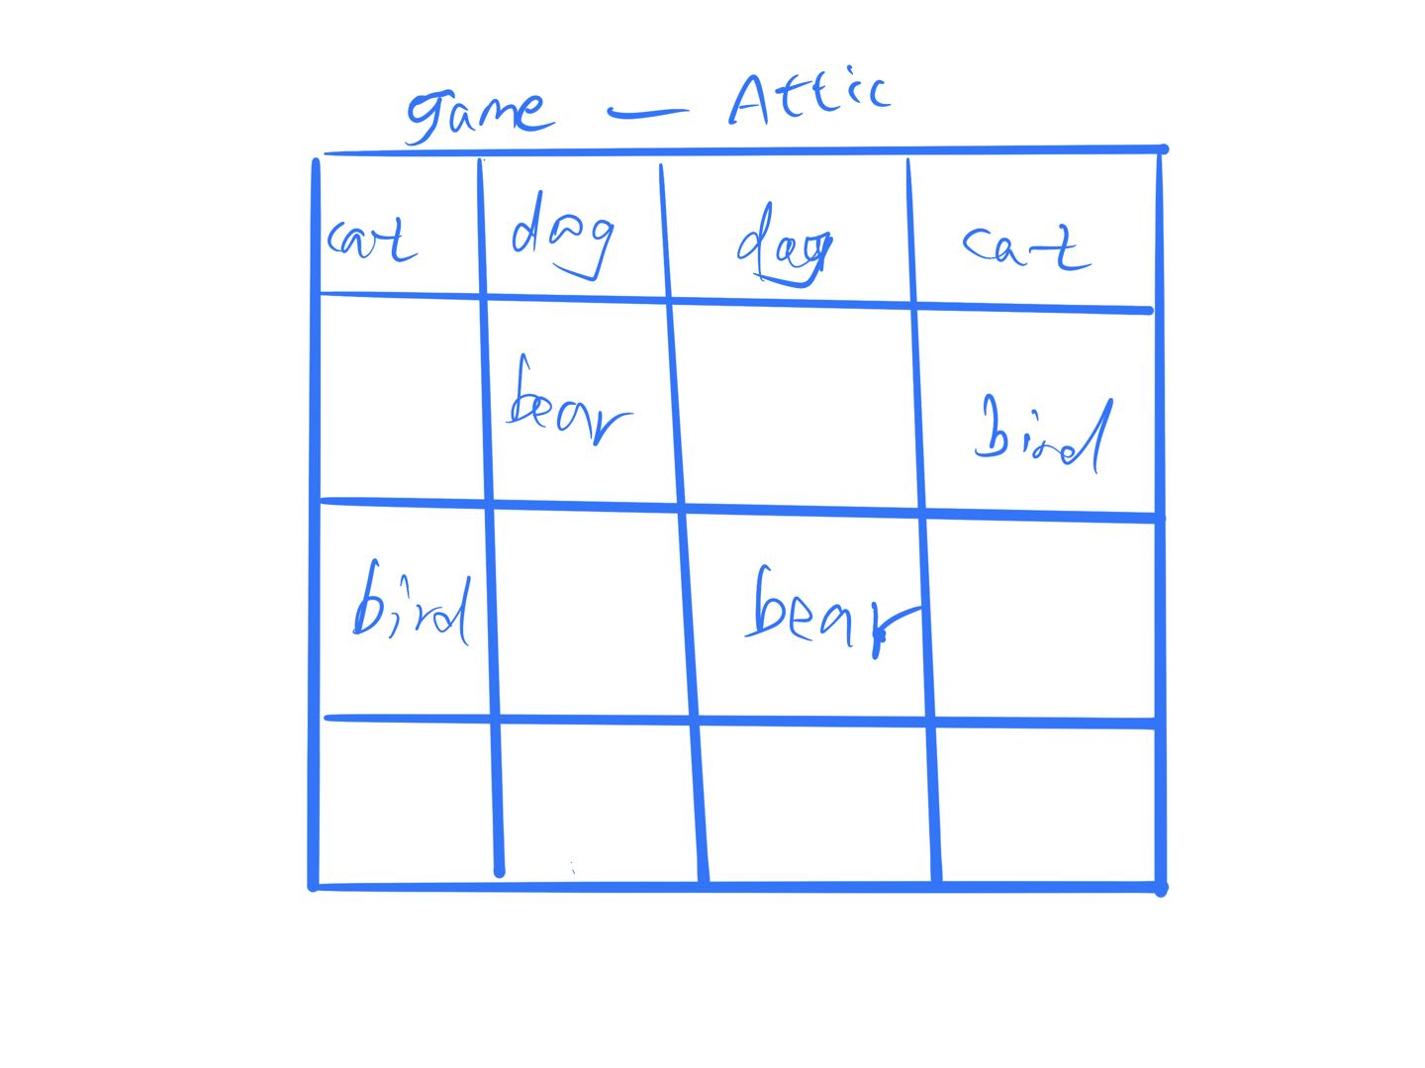

Safe Box: "I don't know what's in the safe" Addi said, "I should try to enter the password''

1489 is the password: Safebox opened! Addi got a key, which was probably the key to Roof.

Choose the correct clues to go to Roof

[["Detective Nunu" + "Roof Key"]]------Right

[["Detective Nunu" + "Study Room Key"]]

[["Detective Willump" + "Roof Key"]]

The attic used to be where Addi worked. The last case that Addi took over was a mission with Detective Nunu, who also died in that mission. Roof's key seems to have some secrets

**7.5 Roof**

To be, or not to be.... That is a question.......

Addi, who came to the roof, saw the sun just set, and he realized that he had spent a day in this old house. In the sunshine, Addi seemed to see the figure of his wife. In that sunshine, he smiled at Addi and said, "Addi, my honey, you finally did it."

"Lucy, is that you?" Addi was so excited that he couldn't help but take a step forward. . .

"Yes Honey, it's all a test for you, you finally found me" Lucy said, "I want to hug you okay? Addi?"

"I've been through so many things in these ten years..." Addi said

"I know, come and hug me" Lucy said

Addi ran up to hug Lucy

Lucy disappeared. . . Addi stepped down and fell off the Roof. . .

Suddenly the scene in front of him changed, the old house in front of him disappeared, he looked up and the roof just now became the roof of his downtown apartment. . .

Addicat and his wife Lucy used to have a wonderful marriage, but that all changed because of Lucy's illness. Lucy's condition is getting worse every day, and Addi's salary cannot pay for Lucy's treatment. Addi's stress was increasing, so he started smoking Catnip to relieve his stress, and as he became more and more addicted, it ended up affecting his life.

Unable to pay for the medicine, Addi sent his wife to a small clinic in the countryside and went on a mission. Because of Addi's mistake, Detective Nunu, who was his teammate, was killed in the line of duty. When Addi returned to the old house, he had hallucinations due to drug addiction, thinking that his wife had gone missing because of a conflict with others. Addi also became more and more addicted to drugs in the following ten years. He tried to quit many times without success, so he wanted to end his life. When he jumped from the roof, the hallucination of drugs brought Addi back to his own life. in the old house. . .

"Hhhhh, well , now I am a real jerk." Addi said

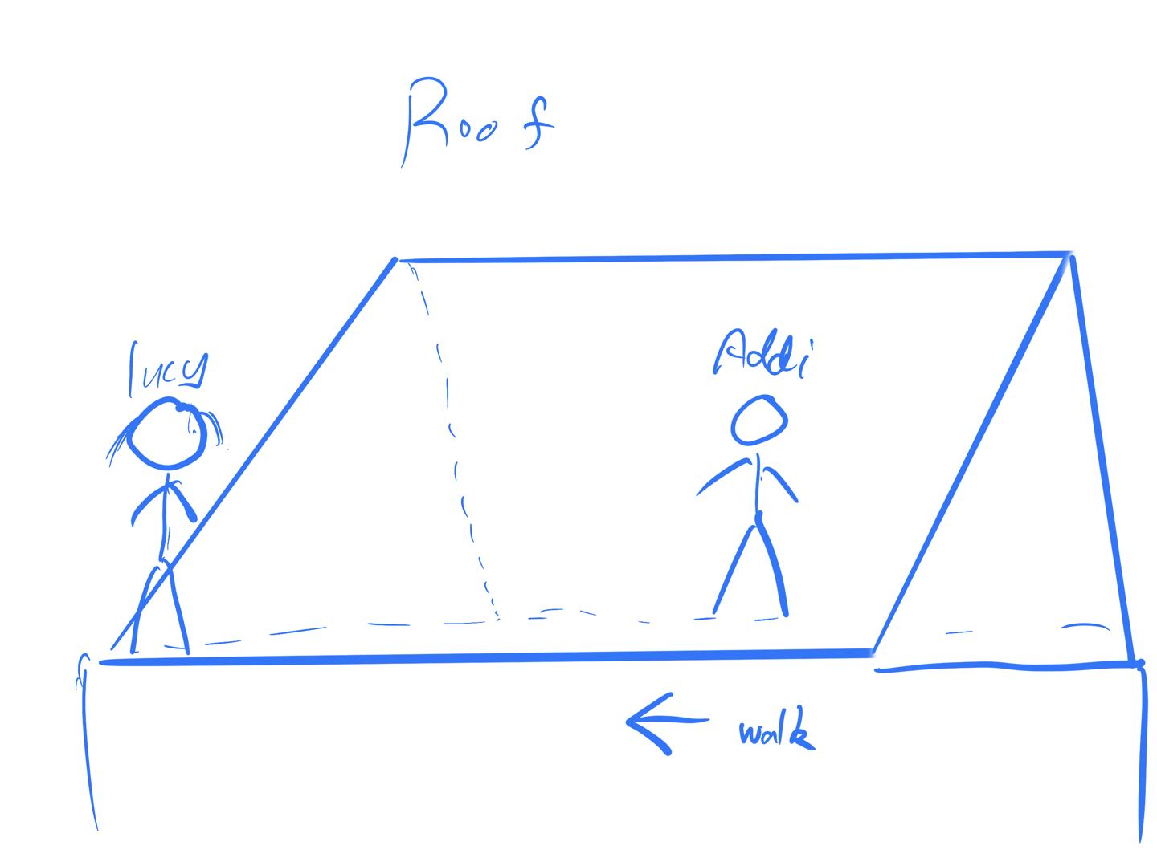

# **8.Interface**

# 

