# **Design Document**

**Game Name:**

Addicat

**Game Concept:**

在游戏中玩家扮演一名侦探，在10年前的一场案件中，他失去了自己心爱的妻子。在这10年当中，他选择吸食毒品来缓解自己悲伤的心情，所以染上了严重的毒瘾。然而一封突如其来的匿名信件，打破了他的生活，信件中透露的了许多10年前案件的细节信息，且所有的线索皆指向了侦探年轻时曾居住过的老宅。于是侦探怀着探究案件真相和亲人真正下落的心情，踏上了调查老宅之旅。然而整个事情的真相好像并没有那么简单。

**Team Members**

Yuang Li ;

Jinju Liu ;

Zhongliang Wang ;

Lihan Zhao ;

Chuansong Zhao ;

# **Game Overview**

游戏发生在一个现代的由动物组成并治理的社会中。在这个社会中，也存在着诸如毒品和酒精成瘾的问题。玩家扮演的是一个由于失去了妻子而染上毒瘾的猫咪侦探，他为了调查10年前妻子失踪的疑案而重返自己曾经生活过的老宅。玩家需要在老宅中收集各种线索，并根据收集出来的线索，拼凑出整个事件的真相。同时他还需要直面自己随时可能会发作的毒瘾。最终的目的就是根据信件提供信息，对老宅完成探索，得到整个事件的真正真相。

**Features List:**

● **Core Mechanic:** 解谜

● **Setting:** 现代的动物拟人化社会

● **Player Character:** 侦探

● **Enemies:** 成瘾性

● **Tone:** 黑暗，严肃的

● **Starting Location:** 10年前的公寓

● **Progression Mechanic:** 与房子中的物品交互，收集并整理线索

● **Goal:** 还原案件真相

● **Game Structure:** 2D

● **Differentiators (selling Points): 叙事诡计**

## **Outline:**

● **Style**

○ 2D

○ pixel art style with dark themes

○ Modern environments

● **Setting**

○ 故事发生在一个由动物组成并管理的社会中

○ 在这个社会中同样也存在着严重的毒品成瘾性问题

○ 玩家主要在自己年轻时生活过的老宅中完成线索的收集和整理。老宅是欧洲古典别墅的风格。

● **Character**

○ 一位因失去亲人而染上毒瘾的落魄侦探

○ 游戏的开始是染毒瘾之前的侦探，拥有着健全的侦探能力。而染毒瘾后的侦探，各方面能力都将受到影响。

● **Mechanics**

○ 线索收集，信息整理，与物品交互

○ 毒瘾对角色的负面影响

● **Game Genre**

○ 2D

○ 动物拟人化

○ 解谜

## **Game Flow Summary:**

1.Intro:

           引入动物拟人化的世界观，表现10年前的健康侦探。

2.Tutorial：

          学习游戏的线索收集以及信息整理的游戏机制。

          玩家在家中，寻找妻子失踪线索，展现主角清醒状态下的完整能力机制，最终引出后续故事。

3.Level / Narrative:

         a.线性故事展开。

         b.玩家从酗酒与吸毒的状态中醒来。

         c.玩家回到古宅中开始查案，但中途会受到毒品戒断反应的影响。

         d.从古宅中调查完所有线索后，得出案件的真相。

4.Ending

          玩家了解了整个事件的来龙去脉。

## **Look and feel:**



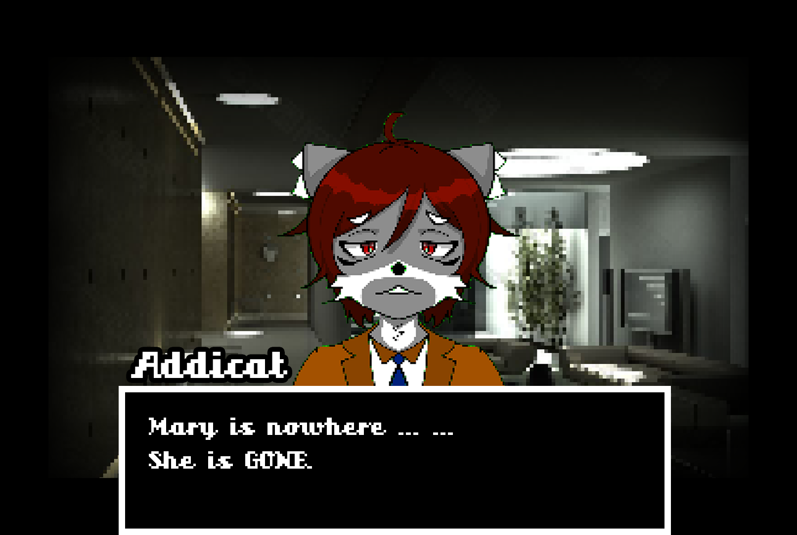

# **Gameplay & Mechanics**

Overview

游戏以解谜为主要玩法。游戏过程为线性叙事的调查主线任务，可以通过收集线索，获取关键物品，整理线索的方式推动剧情与场景的切换（可以参考福尔摩斯系列作品）。在正常的时间线以外，Addicat可以通过他的能力跳出正常时间线，进入“Mind Palace”，整理收集到的全部线索，获得通往下一个场景/关卡的资格。

Gameplay Description

游戏分为“凡是过去，皆为序章（What’s past is prologue）”与“谜团揭开”两部分。

“What’s past is prologue”主要玩法如下：

玩家的视角为第三人称视角，通过摄像机跟随主角移动的功能实现。“What’s past is prologue”为教学关卡，故事将在与妻子结婚的新宅子中进行。本关卡只有个场景，玩家可以在场景中进行探索，通过在探索区域中获得的线索，得到所有的信息后，侦探会理清脑海中的所有想法和线索。在这个过程中，玩家可以通过思维整理来帮助侦探梳理整个案件的来龙去脉。

“谜团揭开“主要玩法如下：

玩家的视角为第三人称视角，通过摄像机跟随主角移动的功能实现。“谜团揭开“为游戏主线剧情，时间线推动到了教学关卡的十年后，由于故事的主角Addicat因长时间的吸食毒品，身体的技能已经不如从前，玩家需要克服戒断反应完成解谜。戒断反应包括但不限于停止走动吸毒，视野变模糊，眼前出现幻觉（可后续引出新玩法，比如共7条线索，玩家需要正确选出五条线索进行排序/自动排序，完成任务推动剧情）。玩家将会从老宅子的花园中开始游戏，需要寻找正确进入老宅子的方式，才可以进入到老宅子内，扩大探索范围。索区域中获得的线索，并排列出正确顺序后获得进入第二场景的资格，同时扩大探索范围。玩家必须依次完成收集每个场景的线索并做出正确的排序才可以进入下一个场景，进入下一个场景的方式有走楼梯，翻窗户，使用关键物品，记忆闪回等方式。得到所有的信息后，侦探会理清脑海中的所有想法和线索。在这个过程中，玩家可以通过思维整理来帮助侦探梳理整个案件的来龙去脉。最终了解了整个事情的真相。。。

第三部分“终章（生存还是毁灭）”，内容为Addicat了解到了整个事件的真相，一切都是毒品带来的幻觉，场景为楼顶， Addicat将由玩家操控，可以通过设计一个东西为引导，引导玩家移动，无论玩家摁下哪个按键都会是操控Addicat往前走（路程极短，目的让玩家意识到毒品的幻觉中已经不可以控制自己，与第三部分名字呼应，无论选择了哪个，都无法改变毒品带来的幻觉），最后走下平台摔落，摔落过程中出制作组人员名字与特别致谢。加入终章

Game Mechanics:

侦探思维：当Addicat开始思考案件的时候，所有的线索将会出现在Mind Palace (独立页面)，玩家需要通过整理线索纸条，获得新线索或进入下一场景资格。

Mind Palace：独立页面，Addicat获得的所有线索将储存在这里，玩家可以自己调整线索的顺序，选择使用/不使用其中的线索。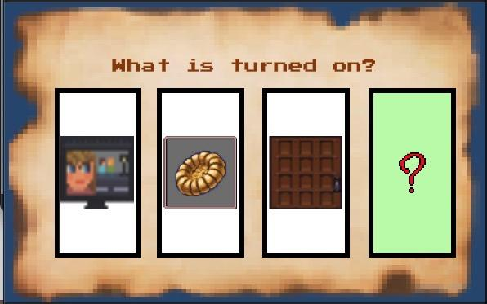

第二阶段：

侦探第六感：Addicat会看到一些关键道具，Addicat的第六感可以意识到道具是否有用，通过第六感这些道具将会在靠近的时候由高亮标出。同时在一定条件下会有hint帮助玩家，使玩家不会那么沮丧，放弃游戏。

Game Controls:

WASD：控制角色四个方向的移动

K：Mind Palace

J：交互

鼠标：线索连线和设置交互

# **MDA MODEL**

| **Aesthetics:** The emotional outcomes the game strives for | **Dynamics:** The gameplay that will lead to the intended aesthetics | **Mechanics:** The rules and features that will lead to the intended dynamics |
| --- | --- | --- |
| **Challenges:** in the sense of accomplishment after solving challenges (puzzles in the form of spatial or texts) | The player will traverse the scenes to find the clues in different positions.  The player can find the hidden information of a clue and the links between pieces of clues.  The player can recover the story of the game by collecting enough messages from the clues. | A simple physics system that player will use to traverse the scene including walking and jumping.  A interaction system that player can interact with the items including changing the items’ positions and getting hints from the items.  A memory collection system that player can drag the clue (will be presented in the form as broken pieces of papers writing clues on them) to find the links between different clues, and if there are connections between them the player can get a new clue. |
| **Curiosity:** in the sense of wondering what will happen next in the following process of playing games. | The player will need to find enough and necessary hints under the clues to knock together a complete story.  The player will learn from the tutorial level not only the basic operations but also together with an incomplete story with a start. | There will be different sub-scenes in the whole scene, and player is not allowed to enter the next scene unless he found all the necessary clues in the previous sub-scene. |
| **Fantasy:** in the sense of immersing the player himself/herself in a fancied and cartoonlish world. | Everything of this gamehappened in a world in which the society is a 1980-liked society governed by animals.  As a detective our hero will have a special power that is good for detecting cases but seems impossible in reality. | The hero is set to be a cat detective with the ability of collating and inferring clues in a very short period of time. |
| **Masochism (**in the sense of experiencing tough puzzles and the frustration of failing to solve the puzzles, together with the overall dark and depressed style of the game that the player has to experience**)** | In some levels of the games there will be some pretty hard puzzles and the player may need to spend long time to solve them.  The whole playing process is under a sad and depressing atmosphere with a detective story. | There will be many scenes and many items in the scenes and player need to select the ones that are useful to finishing the level.  Some of the puzzles require a lot of information and player need to grasp the necessary ones for themselves, and player also need to ）find the links between different clues, so there will be hints that help player to make them not so frustrated. |
| **Unpredictable (**in the sense of being surprised with the outcome of a story and got no idea of what the result will be before seeing the result**)** | The player will collect the truth of the story by himself and through the progress of the story the player will find at the end of the game the story is not what the player thought it should be. | There will be information collected after getting an item or solving a puzzle, the player need to recover the truth based on the clues. |
| **Suspense (**in the sense of a state of excitement or anxiety about something that is going to happen very soon**)** | The player will feel a strange atmosphere with unknown mysteries through the progress of the game. | The collected information will remain some blurry information to imply the truth behind the story. |

# **Story and Narrative**

第一关发生在自己家中，侦探在家中发现妻子不见了，通过侦探的技能收集了所有的线索，得出一个结论，妻子被人绑走了，但是并没有任何证据留在现场。后续通过幻灯片形式展现后续十年主角逐渐堕落的变化，直到匿名来信。

信中的内容写到，想知道你妻子的消息吗，回到你年轻时住的地方吧。虽然已经10年过去，但侦探仍然能够认出，这是自己妻子的字体，于是他立刻启程，前往自己曾经生活了20年的古宅。

由于已经持续多年的酗酒和吸毒，侦探的身体机能与大脑已经早不如从前，他在整理线索时思考的速度大大下降甚至时常会出现错误的决策。调查的过程中可能会不由自主的开始吸食猫薄荷毒品，当一段时间没有吸食时，他会出现严重的戒断反应，视野变得模糊，眼前出现幻觉。

在深入调查古宅的每一间房屋后，侦探逐渐回忆起了10年前那场事件的真实情况。原来早在那个时候，自己就已经沾染了毒瘾，但同时妻子也患上了严重的疾病。他购买毒品花费了大量的积蓄，无法继续支撑妻子的治疗花费。那时的他心中对妻子充满了愧疚，但是初步沾染毒品的他也没有办法控制自己对毒品的依赖，这两种因素在他的心中交织，最终让他在自己的潜意识中将整个事情包装成妻子被坏人绑架带走的故事。他将10年前抛弃妻子的事情完全的封印在了自己的潜意识里，从而不用再去面对，让自己内心遭受煎熬。

古宅的调查结束后，主角找到了曾经被自己抛弃的妻子，他很庆幸上天能给自己第二次来过的机会，充满幸福的走向自己的妻子。 这时游戏画面逐渐模糊，原来古宅中发生的一切也是侦探吸食过量毒品后产生的幻觉。 主角的妻子早因病过世，而长年累月吸食毒品的习惯早已彻底摧毁了侦探的心理和身体。

# 在现实中，侦探早已登上了公寓的楼顶，而在幻境中，妻子正在前方向自己招手。 现实与幻梦交替，侦探不受控制地向楼顶的边缘走去。随后在坠落中，游戏正式结束。

# **Character**

Addicat:

对生活失去希望。

唯一活下去的动力就是寻找妻子。

终日酗酒吸毒。

在10年之前是一名出色的侦探，拥有强大的刑侦能力。

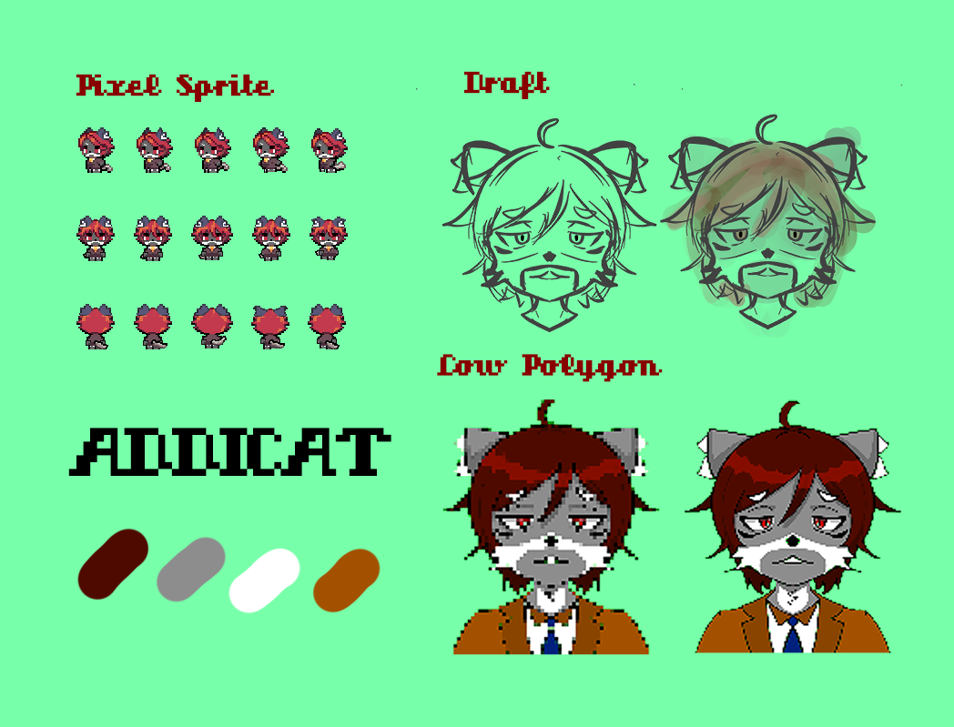



**Tutorial**

玩家回到自己的家中发现妻子失踪，于是在家中展开侦查寻找线索，让玩家熟悉角色操控以及游戏的基本机制和玩法。

第一层：客厅 厨房

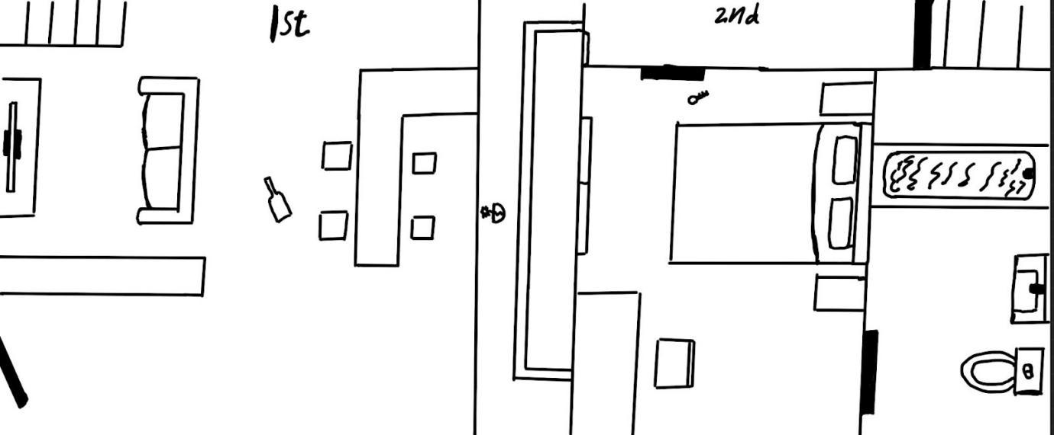

侦探首先观察到房屋的大门是虚掩的并没有关紧，获得【线索：虚掩的门，相关联想：妻子出门忘关/有人入室】。获得的线索将直接呈现于一个独立的页面当中，让玩家知道这是侦探的线索收集和整理能力（思维殿堂）。

进入后，观察到厨房有切好的蔬菜但是还没有烹饪，有一瓶红酒洒在地上。获得【线索：凌乱的厨房，相关联想：这里曾发生过冲突/妻子的疏忽大意】。此时在侦探的思维殿堂中，两条线索高亮，提示玩家可以交互产生新的结论。玩家需要选择“有人入室”以及“发生冲突”这两者联想，即可获得新结论——有人闯入家中并与妻子发生冲突。若是没有选择正确的联想，侦探会自言自语“天呐Addi，你究竟在想些什么”，直到玩家选择正确的选项才能继续游戏。

一层的客厅，电视正在开着，播放的是妻子不爱看的综艺节目，且声音开的很大。在与这一场景互动后，侦探会自己得出结论，有人妄图通过电视声音来掩盖冲突的声音。

最后，将两次结论与两条没有联想的线索相结合，还原出整个事件的原貌。有人从一楼进入家中，与妻子在厨房发生冲突并将其带走。

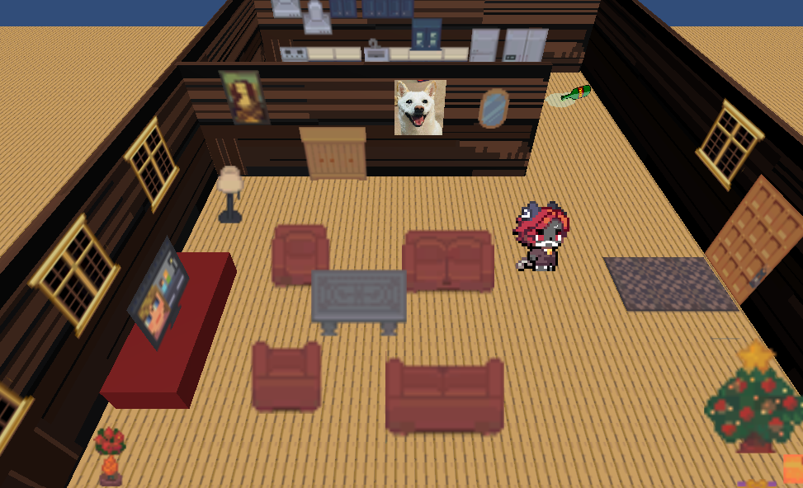

# **Levels**

# 主要场景：老宅

次要场景：厨房，主卧，客厅，次卧，卫生间， 阳台，阁楼

As the player finishes the tutorial, the player will start at the old house garden. There will be only one house right in front of the player, it will make the player think that’s the only way to enter the house. The player can not enter the house because the door was locked, then a text window will show up to hint to the player where is the key.

As the player enters the house, the first scene is the living room and kitchen. It is a messy old house. The first thing the player will notice is a twinkling on the living room table, it will lead the player to find the first clue, that tells the player what to do next.

After the player reaches the second clue, it will guide the player to go to the second bedroom. The second room is located on the first floor. However, the door was jammed by a wood stick that blocks the door handle, the player needs to find something that can push the wood stick away.

The player will be guided to the master bedroom which is located on the second floor. Unfortunately, the room was locked, and then it will  hint the player about the possible way to get into the master bedroom.

Level 2: Living Room

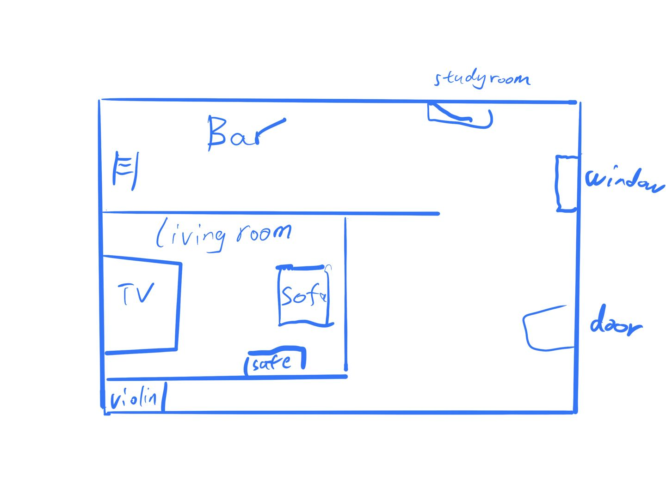

侦探来到了客厅，他巡视了一圈，想要尝试打开一楼次卧的门，发现打不开，通往二楼的楼梯门也紧闭，侦探的第六感告诉他房间内可以寻找到很多线索。客厅的场景如同回忆中的一样温馨，只是因为常年没人居住上面落满了灰尘，门的右边是吧台和厨房，酒柜上的酒至今没有人动过，可能里面的酒已经不能喝了吧（侦探第六感“靠近吧台的时候高亮吧台上的书和酒柜”，相关联想：曾经和妻子经常在厨房一起调酒）。侦探来到吧台，与酒谱交互，打开酒谱。酒谱中有三种酒，分别是“Jackie Welles”，“David Martinez”,和“Margarita”。

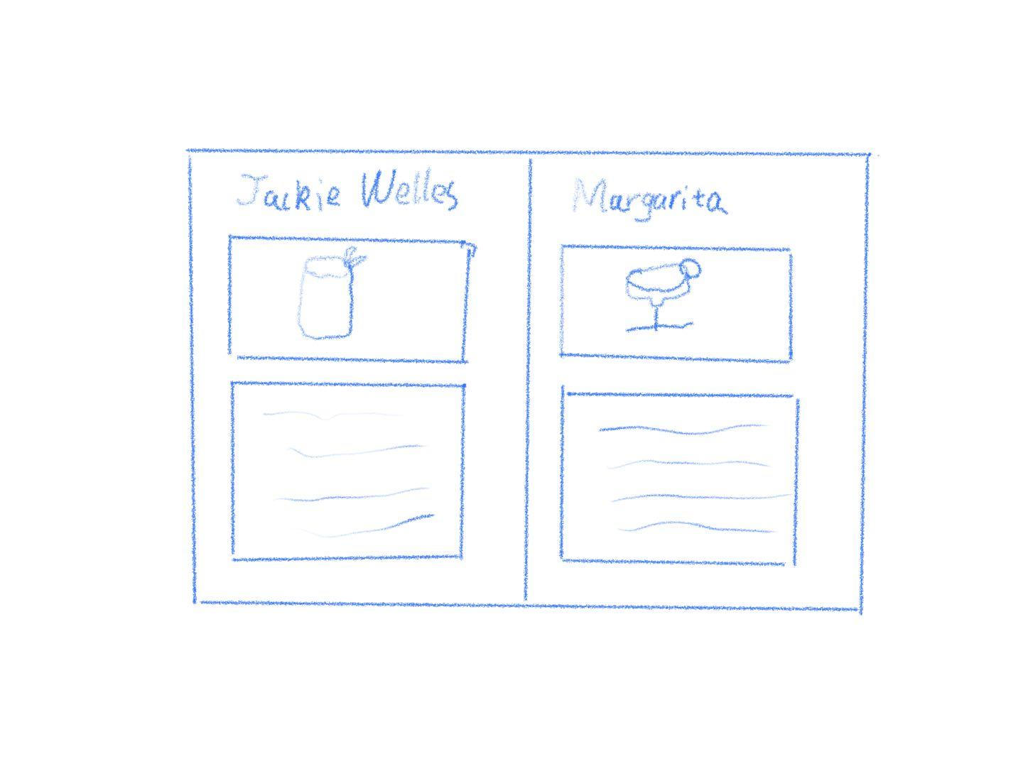

酒谱中Margarita做法上写有盐代表着情人的眼泪，并标明了是妻子最爱喝的酒，但是页面上有一个tag上面写着“不喜欢情人的眼泪“，关闭酒谱。（获得三个线索：“Jackie Welles”，“David Martinez”,和“Margarita”），侦探走到酒柜，与酒柜交互，进入调酒小游戏，酒柜上摆着酒，还有一个纸条上面写着当你忘记怎么调酒，记得查看酒谱。

随后将开始进行一个音游小游戏，玩家根据节奏和方向在合适的时机按下正确的方向键。

调出玛格丽特后会获得关键线索“玛格丽特“（1）。

侦探继续在客厅里搜索线索，走到电视柜的时候，侦探第六感会高亮出电视柜上的电影“东方快车杀人案“。与影片交互，侦探会自言自语“我还记得这是16年前买的影片，那时我们经常一起在沙发上看电影”。获得关键线索“东方快车杀人案”（2）。

侦探继续在客厅里搜索线索，房间中有一个断了弦的小提琴，侦探第六感会高亮小提琴，与小提琴交互，侦探会自言自语“小提琴，我喜欢在喝酒的时候听她演奏，可是为什么弦会断？”。获得关键线索“断弦的小提琴”。（3）

侦探继续在客厅里搜索线索，走过唱片机的时候，侦探第六感会高亮唱片机，与唱片机交互，侦探会自言自语“emmmm，16年前的老歌，听起来依旧好听”。获得关键线索“唱片”。（4）

侦探继续在客厅里搜索线索，保险箱与书架挨着，侦探第六感会高亮出保险箱，点击保险箱上面有字，第一行为空白，第二行为LOCK。侦探自言自语，密码是什么？也许书架上会有线索吧。“之后书架会高亮，交互书架，侦探会自言自语“这些书，看起来像要表达什么讯息”。一本书的名字是Sherlock Foxmes，书内有一个镂空的空间像是能摆放一个戒指（同肖申克的救赎）。通过解谜发现密码是SHER，正是那本书的名字SHERLOCK。打开保险柜看到一个打开的戒指盒，获得关键线索“打开的戒指盒”。

记忆殿堂被高亮并发出提示，玩家需要把五个线索放在记忆殿堂里的空位上，关键线索收集完成，玩家进入回忆，曾经和妻子很美好，曾一起调酒，听妻子演奏小提琴，在沙发上一起看电影，午睡的时候一边放音乐，一边讲侦探故事。回忆结束，一楼次卧门依旧紧闭，二楼楼梯可交互并高亮，玩家可以进入二楼主卧。

After turning over the window, addicat came to the living room. The layout of the living room was the same as it was ten years ago, but because no one lived for a long time, the house was very dusty. There is a thick layer of dust on the bar on the right, the books on the bookshelf on the left are still neatly arranged, there are some spider webs on the phonograph, the TV on the TV cabinet can no longer be turned on, and there is a broken violin next to the TV cabinet. The safe, addicat has forgotten what was in it. (Explore living room)

Bar: 'Oh my God, how long has it been since I've been back', addicat said to himself. Looking at the expired wines on the wine cabinet, addi's thoughts seemed to return to his original life. 'I almost forgot how her favorite wine is made, let me find the wine list'. addicat looked at the grey wine book on the bar, I should make a glass of wine.

Wine spectrum:

Margaritas ''consisting of tequila, orange zest, lemon juice, shake, and salted in a margarita glass''. Margaret commemorates the bartender's girlfriend, tequila and lemon juice represent the passion and bitterness of the love period, and the salt on the glass represents the lover's tears. tip: I like this story, but I don't like the tears of a lover.

Jack Wells: ''Vodka, lime juice, ginger beer, served in a copper cup. '' Jack Wells, Legendary City: The Big Shots of Night City, Legend. Most people like it as one of afterlife's signature drinks, because Jack said the most important thing is to add a little love.

David Martinez: ''Vodka, Coke'' bullet glass served with ice. David Martinez, the legendary city: one of the legends of the night city, the leader of the cyberpunk squad, once the top student in the school, and later became the legend of the night city, Coke represents the lover Lucy, As the drinkers in afterlife say: life is great, death is glorious.

Wine Cabinet: Choose the wine you want to blend:

Margaret --- Get the clue "Lover's Tears"

Addicat's wife's favorite cocktail ever. Ten years ago, Addi often made cocktails at home with his wife. Because Addi was a detective, he liked to write some interesting messages under different wine bottles for his wife to solve puzzles. And the message left at the bottom of the bottles that made these bottles was "Go to the safe and the bookshelf for information"

Jack Wells - Jack, you are the big man in Night City

David Martinez - David, sorry to not see you on the moon together

Safe:

Addicat looked at the safe and said to himself 'Oh, the password to the safe, on the bookshelf, I remember the clues are on the bookshelf, this is a little game we play a lot. "

Lock-Foxmes is printed on the safe, there is a screen and a small keyboard above the Lock, choose the password "sher", "big", "time", "tea" you want to enter.

sher - safe open, get clue 'empty ring box'

big - no response

time - no response

tea——no response

bookshelf:

There are all kinds of books on the shelves, and detective novels can always give you a different inspiration. Look at these familiar books: Acattha's Puppy under the sun, Conan Dogge's Sherlock-Foxmes series. Addi thought he already knew the password to the safe. Get clues Acattha, Conan Dogge, sherlock-foxmes - jump to safe page

TV cabinet: There is an old cd on the TV cabinet, which is addi's favorite movie 'Murder in the panda restaurant'. I used to like to watch this movie on the sofa with my wife after dinner.' I like the human thinking in it, ' addicat said to himself. He recalled that his wife didn't like this kind of human thinking because she believed that love can't be changed by anything. Get clues: The Panda Restaurant Murder.

Violin: This is my wife's favorite instrument, she likes to drink at home and play the violin. Maybe the strings of the violin have been broken because they have not been maintained for too long. Get clues - violin with broken strings.

Gramophone: This is addi's favorite gramophone, a gift from his wife to addi. He used to like to drink while listening to the music of the gramophone and dancing. Get clues ---- record end of the world.

Story: The living room used to be a place where Addicat and his wife often played together. They used to drink here and dance in the living room listening to songs. Occasionally on holiday afternoons, Addi would watch TV with his wife on the sofa, occasionally tell his wife about his favorite novels, or listen to his wife play the violin. "It used to be a good time," Addi said. "I just don't know where I can go next...

Suddenly Addi noticed a small black box in the safe box, and he found a small key. This is the key to the bedroom. . . There is a note under the key "I hope you will search for clues a little bit to unlock the secret of this old house, and you will know where I am." It is still a note from the wife

Addi looked at the key in his hand, he knew it was time to explore the bedroom.

Level 3 bedroom

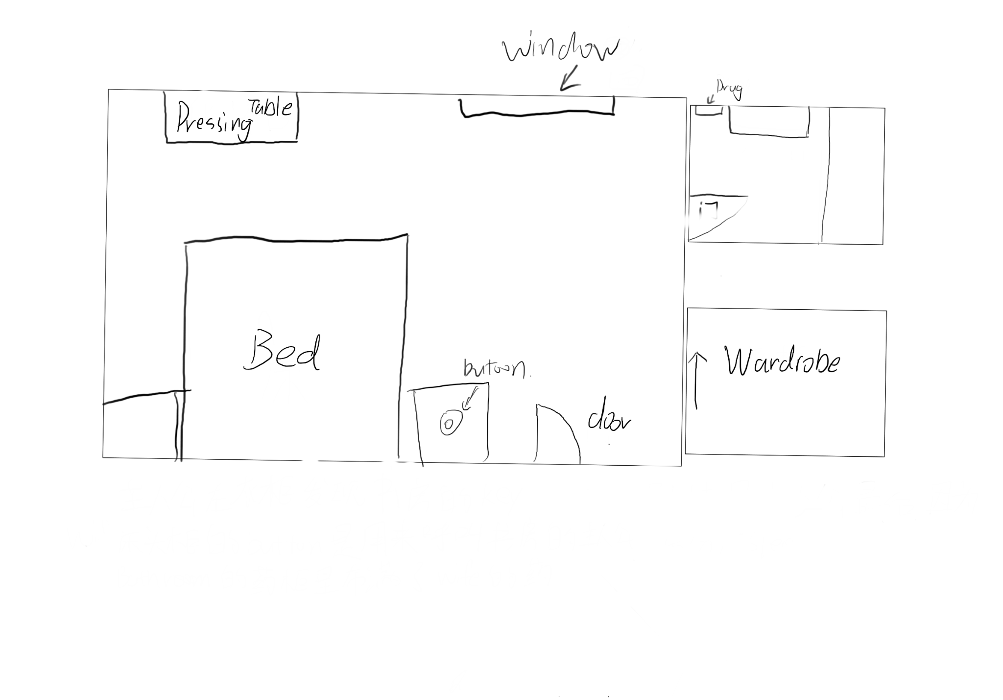

经过客厅的探索，Addicat来到了他和妻子相处时间最多的房间，他们的卧室。进门的瞬间Addicat就发现因为长时间废置的房间，他们昔日的甜蜜小屋已经不复存在。虽然房间的样貌已经看不出当年的情景，但是所有东西还是保持原样留在了原地。映入眼帘最吸引Addicat目光的就是妻子最爱用的粉色化妆台，其后面就是卧室的双人床。双人床的两侧是床头柜。这就是卧室的主要区域，在房间的右上侧是厕所，右下方则是两个人的衣柜。（探索Master Bedroom）

客厅：回到上一个场景。

床头柜：“上面有一个红色的按钮，我已经忘了这个东西的作用了。” Addicat感到疑惑。

甜蜜小屋：“哎，真是令人怀念的房间。和妻子相处的时间可以说是我这荒废的人生中的唯一的亮点了。当时的我们经常在卧室里看侦探电影，她还经常吐槽我，在看电影的途中特别喜欢给她出谜语，哈哈，现在想起来那个时光真是美好啊。” 在Addicat自言自语的同时看向那个无法忽略的粉色化妆台。

粉色化妆台：“这个化妆台好怀念啊，以前还没有那么多的化妆品现在桌子上居然还有这么多瓶子留下。我还经常嘲笑她化妆技术差，哈哈。” 慢慢的Addicat的神情变得沉了下来，可能是想到了什么吧。“这个明显的化妆台是我当是给她买的入住礼物啊，现在居然保存的这么完好。”

瓶子：Addicat注意到桌子上的这些装化妆品的瓶子并不自觉的拿了起来看。“这些瓶子上面怎么会有数字呢？可能是什么线索吧。”

数字：一共有5个瓶子每个瓶子上的数字和日期都不一样。

化妆水：4，10/10

定妆粉：1，8/30

口红：5，1/20

面霜：2，3/25

乳液：8，12/25

厕所：Addicat进到厕所看到药柜后感叹道：“会有些什么药在里面？”

药柜：“这么多药也是为了妻子，后来给妻子买药成了我生活的一部分。”

这里面有很多不同药名的空瓶子其中最明显的就是止痛药，不知为什么感觉很伤心。（进入线索）

（“这里也没什么了，我记得衣柜里还有我藏东西的机关。”）

衣柜：“这里居然还有衣架在，等等，我记得这些衣架好像跟我以前设计的机关有些不一样，上面的数字也变了。”

衣架：衣架上面有不同的数字，根据前后顺序来是2，5，8，4，1. “这应该是我的机关可是数字和衣架的数量已经不一样了，这些数字好像在哪里见过？” Addicat思索着说出了这段话。“虽然机关跟以前不太一样，但是应该还是和我以前的设计只要排出正确顺序就可以启动机关了。”Addicat很确定的说出了这句话。

25481-无反应

85124-无反应

48215-无反应

52148-启动了机关。

机关里有一把钥匙，上面写着书房的钥匙。

Level4: 书房

侦探从主卧室拿到书房的钥匙，回到一楼，进入书房。

书房的地上有一个垃圾桶，里面装满了猫薄荷烟盒，旁边的地上还散落着一盒没有抽完的猫薄荷。侦探走过去查看，十分疑惑的自言自语：**“为什么这里会有猫薄荷呢，在这里住的时候，我明明还没有…，算了，正好我带的烟也抽完了，把这包带在身上吧。”** 获得道具，猫薄荷。

随后侦探看到了自己的电脑，打开电脑后，发现需要密码，密码的提示是：实现梦想的那天。侦探自言自语：**“该死，我怎么连自己的密码都不记得了，该去别的地方找找线索了。”**随后翻找书橱，在书橱上找到了自己当警探时的警徽，上面有自己成为警察的时间：2010.10.1 侦探这时自言自语：**“成为一名警察，一直是我小时候的梦想。”**

电脑密码就是2010101，输入正确密码后，侦探可以打开电脑。 电脑的浏览记录依次显示：**2012.4.23XX疾病的治疗花费**

**2012.4.24XX疾病的康复几率**

**2012.5.15抗抑郁药物**

**2012.5.20 如何戒掉Catnip**

**2012.6.2 Catnip购买渠道**

看完所有浏览记录后，侦探陷入沉思：**“不可能，这绝对不是真的，那时的我不应该染上毒瘾才对，我所有的努力都是为了给妻子治病才对，我怎么可能会吸毒！”**

这时身后的床上传来一声清脆的声音，仿佛有什么东西掉到了地上。侦探在床边发现了阁楼的钥匙。**“这应该是阁楼的钥匙，我要上去查个究竟，整件事情真的是太诡异了，该死！”**

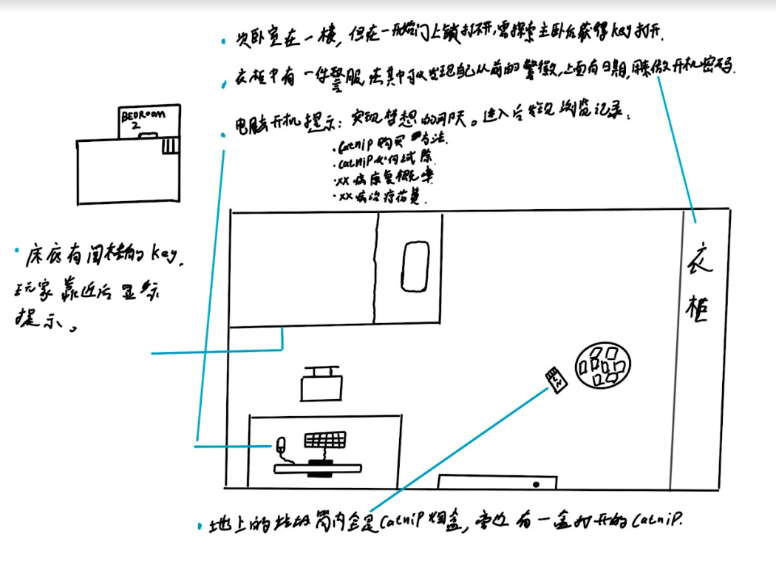

Level 5：Attic

侦探上到阁楼，阁楼面积很小，只有一张桌子，一个白板，和一个小保险箱。桌子上有一个小盒子，里面是侦探曾经最喜欢玩的游戏，有不同的板子，侦探需要将16张牌画面扣下，背面朝上，并打乱顺序，每次只能翻两张牌，依次翻开并记住木板上的小动物的顺序，并两两消除。玩家将所有的牌消除后，板子上是一串文字“时间是找寻真理的途径”。（获得线索：板子后的文字）侦探又看到桌子上的一串表，上面记录着4个不同动物城的时间，侦探将表收入背包，表进入背包和记忆殿堂（获得线索：动物城的时间）。侦探会自言自语一句“不知道是不是时间太久了，这些表已经不走了”。四个时间从左到右依次代表了保险箱的密码（xxxx）。通过收集密码打开保险箱，获得通往楼顶的钥匙。

再来到白板面前，白板上字迹已经随着时间逐渐看不见，但是上面发黄的纸张上还留着一些信息，这些信息有关于十年前的一个追凶案，侦探通过排列连接白板上的纸张的顺序，回忆起当时因为自己的未知失误（突然的戒断反应，暗示十年前已有吸毒的情况），自己的搭档努努警官因公殉职，自己也面临一段时间的停职与调查，使他在一段时间内都没有了收入，这也成为了压死骆驼的最后一根稻草。（获得线索：压死骆驼的最后一根稻草）

记忆殿堂高亮并提示，玩家需要连线所有的线索，连接线索后进入回忆，自己回家后重病的妻子曾主动来到阁楼，带着他一起去楼顶看日出日落，突然楼顶仿佛传来了妻子的声音，呼唤侦探走上去。通往楼顶的梯子高亮，侦探可以去往顶楼。侦探在走到梯子前又出现了戒断反应，可他听到了妻子反复的呼唤，于是快速的给自己注射了一针，画面出现模糊的特效（持续5s），然后侦探上楼进入顶楼。

Addi took the ladder to the attic, where nothing changed. The attic used to be where Addi worked. Addi often came to the attic to work by himself. Every time he handled a case, he would sort out every detail on the [[whiteboard]] on the right. There is a [[desk]] and a chair next to the whiteboard, which Addi uses for office work. There is a row of clocks on the table, and one of Addi's toy games. On the left side of the attic is another [[safe box]], and Addi doesn't know what is in it.

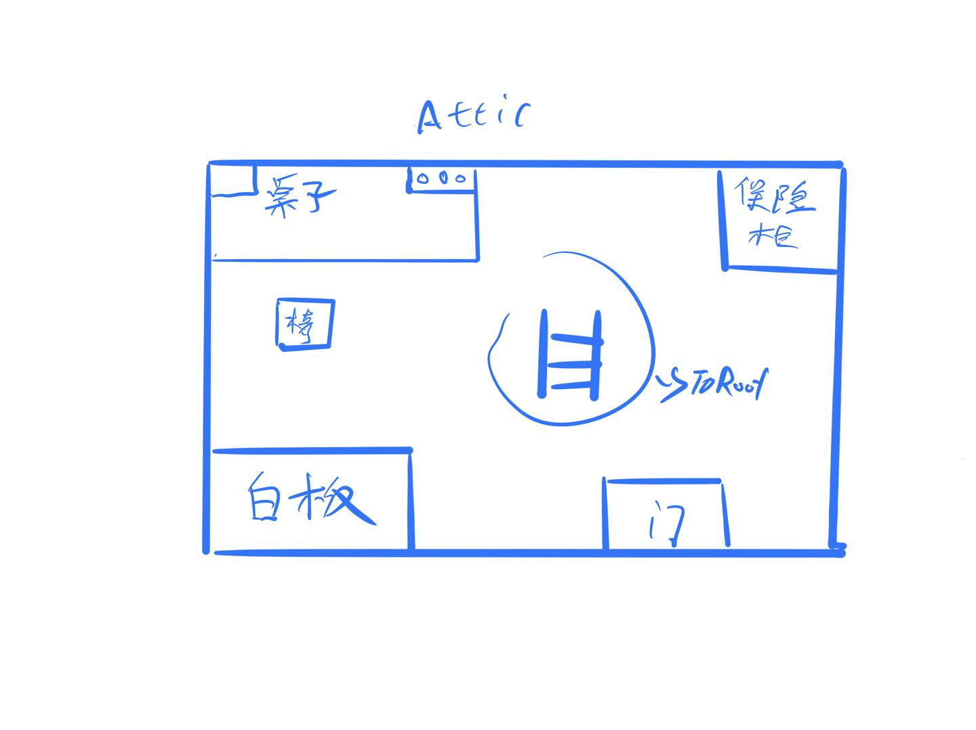

Whiteboard: It's been too long, and the words on the whiteboard can no longer be read clearly. There is only a photo of Detective Nunu, with a good friend written on the back of the photo.Get clues: "Detective Nunu"

Desk: There is a row of clocks and a [[small toy game]] on the desk

Clock: There are four clocks in total, which are the time of four different cities around, which may represent some special meaning. The four watches are no longer running, the time on each clock is 1 o'clock, 4 o'clock, 8 o'clock and 9 o'clock.

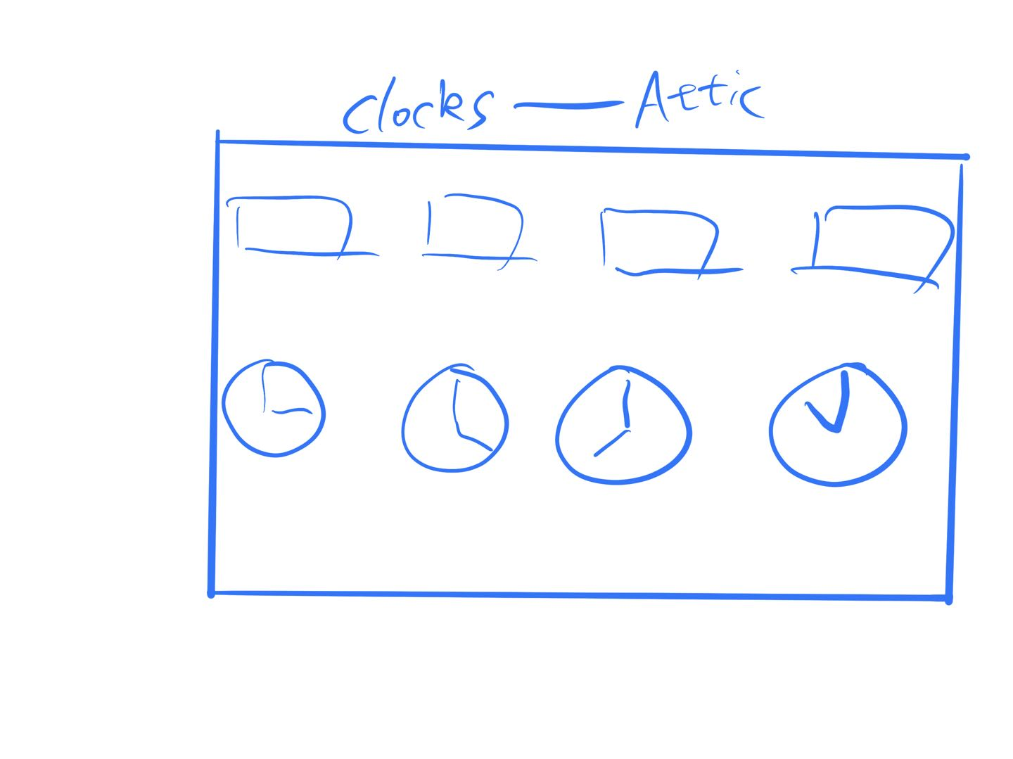

Small toy: A small puzzle toy, after unlocking the puzzle toy, there is a phrase

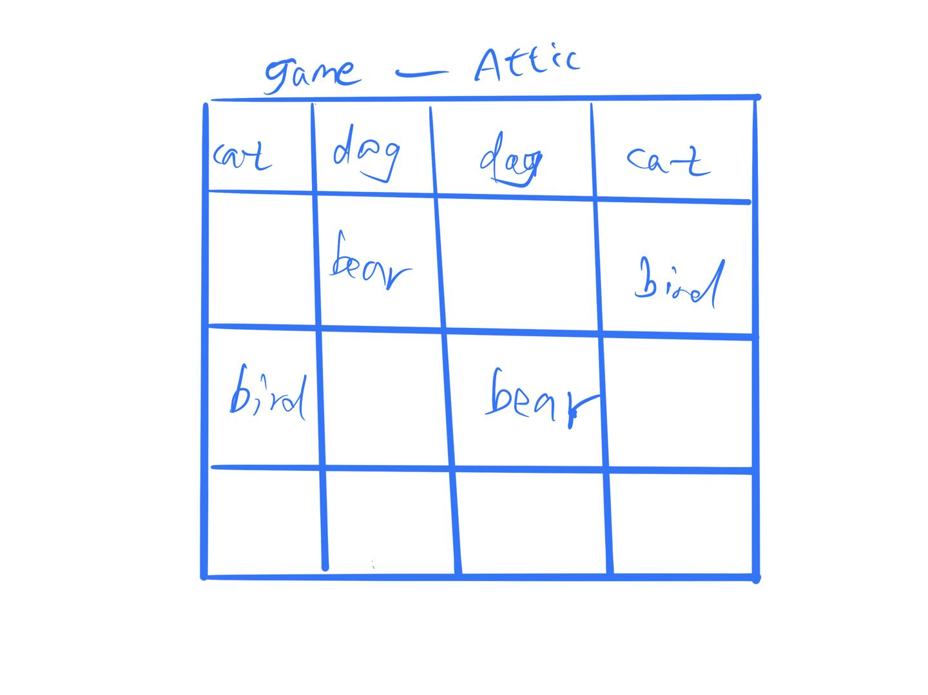

Safe Box: "I don't know what's in the safe" Addi said, "I should try to enter the password''

1489 is the password: Safebox opened! Addi got a key, which was probably the key to Roof.

Choose the correct clues to go to Roof

[["Detective Nunu" + "Roof Key"]]------Right

[["Detective Nunu" + "Study Room Key"]]

[["Detective Willump" + "Roof Key"]]

The attic used to be where Addi worked. The last case that Addi took over was a mission with Detective Nunu, who also died in that mission. Roof's key seems to have some secrets

Level 6: **Roof**

To be, or not to be.... That is a question.......

Addi, who came to the roof, saw the sun just set, and he realized that he had spent a day in this old house. In the sunshine, Addi seemed to see the figure of his wife. In that sunshine, he smiled at Addi and said, "Addi, my honey, you finally did it."

"Lucy, is that you?" Addi was so excited that he couldn't help but take a step forward. . .

"Yes Honey, it's all a test for you, you finally found me" Lucy said, "I want to hug you okay? Addi?"

"I've been through so many things in these ten years..." Addi said

"I know, come and hug me" Lucy said

Addi ran up to hug Lucy

Lucy disappeared. . . Addi stepped down and fell off the Roof. . .

Suddenly the scene in front of him changed, the old house in front of him disappeared, he looked up and the roof just now became the roof of his downtown apartment. . .

Addicat and his wife Lucy used to have a wonderful marriage, but that all changed because of Lucy's illness. Lucy's condition is getting worse every day, and Addi's salary cannot pay for Lucy's treatment. Addi's stress was increasing, so he started smoking Catnip to relieve his stress, and as he became more and more addicted, it ended up affecting his life.

Unable to pay for the medicine, Addi sent his wife to a small clinic in the countryside and went on a mission. Because of Addi's mistake, Detective Nunu, who was his teammate, was killed in the line of duty. When Addi returned to the old house, he had hallucinations due to drug addiction, thinking that his wife had gone missing because of a conflict with others. Addi also became more and more addicted to drugs in the following ten years. He tried to quit many times without success, so he wanted to end his life. When he jumped from the roof, the hallucination of drugs brought Addi back to his own life. in the old house. . .

"Well, I hate drugs...and I am a real jerk." Addi said

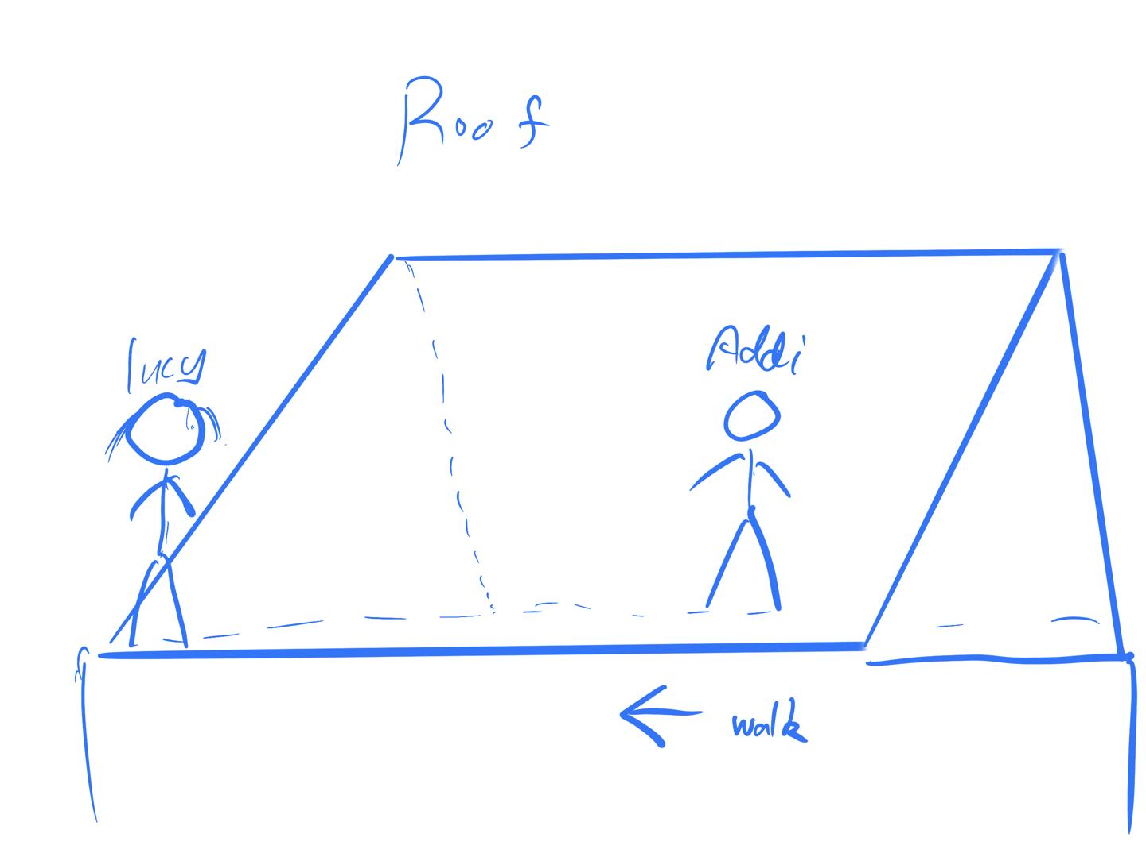

# **Interface**

# 

