**Legacy of Mendel**

A tower defense game that uses the laws of genetic inheritance to raise creatures to fight for the player.

**Game Concept**

This is a game that combines elements of tower defense, strategy, RPG and science, and is set in a parallel universe to our own. In this world, the existence of monsters is a common phenomenon. In this world, the existence of monsters is a common phenomenon, and the study of genetics is mainly focused on these monsters. You'll play as a student at the Royal Institute of Biology. You'll play as a student at the Royal Institute of Biology, where your teacher is the famous geneticist ⸺ Mendel. Coincidentally, Mendel's laws of heredity seem to be universal in. Coincidentally, Mendel's laws of genetics seem to be universal in all universes. As his personal disciple, extract the dominant and recessive genes you want from the tissues of the monster's limbs and breed the most powerful monsters for your use. As his personal disciple, extract the dominant and recessive genes you want from the tissues of monster limbs, breed the most powerful monsters for your use, and become the last shield of the Royal Institute of Biology.

**Game Overview**

**Features List**

● Core Mechanic: Breeding, Tower Defense

● Player Character: Student of the Royal Institute of Biology

● Enemies: Monsters with various creature traits

● Tone,Genre: Western Fantasy, Relaxed

● Progression Mechanic: Sift through the favorable trait combinations.

● Goal: Breed a variety of monsters to defend against attacks

● Game Structure: Top-down 3D/2D

**Game Flow Summary**

a. Defeat invading monsters to obtain biological tissues.

b.Analyze biological tissues to identify dominant and recessive traits.

c.Select the parent tree to breed a specific monster.

d.Put into the next round of battle to test the strength of the combination.

**Gameplay & Mechanics**

**Gameplay Overview**

The gameplay is divided into two main parts: day and night. At night, the player works in a laboratory studying genetic samples obtained from defeated monsters to try to combine and breed new monster units.

Genetic samples obtained from defeated monsters are studied in the laboratory at night, where the player tries to combine and breed new monster units. These units have different characteristics and abilities and can be used to fight against the constantly attacking enemies.

During the day, players need to use the monster units they have researched and bred during the night to build a defense line against the monsters' attacks. Strategies need to be developed to determine which units to place where, and how to utilize the units' characteristics and abilities to defend against the enemy.

Through this cycle, players can gradually upgrade their monster units, making them stronger and more adaptable to various attacks. The goal of the game is to Protect the Royal Institute of Biology and Mendel's legacy by successfully fending off all monster attacks through clever strategy and the right combination of genes. Mendel's legacy.

**Game Mechanics**

Night Breeding System

Players will obtain biological tissues from various monsters during daytime battles and return them to the lab to quickly breed new monsters using Professor Mendel's Genetic Machine.

monsters. Each monster will have a specific amount of blood and attack power, as well as the most important unique traits. Normal monsters will only have a single

However, as the difficulty level increases, players will have the opportunity to acquire more powerful multi-trait monster tissues.

Genetic Machine

The interface of the Genetic Machine is as shown in the picture, each slot can place two monster tissues, which are regarded as the parent and the mother, and cannot be undone after being placed. Tissue Before placing the tissues into the Genetic Machine, the player can only observe their traits but cannot know their genotypes, after placing the tissues into the machine, the machine will automatically analyze their genotypes and display them.

The genotype will be analyzed and displayed automatically after it is placed in the machine. (This design is intended to provide strategy and uncertainty for the game, players need to pay attention to the appearance of different traits and drop frequency of monsters to infer the dominant and recessive traits. (This design aims to provide strategy and uncertainty in the game, players need to pay attention to the frequency of appearance and dropping of monsters with different traits in order to infer dominant and recessive traits). The number of new monsters with different traits is determined by the genotype of the parent.

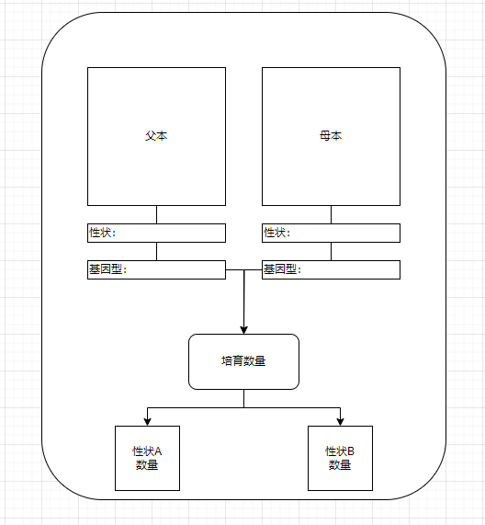

Resource Consumption

In addition to the basic monster tissues used for crossbreeding, breeding new monsters requires another resource: cloning nutrients. There are two ways for players to obtain Clone

There are two ways to get clone nutrients.

1. For every monster you kill during the day, you will receive a certain amount of Clone Nutrient.

2. You can use the unused monster tissues as waste, and each monster tissue can be exchanged for a certain amount of Clone Nutrient.

Storage Warehouse.

The warehouse page is divided into two parts, one is the monster organization warehouse, the other part is the monster warehouse.

Monster tissues obtained during daytime battles are automatically deposited into the Monster Tissue Warehouse, while new monsters bred at night are automatically deposited into the Monster Warehouse. Both

There is an upper limit to the number of storage units in both warehouses. If the warehouse is full, you will not be able to get new organizations or new monsters.

Battle Preparation.

At the end of the Night Breeding Phase, when the player has finished breeding and obtained a new monster, the page jumps to the Monster Warehouse, where the player selects a new monster from the Monster Warehouse to bring into the daytime battle.

The player selects a monster from the Monster Warehouse and chooses the type of monster he wants to bring into the daytime battle. Once the selection is complete, the player can enter the daytime tower defense battle mode.

Daytime Tower Defense Battles:

Scenery

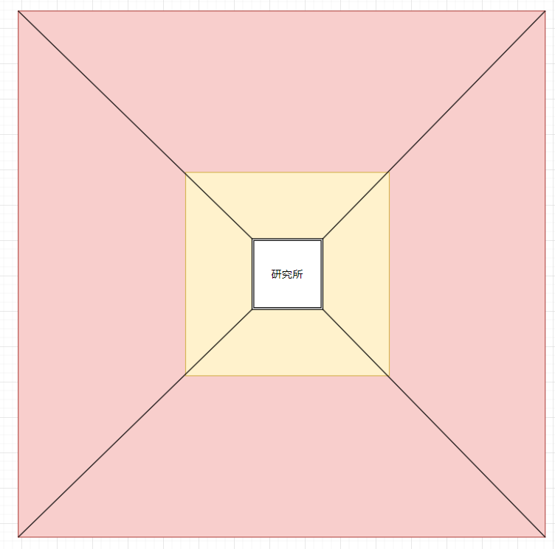

The yellow area is the placeable area and the red area is the monster attack area. As shown in the picture, there are four directions, monsters will attack from different directions.

At the beginning of the game, there is only one direction, with the progress of the process to increase the attack area to enhance the difficulty of the game.

The placement area is divided into three rings, players according to their own ideas of their own monsters arranged in these three rings, to defend against foreign enemies, if a certain area of defense is breached, the

If the defense of an area is breached and the Royal Biological Institute in the center is destroyed by monsters, the game will be considered a failure.

Battles.

Each battle begins with an initial number of players. The number of placements is 10 x the currently open attack area. For each subsequent kill.

For each monster killed, the maximum number of placements increases by 1, or by 2 if an Elite monster is killed.

Each of the player's monster units has the following base values.

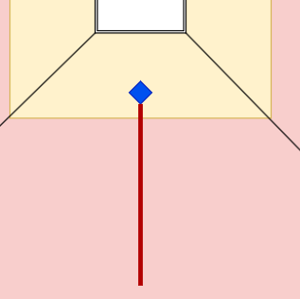

radiation area.

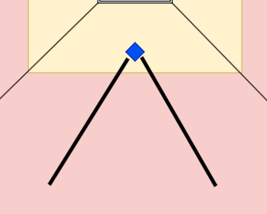

Attack Speed

- Blood

- Attack Power

In addition to the base values, each monster has a separate creature trait.

Monster: The player can move the mouse over the monster when it is attacking, and information about the monster will appear.

Players can move the mouse to the top of the monster when the monster attacks, then the monster's information will appear, including the basic values and its biological traits, as shown in the figure: the monster's basic values and its biological traits, as shown in the figure.

As shown in the picture.

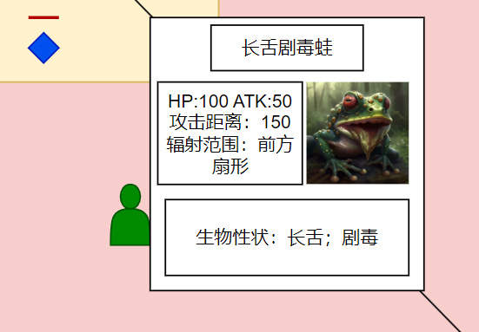

After the death of the monster dropped organization automatically into the warehouse, the battle process players can also open the warehouse at any time to check the current battle has been obtained

The monster's tissues will be returned to the warehouse automatically after the monster's death.

Attack Attributes.

Different monster traits may bring about changes in attack attributes. There are four types of damage in the game: fire, lightning, ice, and poison.

If a creature does not have any traits that alter its attack attributes, the damage is considered physical.

Traits.

Monster traits are rare and common, but there is no obvious advantage or disadvantage, some seemingly inferior traits can play an unexpected role after crossbreeding with other traits.

Some seemingly inferior traits, when crossed with other traits, can have unexpected effects. For example, the crab pincer length mentioned in the previous article, the recessive gene short crab pincer seems to be rarer and more powerful than the dominant gene short crab pincer, but it is more powerful than the dominant gene short crab pincer, which is more rare.

However, if the short crab claw is combined with a trait that requires a bonus to attack speed, it will have a greater advantage than the short crab claw.

The following are some of the currently envisioned monsters.

Here are some currently envisioned monsters and their traits.

- Stone Beetle: Hard Shell (% damage reduction)/Soft Shell (immune to damage every three hits).

- Webbing Spider: Linear Web (imprisons single target)/ Wide Web (briefly imprisons multiple targets)

- Thunderbolt: Wide Wingspan (wide attack radius)/Narrow Wingspan (faster travel speed); Chain Discharge (attacks one target and then randomly ejects it to its neighboring targets)

(attacks a target and then bounces it off to its neighboring targets, damage decreases)/Lightning Strike Discharge (attacks a target with high damage and stuns it for a short time).

- Fire Lizard: Tarantula (higher lifesteal)/Short Tail (faster crawling); Volcanic Scales (better fire damage reduction)/Swamp Scales (better fire damage reduction).

Scales (better fire damage reduction) / Swamp Scales (better physical damage reduction); Volcanic Breath (greater range of fire attacks) / Feeble Breath (causes less fire damage, but will

(inflicts less fire damage, but slashes enemy attack power for a short time).