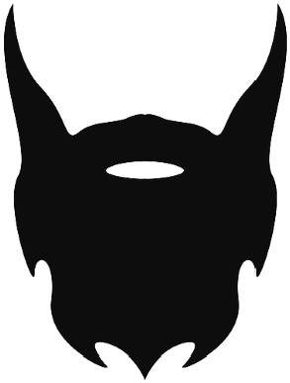

**BEARD & STACHE CONTEST**

**2024**

**OLD FASHION DAYS**

**NORTH SALEM, INDIANA**

**REGISTRATION @**

**2:30 P.M. SUNDAY, SEPTEMBER 1ST**

**CONTEST STARTS**

**@**

**3 P.M.**

The North Salem Old Fashion Days Committee reserves the right to change

the foregoing terms and conditions at any time as may be deemed expedient

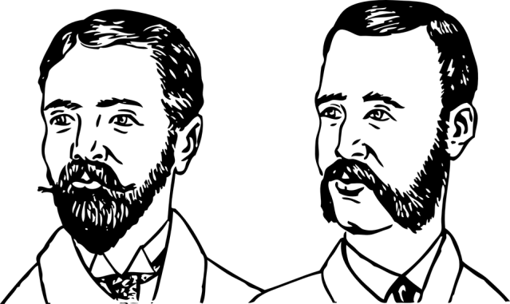

**Categories**

**–**

Best Groomed Beard

Longest and/or Biggest Beard

–

We will bring out the tape measure!

Best Groomed Mustache

Longest Mustache

–

We will bring out the tape measure!

Famous Person look

-

alike

–

You are welcome to dress up as someone famous who looks similar to

you

–

Our judges will make the decisions as to whether that

’

s true or not!

**Location**

**–**

The bandstand on N Broadway St

**Date & Time**

**–**

Sunday, September 1st

–

Registration starts @ 2:30 p.m.

Contest starts @ 3 p.m.

You may register early by emailing rhubbard.co.hendricks@gmail.com

**Cost**

**–**

$10 per person

–

Cash or Checks only

–

ATMS are within walking distance

Checks are to made payable to: NSOFD Committee

**Judges**

**–**

To be 3 of Hendricks County Favorites

**Prizes**

**–**

We will have a variety of prizes including but not limited to:

Dude Wipes, Duke Cannon Soap, Gift Card to Perillos Pizzeria, Gift Cards to Garage 17, Gift Cards from Manscapes Grooming Lounge, Gift Cards & Beard Oils/Butters from Dappered Man.

