Prepared for:
Lansing Point Condo Corporation 124
c/o Denali Gaetz
105 Copper Road
Whitehorse, YT Y1A2Z7
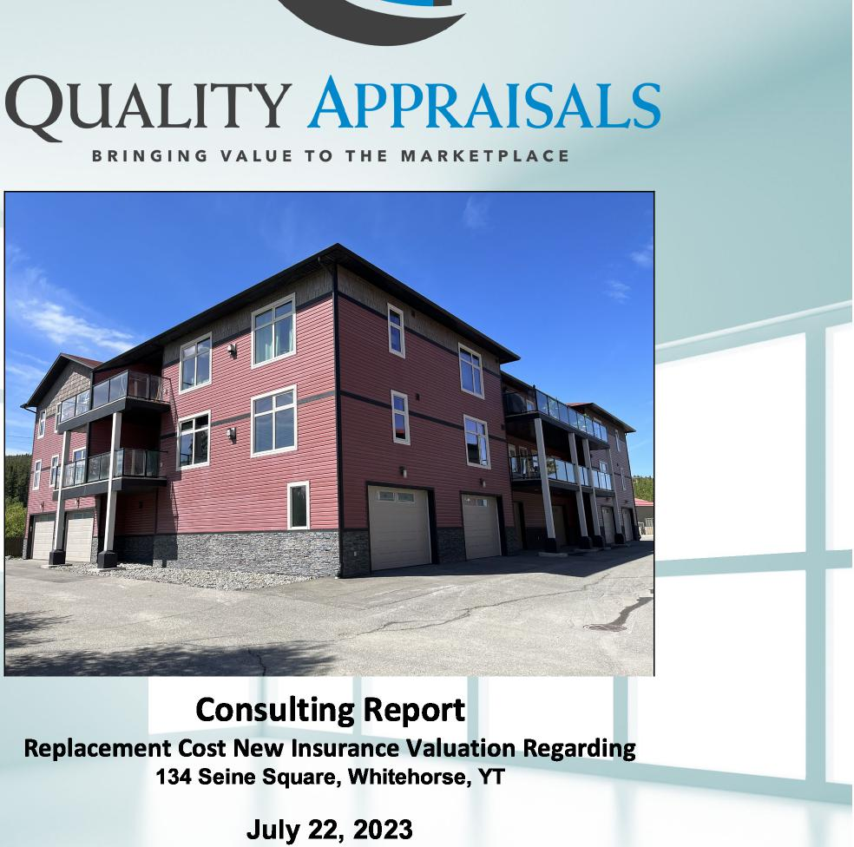
QUALITY APPRAISALS
BRINGING VALUE TO THE MARKETPLACE
Consulting Report
Replacement Cost New Insurance Valuation Regarding
134 Seine Square, Whitehorse, YT
July 22, 2023
Prepared by:
Jlanuel Kennedy-Kuiper, B.Comm
AIC Candidate Member
867-393-3709
office@qualityappraisals.ca

 | QUALITY APPRAISALS INC.  BRINGING VALUE TO THE MARKETPLACE

July 22, 2023
Our File #2023-1014
Lansing Point Condo Corporation 124
105 Copper Road
Whitehorse, YT Y1A2Z7
Attention: Denali Gaetz
Re: Consulting Report for Replacement Cost New Insurance Valuation Including Demolition and Debris Removal of the Residential Condominium Complex Property Located at; 134 Seine Square, Whitehorse, YT
In accordance with your instructions, I have prepared this consulting report of the above noted building improvements, hereinafter referred to as the "Subject Property" in order to estimate the Replacement Cost New of the improvements for fire insurance purposes.
After analyzing the data gathered during my inspection and subsequent investigation, it is my opinion that the Replacement Cost "as new", including demolition and debris removal, of the Subject Property, as built and as described in this report, including demolition and debris removal, as at June 15, 2023, and subject to the Assumptions and Limiting Conditions contained herein, is:
FOURTEEN MILLION DOLLARS
($14,000,000)
My report in support of this fire insurance valuation is attached and forms the basis for this opinion. This report contains a total of 66 pages including the Addenda, my certification and signature.
Best regards,
 | 
Manuel Kennedy-Kuiper, B.Comm  AIC Candidate Member  AIC Candidate Member # 914609  The Appraiser and Author of this Report | Jonathan Sobottka, BA, P. App, AACI  Principal  AIC Member # 905421  Co-signing Appraiser

Salmon Arm Office - 751 Marine Park Drive NE, PO Box 489 Salmon Arm, BC V1E 1A0
Whitehorse Office - PO Box 33019, Whitehorse, YT Y1A 5Y5
+1-867-393-3709 www.qualityappraisals.ca
+1-833-834-5263 office@qualityappraisals.ca

i
TABLE OF CONTENTS
PART 1. INTRODUCTION 2
EXECUTIVE SUMMARY 3
PART 2. BASIS OF THE APPRAISAL 5
REPORT DEFINITIONS 6
TERMS OF REFERENCE 8
SCOPE OF WORK 9
LIMITATIONS 11
PART 3. PRESENTATION OF DATA 12
AERIAL VIEW 19
BUILDING FLOOR PLANS 20
PART 4. ANALYSES AND CONCLUSIONS 27
HIGHEST AND BEST USE 28
METHOD OF REPORT 29
RECONCILIATION AND FINAL ESTIMATE OF VALUE 35
ASSUMPTIONS, LIMITING CONDITIONS, DISCLAIMERS AND LIMITATIONS OF
LIABILITY 36
CERTIFICATION 39
PRIVACY STATEMENT FOR PRINTED MATERIALS AND RESOURCES 40
ADDENDA AND SUPPORTING DOCUMENTS I
PHOTOGRAPHS OF THE SUBJECT PROPERTY I
PLAN 93788 CLSR YT IX

www. QualityAppraisals. ca

PART 1. INTRODUCTION

www. QualityAppraisals. ca

Page 3 of 53
EXECUTIVE SUMMARY  Residential Condominium Complex  134 Seine Square Whitehorse YT | Replacement Cost New Including  Demolition and Debris Removal  $14,000,000

Effective Date June 15, 2023
Property Information
Zoning Residential Multiple
Housing
OCP Residential - Urban
Improvements
Residential Condominium Building (2)
Size (sq. ft.) 23,976 sq. ft. (each)
Year Built 2008
Condition Average
Site Improvements
Highest and Best Use Summary
Site Improvements have not been included in the value estimates. E.g. landscaping, fencings, asphalt paving.
The Highest and Best Use Analysis was not the subject of this report and has not been completed.
The Replacement Cost New estimate includes demolition & debris removal.
I www.QualityAppraisals.ca
I

Page 4 of 53

LOCATION MAP
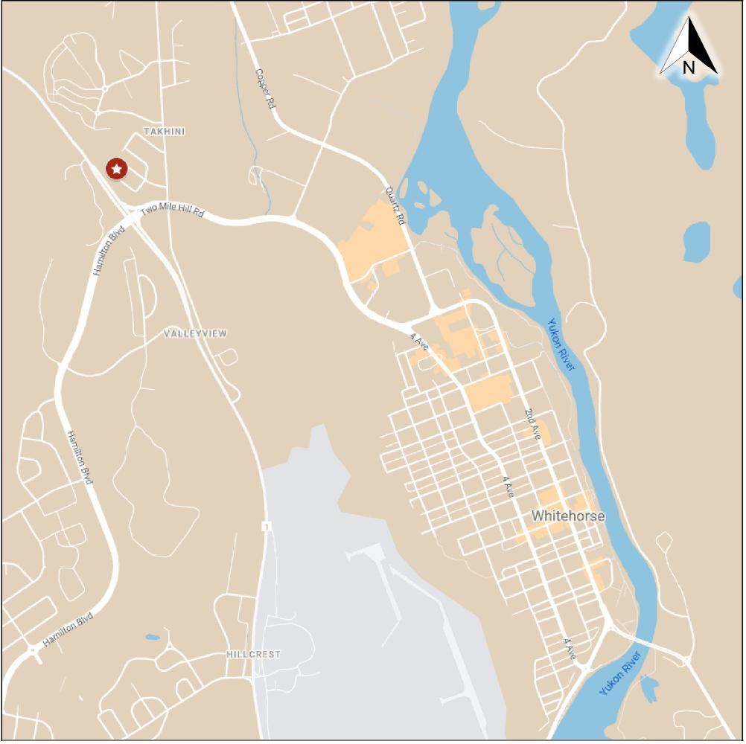
Whitehorse, YT

I www.QualityAppraisals.ca
I

PART 2. BASIS OF THE APPRAISAL

www. QualityAppraisals. ca

Page 6 of 53
REPORT DEFINITIONS
Market Value
The applicable definition of Market Value for the purpose of this report is:
"The most probable price, as of a specified date, in cash, or in terms equivalent to cash, or in other precisely revealed terms, for which the specified property rights should sell after reasonable exposure in a competitive market under all conditions requisite to a fair sale, with the buyer and seller each acting prudently, knowledgeably, and for self-interest, and assuming that neither is under undue duress."'
Types of Reports
As defined by CUSPAP, report types may include "form reports, concise narrative reports, or comprehensive reports in complete or draft form." This report takes the form of a concise narrative report. [CUSPAP, 2022; 3.4]
Current Replacement Cost New
Replacement Cost has been defined as:
"The estimated cost to construct, at current prices as of the effective appraisal date, a substitute for the building being appraised using modern materials and current standards, design, and layout. "²
Current Replacement Cost New
The replacement cost of a building, as defined by Marshall Valuation Services, is the total cost of construction required to replace the subject building with a substitute of similar utility. These costs include labour, materials, supervision, contractor's profit and overhead, architects plans and specification, sales tax, and insurance.
Demolition and Debris Removal
The total cost to demolish the remaining improvements after a total loss event, as well as to remove the debris from the site before beginning construction of the replacement improvements.
Depreciated Value
Marshall Valuation Service defines depreciation as: "a loss in value due to any causes." It is the difference between the value of a structural improvement or piece of equipment and its replacement cost as of the date of valuation. Physical depreciation is loss in value due to physical deterioration. Functional obsolescence is loss in value due to lack of utility or desirability of part or all of the property. Economic obsolescence is loss in value due to causes outside the property. The Subject Property's depreciation is not the subject of this report.
¹ The Appraisal of Real Estate, Third Canadian Edition, ed. Dybvig, (UBC, Real Estate Division, 2010) p.2.8.
² The Appraisal of Real Estate, Third Canadian Edition, ed. Dybvig, (UBC, Real Estate Division, 2010) p.17.9.
I www.QualityAppraisals.ca
I

Page 7 of 53
7ffective Age
The effective age of a property is its age as compared with other similar properties. It is the actual age, less the age as affected by maintenance, modernization, etc. Determination of effective age on older structures may be estimated by establishing a remaining life, which, subtracted from a typical life expectancy will result in an appropriate effective age. The Subject Property's effective age is not the subject of this report.
Remaining Economic Life
The remaining economic life is the remaining time that a structure may be expected to continue to perform its function economically. The Subject Property's remaining economic life is not the subject of this report.

I www.QualityAppraisals.ca
I

Page 8 of 53
TERMS OF REFERENCE
Purpose of the Report
This consulting report was completed for the purpose of estimating the Replacement Cost New including demolition and debris removal of the Subject Property's improvements, as at June 15, 2023, subject to the Assumptions and Limiting Conditions contained herein.
Intended Use of the Report
This consulting report is for the Client's use to inform building insurance coverage for the Subject's two building improvements.. The current market value of the Subject Property is not the subject of this report.
Intended User of the Report
This report is prepared for the exclusive use of the Client, Lansing Point Condo Corporation 124 do Denali Gaetz, as named above. The Client is herein named as the Intended User of this report. This report and its contents are considered confidential between the Client and Quality Appraisals Inc. and will not be conveyed or disclosed to any other party without the Client's permission. No other person or party, other than the identified Intended Users, should rely on this report for any other purpose or use and liability to all such persons or parties is denied. Should the Client wish to name other intended users after the issuance of this report, a written Letter of Reliance will be issued by the author of this report at the author's discretion.
Date of Inspection
June 15, 2023
Effective Date of Appraisal
June 15, 2023
www. QualityAppraisals. ca

Page 9 of 53
SCOPE OF WORK
The Canadian Uniform Standards of Professional Appraisal Practice (CUSPAP 2022) defines Scope of Work in a Report:
"Scope of Work in a Report describes the amount and type of information researched, and the analysis applied to complete an Assignment and includes:
- Inspection (Inspection of the subject property is mandatory, subject to any Extraordinary Limiting Condition);
- Research into physical, legal, social, political, economic and/or other factors that could affected the property;
- Data research and verification, and inspection of comparable data;
- Documents relied upon and their availability for review by the Client or an Intended User;
- Analysis applied; and
- Any limitations to the Assignment." (CUSPAP 2022; 7.5.1]
Each consulting assignment is unique, depending upon the type and size of property; the complexity and significance of the appraisal problem; and the intended use of the report. The problem that is the focus of this engagement has been discussed and defined with the client; the work required to solve the problem planned; and the necessary market data acquired, analyzed, and reconciled into an estimate of value.
The general tasks and items necessary to complete this assignment included the following:
- Assembly and analyses of relevant information pertaining to the subject property.
- An inspection of the subject property's improvements.
- Assembly and analyses of pertinent market cost data.
- A statement of land use controls pertaining to the subject property.
- Discussion of the methodologies and procedures employed in arriving at an estimate of Replacement Cost New.
- Inclusions of all appropriate photographs, maps, graphics, and addenda/exhibits.
- Reconciliation of the collected data into an estimate of Replacement Cost New as at the Effective Date of the report.
www. QualityAppraisals. ca

Page 10 of 53
The specific tasks necessary to complete this report included the following:
Inspection
The Appraiser, Manuel Kennedy-Kuiper, B.Comm conducted an inspection of the Subject Property on June 15, 2023; photographs included in the report were obtained during the inspection.
Type of Analysis
In consideration of the Purpose and Intended Use of the appraisal herein, assistance from the Marshall & Swift® Cost Valuation Service Cost Manual and/or the online tool Marshall & Swift® SwiftEstimator® by CoreLogic® were used as well as information regarding local cost estimates.
Data Research
Primary data concerning the Subject Property was obtained from the Whitehorse/Yukon Geo-spatial Information System and the Government of Canada Lands Survey Plan Search. Interviews concerning the Subject Property and general information regarding local cost rates were conducted with real estate brokers, property owners, municipal planning department staff, contractors, and developers. Additional property information and access to the Subject Property was obtained from agents of the Client, and is assumed to be factual and correct.
Audits and Technical Investigations
Technical investigations such as detailed inspections or engineering review of the existing structure, roof or mechanical systems, an environmental review of the property, a site or building survey, or investigations into the bearing qualities of the soils were not completed.
www. QualityAppraisals. ca

Page 11 of 53
LIMITATIONS
Verification of Third-Party Information
The analysis conducted in this report relied upon written and verbal information obtained from a variety of sources considered to be reliable. Unless otherwise stated herein, the information provided by the Client was not verified and is assumed to be correct. The mandate for this consulting report did not require a report to be prepared to the standard appropriate for court purposes or for arbitration, therefore full documentation of confirmation of primary information was not undertaken.
Compliance
All data considered appropriate for inclusion in the report is to the best of our knowledge factual. The findings have been conveyed as a narrative report in full compliance with the 2022 Canadian Uniform Standards of Professional Appraisal Practice (CUSPAP 2022) as adopted by the Appraisal Institute of Canada (AIC).
This report presents only summary discussions of the data, reasoning and analyses that were used in the report writing process to develop the appraisers opinion. Supporting documentation concerning the data, reasoning, and analyses is retained in the work-file saved securely in electronic format and/or hard copy on-site at the premises of Quality Appraisals Inc. The information contained in this report is specific to the needs of the Client and for the stated Intended Use. The Appraiser is not responsible for the unauthorized use of this report.
Environmental Assumption
It is assumed that there are no environmental contaminants on/or in the property being appraised, which could affect its utility. Should there be any question or concern regarding the potential possibility of any such contaminant or hazard being present therein/on, it is recommended that an environmental assessment of the property be conducted.
www. QualityAppraisals. ca

PART 3. PRESENTATION OF DATA

www. QualityAppraisals. ca

Page 13 of 53
DESCRIPTION OF THE IMPROVEMENTS
The Subject Property consists of two identical residential condominium buildings. Each building consists of three-levels, fully above grade. Each building consists of ten individually partitioned garages and ten residential condominium units. The garages are located on the ground level, with the residential units spanning across the two higher levels. There are five residential units on each level. There are three types of units (type A, B, and C), with the distinction between the units being minor variations of the interior layout. Each type of unit consists of entry, kitchen, dining room, living room, mechanical room with laundry, two bedrooms, one living area four-piece bathroom, one ensuite-four-piece bathroom, and walk-out to attached private exclusive use patio. The exclusive use
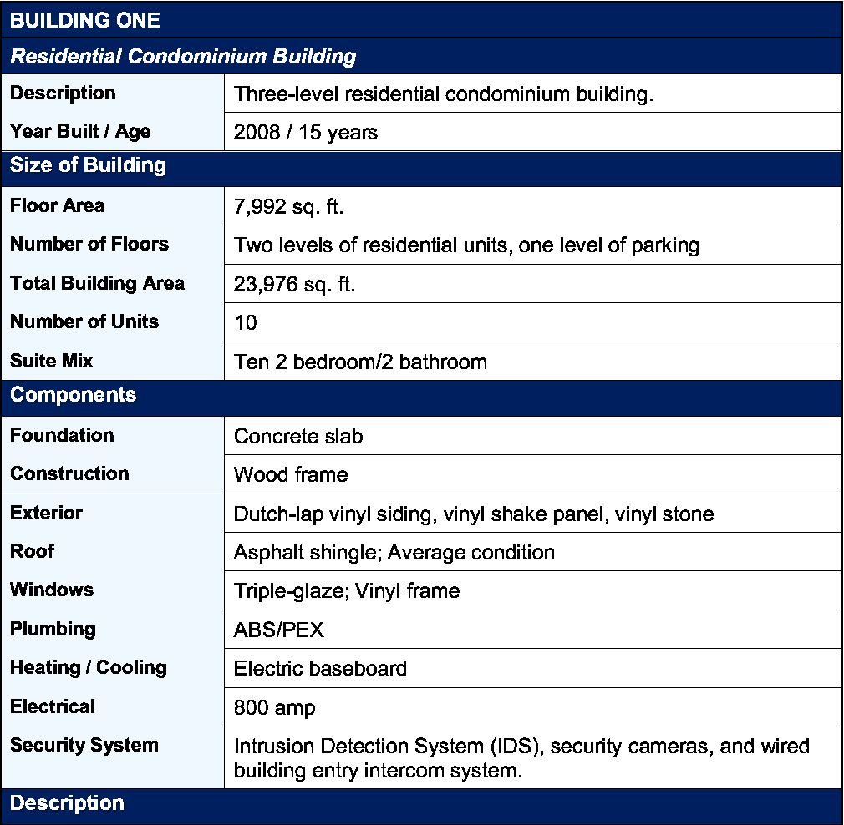
Description Year Built / Age
Three-level residential condominium building.
2008 / 15 years
Foundation Construction Exterior
Roof
Windows Plumbing Heating / Cooling Electrical Security System
Concrete slab
Wood frame
Dutch-lap vinyl siding, vinyl shake panel, vinyl stone
Asphalt shingle; Average condition
Triple-glaze; Vinyl frame
ABS/PEX
Electric baseboard
800 amp
Intrusion Detection System (IDS), security cameras, and wired building entry intercom system.
Floor Area
Number of Floors Total Building Area Number of Units Suite Mix
7,992 sq. ft.
Two levels of residential units, one level of parking
23,976 sq. ft.
10
Ten 2 bedroom/2 bathroom
BUILDING ONE
Residential Condominium Building
Size of Building
Components
Description
I www.QualityAppraisals.ca
I

Page 14 of 53
patios for unit types A and B total 94 sq. ft. +/-, while the patio for unit type C totals 362 sq. ft. +/-.
The main entry door casing has two fully-glazed doors with keyed/magnetic locks. A building intercom is located to the right of the entry doors to facilitate visitor entry into the building. Main boxes for the residents are located on the exterior of the building at the main entrance.
Following the main entrance, there is a small lobby area. This space serves as a transitional zone between the exterior and interior of the building, providing a secure and protected environment for visitors. The lobby is positioned directly opposite and elevator and between two stairwells. This arrangement allows for easy access to both the lobby and the stairwells from the main entrance.
A central hallway that runs along the length of each floor. Each hallway provides access to the different units and common areas. A small common area den is located within the hallway on each residential floor (located above the entrance and lobby). The hallway on the ground floor provides access to each garage, as well as two electrical rooms, the elevator room, and janitorial room.
Finish Details
Interior finishes for the units are moderately above average.
The entry area is finished with standard high-end flooring options including ceramic tile or hardwood. The living area is finished with standard high-end flooring options including carpet or hardwood as well as propane fireplace. The walls are painted with a neutral tone, and the ceilings are textured (orange peel) and painted. The kitchen area is finished with standard high-end flooring options including ceramic tile or hardwood. Kitchens are equipped with stainless steel appliances, granite countertops, Merit cabinets, and 4" granite backsplash. Cabinets feature a textured trim and ornamentation that feature embellishments such as raised panels, moulding, carvings, or additional trim work. Each kitchen also includes a centre island. Bedrooms feature extra-large windows for natural light, a walk-in closet with built-in safe and carpeted floors. Bathroom finishes include linoleum flooring, laminate countertops, porcelain/glass toilet and sink, and polymer shower and tub fixtures. Baseboard and door trim throughout are moulded painted wood. Windows are finished with picture-frame style moulded trim.
Garages are finished with polished concrete floors and drain pipe. The walls are painted with a neutral tone, and the ceilings are textured (orange peel) and painted. Entry is provided via a ceiling mounted 2" automatic sectional garage door.
Common area hallways on the ground floor are finished with linoleum. Common area hallways on the residential floors are finished with carpet. The walls are painted with a neutral tone, and the ceilings are textured (orange peel) and painted. Lighting is provided by wall-mounted sconces. Ceilings are finished with acoustic tile. Baseboard and door trim
I www.QualityAppraisals.ca
I

Page 15 of 53
throughout are moulded painted wood. Windows are finished with picture-frame style moulded trim.
Exclusive use and common area patios are finished with polyvinyl chloride or thermoplastic olefin membrane floors, powder-coated aluminium glass panel railings, and a propane hook-up.
Overall Condition and Remaining Economic Life
The Subject Property has been well maintained with an effective age of 15 years and a remaining economic life of 50 years.

I www.QualityAppraisals.ca
I

Page 16 of 53
Description Year Built / Age |  | Three-level residential condominium building.
Description Year Built / Age |  | 2008 / 15 years
BUILDING TWO
Residential Condominium Building
Size of Building
Floor Area
Number of Floors Total Building Area Number of Units Suite Mix
7,992 sq. ft.
Two levels of residential units, one level of parking
23,976 sq. ft.
10
Ten 2 bedroom/2 bathroom
Components
Concrete slab
Wood frame
Dutch-lap vinyl siding, vinyl shake panel, vinyl stone
Asphalt shingle; Average condition
Triple-glaze; Vinyl frame
ABS/PEX
Electric baseboard
800 amp
Intrusion Detection System (IDS), security cameras, and wired building entry intercom system.
Foundation Construction Exterior
Roof
Windows Plumbing Heating / Cooling Electrical Security System
Description
The Subject Property consists of two identical residential condominium buildings. Each building consists of three-levels, fully above grade. Each building consists of ten individually partitioned garages and ten residential condominium units. The garages are located on the ground level, with the residential units spanning across the two higher levels. There are five residential units on each level. There are three types of units (type A, B, and C), with the distinction between the units being minor variations of the interior layout. Each type of unit consists of entry, kitchen, dining room, living room, mechanical room with laundry, two bedrooms, one living area four-piece bathroom, one ensuite-four-piece bathroom, and walk-out to attached private exclusive use patio. The exclusive use patios for unit types A and B total 94 sq. ft. +/-, while the patio for unit type C totals 362 sq. ft. +/-.
www. QualityAppraisals. ca

Page 17 of 53
The main entry door casing has two fully-glazed doors with keyed/magnetic locks. A building intercom is located to the right of the entry doors to facilitate visitor entry into the building. Main boxes for the residents are located on the exterior of the building at the main entrance.
Following the main entrance, there is a small lobby area. This space serves as a transitional zone between the exterior and interior of the building, providing a secure and protected environment for visitors. The lobby is positioned directly opposite and elevator and between two stairwells. This arrangement allows for easy access to both the lobby and the stairwells from the main entrance.
A central hallway that runs along the length of each floor. Each hallway provides access to the different units and common areas. A small common area den is located within the hallway on each residential floor (located above the entrance and lobby). The hallway on the ground floor provides access to each garage, as well as two electrical rooms, the elevator room, and janitorial room. Building 2 includes a 300 sq. ft. +/- common area patio on the south side of the third floor. Building 1 does not have this feature.
Finish Details
Interior finishes for the units are moderately above average.
The entry area is finished with standard high-end flooring options including ceramic tile or hardwood. The living area is finished with standard high-end flooring options including carpet or hardwood as well as propane fireplace. The walls are painted with a neutral tone, and the ceilings are textured (orange peel) and painted. The kitchen area is finished with standard high-end flooring options including ceramic tile or hardwood. Kitchens are equipped with stainless steel appliances, granite countertops, Merit cabinets, and 4" granite backsplash. Cabinets feature a textured trim and ornamentation that feature embellishments such as raised panels, moulding, carvings, or additional trim work. Each kitchen also includes a centre island. Bedrooms feature extra-large windows for natural light, a walk-in closet with built-in safe and carpeted floors. Bathroom finishes include linoleum flooring, laminate countertops, porcelain/glass toilet and sink, and polymer shower and tub fixtures. Baseboard and door trim throughout are moulded painted wood. Windows are finished with picture-frame style moulded trim.
Garages are finished with polished concrete floors and drain pipe. The walls are painted with a neutral tone, and the ceilings are textured (orange peel) and painted. Entry is provided via a ceiling mounted 2" automatic sectional garage door.
Common area hallways on the ground floor are finished with linoleum. Common area hallways on the residential floors are finished with carpet. The walls are painted with a neutral tone, and the ceilings are textured (orange peel) and painted. Lighting is provided by wall-mounted sconces. Ceilings are finished with acoustic tile. Baseboard and door trim throughout are moulded painted wood. Windows are finished with picture-frame style
www.QualityAppraisals.ca
I

Page 18 of 53
moulded trim.
Exclusive use and common area patios are finished with polyvinyl chloride or thermoplastic olefin membrane floors, powder-coated aluminium glass panel railings, and a propane hook-up.
Overall Condition and Remaining Economic Life
The Subject Property has been well maintained with an effective age of 15 years and a remaining economic life of 50 years.

I www.QualityAppraisals.ca
I

Page 19 of 53

AERIAL VIEW
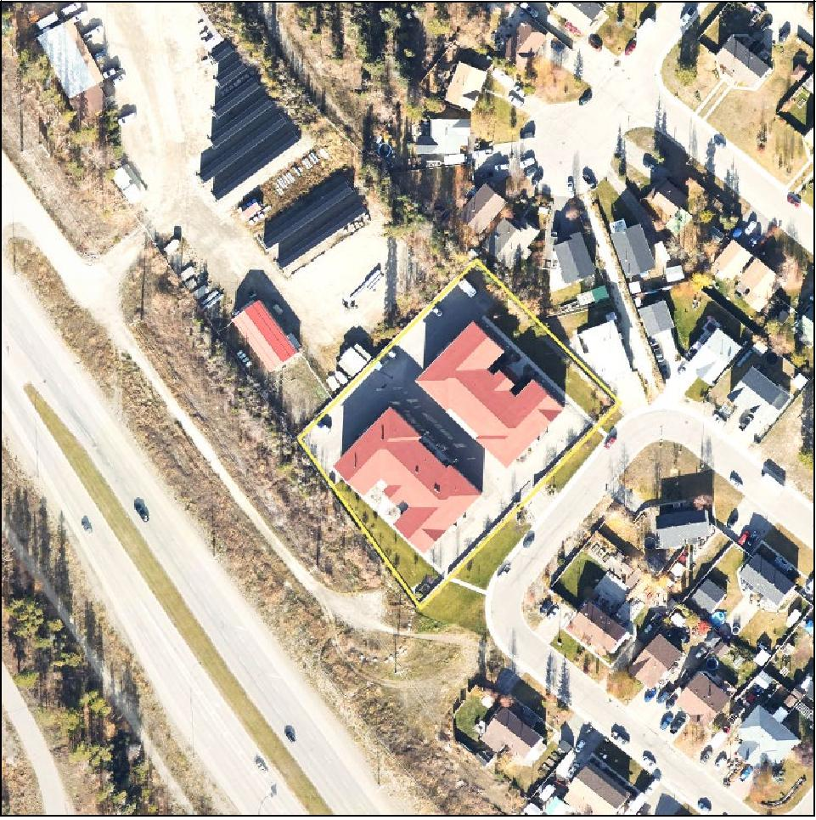

www.QuatityAppraisals.ca

Page 20 of 53
BUILDING FLOOR PLANS
Main Floor
onen-ses-cal
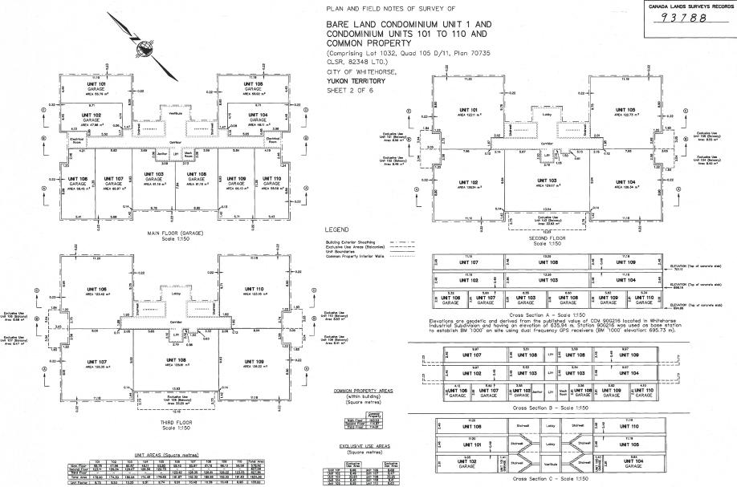
ag
411.1.106
641;
1.61.1,11A
I ex
I 'ET a
PLAN AND FIELD NOTES OF SURVEY OF
BARE LAND CONDOMINIUM UNIT 1 AND CONDOMINIUM UNITS 101 TO 110 AND COMMON PROPERTY
(Comprising Lot 1032, Quad 105 0/11, Plan 70735
CLSR, 82348 LTO.)
CITY OF WHITEHORSE,
YUKON TERRITORY r
SHEET 2 OF 6
LEGEND
SEGNI, FLOOR Scale 1:1S0
too, 1(12
?a,Fewle;
,..  IMMO | ..*. |  |  | ! | OW 110
 |  |  |  | altAT | 106
 | Err. | '-„.. | spar | ₅₁, | ..?„.. aw
Cross Section C - Scale 1:150
Scale Talled.v
\
L _ _
mJ
t '
L f.⁴³
—
CANADA LINOS SURVEYS RECORDS
93 788
YES,
Iwww.QualityAppraisals.ca

Page 21 of 53
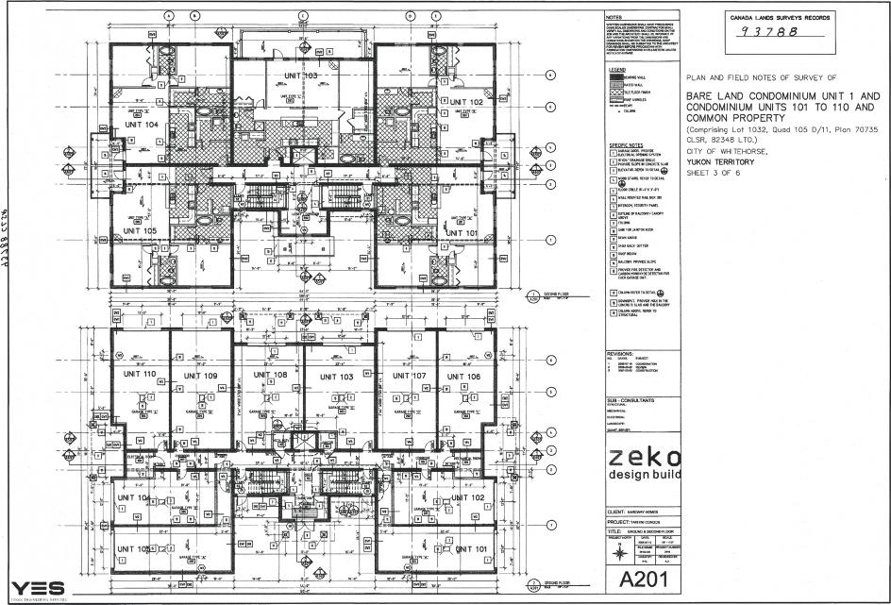
A2WIS1 ttt,o
PLAN AND FIELD NOTES OF SURVEY OF
BARE LAND CONDOMINIUM UNIT 1 AND CONDOMINIUM UNITS 101 TO 110 AND COMMON PROPERTY
(Comprising Lot 1032. quad 105 D/11, Plan 70735
CLSR, 132348 LTD.)
CITY OF WHITEHORSE,
YUKON TERRITORY
SHEET 3 OF 6
Iwww.QualityAppraisals.ca

Page 22 of 53

CANCA LAMS SURVEYS RECORDS
7 3 7 8 8
 | , Q |  |  |  |  |  |  |  |  |  |  |  |  |  |  |  |  |  |  |  |  |  |  |  |  |  |  |  |  |  |  |  |  |  |  |  |  |  |  |  |  |  |  |  |  |  |  |  |  |  |  | NOTES |  |  |  |  | CANCA LAMS SURVEYS RECORDS  7 3 7 8 8
 |  |  | _ |  |  |  |  |  |  |  |  |  |  |  |  |  |  |  |  |  |  |  |  |  |  |  |  |  |  |  |  |  |  |  |  |  |  |  |  |  |  |  |  |  |  |  |  |  |  |  |  |  |  |  |  |  | CANCA LAMS SURVEYS RECORDS  7 3 7 8 8
 |  |  |  |  |  |  |  |  |  |  |  |  |  |  |  |  |  |  |  |  |  |  |  |  |  |  |  |  |  |  |  |  |  |  |  |  |  |  |  |  |  |  |  |  |  |  |  |  |  |  |  | - alf.:
PLAN AND FIELD NOTES OF SURVEY OF
BARE LAND CONDOMINIUM UNIT 1 AND
CONDOMINIUM UNITS 101 TO 110 AND
COMMON PROPERTY
(Comprising Lot 1032, Ouod 105 0/11. Plan 70735
^{CLSR, 82348 LTO.)}
010 OF WHITEHORSE,
YUKON 1ERRI TORY
SHEET 4 OF 8
 |  |  |  |  |  |  |  |  |  |  |  |  |  |  |  |  |  |  |  |  |  |  |  |  |  |  |  |  |  |  |  |  |  |  |  |  | --L |  |  |  |  |  |  |  |  |  |  |  |  |  |  | oup
 |  |  |  |  |  |  |  |  |  |  |  |  |  | — |  |  |  |  |  |  |  |  |  |  |  |  |  |  |  |  |  |  |  |  |  |  |  |  |  |  |  |  |  |  |  |  |  |  |  |  |  | Mil.....
 |  |  | 11,1 I  — |  |  |  |  |  |  |  |  |  |  | , |  |  |  |  |  |  |  |  |  |  |  |  |  |  |  |  |  |  |  |  |  |  |  |  |  |  |  |  |  |  |  |  |  |  |  |  |  | 5.''''''''
 |  |  |  |  |  |  |  |  |  |  |  |  |  |  |  |  |  |  |  |  |  |  |  |  |  |  |  |  |  |  |  |  |  |  |  |  |  |  |  |  |  |  |  |  |  |  | I
 |  |  |  |  |  | I |  |  |  |  |  |  |  |  |  |  |  |  |  |  |  |  |  |  |  |  |  |  |  |  |  |  |  |  |  |  |  |  |  |  |  |  |  |  | I
 |  |  |  |  |  |  |  |  |  |  |  |  |  |  |  |  |  |  |  |  |  |  |  |  |  |  |  |  |  |  |  |  |  |  |  |  |  |  |  |  |  |  |  |  |  |  |  | AD-  —0 |  |  |  | =MUM
 |  | ₁ |  |  |  | . |  |  |  |  |  |  |  |  |  |  |  |  |  |  |  |  |  |  |  |  |  |  |  |  |  |  |  |  |  |  |  |  |  |  |  |  |  |  |  |  |  |  |  |  |  | ¹:¹,7=  .......
 |  | ⁻I |  |  |  |  |  |  |  |  |  | , |  |  |  |  |  |  |  |  |  |  |  |  |  |  |  |  |  |  |  |  |  |  |  |  |  |  |  |  |  |  |  |  |  |  |  |  |  | ⁻⁻⁻J  - le"^{.7........--}e
 |  |  |  |  |  |  |  |  |  |  |  |  |  |  |  |  |  |  |  |  |  |  |  | 01—
 |  |  |  |  |  |  |  |  |  |  |  |  |  |  |  |  |  |  |  |  |  |  |  |  |  |  |  |  |  |  |  |  |  |  |  |  |  |  |  |  |  |  |  |  |  |  |  |  |  |  |  | 44.7^{I},R5'.."`
 |  |  |  |  |  |  |  |  |  |  |  | '1⁴ .....  — |  |  |  |  |  |  |  |  |  |  |  |  | — |  |  |  |  |  |  |  |  |  |  |  |  |  |  |  | , |  |  |  |  |  |  |  |  |  |  | 0^{.8...}
 |  |  |  |  |  |  |  |  |  |  |  |  |  |  |  | — |  |  |  |  |  |  |  |  |  |  |  |  |  |  |  |  |  |  |  |  |  |  |  |  |  |  |  |  |  |  |  |  |  |  |  | 0 ....
 |  |  |  |  |  |  |  |  |  |  |  |  |  |  |  | . |  |  |  |  |  |  |  |  |  |  |  |  |  |  |  |  |  |  |  |  |  | ' |  |  |  |  |  |  | I |  |  |  |  |  |  | 0.,..."'"
 |  | _...— |  |  |  |  |  |  |  |  |  |  |  |  |  |  |  |  |  |  |  |  |  | , |  |  |  |  |  |  |  |  |  |  |  |  |  |  |  |  |  |  |  |  |  |  |  | 0
 |  |  |  |  |  |  |  |  |  |  |  |  |  |  |  |  |  |  |  |  |  |  |  |  |  |  |  |  |  |  |  |  |  |  |  |  |  |  |  |  |  |  |  |  |  |  |  |  |  |  |  | Etr'""'''''"
 |  |  |  |  |  |  |  |  |  |  |  |  |  |  |  |  |  |  |  |  |  |  |  |  |  |  |  |  |  |  |  |  |  |  |  |  |  |  |  |  | dI
 |  |  |  |  |  |  |  |  |  |  |  |  |  |  |  |  |  |  |  |  |  |  |  |  |  |  |  |  |  |  |  |  |  |  |  |  |  |  |  |  |  |  |  |  |  |  | .
 |  |  |  |  |  |  |  |  |  | . |  |  |  |  |  |  |  |  |  |  |  |  |  |  |  |  |  |  |  |  |  |  |  |  |  | =
 |  |  |  |  |  |  |  |  |  | ...:',  If |  |  |  |  |  |  |  |  |  | _ |  |  |  |  |  |  |  |  | ►
 |  |  |  |  |  |  |  |  |  | i.
 |  |  |  |  |  |  |  |  |  | n U Ir 109 ' |  |  |  |  |  |  |  |  | -  0— |  |  |  |  |  |  |  |  | .  ii |  |  | .  UNIT 107
 |  |  |  | VI |  |  |  |  |  | _{x} :MN • |  |  |  |  |  |  |  |  | p IT 108 |  |  |  |  |  |  |  |  | - ; |  |  | ..r;::::: 771 47....M  '.......!:!:!:!,?,:!:! 1
 |  | — |  | La |  |  |  |  |  | .  ^{r} |  |  |  |  |  |  |  |  |  | .  ₀., |  |  |  |  |  |  |  |  |  |  |  |  |  |  |  |  |  |  | 4,,,
 |  |  |  | -Aro
 |  | CV |  | MI • • |  |  |  |  |  | .  .⁷:: |  |  |  |  |  |  |  |  |  |  |  |  | ...mi.  ...  R = • |  |  |  |  |  |  |  | ii. Ili  .  ,.  . in - |  |  |  |  |  |  |  |  |  |  |  |  |  |  |  | _.. |  |  |  | ...  _ | zeko
 |  |  |  | ED1 |  |  |  |  |  |  |  |  |  |  |  |  |  |  |  | 4:11:1,;:i1,, |  |  | ₁ 1₁₁:... |  |  |  |  |  |  |  |  |  |  |  |  |  |  |  |  |  |  |  |  |  |  | * |  |  |  |  |  | design build
 |  |  |  | ' |  |  |  |  |  | :,..⁻.7 ii |  |  |  |  |  |  |  |  |  | v• |  |  | • |  |  |  |  |  |  |  |  |  |  | _.
 |  |  |  | _{umr ti} |  |  |  |  |  | $..t., g |  |  |  |  |  |  |  |  |  | tiii |  |  |  |  |  |  |  |  |  |  |  |  |  |  |  |  |  |  |  |  |  |  |  |  |  |  |  |  |  |  |  | —
 |  | _ |  | _ , |  |  |  |  |  |  |  |  |  |  |  |  |  |  |  |  |  |  |  |  |  |  |  |  |  |  |  |  |  |  |  |  |  |  |  |  |  |  |  |  |  |  |  |  | 0
 |  |  |  |  |  |  |  |  |  |  |  |  |  |  |  |  |  |  |  |  | nall
 |  |  |  |  |  |  |  |  |  | . . |  |  |  |  |  |  |  |  |  |  |  |  | .  _{no} |  |  |  |  |  |  |  | .
 |  |  |  |  |  |  |  |  |  | 1111  - |  |  |  |  |  |  |  |  |  |  |  |  | ..., |  |  |  |  |  |  |  | IIII
 |  |  |  |  |  |  |  |  |  |  |  |  |  |  |  |  |  |  |  |  |  |  | r,....., |  |  |  |  |  |  |  |  |  |  |  |  |  |  |  |  |  |  |  |  |  |  |  |  |  |  |  |  | A202
YES  _ . |  |  |  |  |  |  |  |  |  |  | z,...

Iwww.QualityAppraisals.ca

Page 23 of 53
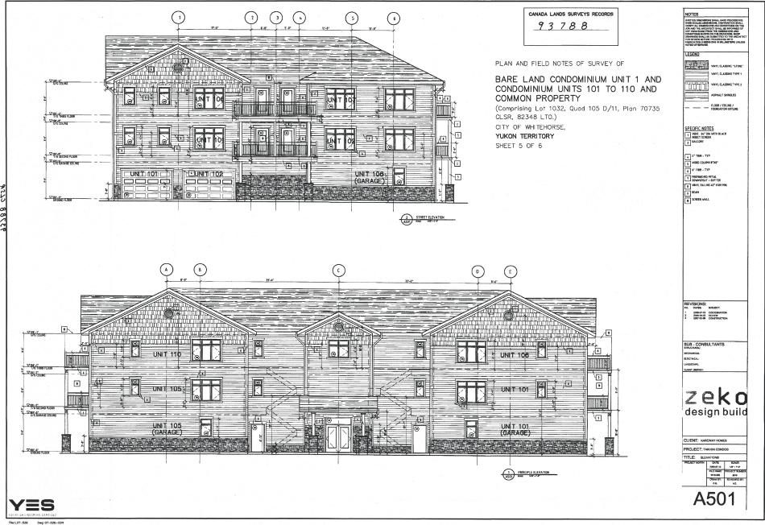
,114i V cciM
PLAN AND FIELD NOTES OF SURVEY OF
„IN p.g,
....--.7.-: III mil i,.1
_{L} _ . ..==, v.. —
gil ilr N - . ma •••1 IlirlUI OH ill II
- Miemnimallir
=fay
BARE LAND CONDOMINIUM UNIT 1 AND CONDOMINIUM UNITS 101 TO 110 AND COMMON PROPERTY
(Comprising Lot 1032, Quad 105 0/11, Plan 70735
CLSR, 82348 LTO.)
CITY OF WHITEHORSE,
YUKON TERRITORY
SHEET 5 OF 6
Pne U-VS-00⁴
Iwww.QualityAppraisals.ca

Page 24 of 53
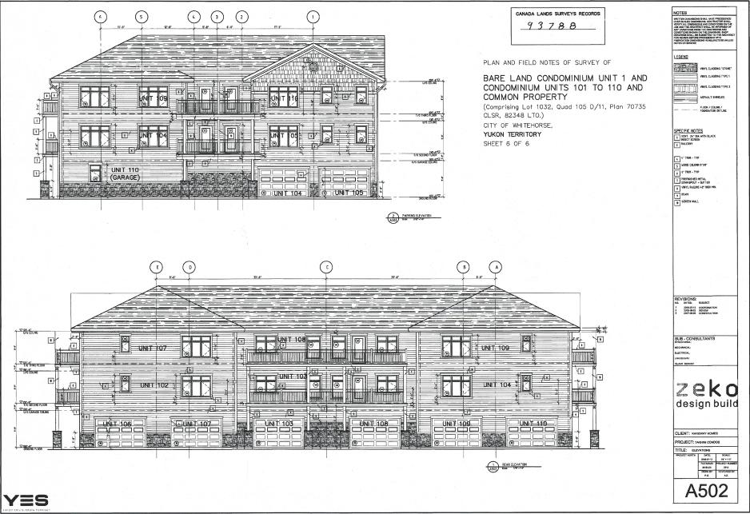
PLAN AND FIELD NOTES OF SURVEY OF
BARE LAND CONDOMINIUM UNIT 1 AND CONDOMINIUM UNITS 101 TO 110 AND COMMON PROPERTY
(Comprising Lot 1032, Oood 105 D/11, Plan 70735
CLSR, 82348 LTD.)
CITY OF WHITEHORSE.
YUKON TERRITORY
SHEET 6 OF 6
'
=
1q il^{7=-1•}411r^{7.11}
= III111111¹1^{1"}i 3
.
Iwww.QualityAppraisals.ca

Page 25 of 53
LAND USE CONTROLS
Official Community Plan
The Subject Property is currently designated as RU (Residential - Urban) under the Official Community Plan. The current uses of the Subject Property would appear to conform.
Zoning
The Subject Property is currently designated as RMx(d)(Residential Multiple Housing) under the City of Whitehorse Zoning Bylaw No. 2012-20. The current uses of the Subject Property would appear to conform.

I www.QualityAppraisals.ca
I

Page 26 of 53

Where a letter appears in brackets following a zoning designation, e.g. RSx(a), the letter corresponds to the 'special restrictions' subsection for that zone.
0 400 Consolidation date:
December 17, 2021
Meters
Projection: NAD 1983 UTM Zone 8
4
1 I
MAP 9 KOPPER KING
TAKHINI, VALLEYVIEW
Map 8
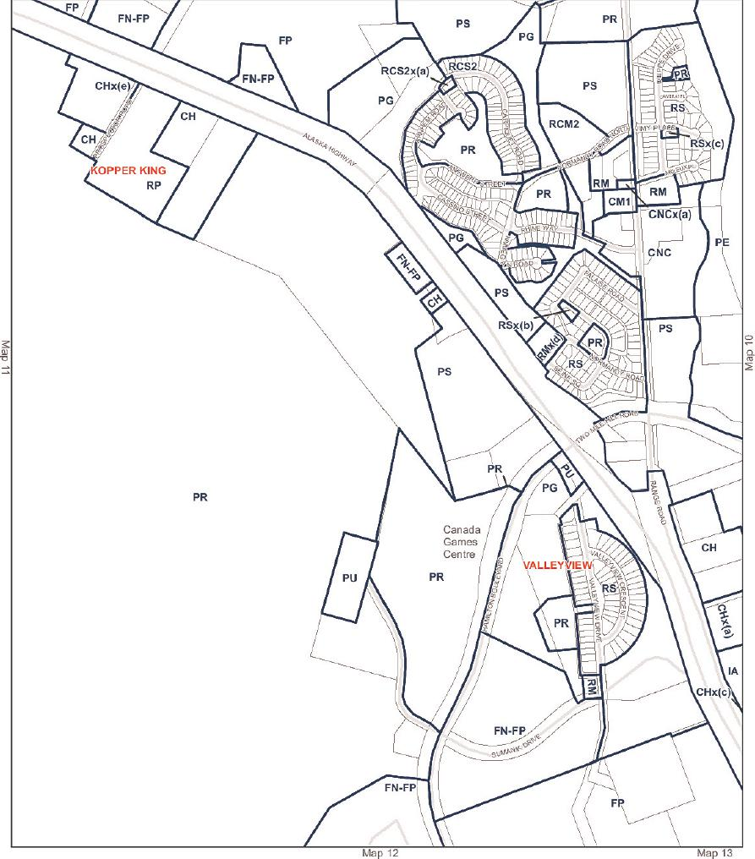
www. QualityAppraisals.ca

PART 4. ANALYSES AND CONCLUSIONS

www. QualityAppraisals. ca

Page 28 of 53
HIGHEST AND BEST USE
Highest and Best Use is defined by CUSPAP as:
"The reasonably probable use of Real Property, that is physically possible, legally permissible, financially feasible, and maximally productive, and that results in the highest value." [CUSPAP, 2022; 3.32].
These are the "four tests" which an appraiser must apply to the subject property in order to develop the opinion of highest and best use, critical to the market value at the conclusion of the report.
The process begins with an analysis of the competitive forces and market data pertinent to the subject property to identify the most profitable, competitive use to which the subject property can be put. It is the legal use which will yield to the land the highest present value and is sometimes referred to as "optimum use".
The theoretical analysis of the highest and best use utilizes the potential uses of the land as though vacant. However, the contributory value of the existing improvements in current use, or with possible alteration are also considered in the analysis of determining the highest and best use.
The Highest and Best Use analysis of the Subject Property has not been completed as part of this assignment, as this report is for fire insurance purposes only.
However, it is noted that the current use of the Subject Property site is legal and conforming. Should the improvements become destroyed, the reconstruction of the building improvements would be permitted.
www. QualityAppraisals. ca

Page 29 of 53
METHOD OF REPORT
Estimated Current Replacement Cost New Including Demolition and Debris Removal of Subject Improvements
The purpose of this report is to estimate the current replacement cost new, including demolition and debris removal, of the described improvements. The estimates herein have been constructed with assistance from the Marshall & Swift® Cost Valuation Service Manual as well as through the application of a comparative analysis using local market construction data.
The current replacement cost new, including demolition and debris removal, of the Subject's improvements has been calculated to include all direct construction costs as well as the contractor's profit, as would be required to construct the improvements on the Effective Date of this report.
There are three methods to calculate the replacement cost new of a Subject Property's building improvements.
- Unit-in-place method — Determines the cost of specific building components, or groups of components using data retrieved from a standardized cost manual
- Comparative-unit method — Determines the reproduction cost of the building improvements by making adjustments to the budget of a recently constructed comparable building.
- Quantity survey method — Individual pricing of components such as windows, doors, roofs, etc.
The unit-in-place method and comparative-unit method have been applied in this cost analysis. The unit-in-place method has been applied to nationally recognized costing manual/computerized service cost quotes, while the comparative method has been applied to a market-sourced construction budget.
The unit-in-place method determines the cost of specific building components, or groups of components using data retrieved from a standardized cost manual. Each individual component is costed individually, then total reproduction costs is determined by the sum of the components. The comparative-unit method determines the reproduction cost of the building improvements by adjusting the budget of a recently constructed or planned construction of a comparable building. Adjustments for total area and quality of finishes are made to the market-sourced budget based on the characteristics of the Subject Property, therefore providing an accurate estimate for the cost to reproduce the Subject improvements.
It is assumed that cases of functional obsolescence as observed within the Subject's improvements would not be reproduced in a replacement building. The value presented assumes total destruction of the Subject's improvements. No insurance exclusions have been considered in this report, due to the individuality of every insurance policy's non-
www. QualityAppraisals. ca

Page 30 of 53
insurable items. In addition, demolition and debris removal has been added into the estimate of the replacement cost new.
Unit In Place Method
The Replacement Cost New estimate for the Subject's improvements has been estimated using the Marshall & Swift® Cost Valuation Service as follows.

I www.QualityAppraisals.ca
I

Page 31 of 53
The Subject's improvements have a Replacement Cost New of $13,230,569 according to the Marshall & Swift® Cost Estimate.

6/22/23, 11:23 AM CoreLogic I Commercial Estimator - Report
CoreLogic - SwiftEstimator
Commercial Estimator - Summary Report
General Information
Estimate ID: Property Owner: Property Address:
Local Multiplier: Architects Fee:
6-22-2023
06-22-2023
06-2023 using default
134 Seine Square  CC124  134 Seine Square Whitehorse, YT Y1A 3C3 2.25 | Date Created: Date Updated: Date Calculated:  Cost Data As Of: Report Date:

Section 1  Area  Stories in Section Stories in Building Shape  Perimeter  Effective Age | 47952  3  3  irregular  (auto-calc) | Overall Depreciation %  Physical Depreciation %  Functional Depreciation %  External Depreciation %

Occupancy Details  Occupancy  352 Multiple Res (Low Rise)  154 Residential Garage - Built-in  Occupancy Total Percentage | 67  33  100 | Class  D  D | Height  9  8 | Quality  3.5  3.5
System : Elevators
%/Units Quality Depr % Other
651 Elevators : Passenger # 2 2.0 3
Addition Details
Addition Units Cost Depr % LM Base Date
Basic Attached 3230 $100 N
patios
Basic Appliance 20 $10,000 N
allowance
Calculation Information (All Sections)
Basic Structure | Units | Unit Cost | Total Less  Cost New Depreciation |  | Total Cost Depreciated
Base Cost | 47,952 | $213.58 | $10,241,588 |  | $10,241,588
Exterior Walls | 32,128 | $32.23 | $1,035,485 |  | $1,035,485
Heating & Cooling | 47,952 | $20.82 | $998,361 |  | $998,361
Elevators | 2 | $216,067.50 | $432,135 |  | $432,135
Attached patios | 3,230 | $100.00 | $323,000 |  | $323,000
Appliance allowance | 20 | $10,000.00 | $200,000 |  | $200,000
Basic Structure Cost | 47,952 | $275.91 | $13,230,569 | $0 | $13,230,569
Cost data by CoreLogic, Inc.
***Except for items and costs listed under ®Addition Details,. this SwiftEstimator report has been produced utilizing current cost data and is in compliance with the Marshall 8, Swift Licensed User Certificate. This report authenticates the user as a current Marshall & Swift user.***
https://www swiftestimator.cnm/Main/CE/reports/PFV.asp 1/2
These costs contain the actual costs and final costs to the owner including architects' and

Page 32 of 53

engineers' fees, plans, permits, surveying, normal site preparation, connection of utilities from the lot line, all material and labour costs, basic appliances, GST, normal interest, contractor's overhead and profit, supervision, workmen's compensation, fire and liability insurance, unemployment insurance, equipment, temporary facilities, and security.
A 5% allowance for demolition and debris removal has been calculated at $661,528 and has been added to the total estimate above.

Costing Service Report Estimate | $13,230,569
Demolition & Debris Removal % | 5%
Demolition & Debris Removal Total ($) | $661,528
Replacement Cost New with demo & debris removal added | $13,892,097
Rounded | $13,890,000
Therefore, the Replacement Cost New for the Subject's improvements, including demolition and debris removal, as calculated using the Marshall & Swift® Cost Valuation Service is $13,892,097 rounded to $13,890,000.
Comparative Method (Market Cost)
The comparative method has been applied to a planned multi-family mixed-use commercial/residential development located on Keno Way, Whitehorse YT, Y1A 059. A detailed budget and plans for the project have been made available to the appraiser by the developer. The development is of similar quality to the Subject Property improvements.
An adjustment for square footage accounts for differences in total area. The comparative cost analysis has therefore been completed as follows.
 | histle Bend Development |  | Sq. Fr  Ratio | 134 Seine  Square
BUILDING AREA |  |  | Sq. Fr  Ratio | 134 Seine  Square
Total Building Area | 9000 |  | 5.33 | 47952
Residential | 6000 |  | 5.33 | 31968
Commercial | 3000 |  | NA
Garage | 0 |  | NA | 15984
 | SOFT COSTS
Architectural fees |  | $82,000 | 2.00 | $164,000
Engineering (Mechanical,  Electrical, Civil) |  | $90,000 | 2.00 | $180,000
Design fees, renderings |  | $3,500 | 5.33 | $18,648
Landscape design fees |  | $3,412 | 5.33 | $18,181
Development permit fees |  | $25,000 | 5.33 | $133,200
Appraisal |  | $4,600 | 2.00 | $9,200
Legal fees |  | $21,000 | 2.00 | $42,000
Project management fees |  | $120,000 | 2.00 | $240,000

www. QualityAppraisals. ca

Page 33 of 53
SUBTOTAL | $349,512 |  | $805,229
SITEWORK COSTS | I
Excavation | $78,000 | 5.33 | $415,584
Deep utilities, site services | $50,000 | 5.33 | $266,400
SUBTOTAL | $128,000 |  | $681,984
BUILDING COSTS | _M_
Concrete, foundation | $75,000 | 5.33 | $399,600
Concrete pump rental | $4,500 | 5.33 | $23,976
Toilet rental | $4,000 | 5.33 | $21,312
Cell phone, printing, general  supplies | $1,500 | 5.33 | $7,992
First aid supplies | $1,500 | 5.33 | $7,992
Lumber & framing | $785,000 | 5.33 | $4,182,480
Deck and railings | $35,000 | 5.33 | $186,480
Roofing systems | $45,000 | 5.33 | $239,760
Siding, fascia, soffit, eaves | $155,000 | 5.33 | $825,840
Windows, exterior doors | $85,000 | 5.33 | $452,880
Drywall, insulation | $143,000 | 5.33 | $761,904
Interior finishing, paint, hardware | $165,000 | 4.00 | $660,000
Cabinet and counter | $120,000 | 4.00 | $480,000
Appliances | $55,000 | 4.00 | $220,000
Flooring materials and labor | $110,000 | 4.00 | $440,000
Mechanical systems | $225,000 | 5.33 | $1,198,800
Electrical and electrical finishes | $235,000 | 5.33 | $1,252,080
SUBTOTAL | $2,244,500 |  | $11,361,096
HARD AND SOFT COST TOTAL | $2,722,01 |  | $12,848,309
CONTINGENCY 5% | $136,101 |  | $642,415
GRAND TOTAL | $2,858,11 |  | $13,490,724
Cost per Square Foot | $317.5 |  | 281.34

Therefore, the applicable current rate for the Subject's improvements, as if constructed new, is estimated to be $281.00/ sq. ft. (rounded) for the finished areas. This rate has been applied to the Subject's total area by square feet in the following calculation. Decks have been included to the total. Total cost for demolishing and debris removal have also been added and are calculated as a percentage of the total current replacement cost new of the improvements. Therefore, the current replacement cost new of the development, including demolition and debris removal is as follows.
A 5% allowance for demolition and debris removal has been calculated at $661,528 and has been added to the total estimate above.

www. QualityAppraisals. ca

Page 34 of 53
Finished Area 47952 | x | 280 | = | 13,426,560
Add Demolition & Debris Removal |  | 5% |  | 671,328
Total Estimated Replacement Cost New |  |  |  | 14,097,888
Rounded to |  |  |  | 14,100,000

Therefore, the Total Replacement Cost New, including demolition and debris removal, for the Subject's improvements using the comparative method is estimated to be $14,097,888.00 rounded to $14,100,000.

I www.QualityAppraisals.ca
I

Page 35 of 53
RECONCILIATION AND FINAL ESTIMATE OF VALUE
In consideration of the Purpose and Intended Use of the appraisal herein, the two methods of estimating Replacement Cost New produced the following value estimates.
COSTING SERVICE $13,890,000
MARKET COST $14,100,000
The Market Cost estimate was slightly higher than the Marshall & Swift estimate and is believed to best represent the cost to replace the utility of the Subject's improvements given the strength of the market evidence observed from the local area. The Market Cost estimate is deemed to be more reflective of the actual cost as it takes into account local market research. The Marshall & Swift estimate is useful in that it supports the conclusions of the Market Cost estimate.
Both methods show a narrow range of estimates for the Subject's improvements. This report gives consideration to both methods, with most weight given to the Market Cost estimate, as it is believed to best represent the true and likely replacement cost "as new", including demolition and debris removal, of the Subject's improvements.
Therefore, the Subject Property's estimated Replacement Cost "as new" of the Residential Condominium Complex, including demolition and debris removal, as at June 15, 2023 and subject to the Assumptions and Limiting Conditions contained herein, is:
FOURTEEN MILLION DOLLARS
($14,000,000)
www. QualityAppraisals. ca

Appraisal Institute of Canada  AO Institut canadien des evaluateurs | Page 36 of 53

ASSUMPTIONS, LIMITING CONDITIONS, DISCLAIMERS AND LIMITATIONS OF
LIABILITY
The certification that appears in this report is subject to compliance with the Personal Information and Electronics Documents Act (PIPEDA), Canadian Uniform Standards of Professional Appraisal Practice ("CUSPAP") and the following conditions:
- This report is prepared only for the client and authorized users specifically identified in this report and only for the specific use identified herein. No other person may rely on this report or any part of this report without first obtaining consent from the client and written authorization from the authors. Liability is expressly denied to any other person and, accordingly, no responsibility is accepted for any damage suffered by any other person as a result of decisions made or actions taken based on this report. Liability is expressly denied for any unauthorized user or for anyone who uses this report for any use not specifically identified in this report. Payment of the appraisal fee has no effect on liability. Reliance on this report without authorization or for an unauthorized use is unreasonable.
- Because market conditions, including economic, social and political factors, may change rapidly and, on occasion, without warning, this report cannot be relied upon as of any date other than the effective date specified in this report unless specifically authorized by the author(s).
- The author will not be responsible for matters of a legal nature that affect either the property being appraised or the title to it. The property is appraised on the basis of it being under responsible ownership. No registry office search has been performed and the author assumes that the title is good and marketable and free and clear of all encumbrances. Matters of a legal nature, including confirming who holds legal title to the appraised property or any portion of the appraised property, are outside the scope of work and expertise of the appraiser. Any information regarding the identity of a property's owner or identifying the property owned by the listed client and/or applicant provided by the appraiser is for informational purposes only and any reliance on such information is unreasonable. Any information provided by the appraiser does not constitute any title confirmation. Any information provided does not negate the need to retain a real estate lawyer, surveyor or other appropriate experts to verify matters of ownership and/or title.
- Verification of compliance with governmental regulations, bylaws or statutes is outside the scope of work and expertise of the appraiser. Any information provided by the appraiser is for informational purposes only and any reliance is unreasonable. Any information provided by the appraiser does not negate the need to retain an appropriately qualified professional to determine government regulation compliance.
- No survey of the property has been made. Any sketch in this report shows approximate dimensions and is included only to assist the reader of this report in visualizing the property. It is unreasonable to rely on this report as an alternative to a survey, and an accredited surveyor ought to be retained for such matters.
- This report is completed on the basis that testimony or appearance in court concerning this report is not required unless specific arrangements to do so have been made beforehand. Such arrangements will include, but not necessarily be limited to: adequate time to review the report and related data, and the provision of appropriate compensation.
- Unless otherwise stated in this report, the author has no knowledge of any hidden or unapparent conditions (including, but not limited to: its soils, physical structure, mechanical or other operating systems, foundation, etc.) of/on the subject property or of/on a neighbouring property that could affect the value of the subject property. It has been assumed that there are no such conditions. Any such conditions that were visibly apparent at the time of inspection or that became apparent during the normal research involved in completing the report have been noted in the report. This report should not be construed as an environmental audit or detailed property condition report, as such reporting is beyond the scope of this report and/or the qualifications of the author. The author makes no guarantees or warranties, express or implied, regarding the condition of the property, and will not be responsible for any such conditions that do exist or for any engineering or testing that might be required to discover whether such conditions exist. The bearing capacity of the soil is assumed to be adequate.
www. QualityAppraisals. ca

Appraisal Institute of Canada  AO Institut canadien des evaluateurs | Page 37 of 53

- The author is not qualified to comment on detrimental environmental, chemical or biological conditions that may affect the market value of the property appraised, including but not limited to pollution or contamination of land, buildings, water, groundwater or air which may include but are not limited to moulds and mildews or the conditions that may give rise to either. Any such conditions that were visibly apparent at the time of inspection or that became apparent during the normal research involved in completing the report have been noted in the report. It is an assumption of this report that the property complies with all regulatory requirements concerning environmental, chemical and biological matters, and it is assumed that the property is free of any detrimental environmental, chemical legal and biological conditions that may affect the market value of the property appraised. If a party relying on this report requires information about or an assessment of detrimental environmental, chemical or biological conditions that may impact the value conclusion herein, that party is advised to retain an expert qualified in such matters. The author expressly denies any legal liability related to the effect of detrimental environmental, chemical or biological matters on the market value of the property.
- The analyses set out in this report relied on written and verbal information obtained from a variety of sources the author considered reliable. Unless otherwise stated herein, the author did not verify client-supplied information, which the author believed to be correct
- The term "inspection" refers to observation only as defined by CUSPAP and reporting of the general material finishing and conditions observed for the purposes of a standard appraisal inspection. The inspection scope of work includes the identification of marketable characteristics/amenities offered for comparison and valuation purposes only.
- The opinions of value and other conclusions contained herein assume satisfactory completion of any work remaining to be completed in a good and workmanlike manner. Further inspection may be required to confirm completion of such work. The author has not confirmed that all mandatory building inspections have been completed to date, nor has the availability/issuance of an occupancy permit been confirmed. The author has not evaluated the quality of construction, workmanship or materials. It should be clearly understood that this visual inspection does not imply compliance with any building code requirements as this is beyond the professional expertise of the author.
- The contents of this report are confidential and will not be disclosed by the author to any party except as provided for by the provisions of the CUSPAP and/or when properly entered into evidence of a duly qualified judicial or quasi-judicial body. The author acknowledges that the information collected herein is personal and confidential and shall not use or disclose the contents of this report except as provided for in the provisions of the CUSPAP and in accordance with the author's privacy policy. The client agrees that in accepting this report, it shall maintain the confidentiality and privacy of any personal information contained herein and shall comply in all material respects with the contents of the author's privacy policy and in accordance with the PIPEDA.
- The author has agreed to enter into the assignment as requested by the client named in this report for the use specified by the client, which is stated in this report. The client has agreed that the performance of this report and the format are appropriate for the intended use.
- This report, its content and all attachments/addendums and their content are the property of the author. The client, authorized users and any appraisal facilitator are prohibited, strictly forbidden, and no permission is expressly or implicitly granted or deemed to be granted, to modify, alter, merge, publish (in whole or in part) screen scrape, database scrape, exploit, reproduce, decompile, reassemble or participate in any other activity intended to separate, collect, store, reorganize, scan, copy, manipulate electronically, digitally, manually or by any other means whatsoever this appraisal report, addendum, all attachments and the data contained within for any commercial, or other, use.
- If transmitted electronically, this report will have been digitally signed and secured with personal passwords to lock the appraisal file. Due to the possibility of digital modification, only originally signed reports and those reports sent directly by the author can be reasonably relied upon.
www. QualityAppraisals. ca

Appraisal Institute of Canada  AO Institut canadien des evaluateurs | Page 38 of 53

- Where the intended use of this report is for financing or mortgage lending or mortgage insurance, it is a condition of reliance on this report that the authorized user has or will conduct lending, underwriting and insurance underwriting and rigorous due diligence in accordance with the standards of a reasonable and prudent lender or insurer, including but not limited to ensuring the borrower's demonstrated willingness and capacity to service his/her debt obligations on a timely basis, and to conduct loan underwriting or insuring due diligence similar to the standards set out by the Office of the Superintendent of Financial Institutions (OSFI), even when not otherwise required by law. Liability is expressly denied to those that do not meet this condition. Any reliance on this report without satisfaction of this condition is unreasonable.
- As of the date of this report Canada and the Global Community is experiencing unprecedented measures undertaken by various levels of government to curtail health related impacts of the Covid-19 Pandemic. The duration of this event is not known. While there is potential for negative impact with respect to micro and macro-economic sectors, as well as upon various real estate markets, it is not possible to predict such impact at present, or the impact of current and future government countermeasures. There is some risk that the Covid-19 Pandemic increases the likelihood of a global recession, however without knowledge of further anticipated government countermeasures at the national and global levels it is not possible to predict any impact at this point in time. Accordingly, this point-in-time valuation assumes the continuation of current market conditions, and that current longer-term market conditions remain unchanged. Given the market uncertainties of the Covid-19 pandemic, a force majeure event, we reserve the right to revise the value estimation set out in this report for a fee, with an update appraisal report under a separate appraisal engagement, incorporating market information available at that time.
Iwww.QualityAppraisals.ca

Appraisal Institute of Canada  AO Institut canadien des evaluateurs | Page 39 of 53

CERTIFICATION
For the property identified as:
134 Seine Square, Whitehorse, YT Y1A 3C3
Lot 1032, Quad 105 D/11, Plan 70735 CLSR, 82348 LTO
I certify that, to the best of my knowledge and belief that:
- The statements of fact contained in this report are true and correct;
- The reported analyses, opinions and conclusions are limited only by the reported assumptions and limiting conditions and are my impartial and unbiased professional analyses, opinions and conclusions;
- I have no past, present or prospective interest in the property that is the subject of this report and no personal and/or professional interest or conflict with respect to the parties involved with this assignment.
- I have no bias with respect to the property that is the subject of this report or to the parties involved with this assignment;
- My engagement in and compensation is not contingent upon developing or reporting predetermined results, the amount of value estimate, a conclusion favouring the client, or the occurrence of a subsequent event.
- My analyses, opinions and conclusions were developed, and this report has been prepared, in conformity with the CUSPAP.
- I have the knowledge and experience to complete this assignment competently, and where applicable this report is co-signed in compliance with CUSPAP;
- Except as herein disclosed, no one has provided significant professional assistance to the person(s) signing this report;
- As of the date of this report the undersigned has fulfilled the requirements of the AIC's Continuing Professional Development Program;
- The undersigned is (are all) members in good standing of the Appraisal Institute of Canada.
Based upon the data, analyses and conclusions contained herein, the Replacement Cost New Value, including demolition and debris removal, of the interest in the property described for building insurance valuation as at June 15, 2023 is estimated at $14,000,000.
As set out elsewhere in this report, this report is subject to certain assumptions and limiting conditions, the verification of which is outside the scope of this report.



Manuel Kennedy-Kuiper, B.Comm
AIC Candidate Member
AIC Candidate Member # 914609
The Appraiser and Author of this Report
Jonathan Sobottka, BA, P. App, AACI
Principal
AIC Member # 905421
Co-signing Appraiser

An Addenda of Supporting Documents is appended to this report following this section.

www. QualityAppraisals. ca

Page 40 of 53

PRIVACY STATEMENT FOR PRINTED MATERIALS AND RESOURCES
Quality Appraisals Inc. takes privacy very seriously. We collect personal information to better serve our customers, for security reasons, and to provide customers and potential customers with information about our services. We would like to have a lifelong relationship of good service with our customers, and for that reason we may retain any personal information provided for as long as necessary to provide our services and respect our obligations to governmental agencies and other third parties. The information will remain confidential to Quality Appraisals Inc., to businesses working for us, and to any organization that acquires part or all of our business, provided that they agree to comply with our privacy policy. By accepting this report, you are agreeing to maintain the confidentiality and privacy of any personal information contained herein and to comply in all material respect with the contents of our Privacy Policy. If you wish to see a copy of our Privacy Policy, or have privacy questions or concerns, please contact us by phoning 867-393-3709 or by email at: office@qualityappraisals.ca.

I www.QualityAppraisals.ca
I

Page 41 of 53
Jonathan Sobottka, BA., AACI, P.App., CPPA
jsobottka@qualityappraisals.ca 250-832-3709
Types of Assignments
Commercial strata
Development lands
Park land dedication
Expropriation
Waterfront properties
Retail stores
Restaurants
Office buildings
Executive homes
Golf courses
Marinas
Hotels
Orchards / Vineyards
Campgrounds
Mobile Home Parks
Wineries
New builds
Resort strata
Rural properties & acreages
Farm operations
Gravel quarries
Machinery
Equipment
Tenant Improvements
Personal Property
Recent Clients
CIBC
Scotiabank
TD Canada Trust
HSBC Bank
Royal Bank of Canada
Bank of Montreal
Farm Credit Canada Revelstoke Credit Union Prospera Credit Union Kootenay Savings Credit Union SASCU Financial Group Interior Savings & Credit Union Valley First Credit Union Vancity Credit Union
Sierra Mortgage Fund ThreePoint Capital
CMHC
Sagen
Canada Guaranty Mort. Ins. Various Brokers
Private Lenders
Various Barristers & Solicitors Various Municipalities & Cities Ministry of Transportation & Infrastructure
Ministry of Energy & Mines Ministry of Forests, Lands, Natural Resource Operations & Rural Development
Credentials
Accredited Appraiser Canadian Institute Designation, Appraisal Institute of Canada
Canadian Personal Property Appraiser Designation, Canadian Personal Property Appraisers Group
Education
Post Graduate Certificate in Real Property Valuation, 2010 University of British Columbia
Honours Bachelor of Arts, Economics, 2008
Wilfrid Laurier University
School of Business and Economics
Experience
2015 — Present Owner and Principal, Quality Appraisals Inc.
Appraising all residential, commercial, and agricultural real estate as well as equipment, machinery, and tenant improvements.
2014 — 2015 Appraiser, HealthTrust Inc.
Specializing in seniors' housing and healthcare real estate appraisal in Canada & USA.
2013 — 2014 Appraiser, Farm Credit Canada
Specializing in agricultural real estate & equipment appraisal.
2008 — 2014 Commercial & Residential Fee Appraiser,
Various private firms.
www. QualityAppraisals. ca

ADDENDA AND SUPPORTING DOCUMENTS

www. QualityAppraisals. ca

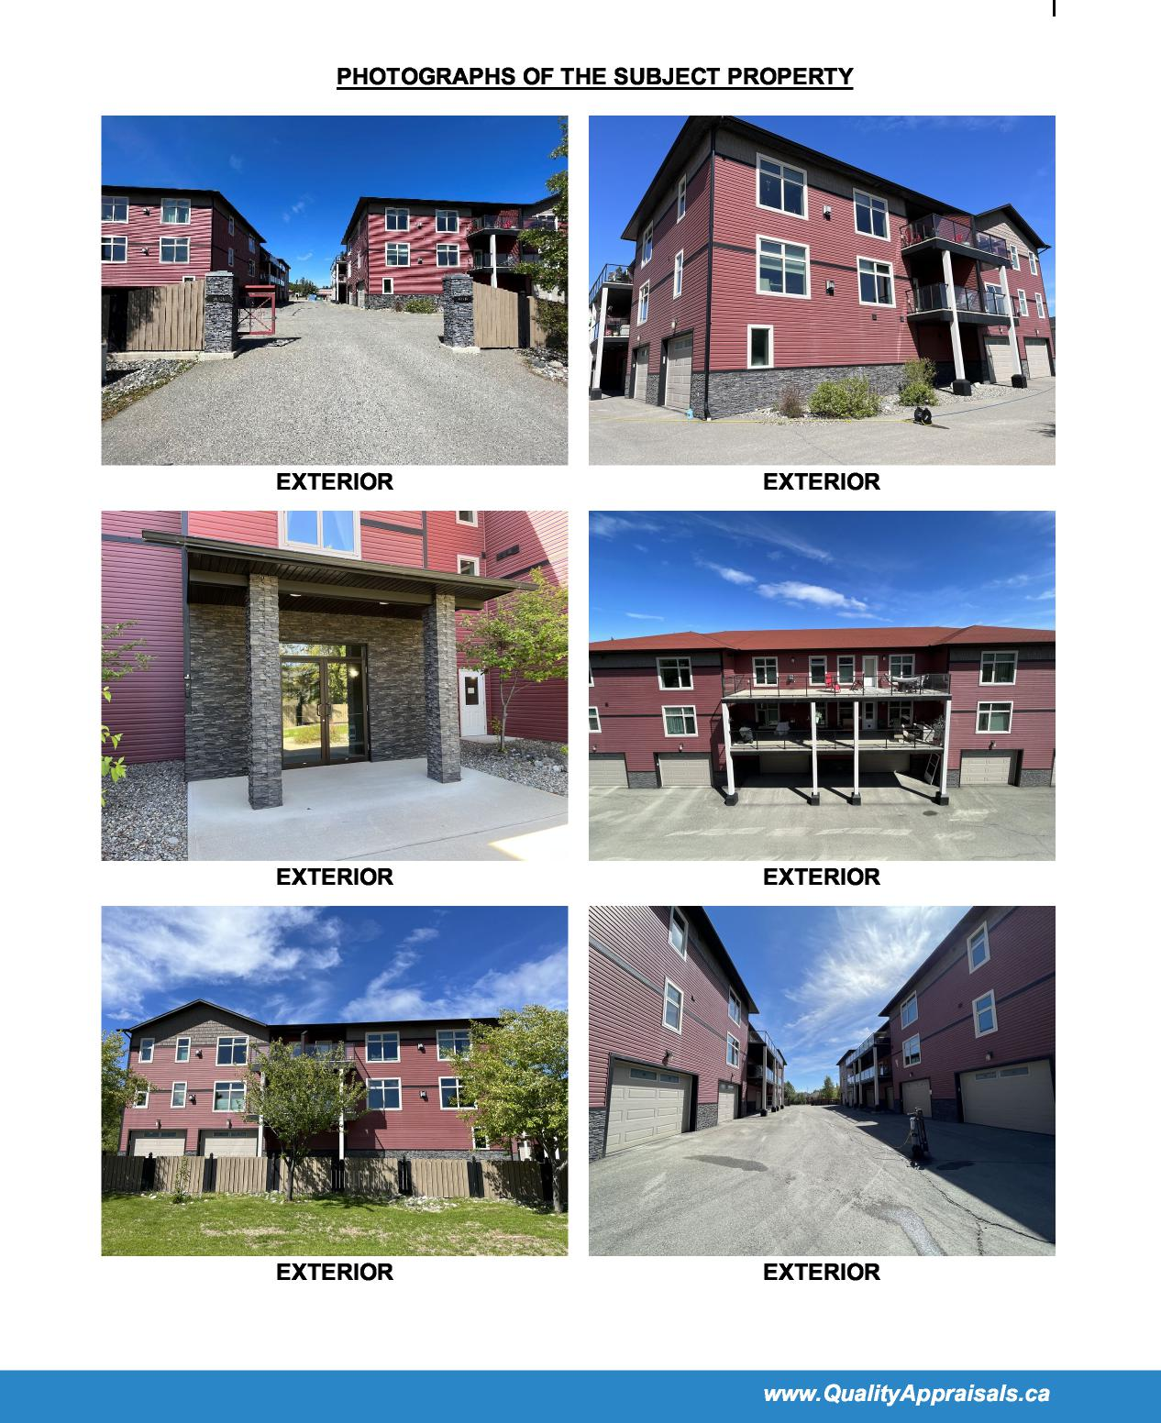
EXTERIOR
EXTERIOR
I
PHOTOGRAPHS OF THE SUBJECT PROPERTY
EXTERIOR
EXTERIOR
EXTERIOR
EXTERIOR
www. QualityAppraisals. ca

II
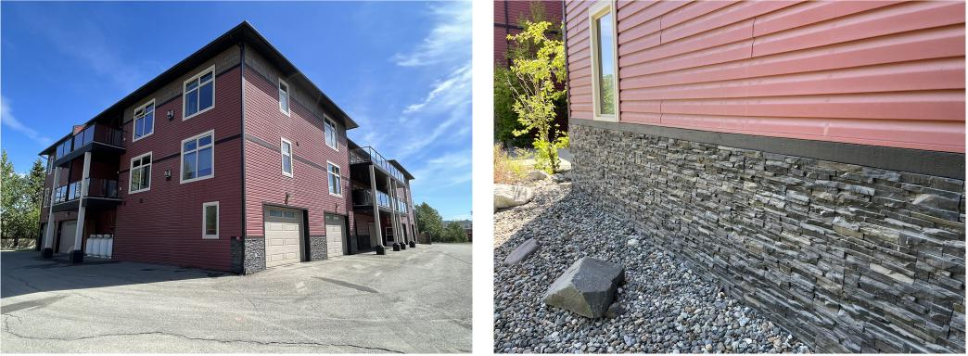
EXTERIOR EXTERIOR
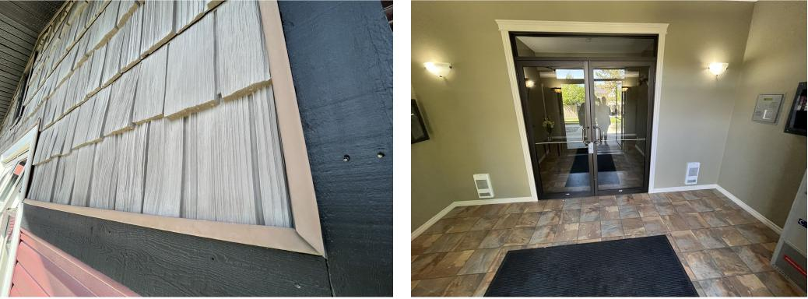
EXTERIOR ENTRY VESTIBULE
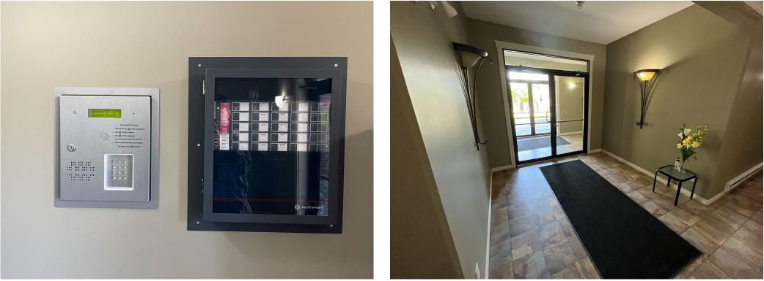
INTERCOM LOBBY

III
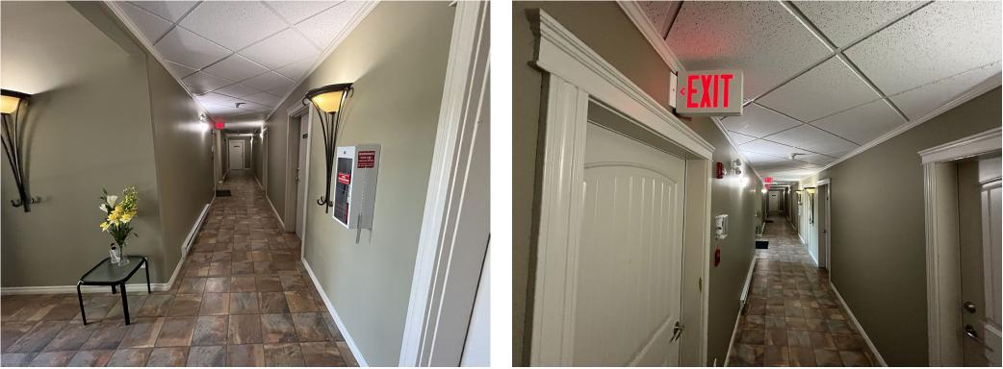
GROUND LEVEL HALLWAY GROUND LEVEL HALLWAY
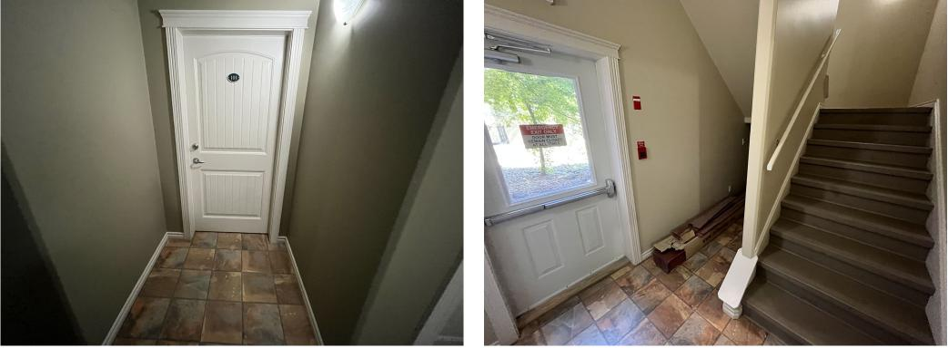
GROUND LEVEL HALLWAY STAIRWELL
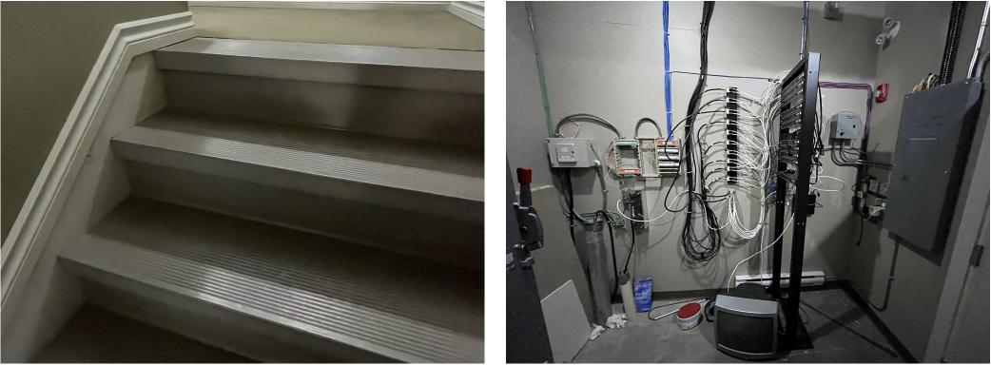
STAIRWELL FINISHES ELECTRICAL ROOM
www. QualityAppraisals. ca

IV
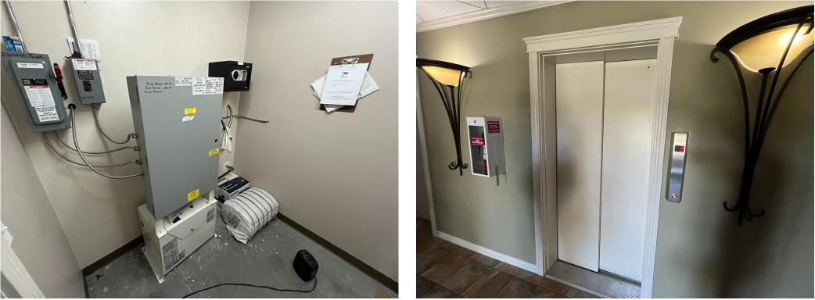
ELEVATOR ROOM ELEVATOR
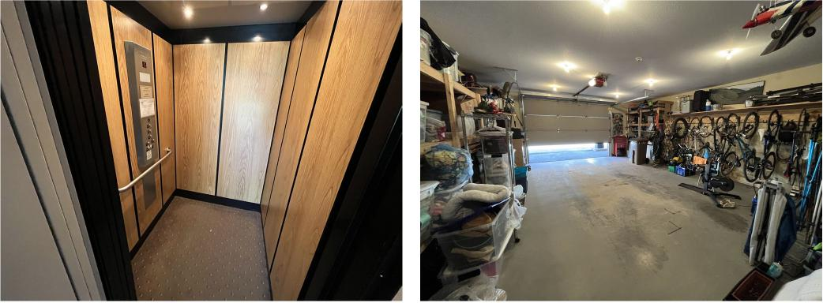
ELEVATOR TYPICAL GARAGE
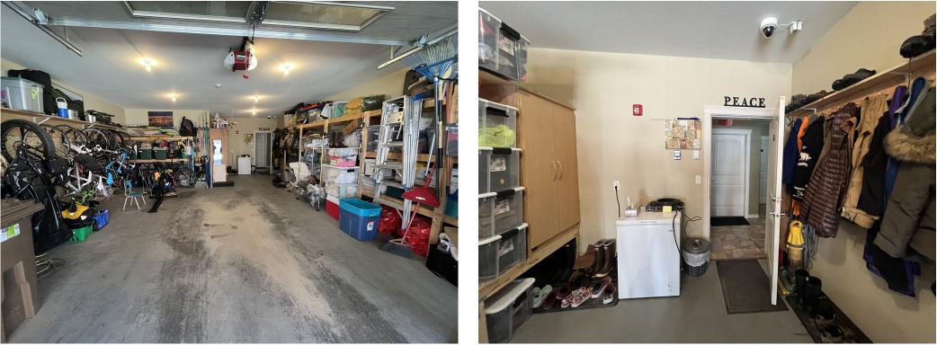
TYPICAL GARAGE TYPICAL GARAGE
www. QualityAppraisals. ca

V
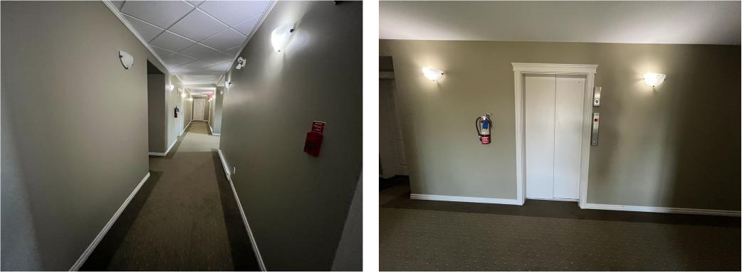
RESIDENTIAL HALLWAY RESIDENTIAL HALLWAY
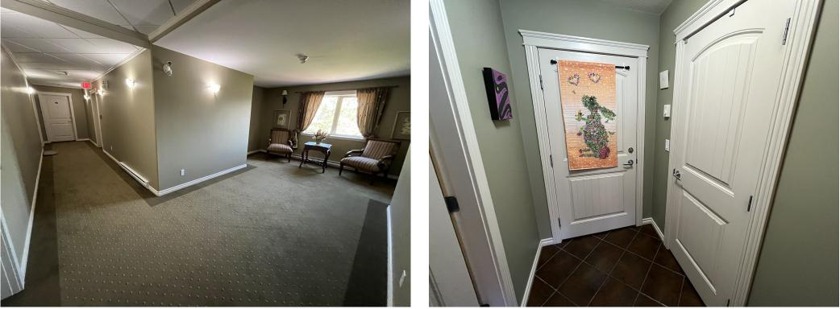
COMMON AREA DEN TYPICAL ENTRY
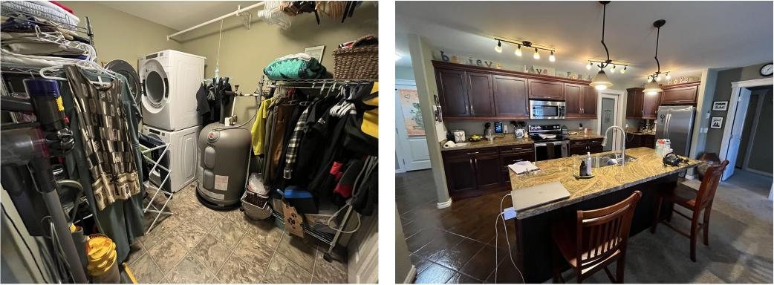
TYPICAL STORAGE/LAUNDRY TYPICAL KITCHEN
www. QualityAppraisals. ca

VI
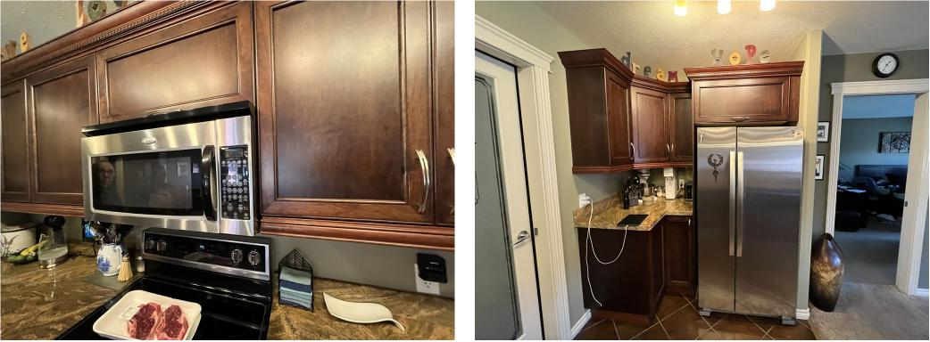
TYPICAL KITCHEN TYPICAL KITCHEN
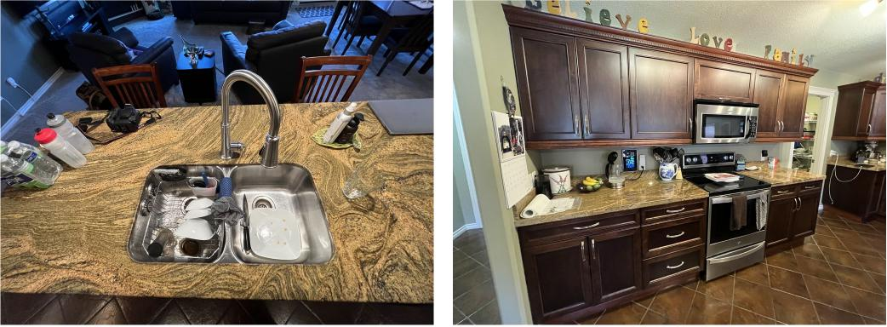
TYPICAL KITCHEN TYPICAL KITCHEN
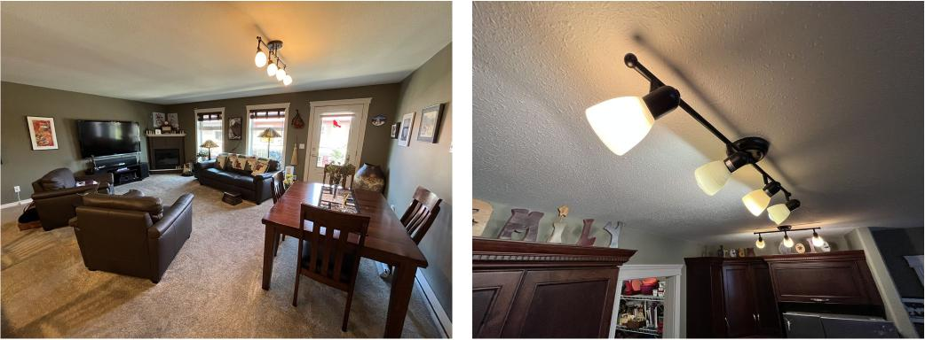
TYPICAL LIVING ROOM TYPICAL LIGHT FIXTURES
www. QualityAppraisals. ca

VII
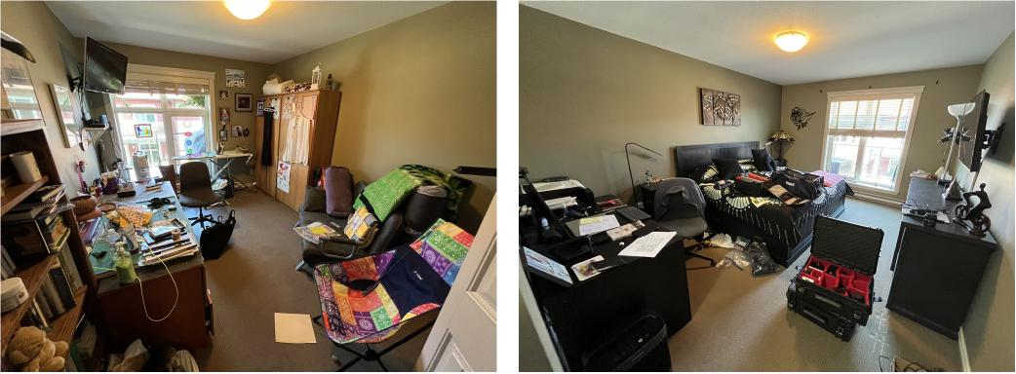
TYPICAL BEDROOM TYPICAL BEDROOM
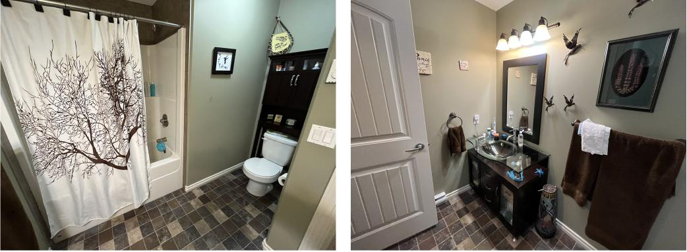
TYPICAL BATHROOM TYPICAL BATHROOM
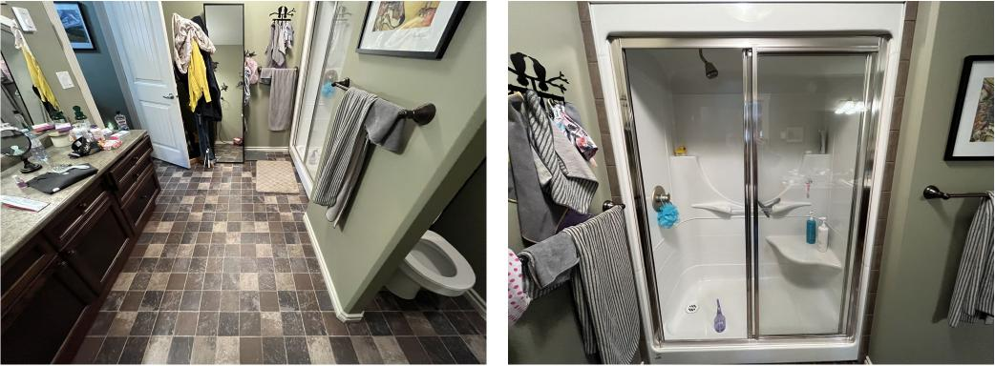
TYPICAL BATHROOM TYPICAL BATHROOM
www. QualityAppraisals. ca

VIII
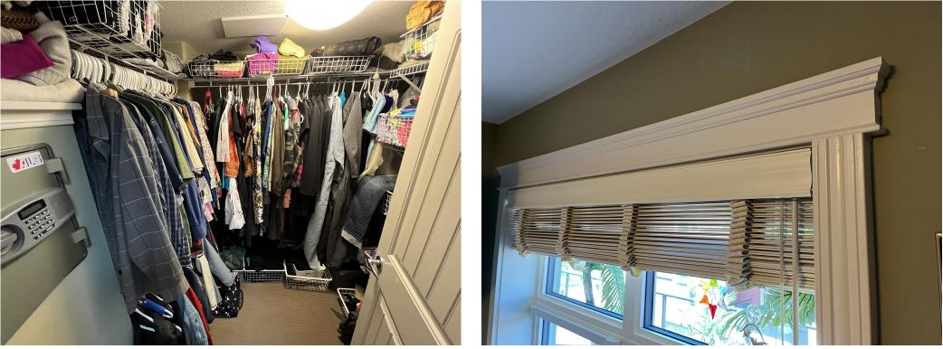
WALK-IN CLOSET, SAFE TYPICAL MOULDINGS
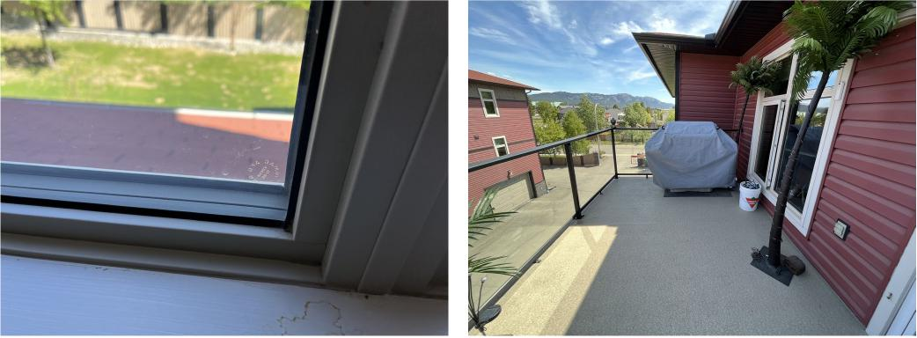
TYPICAL WINDOW TYPICAL PATIO FINISHES
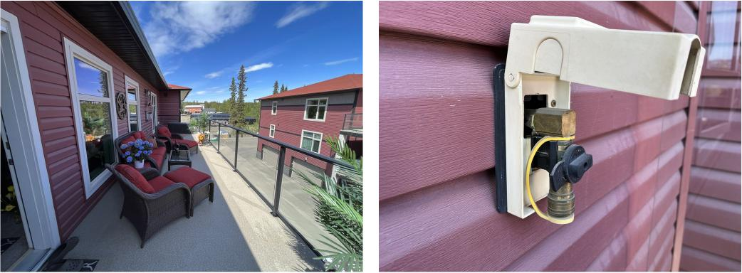
TYPICAL PATIO FINISHES PROPANE HOOK-UP
www. QualityAppraisals. ca

IX
PLAN 93788 CLSR YT

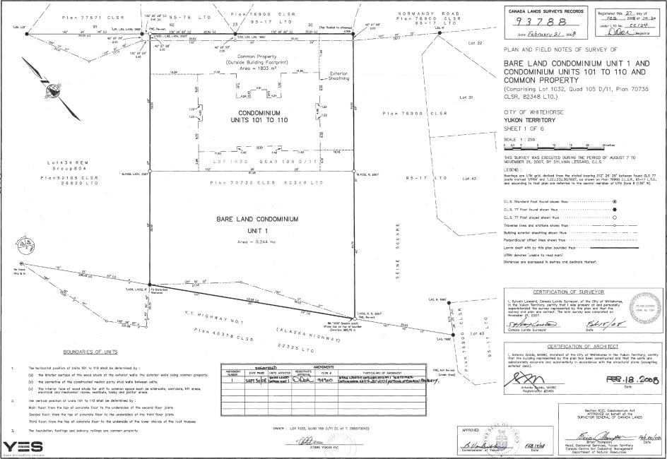
CARADA LARDS SURVEYS RECORDS
7 8 r.s..." AU ms8
NORMANDY ROAD
R^{,99 75900} C,SR
D5-17 LTO
129 Fr —
-----'"---- ------
/ ( N ,.... BARE LAND CONDOMINIUM UNIT 1 AND N PLAN AND FIELD NOTES OF SURVEY OF
1 \\ CONDOMINIUM UNITS 101 TO 110 AND COMMON PROPERTY
1 (Comprising Lot 1032, Ouod 105 0/11. Plan 70735 CLSR, 82348 LTO.)
CITY OF WHITEHORSE YUKON TERRITORY
SHEET 1 OF 6
SCALE 1 : 250
⁹ 9⁹ 1 9
•
•
DOUNDARIES OF UNITS
n99..99 99.9r9. 9.99 no vow., e• 9.99999 by :
9N• Interier surfoo< thew. owe onto 991 I.,M properly
Of ⁵. offotOillot of to c000l000tool froolloo ps, sloe ogio
!e)
^1.1^ --w ro -Im ar ...•- ^-
9 99 '99949999 '909.99 one .919999 ⁹⁹ ⁹⁹⁹⁹⁹⁹ Proloof f
YES,
OMER 5051011. WM105 DM CC of 99.90099)
Plon CL59
Plan 77571 CLSR 9S-78 LI, A5900
„ 95-17 LTO
30
^{a.L'"'""}e V ise 29,9(9
"1"..
COmmOn Property
(Out eNe BuldIng Footprint) Area 1803 m²
— • xterlor
L.^{E}-51190.9,g
•
CONDOMINIUMUNITS 101 TO 110
LOr 1032 ODA, 105 D/11
Lel," REM Drou9804
P19970731 CLSR 02348 LIC
BARE LAND CONDOMINIUM UNIT 1
vir
Pion 78900 lc 8R
^{mil}
II
5
CERTIFICATION OF AIN1-11TFCT
Fee • la .2ett,
Poo 1 replaces Page 2 part 01 the Yukon LaNd "Mee Reconciliation.. to Canada Land Survey Records. | .6 /Wog

Iwww.QualityAppraisals.ca

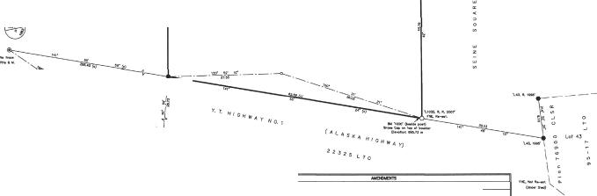
m.n.

el, 4037S CI.SR
ztv-
g.
BOUNDARIF, OF UNITS
norittotal realm of 101 to Ro ono p• gloal
0, RD moor .olat• mo Dope epee of M. Mork, d eon Da b.,
RI ¹. cn.,. of m• ccowircive maDa. ...runwn at=ontrrnogaZrtt. t^{e}Lire'L'41•=7:4,.=
11,...orlioa aDon on. m ow, .3•DORRoY
RADDIJR8 ODIRPARK,
YES
ONDR LOT 1o3o. oRAD VD ,0.t T. DOD0MORD)
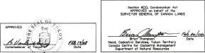
/
/ Plan 77671 CLSR ^{1.........}.95-7/3 LTO \ ^{P}V^{"9°.} ."°
. / t I '''' 92 \./ 95-17 LTO
,,, ._{1.}.........L.06...4 _{z:}— .,
—.. V or Dea,Da
,....₄
(Ow side a Contfnen PrOpetly
Argo = 1803 m.
1—s^{E}nVit^{r}
91 le .., 51
L4— —I.6._1
^{k}i ;⁻1 i....
9 CONDOMINIUM e,
,.
UMTS 101 TO 110 __{I}
91 19
Lo1•54 REN 5 _{Lor} ,₀,_{2 QvAD} ,_{o},
Groupe“
.4,
Plan 70735 CLSR B2340 LTO
BARE LAND CONDOMINIUM
UNIT 1
Areo 0.266 Ho
R•00.roa _21 day of
NOS
SMNE.:
LAN AND FIELD NOTES OF SURVEY OF
BARE LAND CONDOMINIUM UNIT 1 AND CONDOMINIUM UNITS 101 TO 110 AND COMMON PROPERTY
(Comprising Lot 1032. Quad 105 DM. Plan 70735 OLSR, 82348 LTD.)
CITY OF WHITEHORSE
YUKON TERRITORY
SHEET 1 OF 6
SCALE 1 950
1. Ls •
L20210
oosonIng ¹:L^{4'}n 'Fir:SFR ?:^{L}0^{T'l}
siomiont
0.1..S. 77 Peet fp., Yoe. 1,0
TnrDroo 1.• otanom ....
Ewa. aRfoR
NORMAN!, ROAD
Ong'
N _{N}
N_{N}
Lots,^{I}_{I}
Plan 78900
9 5 - 1 7 INTO Lots
C_{N}
CADIADA LMOD DIRDVD⁻D8 REODROD
? 7 8
nad
•
CERTIFICATION OF SURVEYOR
4:41..m;⁻14",
CERIFI0AION OF ARrHITEGS
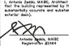 | Rge . 2coto

Pogo 2 is MAR. by Page 1 w tersoiosmAton Lend Tiles Romndiationmosmcanase Lard soveyRecoico

Iwww.QualityAppraisals.ca

