In a Pinch Pottery Workshop
This fun, guided workshop teaches you basic Hand Building techniques and is suitable for beginners. All materials supplied.
Class held by Trish Richers

Cost: $55 per person,  Maximum group size - 6 people  Duration: 2 hour class  Venue: Art as Mania  20 – 22 Emu Bay Rd, Deloraine  Dates Thursday September 22nd  Time: 11 am – 1 pm | 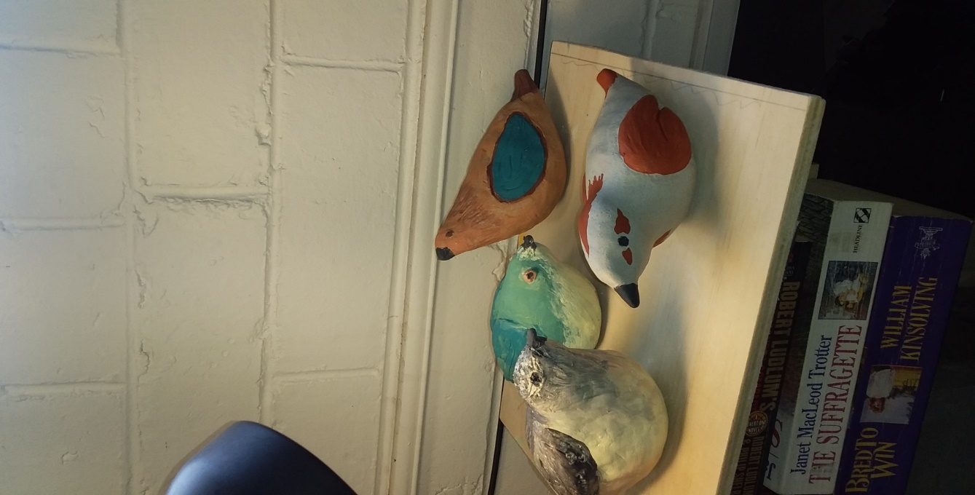
To enrol or for more information contact Art as Mania contact@artasmania.com.au or phone 0488 137 315
Workshop Fun in Deloraine
@ArtistinResidenceTrailTasmania

